**WEEK 8 HANDSON : GIT**

**TASK 5 :**

**In this hands-on lab, you will learn how to:**

* **Execute steps involving clean up and push back to remote Git.**

**TASKS AND OUTPUT :**

**Please follow the instructions to complete the hands-on. Each instruction expects a command for the Git Bash.**

1. **Verify if master is in clean state.**

**git checkout master**

**git status**

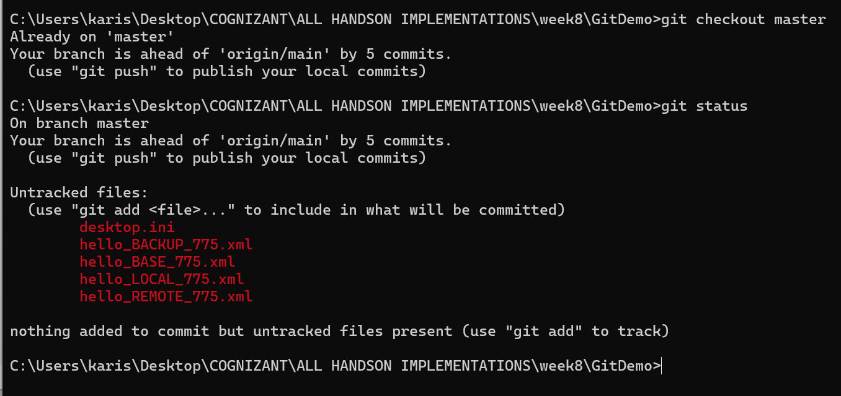

1. **List out all the available branches.**

**Git branch -a**

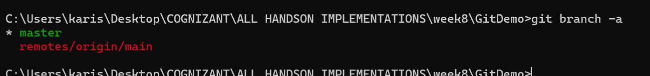

1. **Pull the remote git repository to the master**

**git pull origin main**

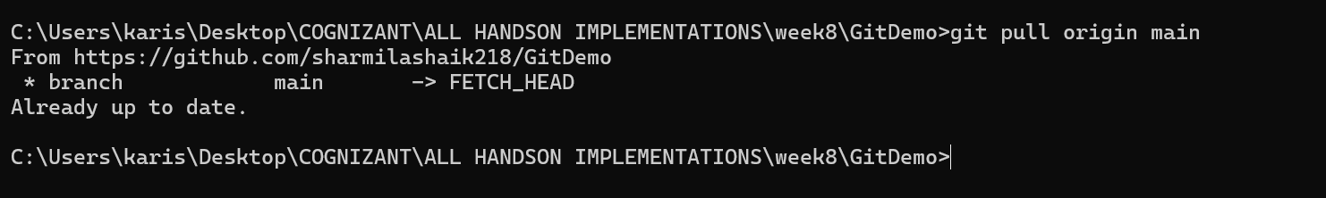

1. **Push the changes, which are pending from “Git-T03-HOL_002” to the remote repository.**

**git push origin master**

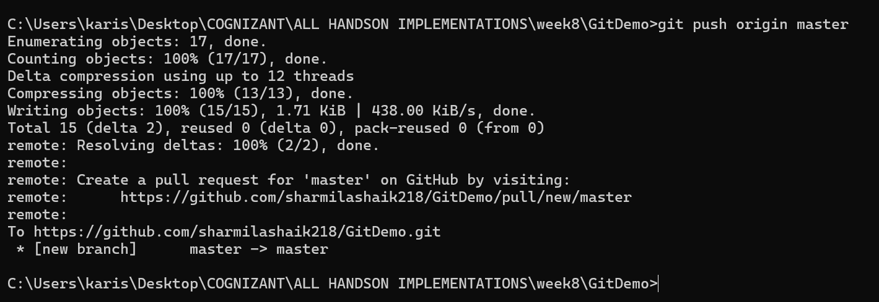

1. **Observe if the changes are reflected in the remote repository.**

**git log --oneline --graph --decorate –all**

