**ANALYSIS OF DEMAND FOR MONEY:**

money<-read.csv("demand for money final.csv")

print(money)

**output:**

Year Interest.rate GDP WPI moneyprinted

1 1978 10.77 5.712532 10.6 17292

2 1979 -1.06 -5.238183 11.8 20000

3 1980 4.48 6.735822 14.2 23424

4 1981 5.12 6.006204 15.9 24937

5 1982 7.77 3.475733 16.3 28535

6 1983 7.32 7.288893 17.6 33398

7 1984 7.95 3.820738 18.8 39915

8 1985 8.68 5.254299 19.7 44095

9 1986 9.09 4.776564 20.8 51516

10 1987 6.56 3.965356 22.2 58555

11 1988 7.64 9.627783 24.1 66786

12 1989 7.44 5.947343 25.8 81060

13 1990 5.27 5.533455 28.1 92892

14 1991 3.62 1.056831 31.9 114406

15 1992 9.13 5.482396 35.7 124066

16 1993 5.81 4.750776 38.3 150778

17 1994 4.34 6.658924 42.4 192257

18 1995 5.86 7.574492 46.3 214835

19 1996 7.79 7.549522 48.4 240615

20 1997 6.91 4.049821 50.6 267844

21 1998 5.12 6.184416 53.6 309068

22 1999 9.19 8.845756 55.4 341796

23 2000 8.34 3.840991 59.1 379450

24 2001 8.59 4.823966 61.9 212936

25 2002 7.91 3.803975 63.5 244655

26 2003 7.31 7.860381 66.9 275444

27 2004 4.91 7.922943 71.3 319761

28 2005 4.86 9.284825 74.7 361229

29 2006 2.57 9.263965 78.2 421940

30 2007 5.68 9.801360 82.1 495950

31 2008 3.77 3.890957 89.2 581598

32 2009 4.81 8.479784 91.3 681113

33 2010 -1.98 10.259963 100.0 788299

34 2011 1.32 6.638363 109.5 936949

35 2012 2.47 5.456389 117.7 1053799

36 2013 3.87 6.386106 124.8 1175645

37 2014 6.70 7.410228 129.0 1283748

38 2015 7.56 8.154425 123.9 1428893

39 2016 6.35 7.112686 123.9 1641571

40 2017 5.46 6.681182 128.1 NA

41 2018 5.13 6.810000 133.6 NA

> str(money)

'data.frame': 41 obs. of 5 variables:

$ Year : int 1978 1979 1980 1981 1982 1983 1984 1985 1986 1987 ...

$ Interest.rate: num 10.77 -1.06 4.48 5.12 7.77 ...

$ GDP : num 5.71 -5.24 6.74 6.01 3.48 ...

$ WPI : num 10.6 11.8 14.2 15.9 16.3 17.6 18.8 19.7 20.8 22.2 ...

$ moneyprinted : int 17292 20000 23424 24937 28535 33398 39915 44095 51516 58555 ...

**SCATTER PLOT:**

> plot(money,col='#0800FFFF')

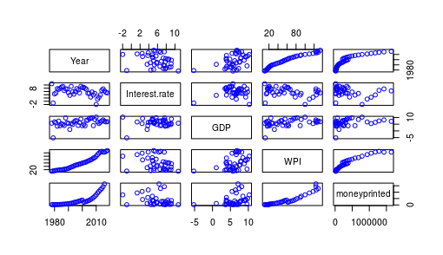

**MULTILINEAR MODEL:**

> multilinearmodel = lm (moneyprinted ~ GDP + Interest.rate + WPI, data = money)

> summary(multilinearmodel)

**OUTPUT:**

Call:

lm(formula = moneyprinted ~ GDP + Interest.rate + WPI, data = money)

Residuals:

Min 1Q Median 3Q Max

-271713 -66042 3187 58287 493508

Coefficients:

Estimate Std. Error t value Pr(>|t|)

(Intercept) -258666.8 84289.4 -3.069 0.00413 **

GDP -13766.0 9874.3 -1.394 0.17207

Interest.rate 10707.5 9745.9 1.099 0.27941

WPI 11595.2 781.5 14.838 < 2e-16 ***

---

Signif. codes: 0 ‘***’ 0.001 ‘**’ 0.01 ‘*’ 0.05 ‘.’ 0.1 ‘ ’ 1

Residual standard error: 148800 on 35 degrees of freedom

(2 observations deleted due to missingness)

Multiple R-squared: 0.8898, Adjusted R-squared: 0.8804

F-statistic: 94.23 on 3 and 35 DF, p-value: < 2.2e-16

**FINAL FORMULA:**

MONEY PRINTED= -258666.8+(-13766*GDP)+(10707.5*Interest.rate)+(11595.2*WPI)