StreamliningITProcurement:AutomatingStandarLaptop
OrderswithFlowDesigner

Phase-1 --BRAINSTORMING&IDEATIONPHASE

Date | 28/092026
TeamId | SWTID-2026-1711
ProjectName | Streaming IT Procurement: Aotumating Standard Laptop Oreders with Flow Designer
ProjectGuideName | Abinaya M

TeamMembers:

Name | Reg.No
Sharmi S | 24CAB 3460
Reshma Sharin H | 24CAB 3458
Sornavalli R | 24CAB 3461
Swathi R | 24CAB 3463
Varshini R | 24CAB 3464

BRAINSTORMING&IDEATION
PHASE

Project:StreamliningITProcurement:AutomatingStandardLaptopOrderswith FlowDesigner

Project Phase: Brainstorming & Ideation. Platform: ServiceNow. Technology: Flow Designer. Process Area: IT Procurement. MainUse Case:StandardLaptopOrdering.AcademicProject.

Thisdocument presents the Brainstorming& IdeationPhasefor anacademicproject that examines howServiceNowFlowDesignercanautomatetheStandardLaptopprocurementflow.Theobjectiveof this phase is to identify the core problems in the current procurement lifecycle,generate candidate solutions, evaluate alternatives, and propose a final automation concept suitable for detailed requirements and subsequent development phases.

Problem Definition
Manual steps in StandardLaptop requests cause delaysand oversight.

Brainstorming
Generateideas spanningmanual, semi-automated, andfully automated approaches.

Evaluation
Assessalignment withServiceNow andoperational feasibility.

Selected Solution
Flow Designer automation creatingCatalog Taskassignedto Hardware.



Shortintroduction:TheprojectaddressesinefficientmanualactivitiesintheStandardLaptoporderingprocessbydesigning a Flow Designer-based automation that links Service Catalog requests, approvals, and Catalog Task creation to the Hardware assignment group.

Understanding the Existing IT Procurement Problem
ThecurrentITprocurementprocessforStandardLaptopordersreliesonahuman-operatedsequence:aService Requestissubmitted,approvalsareobtained,andconfigurationtasksmust becreatedandroutedmanually.When configurationtaskcreationorassignmentisomittedordelayed,downstreamactivitiesarestalled.Theresultingprocess inefficiencyincreasesuser waittimeand administrativeoverheadin the ITprocurementand Hardwareteams.

- Manualintervention
- Delayedtaskcreation
- Configurationdependency
- Taskassignmentproblems
- Userwaitingtime
- Resourceutilization
- Processinefficiency

ExistingChallenge | EffectonProcess
Manualtaskcreation | Additionaladministrativeeffort—Configurationstepmaybeoverlooked (Proposed)
Configurationdependency | Possibledelayinconfigurationstart—Tobevalidated
Manualassignment | Taskmaynotreachthecorrectteamquickly—Observationduringideation
Lackofautomation | Morehumaninterventionrequired—Proposedsolutiontargetsthis
Delayedconfiguration | Longeruserwaitingtime—Expected

Laptop Request
ConfigurationReq
PossibleDelay
Approval
ManualActivities

ThediagramabovevisualizeshowaStandardLaptoprequestprogressesandwheremanualactivitiescreateriskof
delay.Theanalysisjustifiestheneedforprocessimprovementandautomationdesign.

IdentificationoftheCoreProblem

Duringbrainstorming,thecentralproblemwasdistilledintoaconcisestatementthatframesthe ideationworkandevaluationcriteria.

MainProblemStatement

“ThecurrentITprocurement processlacksefficiencyandautomation,particularlyforStandardLaptop orders. Configuration activities may require manual attention, creating the possibility of oversight, delays,andadditionaladministrativeeffort.”

- A user requiresaStandardLaptop.
- AServiceRequestiscreated(ServiceCatalog).
- Therequestrequiresapproval.
- Post-approval,configurationisrequired.
- TheconfigurationtaskmustbeassignedtotheHardwareteam.
- Manualhandlingcanintroducedelaysandoversight.


InefficientProcurement
ManualActivities
ProcessDelays
ResourceIssues
UserExperience

TheProblemTreeabovedecomposescausalfactorsanddownstreamimpactstoinformsolution requirementssuchasautomaticCatalogTaskcreationandreliableassignmentrules.

UnderstandingtheUserNeed

Thebrainstormingphaseprioritized userneedsdrawnfromITprocurement stakeholders.Theseneeds guided idea generation and success criteria for the automation concept.

UserNeed | Description/ExpectedBenefit
Easylaptopordering | StandardLaptopshouldberequestedthroughthecatalog—  Simplifiedrequestprocess(Expected)
Automatictask generation | Configurationtaskshouldbecreatedautomatically—Lessmanual work (Proposed)
Correctassignment | TaskshouldreachHardwareteam—Betterresourceallocation(To bevalidated)
Timelyconfiguration | Configurationshouldbeginpromptly—Reducedwaiting(Expected)
Bettervisibility | Requestandtaskshouldbetraceable—Improvedprocess understanding(Proposed)

“AsanITprocurementteammember,IwantStandardLaptoprequeststoautomaticallygenerate
configurationtasksandassignthemtotheHardwareteamafterapproval,sothatlaptop
configurationcanbeginpromptlywithlessmanualintervention.”


UserRequest
Approval
AutoConfig Task
HardwareTeam

Definingthis user story anchors acceptancecriteria: the Requested Item record must trigger automationafterapproval,producingaCatalogTaskwithassignmenttoHardwareandtraceabilityin the CMDB/RequestedItem context.

ObjectivesDefinedDuring
Brainstorming

Thebrainstormingsessiontranslatedstakeholderneedsintomeasurableobjectivesthattheproposed automation should satisfy.

- CreateaseamlessStandardLaptoporderingexperience.
- Ensuretimely laptopconfigurationafterapproval.
- Reducemanualinterventionandhumanerror.
- ImproveresourceutilizationbycorrectassignmenttoHardware.
- Increaseprocurementefficiencyandproductivity.
- Providebettertraceabilityandprocessvisibility.

Objective | ProblemAddressed | ExpectedDirection
Seamlessordering | Complex/manualprocess | Simplify
Timelyconfiguration | Configurationdelays | Automatetaskcreation
Reducemanualwork | Administrativeoverhead | UseFlowDesigner
Correctassignment | Manualrouting | AssigntoHardware
Betterproductivity | Repetitiveactivities | Automate

Automation Efficiency
1
2
6
3
5
4

Productivity Accuracy

UserExperience ResourceUtilization

Theseobjectivesformtheevaluationframeworkusedlatertocomparecandidateideas.

BrainstormingofPossibleSolutions

Multiplesolutionapproachesweregeneratedandbrieflycharacterized.Theaimwastocapturelow- risktohigher-automationconceptsforqualitativeevaluation.

- Idea1—Manualtaskcreation:Continuemanualcreationandassignment;familiarbutretains
processriskandhumanerror.
- Idea2—Automatedtaskcreation:CreateCatalogTaskautomaticallyfromthe RequestedItem afterapproval.
- Idea3—Automaticassignment:AssigngeneratedCatalogTasktoHardwaregroupusing assignmentrules.
- Idea4—Flow-basedautomation:UseServiceNowFlowDesignertoconnectapprovaloutcome to Create CatalogTaskand assignmentactions.

Idea | MainConcept | AutomationPotential
Manualtaskcreation | Createtaskmanually | Low
Automatictaskcreation | Generatetaskautomatically | High
Automaticassignment | RoutetoHardware | High
FlowDesigner | Connectprocesssteps | High
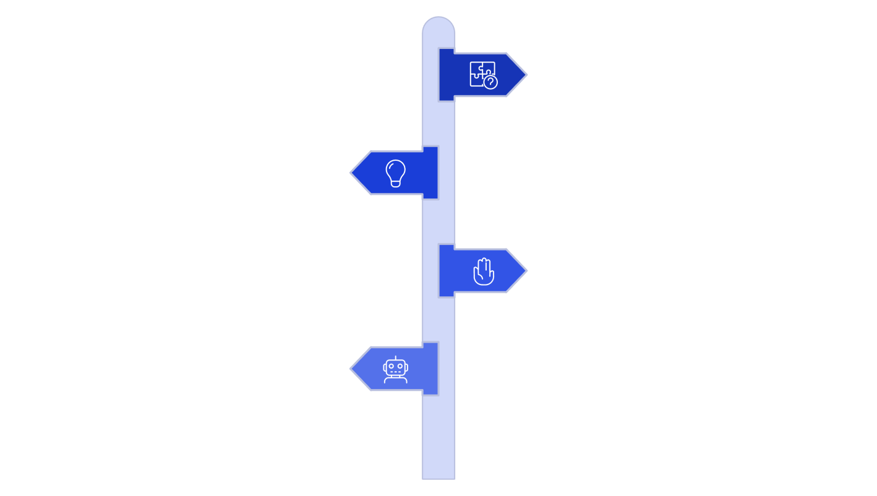
Problem
Definethecoreissueto solve.
GenerateIdeas
Brainstormlow-risktohigh-automation
options.
ManualApproach
Keeptaskscreatedandassigned manually.
TaskAutomation
Automatetaskcreationviarulesor
scripts.

Eachideawascaptured with expected trade-offs.Flow Designerprovidesthe mostdirect pathto integrateServiceCatalogtriggers,approvals,andCatalogTaskactionswithinServiceNow'snative workflowcapabilities.

ExploringAutomationPossibilities

ExplorationfocusedonhowtocombineautomatedtaskcreationandassignmentwithServiceCatalog and approval logic to produce a cohesive solution.

Component | RoleinProposedSolution
ServiceCatalog | ProvidestheStandardLaptopcatalogitemandcaptures requested-item metadata.
ServiceRequest(RequestedItem) | Represents the user's order instance and stores details used by the flow.
Approval | Controlswhethertherequestprogressestoautomation; approvalstateisatriggerguard.
FlowDesigner | Automatestheprocess:triggersonrequesteditemstate changeandexecutesCreateCatalogTaskaction.
CreateCatalogTaskaction | GeneratesaCatalogTaskrecordwithshortdescription andassignment.
Hardware | Assignmentgroupthatreceivestheconfigurationtask forexecution.
Service Catalog
Service Request
Approval
FlowDesigner

Thisconceptualmappingclarifiesdataflowandintegrationpoints:theRequestedItemrecordisthe authoritative trigger; Flow Designermust read requested item fieldsand the approval result to populate Catalog Task fields and assignment.

RefiningtheSelectedConcept

RefinementfocusedonoperationaldetailsandhowtoconvertthebroadconceptintoactionableFlow Designer requirements and triggers.

InitialIdea | Refinement | ImplementationNote
Automatetaskcreation | UseFlowDesignerCreate Catalog Task action | MapRequestedItemfieldsto Catalog Task attributes
Automaterouting | AssigntasktoHardwarevia assignmentrules or flow | Useassignmentgroupfield—  Tobevalidated
Connectrequestandtask | UseRequestedItemRecord as flow trigger | Triggeronapprovalstate transition
Trackconfiguration | CatalogTaskrecordforaudit andtraceability | LinkCatalogTaskto Requested Item
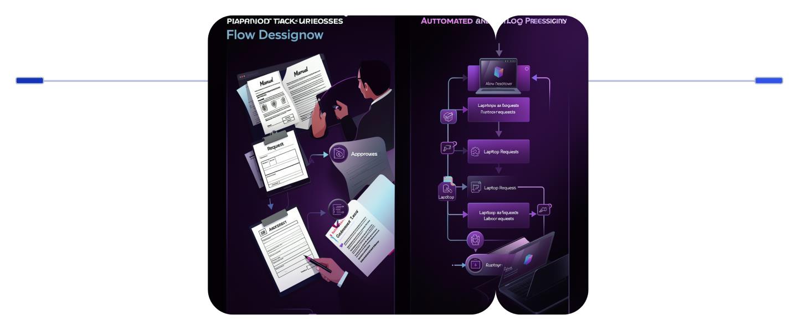
Before
Manuallaptop requests and hand-configured assignments
After
Standardrequest withapprovalsand FlowDesigner automation

Refinementidentifiesrequireddatamappings(requesteditem→catalogtask),triggerconditions (approvalstatus= Approved), andassignmentlogic(explicitHardwaregroupmapping).These elements will feed the requirements specification in the next phase.

InitialFlowDesignerConcept

ThispagespecifiestheproposedFlowDesignerconfigurationataconceptualleveltosupport subsequentformalrequirementdocumentation.

Configuration | ProposedValue/Notes
FlowName | StandardLaptopTaskAutomation(Proposed)
Application | Global(orscopedunderprocurementapp)—Tobe validated
RunAs | System user (Proposed) — ensure leastprivileges documented
Trigger | ServiceCatalogRequestedItemrecord state/approval change
Action | CreateCatalogTask
TargetTable | CatalogTask
KeyFields | ShortDescription:"LaptopneedtoConfigured" (Proposed); Description:requesteditemdetails; Assignment Group: Hardware
ApprovalCondition | Approval=Approved(Flowproceeds)
Request
Trigger
Approval
CreateTask

Thisflowchartrepresentsthe coretechnicalsequencetheFlowDesignerimplementationmustrealize. Fieldmappings,securitycontext, andfailurehandlingareidentifiedasrequirementitemsforthenext phase.

EvaluationofProposedSolution
Concepts

Aqualitativecomparisonacrossthecandidateideaswasperformedusingfactorsalignedtoproject objectives.Nonumericalscoringisassigned;descriptionsprovidecomparativeinsight.

EvaluationFactor | ManualProcess/AutomatedTask/FlowDesignerApproach
Manualintervention | Manual: Required; Automated task: Reduced; Flow Designer: Reduced(Proposed)
Taskcreation | Manual:Manual;Automatedtask:Automated;FlowDesigner: Automated and integrated
Assignment | Manual:Manualrouting;Automatedtask:Canbeautomated;Flow Designer: Automated assignment to Hardware (Proposed)
Processconsistency | Manual:Dependsonuser;Automated:Higher;FlowDesigner:High  (Standardized)
Integrationwith  ServiceNow | Manual:Limited;Automatedtask:Possible;FlowDesigner:Directly  aligned(Preferred)

PossibleIdeas
SelectedConcept
CompareNeeds

Explanation:FlowDesigneralignsdirectlywithobjectivesbyconnectingtheServiceCatalogrequested- item lifecycleto anautomated CreateCatalogTaskactionandexplicitassignment.Therefore, itis selected asthe preferred conceptual approach(Proposed Solution) pending formalrequirements and validation.

