**Qs 2))**

**SVM (max iteration = 1000, tolerance = 0.01)**

C : 0.01 accuracy : 47.61904761904761 %

C : 0.1 accuracy : 61.904761904761905 %

C : 0.2 accuracy : 100.0 %

C : 0.3 accuracy : 90.47619047619048 %

C : 0.4 accuracy : 66.66666666666666 %

C : 0.5 accuracy : 61.904761904761905 %

C : 0.6 accuracy : 95.23809523809523 %

C : 0.7 accuracy : 90.47619047619048 %

C : 0.8 accuracy : 85.71428571428571 %

C : 0.9 accuracy : 95.23809523809523 %

C : 1.0 accuracy : 66.66666666666666 %

C : 2.0 accuracy : 66.66666666666666 %

C : 3.0 accuracy : 66.66666666666666 %

C : 4.0 accuracy : 71.42857142857143 %

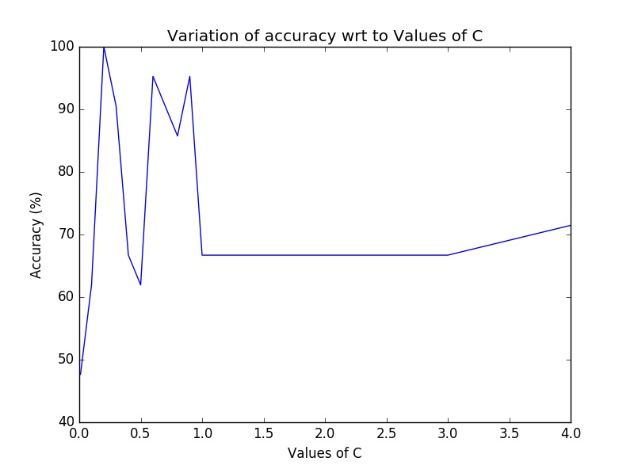

**Qs 3 ))**

**Multilayer Perceptron (learning_rate = 0.01, regularizing_param = 0.01, max_iterations = 2000)**

hidden units = 10 accuracy = 95.23809523809523 %

hidden units = 20 accuracy = 100.0 %

hidden units = 30 accuracy = 95.23809523809523 %

hidden units = 50 accuracy = 95.23809523809523 %

hidden units = 100 accuracy = 100.0 %

