What is Serlvet ?

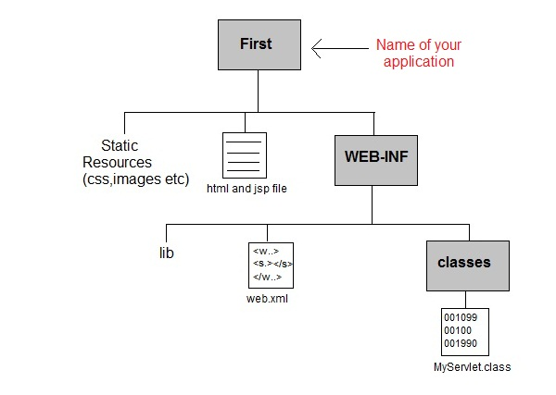

PurchasseOrder
Source
Static pages
WEB-INF
classes
Web.xml

Mapping

<web-app>
<display-name>Archetype Created Web Application</display-name>
<servlet>
<servlet-name>AddStudentServlet</servlet-name>
<display-name>AddStudentServlet</display-name>
<description></description>
<servlet-class>com.example.servlet.AddStudentServlet</servlet-class>
</servlet>
<servlet-mapping>
<servlet-name>AddStudentServlet</servlet-name>
<url-pattern>/AddStudentServlet</url-pattern>
</servlet-mapping>
</web-app>

