Design Iteration Report
Student Queue — Virtual Queue Management Mobile Application

1. Introduction
This report documents how the Student Queue Balsamiq prototype was revised in response to the seven usability problems identified during testing (see the accompanying Usability Testing Report). Each entry below states the problem addressed, the change made (or planned), and the supporting before/after evidence.
In the interest of accuracy, each iteration is labelled with its current status: screens marked Implemented show real before/after screenshots from the revised prototype; screens marked Planned describe the intended change, to be completed in the next Balsamiq revision pass before final submission.

2. Status Overview
# | Problem addressed | Status
1 | Role at login not clearly distinguished (student / staff / visitor) | Implemented
2 | No dedicated path for visitors to browse before logging in | Implemented (new screens)
3 | Queue-joining entry point not immediately visible | Planned
4 | Some Home screen elements did not respond as expected | Planned
5 | Settings screen hard to reach; effect of toggles unclear | Planned
6 | Profile screen's editable options not obvious | Planned
7 | Exit confirmation buttons did not restate the action | Planned
8 | Password recovery link's purpose not obvious | Planned

3. Implemented Iterations

Iteration 1 — Clearer role selection at login
IMPLEMENTED
Problem: Testing showed the visitor participant (P4) was unsure which login option applied to them, since only Student and Staff options were available.
Change made: A third “Visitor” button was added alongside Student and Staff on the Login screen, so all three primary user types identified in the personas and research have an explicit, self-selected entry point.
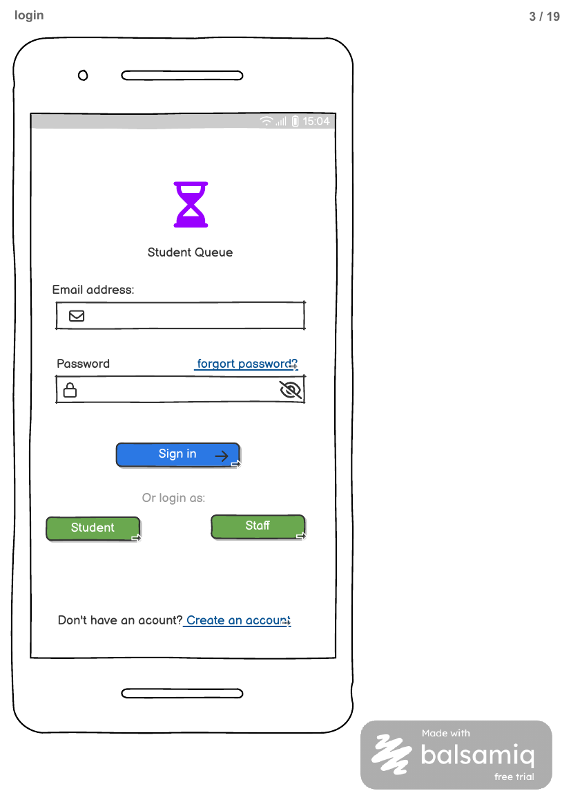  Before — Student / Staff only | 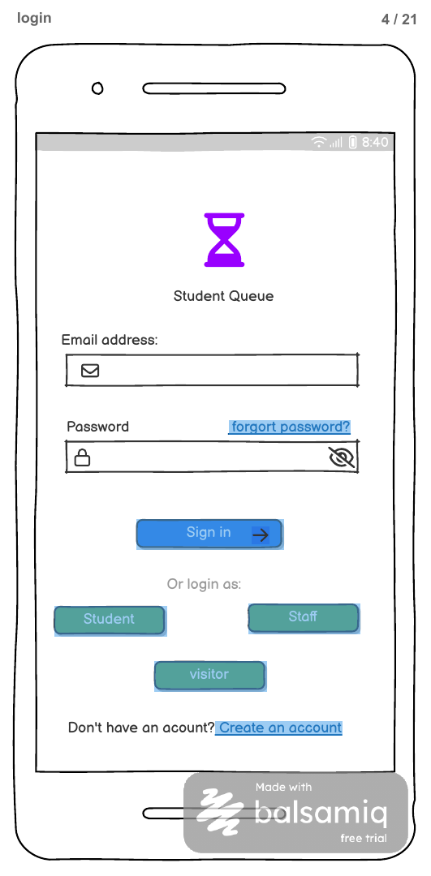  After — Student / Staff / Visitor
Rationale: Matches HCI principle of user control and recognition over recall — users should not have to infer which generic option applies to them.

Iteration 2 — Dedicated visitor onboarding flow
IMPLEMENTED (NEW SCREENS)
Problem: Beyond simply logging in, visitors had no way to browse available services before committing to an account or a queue.
Change made: Two new screens were added: an “Explore Offices” directory (searchable list of all campus offices) and a Visitor welcome screen offering a lightweight path to browse and continue straight to the homepage without full registration.
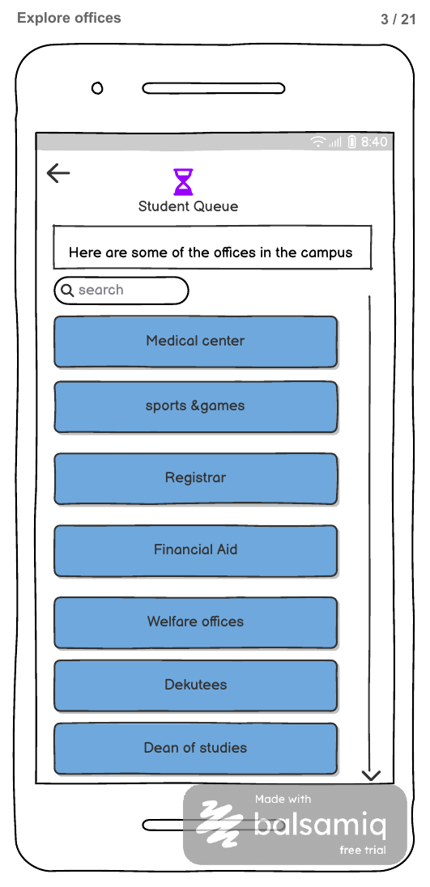  New — Explore Offices | 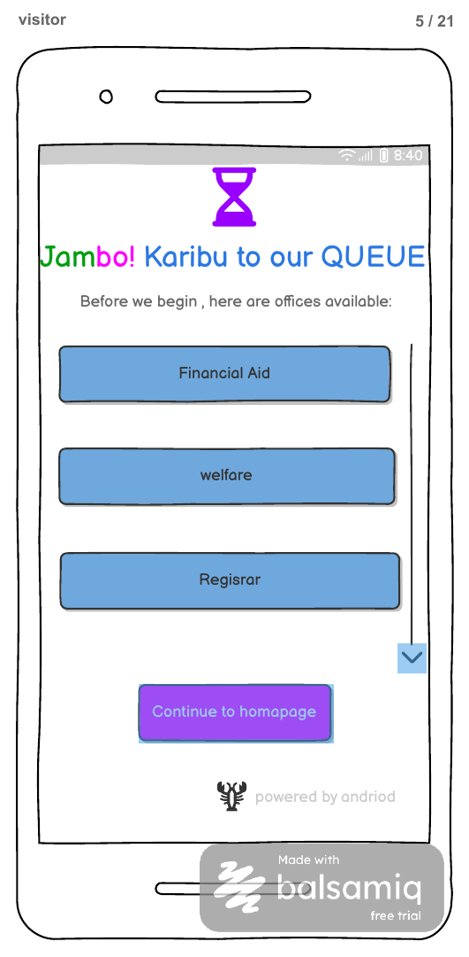  New — Visitor Welcome
Rationale: Strengthens Scenario coverage for the Visitor user type identified in Section 6 (Target Users) of the project documentation, and reduces friction for users who only need to browse.

4. Planned Iterations
The following changes are scoped and ready to implement in the Balsamiq file, but are not yet reflected in the current screen exports. They are listed here so the design intent is documented ahead of the next revision pass.
Planned — Problem 3: Queue-joining entry point
PLANNED
Proposed change: Enlarge and re-colour the primary “Join Queue” action on the Home/service-selection screen so it sits above the fold as a single prominent call-to-action, rather than being one of several equally-weighted list rows.
Planned — Problem 4: Non-responsive Home screen elements
PLANNED
Proposed change: Audit and wire every tappable element on the Home screen to its destination screen in the live Balsamiq link map, so no element in the prototype is a visual dead end.
Planned — Problem 5: Settings discoverability and feedback
PLANNED
Proposed change: Add a brief toast/confirmation state when a toggle is changed (e.g. “Preference saved”), and confirm the gear icon in the bottom navigation is visually distinct enough to be noticed on first use.
Planned — Problem 6: Profile vs. Edit Profile redundancy
PLANNED
Proposed change: Add a single visible “Edit” affordance directly on the Profile screen (rather than relying on users to find Edit Profile as a separate menu row) to make editability obvious at a glance.
Planned — Problem 7: Exit confirmation button labels
PLANNED
Proposed change: Replace the generic “YES / NO” buttons on the exit-confirmation dialog with explicit action labels: “Leave Queue” and “Stay in Queue.”
Planned — Problem 8: Password recovery discoverability
PLANNED
Proposed change: Increase the visual weight of the “forgot password?” link on the Login screen, and add a short reassurance line on the reset screen itself (e.g. “You don't need your old password to continue”) to reduce hesitation.

5. Conclusion
Two of the eight usability findings have been resolved with implemented, evidenced changes to the prototype: role clarity at login and a new visitor onboarding path. The remaining six findings are scoped as planned iterations with a specific, actionable change defined for each, ready to be carried out in the next Balsamiq revision before final submission. This keeps the project's iteration evidence accurate and defensible against the actual state of the prototype at each point in time.

