**Tables**

**Table Name: Login**

**Primary Key: Login Id**

**Description : Store the login details**

|  |  |  |
| --- | --- | --- |
| **FIELD NAME** | **DATA TYPE** | **DESCRIPTION** |
| **login_id** | **int** | **Login id of user** |
| **Usertype** | **varchar** | **Specifies the type of user** |
| **username** | **varchar** | **User name of the user** |
| **password** | **varchar** | **Password of the user** |

**Table Name: Producttable**

**Primary Key: P_ID**

**Description :Store the product details**

|  |  |  |
| --- | --- | --- |
| **FIELD NAME** | **DATA TYPE** | **DESCRIPTION** |
| **P_ID** | **int** | **Product id of the products** |
| **P_Name** | **varchar** | **Product Name of the products in the database** |
| **P_Quantity** | **varchar** | **Quantity of the product** |
| **UsagePeriodTime** | **varchar** | **The usage period time the** |
| **Price** | **varchar** | **Price of the product** |
| **Mfd** | **varchar** | **Date of manufacturing the product** |
| **Exp_Date** | **varchar** | **Date of expiry the product** |
| **Type** | **varchar** | **It specify the product is veg or others** |
| **ProductBrand** | **varchar** | **Which company manyfacture the product** |

**Table Name: offertable**

**Primary Key:cap_id**

**Description :Store new offers**

|  |  |  |
| --- | --- | --- |
| **FIELD NAME** | **DATA TYPE** | **DESCRIPTION** |
| **P_ID** | **int** | **Product id of the products** |
| **Pro_id** | **varchar** | **Product id contain the products which contain offer** |
| **P_Offer** | **varchar** | **It is the offer provided by the Manufacturer** |
| **Sp_Offer** | **varchar** | **It is the offer provided by the shop** |
| **Discription** | **varchar** | **Discription about the offer** |
| **From_Date** | **varchar** | **Date of offer which starts** |
| **End_Date** | **varchar** | **Date of offer which ends** |
| **Total_Price** | **varchar** | **Total price that is reduced by the offer** |

**Table Name: billmain**

**Primary Key: B_ID**

**Description: Store the details of entire billing section**

|  |  |  |
| --- | --- | --- |
| **FIELD NAME** | **DATA TYPE** | **DESCRIPTION** |
| **B_ID** | **int** | **Bill id for each purchase** |
| **Uid** | **varchar** | **User id for identify the user** |
| **total_amount** | **varchar** | **Total amount of purchase** |
| **gen_code** | **varchar** | **One time generated code for passing the values user to database** |
| **Date** | **varchar** | **Date of purchase** |
| **Status** | **varchar** | **It is the purchasing status** |

**Table Name: billsub**

**Primary Key: B_ID**

**Description: Store bills of each product**

|  |  |  |
| --- | --- | --- |
| **FIELD NAME** | **DATA TYPE** | **DESCRIPTION** |
| **B_ID** | **int** | **Bill id for each purchase** |
| **P_ID** | **varchar** | **Product id of the products** |
| **Price** | **varchar** | **Total amount of purchase** |

**Table Name: cart**

**Primary Key: Ct_id**

**Description:Cart table is used to store the recent purchases of a customer as individual**

|  |  |  |
| --- | --- | --- |
| **FIELD NAME** | **DATA TYPE** | **DESCRIPTION** |
| **Ct_id** | **int** | **Crt id for products added in the cart** |
| **P_ID** | **varchar** | **Product id of the products** |
| **Cus_id** | **varchar** | **Customer id for the users** |

**Table Name: customertable**

**Primary Key: Cus_ID**

**Description : Store the details of customers**

|  |  |  |
| --- | --- | --- |
| **FIELD NAME** | **DATA TYPE** | **DESCRIPTION** |
| **Cus_ID** | **int** | **Customer id for users** |
| **FirstName** | **varchar** | **Firstname of the users** |
| **SecondName** | **varchar** | **SecondName of the users** |
| **Place** | **varchar** | **Place of the user** |
| **Email** | **varchar** | **Email of the user** |
| **Phone** | **varchar** | **Phone number of the user** |
| **UserName** | **varchar** | **User name of the user** |

**Table Name: dummybank**

**Primary Key: Cus_ID**

**Description :Dummybank is used to store the bank details of the customer**

|  |  |  |
| --- | --- | --- |
| **FIELD NAME** | **DATA TYPE** | **DESCRIPTION** |
| **Cus_ID** | **int** | **Customer id for users** |
| **Acc_No** | **varchar** | **Registered account number of the user** |
| **Security** | **varchar** | **Secuirity code of the account** |
| **Amount** | **varchar** | **Bank balance of the user** |

**Table Name: purchasetable**

**Primary Key: Cus_ID**

**Description : Store the details of purchase**

|  |  |  |
| --- | --- | --- |
| **FIELD NAME** | **DATA TYPE** | **DESCRIPTION** |
| **Cus_ID** | **int** | **Customer id for users** |
| **P_ID** | **varchar** | **Product id of the products** |
| **Pur_Qty** | **varchar** | **Quantity of purchased items** |
| **Price** | **varchar** | **Price of the products** |
| **Pur_Date** | **varchar** | **Date of purchase** |

**Table Name: ratingtable**

**Primary Key: P_ID**

**Description: Rating table is used to store the store the customers ratings over the products and services of the shop**

|  |  |  |
| --- | --- | --- |
| **FIELD NAME** | **DATA TYPE** | **DESCRIPTION** |
| **P_ID** | **int** | **Product id of the products** |
| **Rating** | **varchar** | **Rating is used to rate the product by the rating stars** |
| **Uid** | **varchar** | **User id for identify the user** |
| **Date** | **varchar** | **Date of rating entered** |
| **Fdb** | **varchar** | **It is the feedback in text** |

**Table Name : reportstable**

**Primary Key : P_ID**

**Description : Reports table is used to store the sale details of the shop**

|  |  |  |
| --- | --- | --- |
| **FIELD NAME** | **DATA TYPE** | **DESCRIPTION** |
| **P_ID** | **int** | **Id of report** |
| **P_Quantity** | **varchar** | **Quantity of product** |
| **Pur_Date** | **varchar** | **Purchase date** |

**Table Name: stocktable**

**Primary Key: stockid**

**Description : Store the details of available stocks**

|  |  |  |
| --- | --- | --- |
| **FIELD NAME** | **DATA TYPE** | **DESCRIPTION** |
| **stockid** | **int** | **Serial number** |
| **P_id** | **varchar** | **Product id** |
| **Stk_qty** | **varchar** | **Quantity of stock** |

**Table Name: stafftable**

**Primary Key: sid**

**Description : Store the details of current staffs in the shop**

|  |  |  |
| --- | --- | --- |
| **FIELD NAME** | **DATA TYPE** | **DESCRIPTION** |
| **Sid** | **int** | **Id of staff** |
| **Name** | **varchar** | **Name of staff** |
| **Place** | **varchar** | **Place** |
| **DOB** | **varchar** | **Date of birth** |
| **Qualification** | **varchar** | **Qualification** |
| **Email** | **varchar** | **e-mail id** |
| **Gender** | **varchar** | **Gender of staff** |
| **Designation** | **varchar** | **Designation of staff** |

**DATA FLOW DIGRAM (DFD)**

**CONTEXT LEVEL DIAGRAM FOR SHOP-OWN**

**Level – 0**

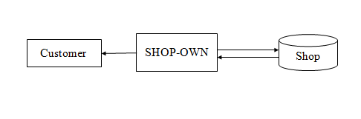

**Level-1 for Admin**

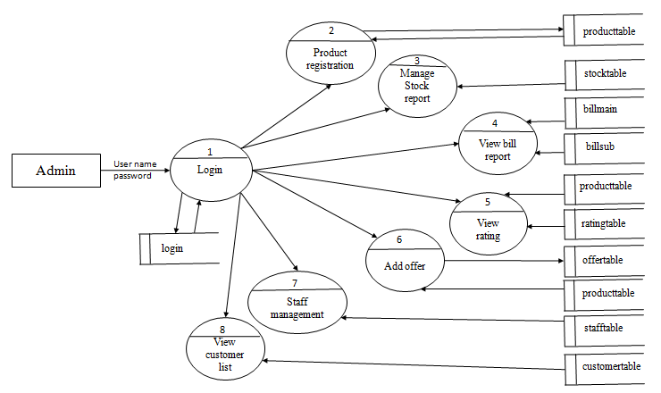

**Level-1 for Store**

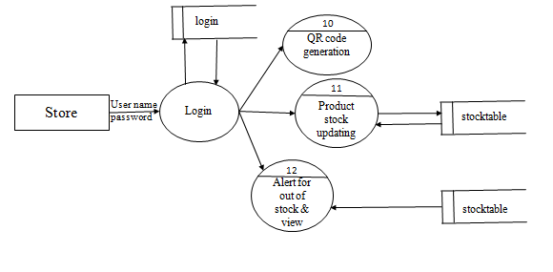

**Level-1 for Customer**

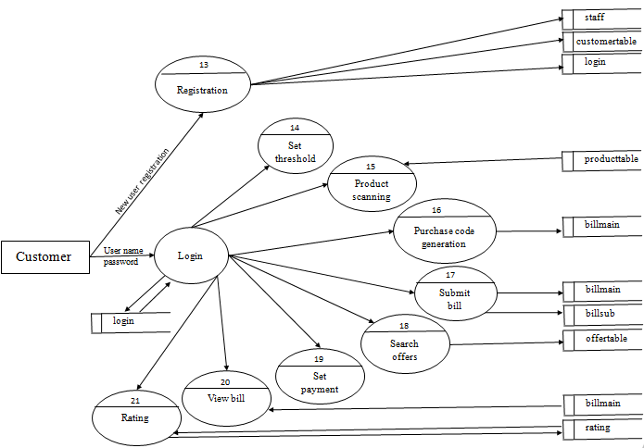

**Level-1 for Bill**

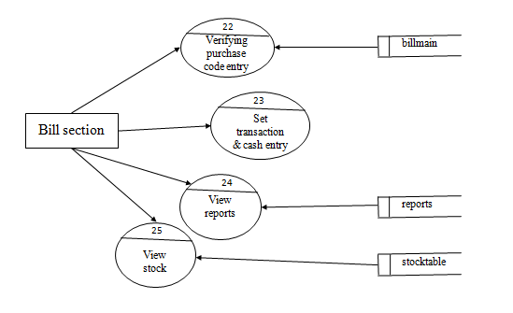

**Level-2 for Registration**

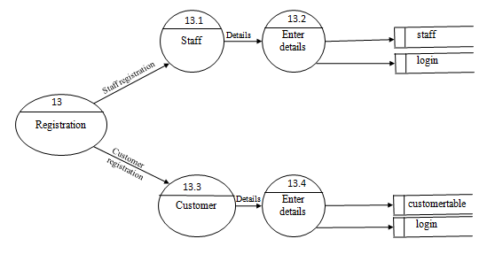

**Level-2 for Customer**

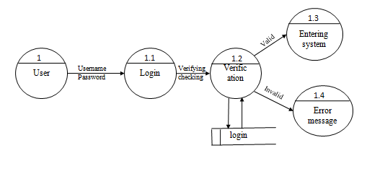

**Level-2 for Product registration**

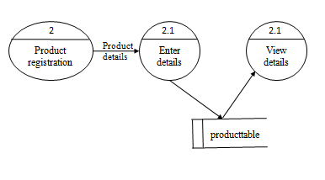

**Level-2 for Stock management**

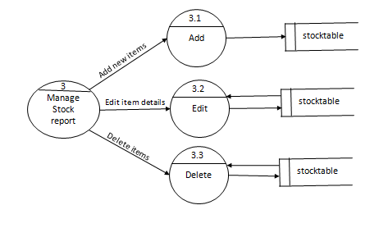

**Level-2 for Add offer**

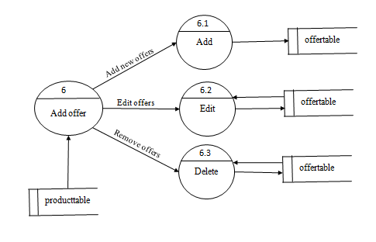

**Level-2 for Staff management**

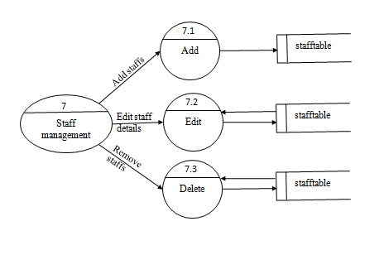

**Level-2 for Alert**

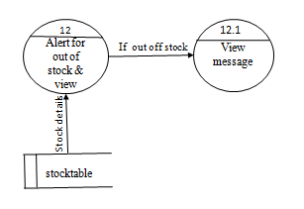

**Level-3 for Add items**

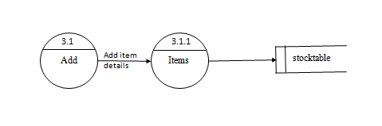

**Level-3 for Edit item details**

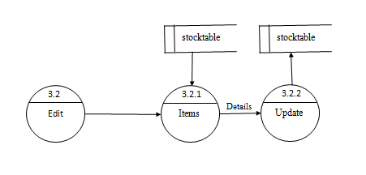

**Level-3 for Delete**

