Experiment – 1

Aim :
Write a program that prompts the user to enter his first name and last name and then
displays a message “Greetings!!! First name Last name”.

Pseudocode:
1. Read firstname and lastname
2. print “Greetings , firstname lastname”

Source Code:
name = input("Enter your full name: ");
print(f"Greetings {name}");

Output:
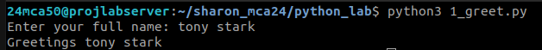
Experiment – 2

Aim :
Write a program to demonstrate different number data types in python.

Pseudocode:
1. Assign 3 types of values to corrosponding variables
2. print datatypes of each variable using type()

Source Code:
num1, num2, num3 = 10, 10.1, 10+10j

print(f"\nType of {num1} is {type(num1)}, Type of {num2} is {type(num2)}, Type of {num3} is {type(num3)}\n")

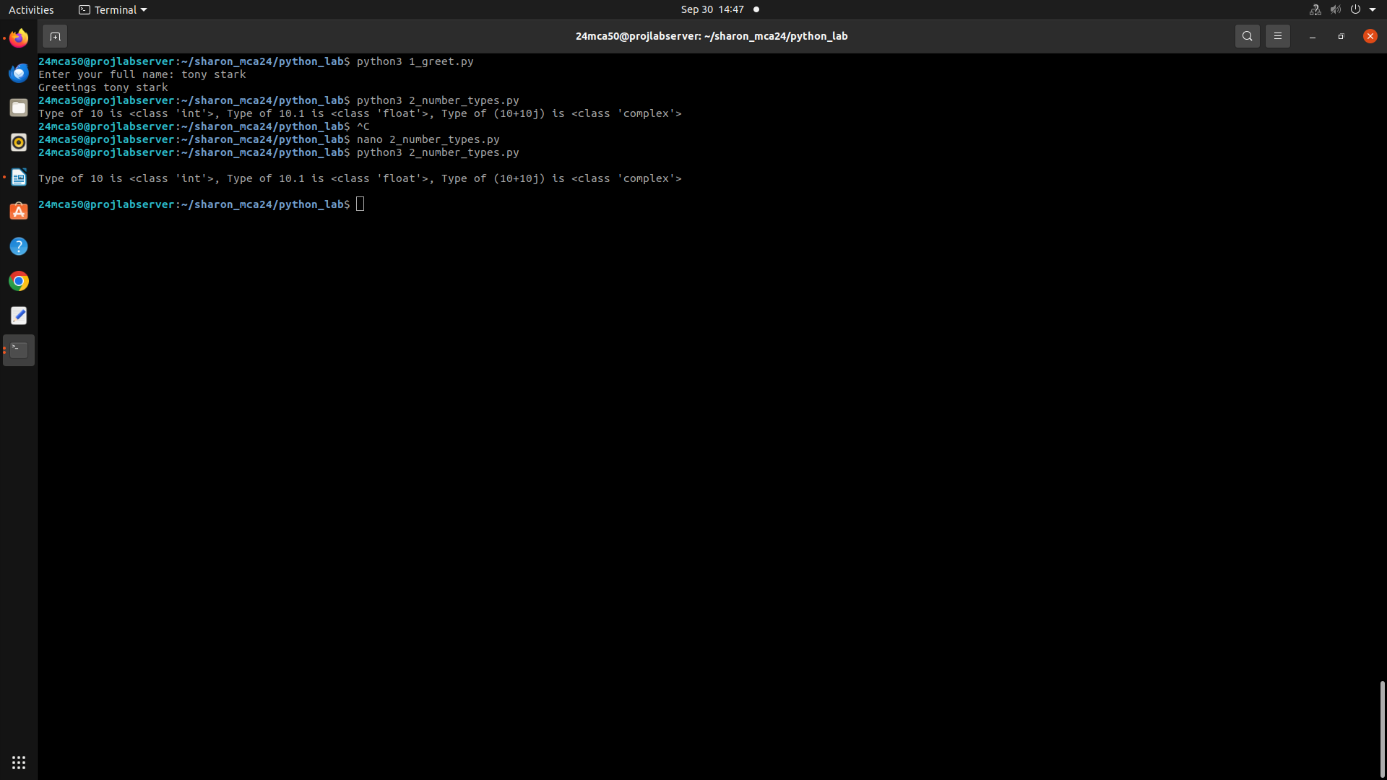
Output:
Experiment – 3

Aim :
Write a program to calculate the area of a circle by reading inputs from the user.

Pseudocode:

Source Code:
radius = float(input("Enter the radius of the circle: "))

area = 3.14 * radius * radius

print(f"Area of the circle with radius {radius} = {area}")

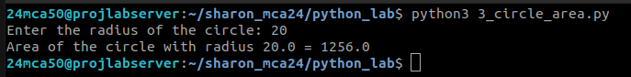
Output:
Experiment – 4

Aim :
Write a program to calculate the salary of an employee given his basic pay (to be entered by
the user) . HRA = 10 percent of the basic pay, TA = 5 percent of the basic pay.

Pseudocode:

Source Code:
basic_pay = float(input("Enter the basic pay: "))

hra = (10/100) * basic_pay
ta = (5/100) * basic_pay

salary = basic_pay + hra + ta

print("Total salary of the employee is : ", salary)

Output:
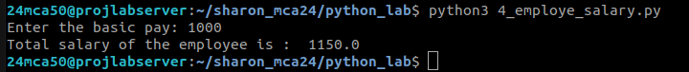

Experiment – 5

Aim :
Write a Python program to perform arithmetic operations on two integer numbers.

Pseudocode:

Source Code:
num1, num2 = int(input("Enter num1: ")), int(input("Enter num2: "))

print(f"The numbers are : num1 = {num1}, num2 = {num2}\nSum = {num1+num2}, difference = {num1-num2}, product = {num1*num2}, quotient = {num1/num2}, remainder = {num1%num2}")

Output:

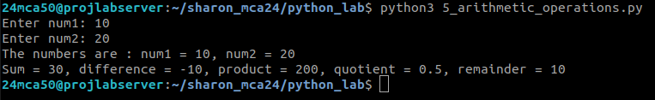
Experiment – 6

Aim :
Write a Python program to get a string which is n (non-negative integer) copies of a given
string.

Pseudocode:

Source Code:
string = input("Enter a string: ")
count = int(input("Enter the number of times to repeat the string: "))

print(string*count)

Output:
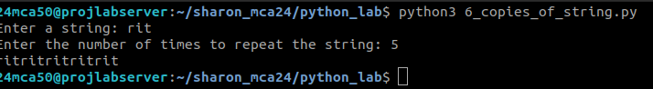

Experiment – 7

Aim :
Program to accept an integer n and compute n+nn+nnn.
[Hint : n = 5, then compute 5 + 55 + 555]

Pseudocode:

Source Code:
number = input("Enter a number : ")
sum = 0

for i in range(1,4):
new_number = number*i
sum += int(new_number)

print("sum = ",sum)

Output:
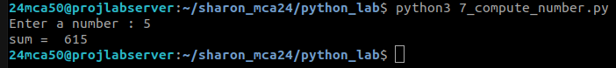

Experiment – 8

Aim :
Find biggest of 3 numbers entered.

Pseudocode:

Source Code:
num1, num2, num3 = int(input("Enter num1: ")), int(input("Enter num2: ")), int(input("Enter num3: "))

largest = 0

if(num1 > num2 and num1 > num3):
largest = num1
elif(num2 > num1 and num2 > num3):
largest = num2
else:
largest = num3

print(f"Largest among {num1},{num2},{num3} is {largest}")

Output:
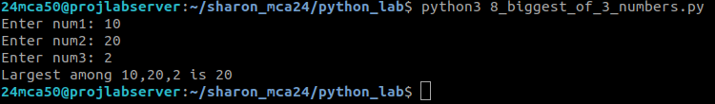

Experiment – 9

Aim :
Program to determine whether a year is a leap year or not.

Pseudocode:

Source Code:
num1, num2, num3 = 10, 10.1, 10+10j

print(f"\nType of {num1} is {type(num1)}, Type of {num2} is {type(num2)}, Type of {num3} is {type(num3)}\n")

Output:
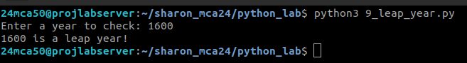

Experiment – 10

Aim :
Write a Python program to determine the rate of entry-ticket in a trade fair based on age as
follows:
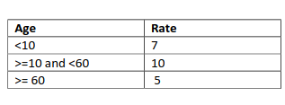

Pseudocode:

Source Code:
num1, num2, num3 = 10, 10.1, 10+10j

print(f"\nType of {num1} is {type(num1)}, Type of {num2} is {type(num2)}, Type of {num3} is {type(num3)}\n")

Output:
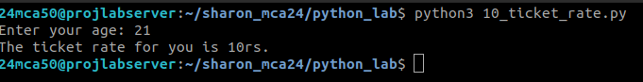

Experiment – 11

Aim :
Write a Python program to solve a quadratic equation.

Pseudocode:

Source Code:
import cmath
a = float(input('Enter a: '))
b = float(input('Enter b: '))
c = float(input('Enter c: '))

d = (b**2) - (4*a*c)

sol1 = (-b-cmath.sqrt(d))/(2*a)
sol2 = (-b+cmath.sqrt(d))/(2*a)

print('The solution are {0} and {1}'.format(sol1,sol2))

Output:

