# Program 1

Aim

Create a string from the given string where the first and last character are exchanged. Eg: Python ⇒ nythoP

Source Code

str=input("Enter string:")

if len(str)>1:

str=str[-1]+str[1:-1]+str[0]

print(str)

Output



# Program 2

Aim

Get a string from an input string where all occurrences of the first character are replaced with ‘$’, except the first character. [eg: onion -> oni$n]

Source Code

s=input("Enter a string:")

if len(s)>0:

first=s[0]

s=first+s[1:].replace(first,'$')

print(s)

Output



# Program 3

Aim

Create a single string separated with space from two strings by swapping the character at position 1.

Eg : str1 = “Hello” str2 =”World” , then create a string str3 = “Hollo Werld” [Hint: use slicing and concatenation ]

Source Code

str1=input("Enter first string:")

str2=input("Enter second string:")

str3=str1[0]+str2[1]+str1[2:]+" "+str2[0]+str1[1]+str2[2:]

print(str3)

Output

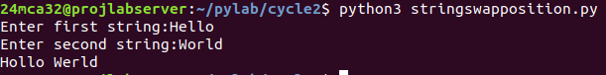

# Program 4

Aim

Count the number of characters (character frequency) in a string.

Source Code

str=input("Enter a string:")

for char in set(str):

count=str.count(char)

print(f"{char} : {count}")

Output

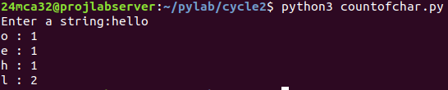

# Program 5

Aim

Add ‘ing’ at the end of a given string. If it already ends with ‘ing’, then add ‘ly’

Source Code

str=input("Enter a string:");

if str.endswith("ing"):

str=str+"ly"

else:

str=str+"ing"

print(str)

Output

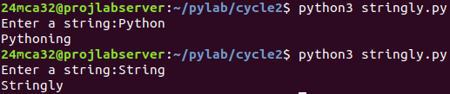

# Program 6

Aim

Store a list of first names. Count the occurrences of ‘a’ within the list.

Source Code

names=input("Enter names:").split(" ")

count=sum(name.count('a') for name in names)

print("Occurance of a:",count)

Output



# Program 7

Aim

Write a python program to read two lists color-list1 and color-list2. Print out all colors from color-list1 not contained in color-list2.

Source Code

color_list1=input("Enter color list 1:").split(' ')

color_list2=input("Enter color list 2:").split(' ')

difference=[color.strip() for color in color_list1 if color.strip() not in [c.strip() for c in color_list2]]

print("Colors in list 1 and not in list 2:",difference)

Output

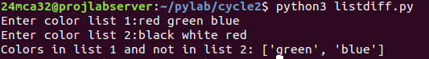

# Program 8

Aim

Create a list of colors from comma-separated color names entered by the user. Display first and last colors.

Source Code

colors=input("Enter colors:").split(',')

first_color=colors[0]

last_color=colors[-1]

print(f"First color: {first_color}\nLast color: {last_color}")

Output

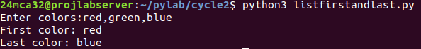

# Program 9

Aim

Write a program to prompt the user for a list of integers. For all values greater than 100,store ‘over’ instead.

Source Code

nums=list(map(int,input("Enter the numbers:").split(' ')))

result=["over" if x>100 else x for x in nums]

print(result)

Output



# Program 10

Aim

From a list of integers, create a list after removing even numbers.

Source Code

nums=list(map(int,input("Enter the numbers:").split(' ')))

result=[x for x in nums if x%2!=0]

print(result)

Output



# Program 11

Aim

Accept a list of words and return the length of the longest word

Source Code

words=input("Enter words:").split(' ')

longest_word=max(words,key=len)

print("Length of the longest word:",len(longest_word))

Output



# Program 12

Aim

Write a program to prompt the user to enter two lists of integers and check

1. Whether lists are of the same length.
2. Whether the list sums to the same value.
3. Whether any value occurs in both Lists

Source Code

list1=list(map(int,input("Enter number list 1:").split(' ')))

list2=list(map(int,input("Enter number list 2:").split(' ')))

print("Same length:",len(list1)==len(list2))

print("Eqaul sum:",sum(list1)==sum(list2))

print("Any value in both list:",any(x in list2 for x in list1))

Output

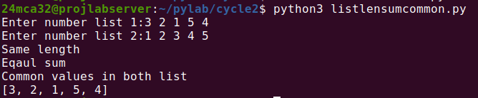

# Program 13

Aim

Write a Python program to count the occurrences of each word in a line of text.

Hint: use split() function and dictionary

Sample input : the quick brown fox jumps over the lazy dog

Output : {'the': 2, 'jumps': 1, 'brown': 1, 'lazy': 1, 'fox': 1, 'over': 1, 'quick': 1, 'dog.': 1}

Source Code

words = input("Enter a line of text: ").split()

word_count = {}

for word in words:

word_count[word] = word_count.get(word, 0) + 1

print(word_count)

Output



# Program 14

Aim

List comprehensions:

1. Generate positive list of numbers from a given list of integers
2. Square of N numbers
3. Form a list of vowels selected from a given word
4. Form a list ordinal value of each element of a word (Hint: use ord() to get ordinal values)

Source Code(s)

a)

nums = list(map(int, input("Enter integers: ").split()))

positive = [x for x in nums if x > 0]

print(positive)

b)

N = int(input("Enter N: "))

squares = [x**2 for x in range(1, N+1)]

print(squares)

c)

word = input("Enter a word: ")

vowels = [char for char in word if char in 'aeiouAEIOU']

print(vowels)

d)

word = input("Enter a word: ")

ord_values = [ord(char) for char in word]

print(ord_values)

Output(s)



# Program 15

Aim

Sort dictionary in ascending and descending order.

Source Code

d = {'b': 3, 'a': 1, 'c': 2}

print(“d=”,d)

print("Ascending order:", dict(sorted(d.items())))

print("Descending order:", dict(sorted(d.items(), reverse=True)))

Output

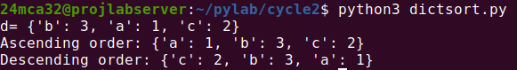

# Program 16

Aim

Merge two dictionaries.

Source Code

dict1={"a":1,"b":2,"c":3}

dict2={"d":4,"e":5,"f":6}

print(f"dict1={dict1}\ndict2={dict2}")

merged_dict={**dict1,**dict2}

print("Merged dictionary:",merged_dict)

Output

