HW2

0853402 吳奐萱

1. Recurrent Neural Network for Classiﬁcation
   1. Please compute the correlation coeﬃcient between two countries.

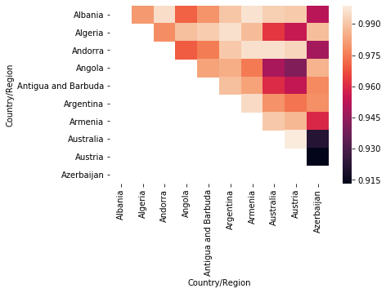

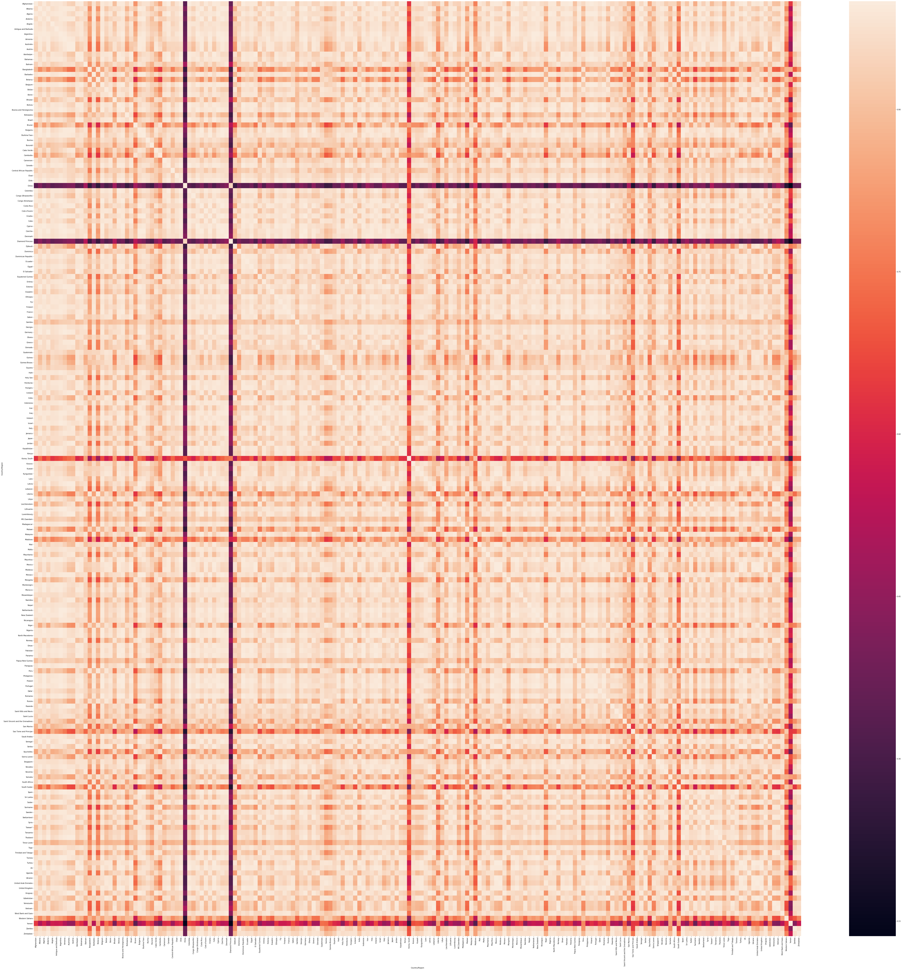

* 1. following is the simple example graph to show how to generate the data.
  2. show the accuracy of training and test.

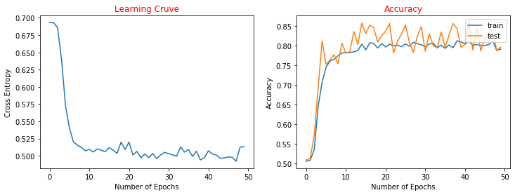

* 1. Please implement diﬀerent recurrent neural network like LSTM and GRU and change the value of interval L to analyze its eﬀect on the result

LSTM GRU

interval 20:

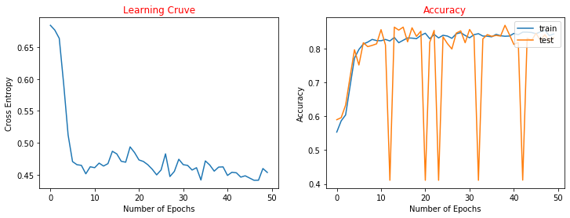

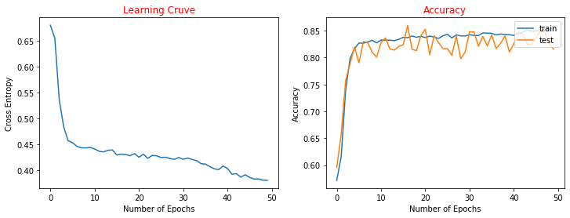

interval 30:



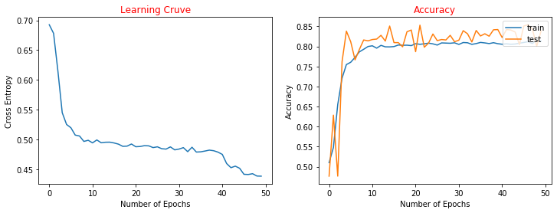

interval 40:

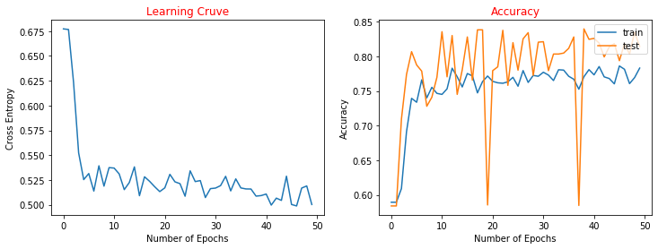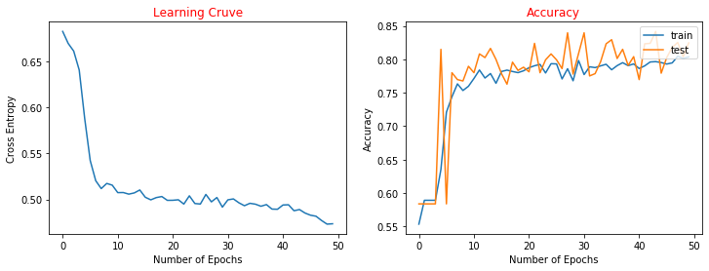

interval 50:

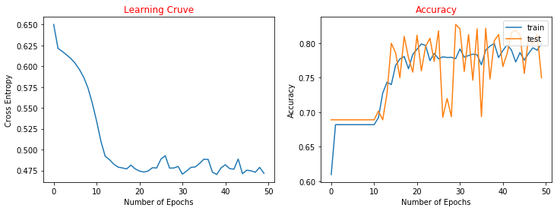

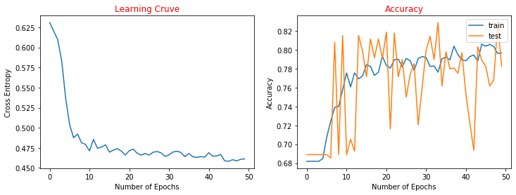

* 1. Compute the probability for each country and plot on a world map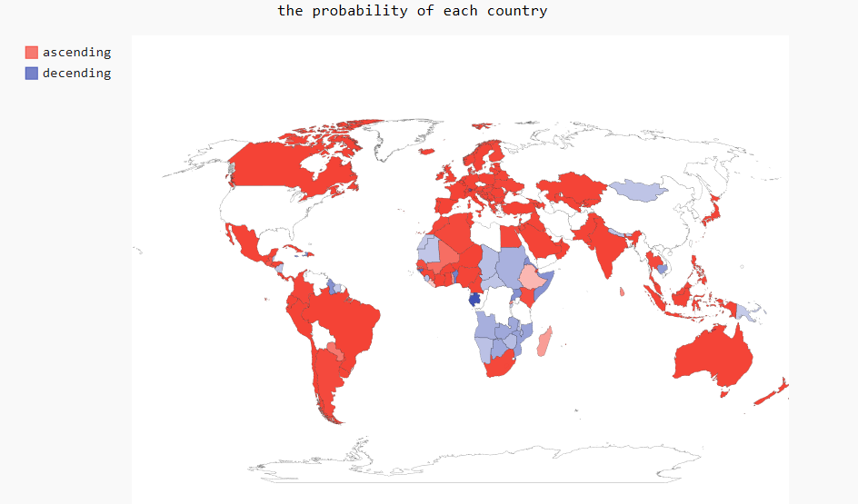
  2. Do some discussion based on your result.

雖然圖沒有很明顯的看出LSTM和GRU的差別(除了LSTM會有一些劇烈的準確度驟降)，但數據上LSTM還是有比GRU高一些，但只有一點點，而interval則是20是最佳的。LSTM我有做clipping，讓loss下降的比較穩定，但還是會有一些劇變，可能是設定的還不夠準確。

1. Variational Autoencoder for Image Generation
   1. Describe in details how to preprocess images (such as resizing or cropping) and design the network architecture.

把全部照片都Resize((64, 64))

* 1. Plot the learning curve of the negative evidence lower bound (ELBO) of log likelihood of training images.

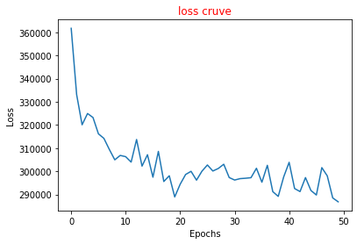

* 1. Show some examples reconstructed by your model.

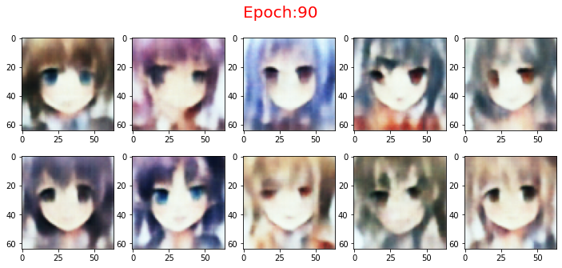

* 1. Sample the prior p(z) and use the latent codes z to synthesize some examples when your model is well-trained.

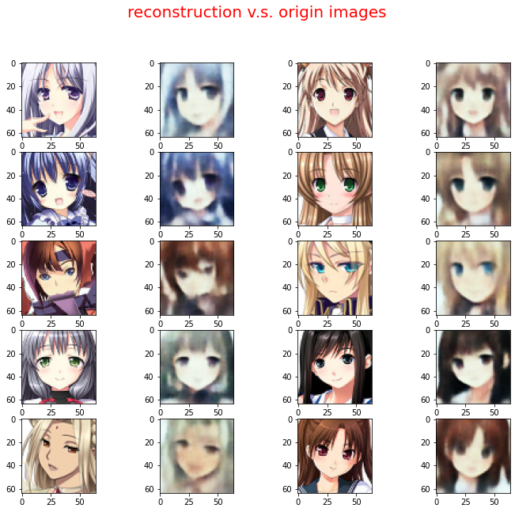

* 1. Show the synthesized images based on the interpolation of two latent codes z between two real samples



* 1. Multiply the Kullback-Leibler (KL) term in ELBO by 100 in your loss and repeat ii ∼ v

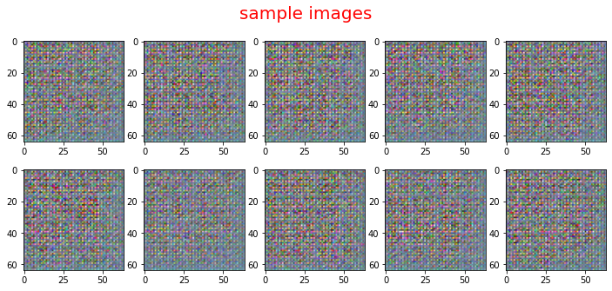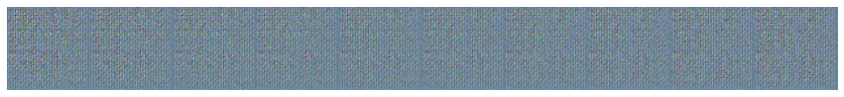

* 1. Multiply the KL term by 0 in ELBO and repeat ii ∼ v

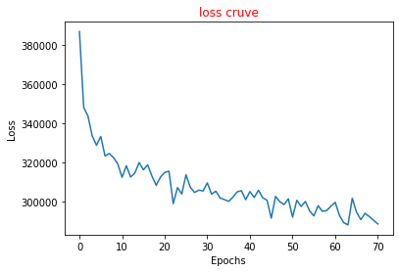



* 1. Do some discussion on the eﬀect of KL term based on your result.

還沒修改KL時，我覺得我的model跑的結果都蠻好的，雖然loss沒有到下降非常多，但照片我覺得train的還行，interpolation的部分也轉得很好，但修改了KL後，不管是*0還是*100結果都相當不好，loss還是依舊下降得差不多，並沒有比較差，但圖片卻全部都編成這種亂馬的形式，原本還有想說會不會是anime_set出了錯誤，沒存好檔之類的，但確認過也重跑過後還是如此，可能修改過KL後的model覺得這樣才是最好的下降loss的方法吧。