Machine Learning based Health Prediction System using IBM Cloud as PaaS

In this paper author is describing concept to automate abnormal health condition using machine learning algorithms such as Support Vector Machine (SVM), KNearest Neighbours (KNN), Decision Tree, Naïve Bayes and Ensemble Algorithm. In this project author is proposing following modules

1. IBM Cloud: This module can be used to store and run ML algorithms and whenever patient mobile sense patient vitals then it will send to IBM cloud and IBM cloud will apply machine learning algorithms on received patient vitals to detect patient condition, if condition is not stable then it will send SMS message to doctor about patient condition. Here to implement this module we need to purchase IBM cloud space using CREDIT CARD details and for students its difficult to manage this payment so I am building this cloud as a dummy cloud which can run in single or other laptop running in LAN. For example you can run dummy cloud in one laptop and can run client from other laptop connecting in LAN. For SMS services also we need to pay money to purchase SMS so we are avoiding this SMS service.
2. Dataset module: using this module we will upload dataset into dummy cloud
3. Preprocess module: using this module we will replace missing or alphabets values to numerical values as 0 or 1.
4. Machine Learning module: using this module we train dataset with multiple machine learning algorithms and evaluate their performance and whatever algorithm performing well will use that algorithm to predict patient condition.
5. Mobile/Client Module: In this module author is saying patient smart phone will sense his body temperature, blood pressure and other vitals and then send to IBM cloud for monitoring. Here we don’t have any sensors so we are uploading test data from client application and then client will send that test data to dummy cloud and dummy cloud will apply machine learning algorithms and then predict patient condition and send result back to client.

To develop this project we have designed two applications

1. Cloud Application: In this application we can upload dataset and then pre-process dataset and apply machine learning to build train model. This application accept vitals from client/mobile application and then apply machine learning algorithms to predict patient condition and send predicted value back to client application.
2. Client Application: This application upload file which contains patient vitals and send this vitals to cloud application and get result back.

Below is the dataset details

**age,sex,cp,trestbps,chol,fbs,restecg,thalach,exang,oldpeak,slope,ca,thal,class**

63,1,3,145,233,1,0,150,0,2.3,0,0,1,1

37,1,2,130,250,0,1,187,0,3.5,0,0,2,1

41,0,1,130,204,0,0,172,0,1.4,2,0,2,1

50,1,0,150,243,0,0,128,0,2.6,1,0,3,0

44,1,0,112,290,0,0,153,0,0,2,1,2,0

60,1,0,130,253,0,1,144,1,1.4,2,1,3,0

In above dataset all bold names are the dataset attributes names and all integer values are the vitals of patient and last column contains values as 0 or 1 where 0 means patient condition is stable and 1 means patient condition is abnormal.

SCREENSHOTS

Double click on ‘run.bat’ file from ‘Cloud’ folder to start cloud application and to get below screen

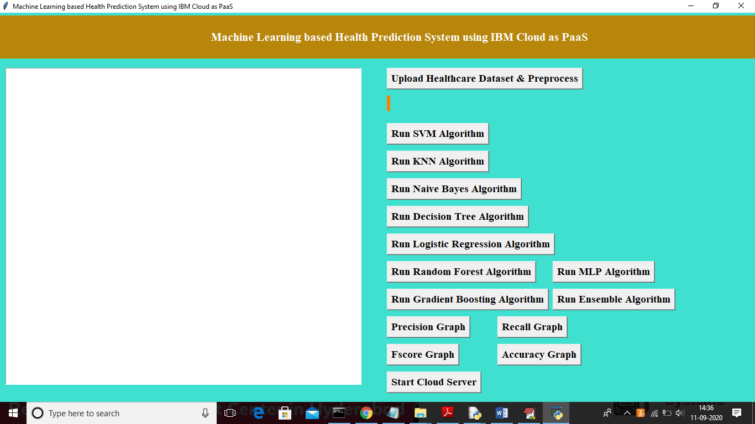

In above screen we can see various buttons are there to run different machine learning algorithms and after building machine learning models we can click on ‘Start Cloud Server’ button to start cloud and to accept request from client. Now click on ‘Upload Healthcare Dataset & Pre-process’ button to load dataset

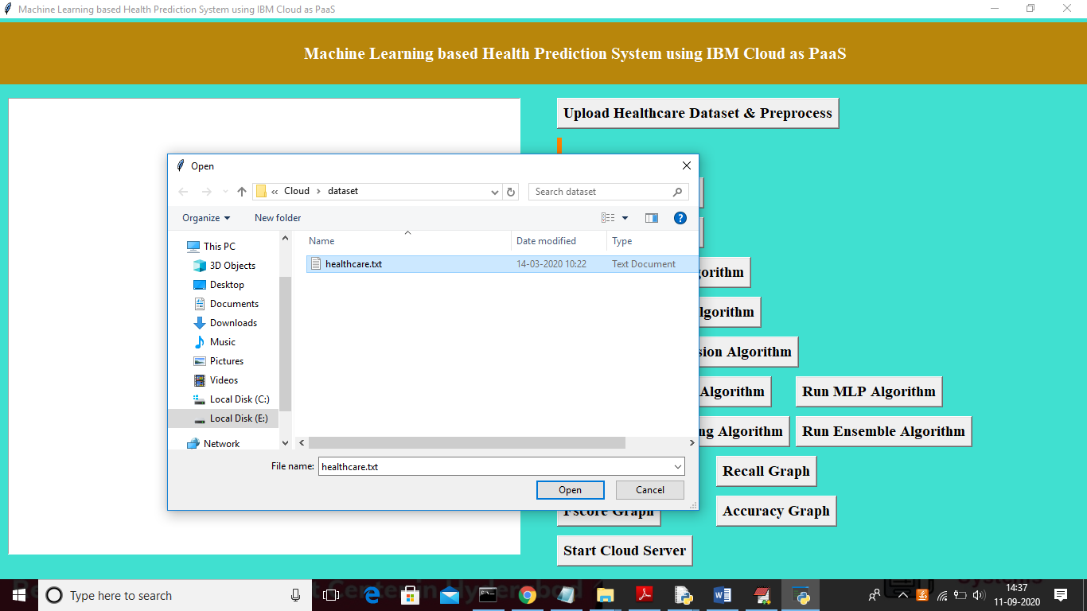

In above screen uploading health care dataset and after uploading dataset will get below screen

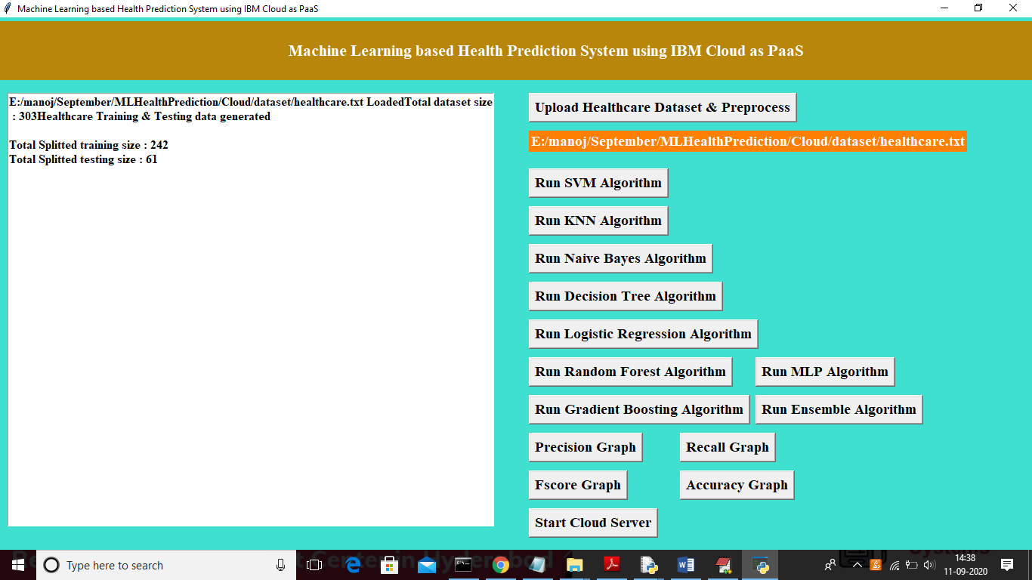

In above screen dataset contains total 303 records and application using 80% dataset records for training and 20% for testing. Now dataset train and test dataset ready and now click on ‘Run SVM Algorithm’ button to apply SVM on train dataset and then evaluate its performance on test data to calculate prediction accuracy

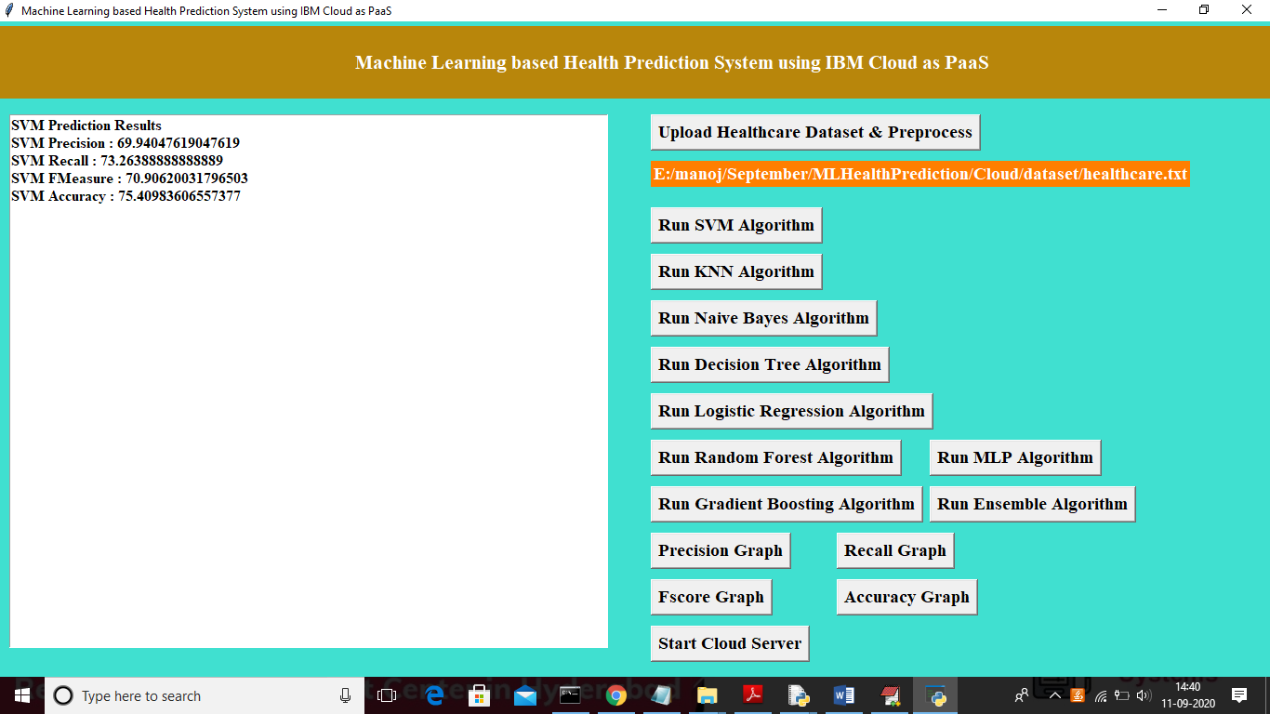

In above screen SVM prediction accuracy on 20% test dataset is 75% and we can see precision, FMeasure and Recall values also. Now click on ‘Run KNN Algorithm’ button to generate KNN model

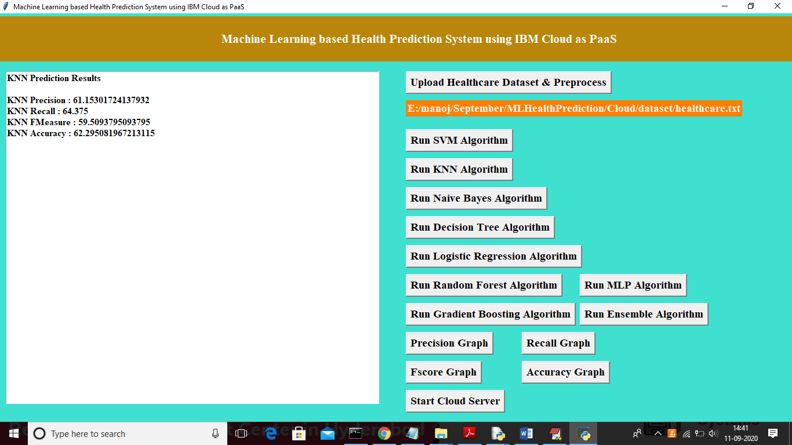

In above screen with KNN we got 62% accuracy and now click on ‘Run Naïve Bayes Algorithm’ button to generate its model

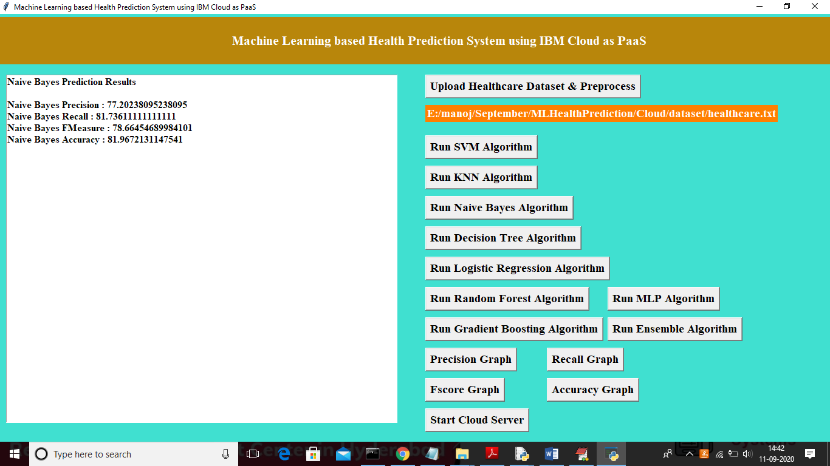

In above screen with Naïve Bayes we got 82% accuracy and now click on ‘Run Decision Tree Algorithm’ button to generate its model

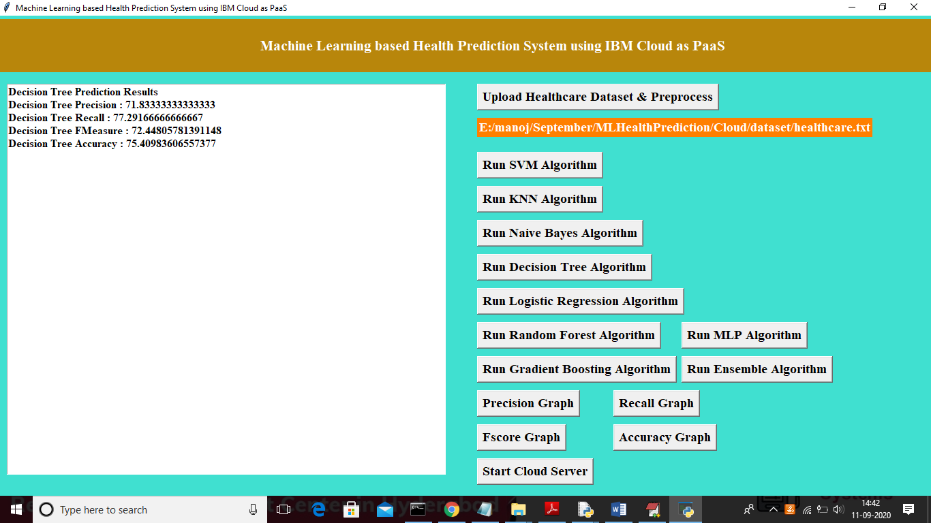

In above screen with Decision tree we got 75% accuracy and now click on ‘Run Logistic Regression Algorithm’ button to generate its model

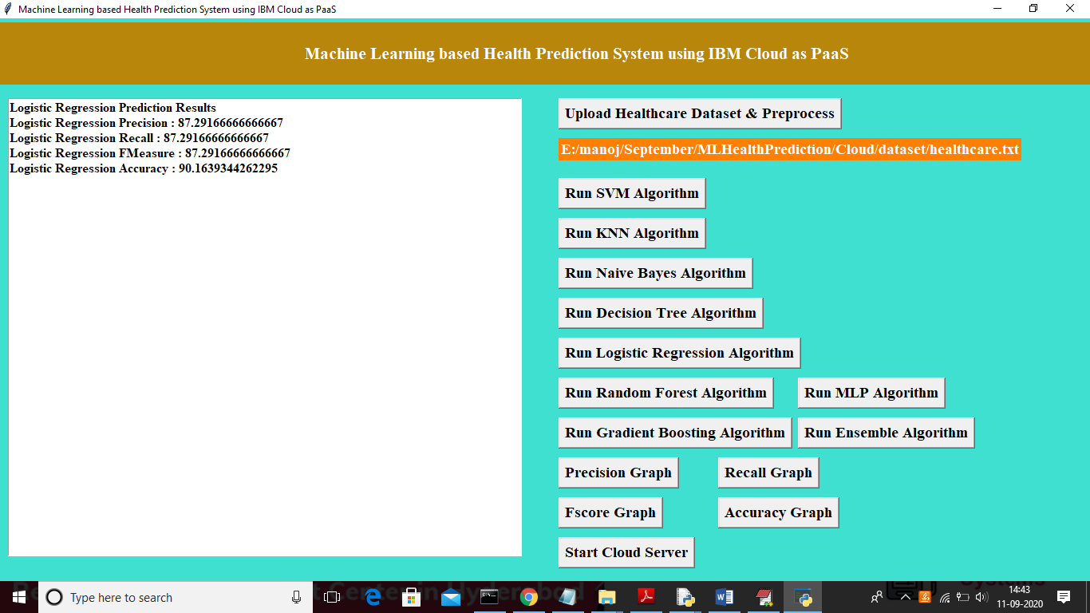

In above screen with Logistic Regression we got 90% accuracy and now click on ‘Run Random Forest Algorithm’ button to generate its model

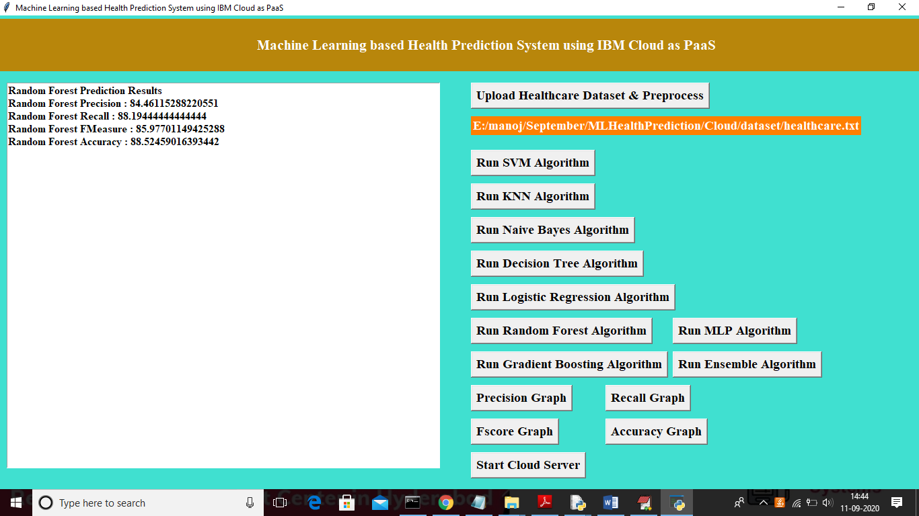

In above screen with Random Forest we got 89% accuracy and now click on ‘Run MLP Algorithm’ button to get its accuracy

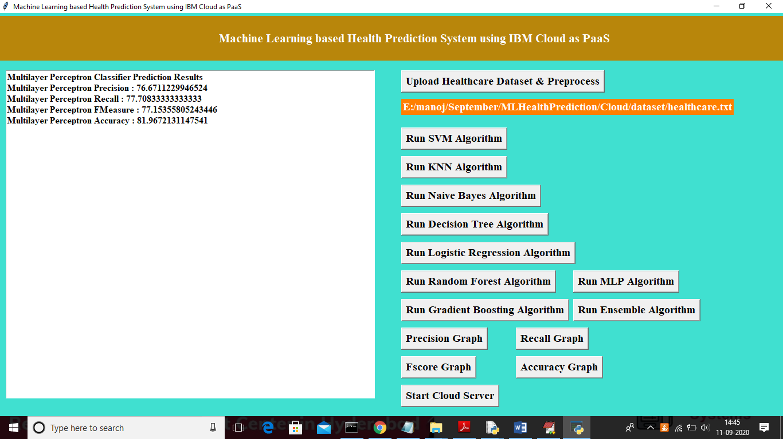

In above screen with MLP we got 82% accuracy and now click on ‘Run Gradient Boosting Algorithm’ button to calculate its accuracy

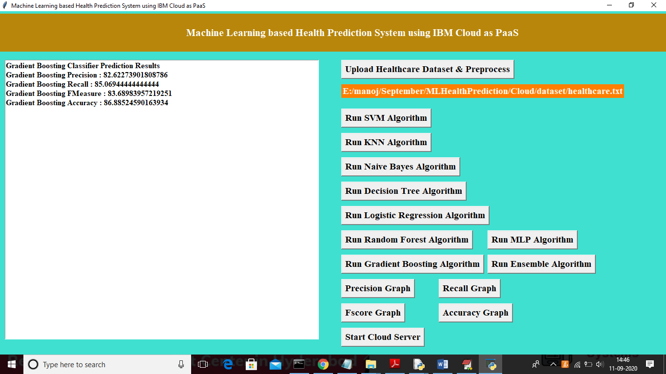

In above screen with Gradient Boosting we got 87% accuracy and now click on ‘Run Ensemble Algorithm’ button to calculate its accuracy

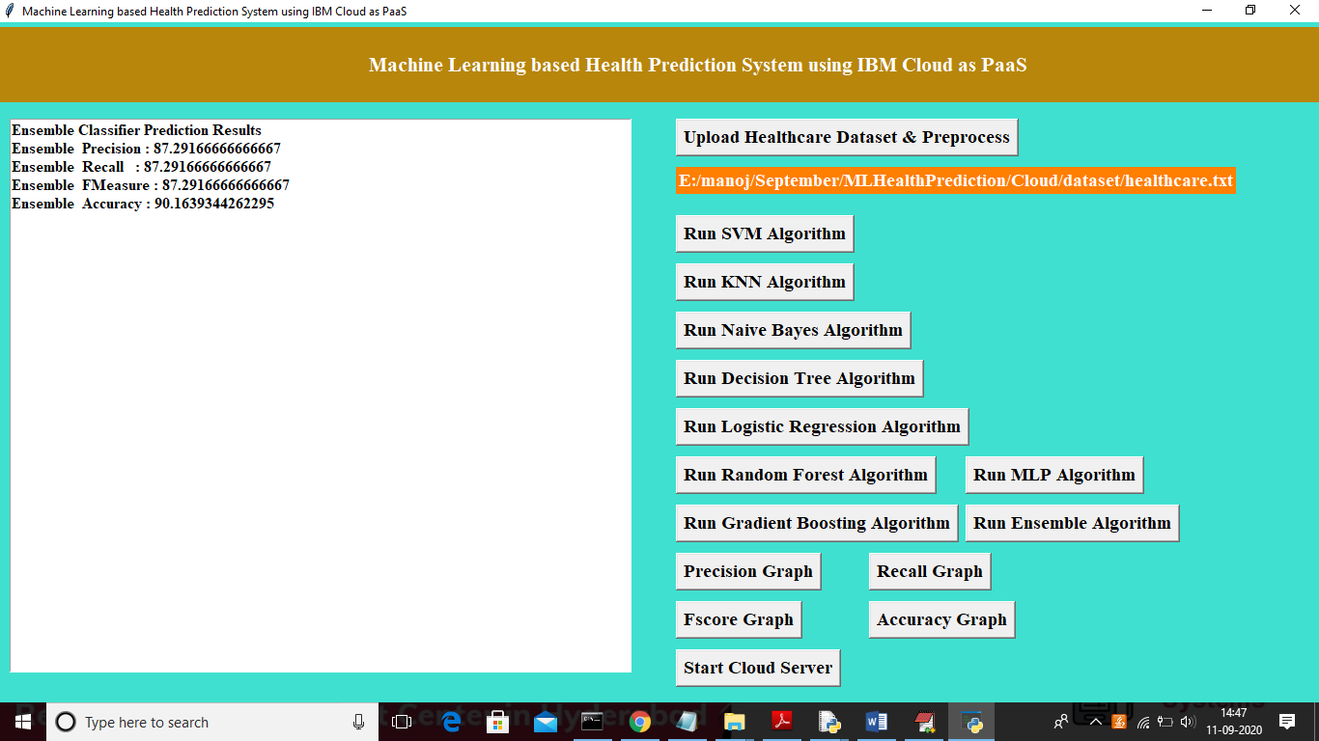

In above screen with Ensemble algorithm we got 90% accuracy and now click on ‘Precision Graph’ button to get below precision graph

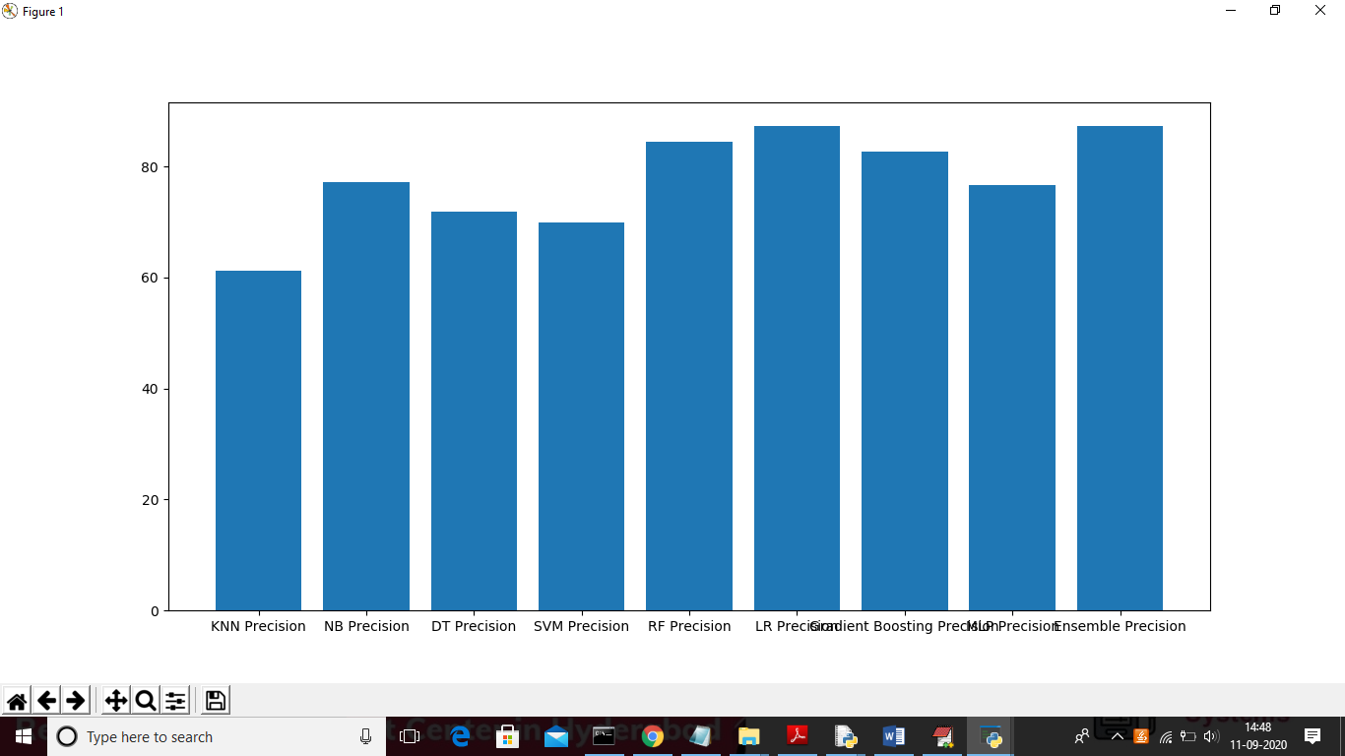

In above screen x-axis represents algorithm names and y-axis represents precision of those algorithms and from all algorithms ensemble is performing well. Now click on ‘Recall Graph’ button to get below graph of recall

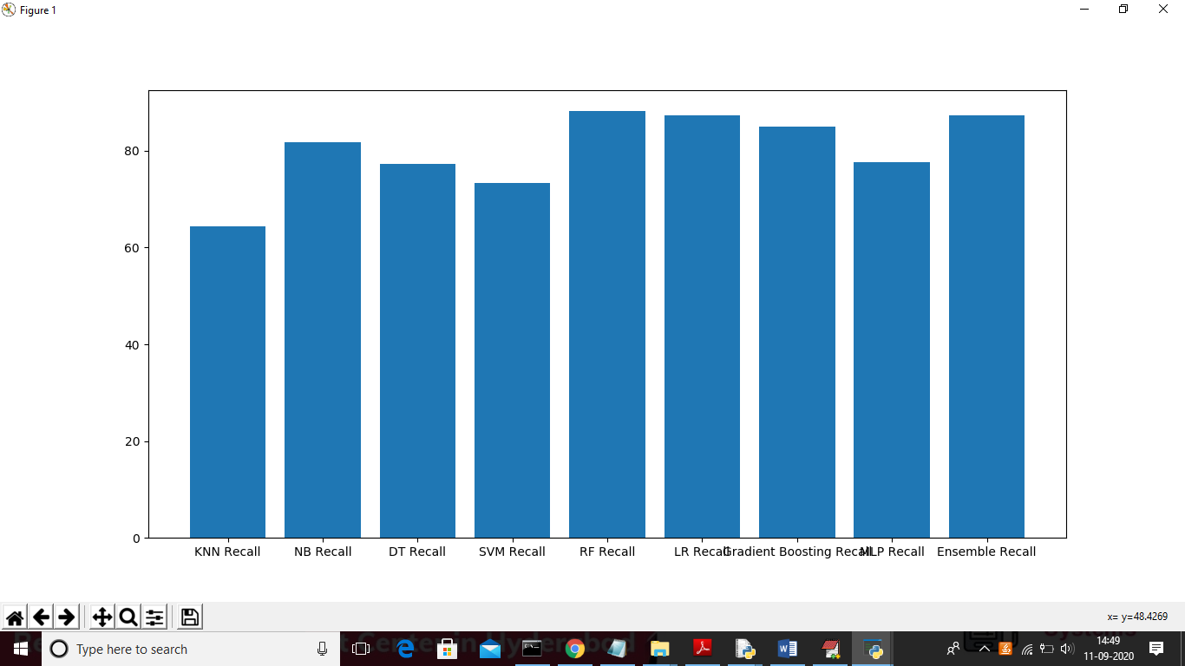

Now click on ‘FScore Graph’ button to get below FMeasure graph

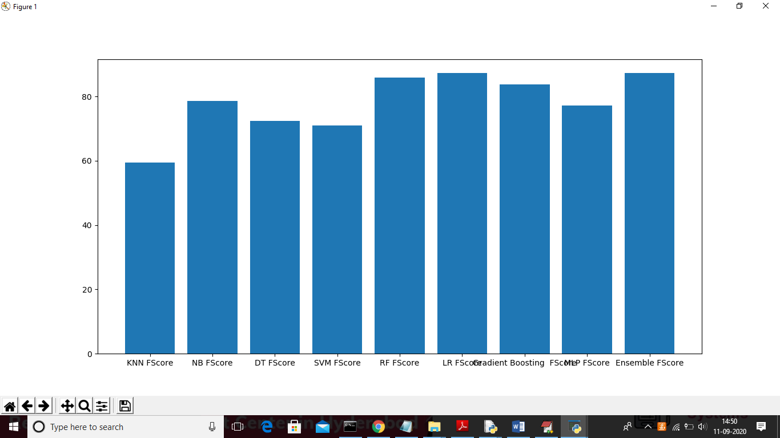

Now click on “Accuracy Graph’ button to get below accuracy graph

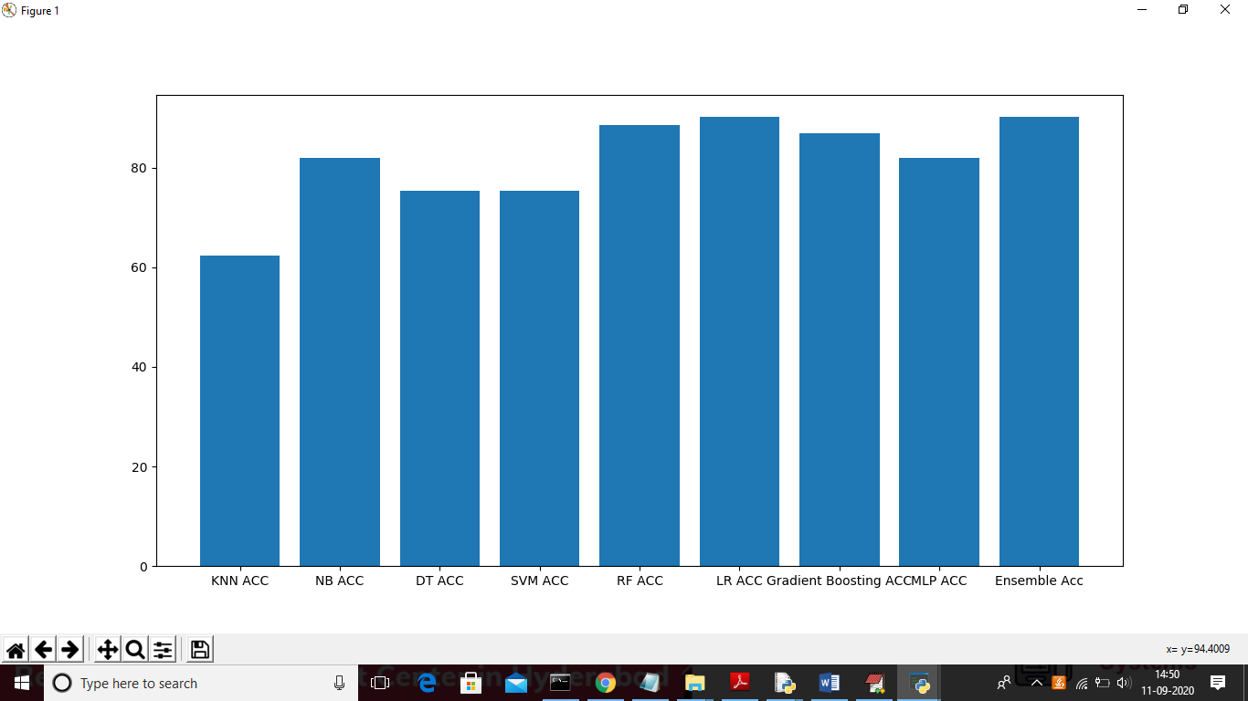

Now click on “Start Cloud Server” button to start cloud server and get below screen

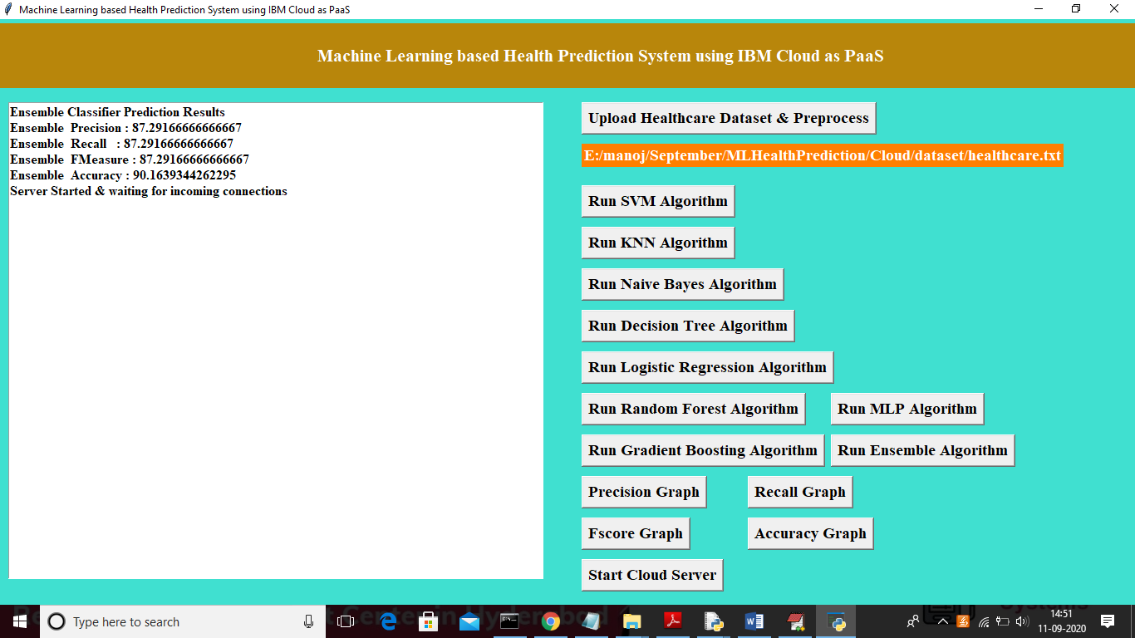

In above screen we can see cloud server started and ready to accept connections from client. Now double click on ‘run.bat’ file from ‘MobileClient’ folder to get below screen

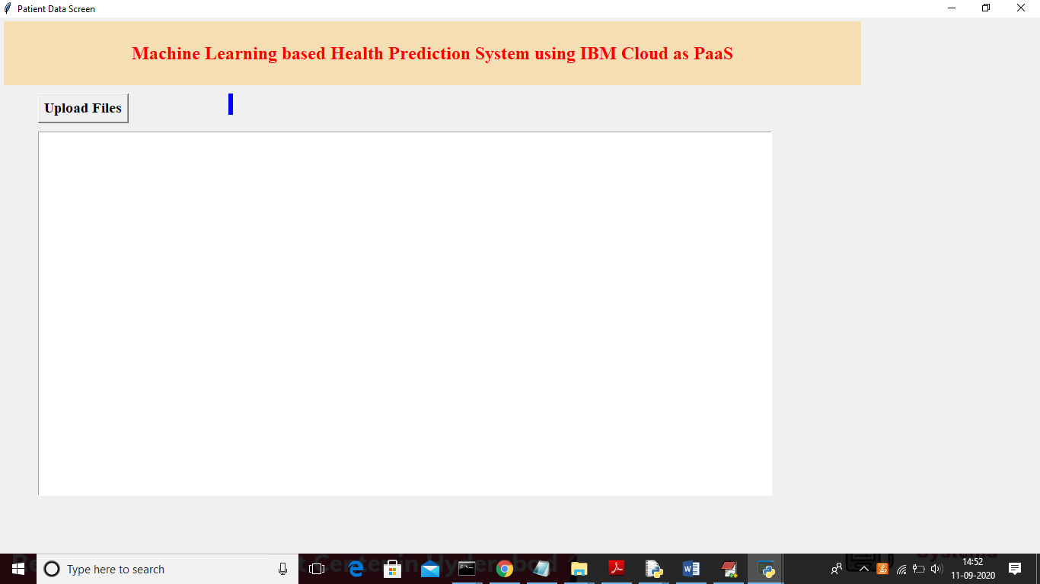

In above screen client can click on ‘Upload Files’ button to upload file with patient vitals and this vitals will send to cloud server

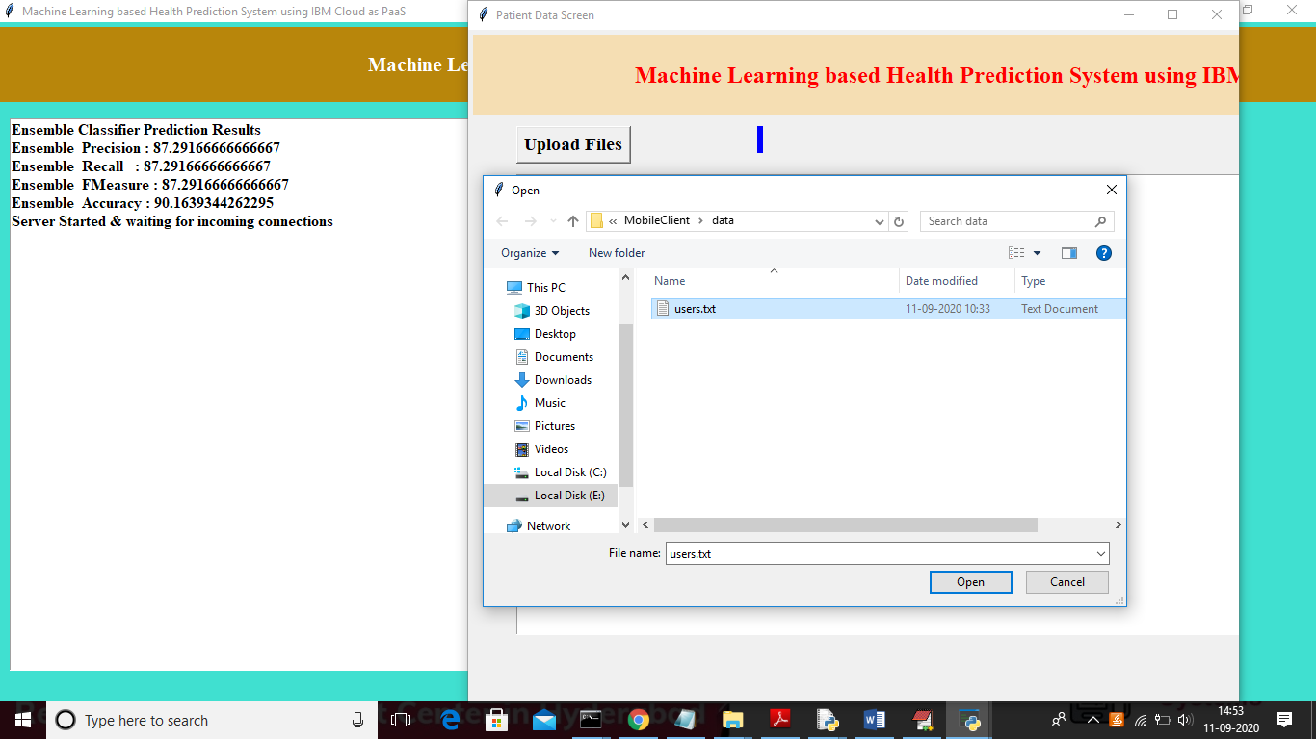

In above screen from client application uploading ‘users.txt’ file with patient vitals and this vitals send to cloud server to get below prediction result

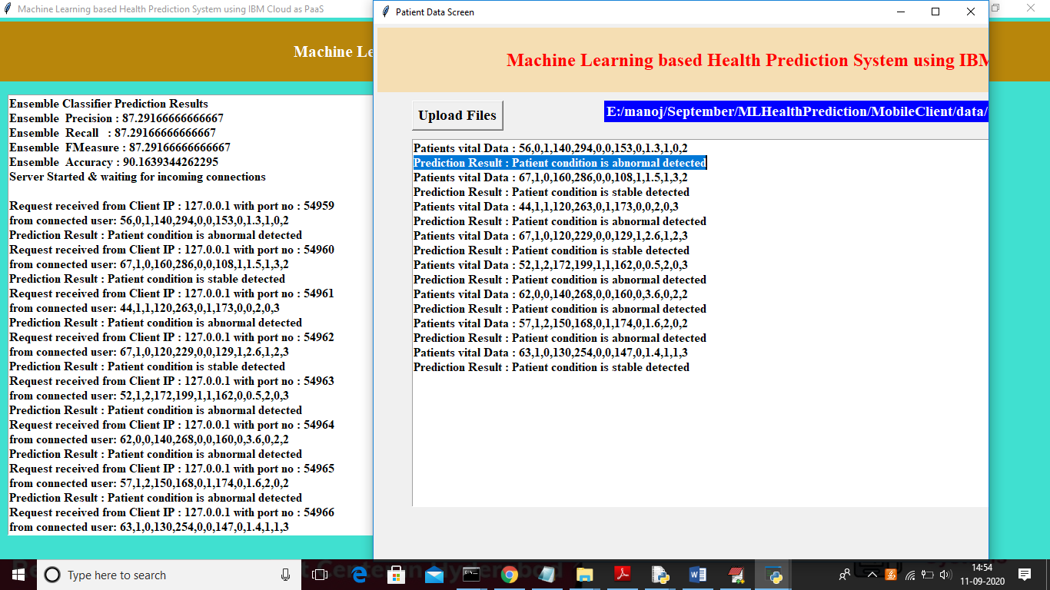

In above screen data sent to server and server sent result back and in above client page first line contains patient vitals and second line displaying patient predicted condition based on vitals by machine learning algorithms. In above screen in first record we can see machine learning has predicted patient condition is abnormal.

Similarly u can upload any vitals to predict patient conditions