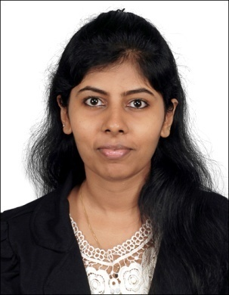**Sahaya Sharona Valluvan**

Address : *14-250, Block 160,*

*Jalan Teck Whye,*

*Singapore*

Ph :  **+65 8648 5387**

E-mail : [**sharona1610@gmail.com**](mailto:sharona1610@gmail.com)

Status : Dependant’s pass holder

(FIN: G3316471N)

**EDUCATION**

* ***PGCBM (Post graduate certification in Business management)*** from Xavier’s Labour Relations institute (XLRI) *(July 2015- July 2016)*
* ***Bachelor of Engineering*** (Electrical and Electronics) from Anna University, Chennai, India (2008-2012) with a CGPA of **8.6/10.**

**EXPERIENCE**

* ***Danfoss industries (December 2015 - August 2016) – Product Cost Engineer, Supply Chain***.
  + Responsible for costing of electrical (motors, electric pumps, compressors etc) and sheet metal (fabricated) parts and further negotiations with global suppliers.
  + Established methodologies and standardised processes for costing and negotiations.
  + Trained in ‘Apriori’ software (cost model work bench), a cost estimating tool and built cost models for company specific manufacturing processes.
  + Good knowledge of manufacturing processes
  + Vendor negotiations and business award
* ***Ashok Leyland (September 2013 - December 2015) – Cost engineer.***
  + Achieved annualised savings of Rs. 12 million (0.24 million SGD) on a family of parts through cost saving measures and value analysis.
  + BOM analysis
  + Responsible for costing of electrical parts of the automobile (motors, alternators, harnesses)
  + Conducted training sessions to inculcate cost sensitivity culture in the organisation.
* ***Ashok Leyland (September 2012 – September 2013) – Graduate engineering traine***e.
  + Complete training on the functioning of a business.
  + Exposure to operations, procurement, marketing and planning departments and their working.

**KEY SKILLS**

**TECHNICAL**

* Cost Engineering – Electrical products, Sheet metal or Fabricated parts
* Trained in SAP MM module
* Skilled in MS Office (Proficient in Macros)
* APriori – Software for estimation of costs of production. Trained and skilled in cost modelling which includes programming custom and specific manufacturing processes into the software. This in turn saves time for future cost computations

**OTHER**

* Good **aptitude** and **Analytical** skills, demonstrated through CAT(Common admission Test) score of **97.6** percentile
* Team player
* Highly enthusiastic and quick learner
* Good interpersonal skills

**ADDITIONAL INFORMATION**

* Scored ***97.6 percentile*** in CAT (Common admission test), an All India Management entrance exam
* ***Interested in teaching*** and been a part of Bhumi, an NGO in Chennai, India to teach under-privileged children
* ***Presented with an award from the Managing Director*** of Ashok Leyland for contribution and performance in the role of costing engineer.

**HOBBIES**

* Reading novels
* Sewing
* Quilling
* Art and Crafts.

**DECLARATION**

I hereby declare that all the information provided in this resume is true to the best of my knowledge.