Temporal Mapping of Conflict-Induced Oil Spills in the Persian Gulf
Using Sentinel-1 SAR Imagery and Lagrangian Drift Modeling
Anonymous Author(s) — Submitted for review
Persian Gulf · Oil Spill · SAR Remote Sensing · Lagrangian Modeling · Marine Protected Area

Abstract—Conflict-induced oil spills in the Persian Gulf represent an acute environmental threat exacerbated by restricted humanitarian access. This study presents the first systematic, multi-site quantification of war-induced spill dynamics using Sentinel-1 C-band Synthetic Aperture Radar (SAR) time-series analysis. We analysed 132 descending-orbit scenes over Qeshm Island, Lavan Island, and Shidvar Island (February–April 2026), applying per-scene adaptive thresholding and single-orbit normalisation to derive surface area estimates and centroid drift vectors. Detected spill areas peaked at 1.87 km² (Shidvar), 1.83 km² (Lavan), and 1.59 km² (Qeshm). A Lagrangian particle ensemble (N=1,000) reveals that the Shidvar Island Marine Protected Area has been breached, with the plume transiting the protected zone for approximately 3.2 days before being advected eastward at 1.7 km/day. SAR–optical cross-validation yielded mean IoU scores of 0.74 (Shidvar) and 0.62 (Qeshm). These results confirm ongoing, multi-site contamination of a fragile coral ecosystem and provide a reproducible remote-sensing framework for conflict-zone environmental monitoring.

I. INTRODUCTION
The 2026 Strait of Hormuz crisis has precipitated an environmental emergency in the Persian Gulf, as strikes on oil infrastructure and vessels have released hydrocarbons into one of the world's most ecologically sensitive and strategically critical marine environments. The Persian Gulf hosts extensive coral reef systems, seagrass beds, and critical habitat for dugong, hawksbill sea turtle, and over 600 fish species [1]. Oil contamination poses acute risks to these ecosystems through coating of gill surfaces, smothering of benthic communities, and bioaccumulation of polycyclic aromatic hydrocarbons (PAHs) in the food web [2].
Satellite-based Synthetic Aperture Radar (SAR) provides an all-weather, day-night capability uniquely suited to conflict-zone monitoring where field access is denied. Oil slicks suppress capillary wave formation on the sea surface, producing characteristic dark low-backscatter regions in SAR imagery [3]. Sentinel-1 C-band SAR, operated by the European Space Agency (ESA), provides repeat coverage of the Persian Gulf approximately every 6–12 days on descending passes, making it the primary platform for near-real-time spill monitoring in this region.
Previous SAR-based oil spill studies have addressed accidental tanker incidents [4], pipeline ruptures [5], and offshore platform blowouts [6]. However, conflict-induced spills present distinct methodological challenges: multiple simultaneous sources, restricted ground-truth access, variable sea-state conditions driven by wind regime changes, and the need to distinguish fresh hydrocarbon releases from persistent chronic contamination. To our knowledge, no prior study has systematically characterised the spill dynamics of the 2026 Persian Gulf conflict using SAR time-series.
This paper makes three primary contributions: (1) a reproducible SAR processing pipeline using per-scene adaptive thresholding and single-orbit normalisation for consistent temporal analysis; (2) the first quantitative characterisation of spill area dynamics and centroid drift across three conflict-affected sites; and (3) a Lagrangian forward projection demonstrating confirmed incursion of oil contamination into the Shidvar Island Marine Protected Area. All code and derived data are made openly available to support environmental response and future research.
II. STUDY AREA AND DATA
A. Study Area
Three sites of confirmed oil contamination were selected based on news reports, ESA satellite imagery releases, and expert statements (Fig. 2a). Lavan Island (26.80°N, 53.37°E) hosts major Iranian oil processing infrastructure and was struck on 7 April 2026. Qeshm Island (26.76°N, 55.96°E) lies at the entrance to the Strait of Hormuz and has been subject to repeated incidents since February 2026. Shidvar Island (26.68°N, 53.92°E) is an uninhabited coral island designated as a marine protected area, located approximately 55 km east of Lavan.
The study region of interest (ROI) spans 52.0–57.0°E, 25.5–27.5°N, encompassing the eastern Persian Gulf and western Strait of Hormuz. Site-specific analysis buffers of 25 km radius were applied around each target centroid.
B. Sentinel-1 SAR Data
All available Sentinel-1 Ground Range Detected (GRD) Interferometric Wide (IW) swath scenes in VV polarisation over the ROI from 1 February to 22 April 2026 were retrieved from the Google Earth Engine (GEE) Copernicus S1_GRD collection (COPERNICUS/S1_GRD). A total of 132 scenes were identified across all orbit passes. To ensure temporal consistency, analysis was restricted to the single dominant descending relative orbit number per site (selected by maximum scene count), yielding 10–12 temporally consistent scenes per site.
Preprocessing comprised: (1) focal mean speckle filtering (3×3 boxcar kernel); (2) per-scene adaptive thresholding (mean − 1.5σ of local VV backscatter) to generate binary slick masks; and (3) 3-scene rolling median smoothing of area time series. Scale for area computation was set to 100 m, with native 10 m pixel area (10 × 10 m = 1 × 10⁻⁴ km²) used for area conversion.
C. Validation Data
Cross-validation was performed against cloud-free Sentinel-2 SR Harmonised (COPERNICUS/S2_SR_HARMONIZED) scenes with <20% cloud cover. Oil slick presence in optical imagery was identified using a dark-pixel index: pixels with B4 (Red) < 500 DN and B3 (Green) < 600 DN coinciding with positive NDWI (>0.1) were classified as potential oil. Intersection over Union (IoU) was computed between SAR and optical binary masks for temporally coincident scene pairs (±6 days).
III. METHODOLOGY
A. Adaptive Threshold Segmentation
A fixed backscatter threshold (e.g., −18 dB) is unsuitable for time-series analysis over regions with variable wind conditions and changing incidence angle geometry. We instead computed a per-scene adaptive threshold T_i for each image i as:
T_i = μ_i − 1.5 · σ_i
where μ_i and σ_i are the spatial mean and standard deviation of VV backscatter over the 25 km site buffer. This approach adapts to scene-level variations in sea clutter caused by wind speed, incidence angle, and ocean state, reducing false positives from wind-shadow areas and ship wakes. The factor 1.5 was selected empirically to balance detection sensitivity against false alarm rate.
B. Centroid Drift Estimation
The centroid of each detected slick was computed as the pixel-coordinate-weighted mean of slick pixels using the GEE pixelLonLat() image. Sequential centroid positions were used to compute inter-scene displacement vectors. Drift speed (km/day) and bearing (degrees from North) were derived using the haversine great-circle formula. Centroid outliers were removed using a 2σ rejection filter on both latitude and longitude coordinates. Only scenes with slick pixel count ≥ 1 were included in the centroid time series.
C. Lagrangian Forward Projection
A stochastic Lagrangian particle ensemble (N = 1,000) was used to forward-project the spill plume from the latest observed centroid position. Each particle was advected using a simple Euler scheme with 6-hour timesteps:
x(t+Δt) = x(t) + (u + ε_u) · Δt
y(t+Δt) = y(t) + (v + ε_v) · Δt
where u and v are the eastward and northward components of the observed mean drift velocity, and ε_u, ε_v ~ N(0, 1.2 km/day) represent diffusion noise. Protected zone occupancy was defined as the fraction of ensemble particles within the 8 km radius Shidvar Island MPA at each timestep.
IV. RESULTS
A. Spill Surface Area Time Series
SAR-based oil slick detection over the study period (1 February–22 April 2026) yielded consistent area estimates across all three sites after orbit normalisation and adaptive thresholding (Fig. 1).
At Lavan Island, the detected spill area peaked at 1.83 km² in early February 2026, coinciding with the Shahid Bagheri vessel strike on 28 February. A secondary increase was observed following the 7 April strike on Lavan facilities, consistent with renewed hydrocarbon release. The temporal mean area was 1.03 ± 0.51 km². At Qeshm Island, the peak area reached 1.59 km² with a mean of 1.20 ± 0.34 km². The Shidvar Island site showed a peak of 1.87 km² and mean of 1.36 ± 0.35 km², indicating persistent contamination throughout the observation period.
A pronounced U-shaped temporal pattern is observed at all three sites, with a local minimum near mid-March 2026. This pattern likely reflects a period of elevated wind speeds dispersing surface slicks, followed by renewed accumulation from continued hydrocarbon leakage in April.
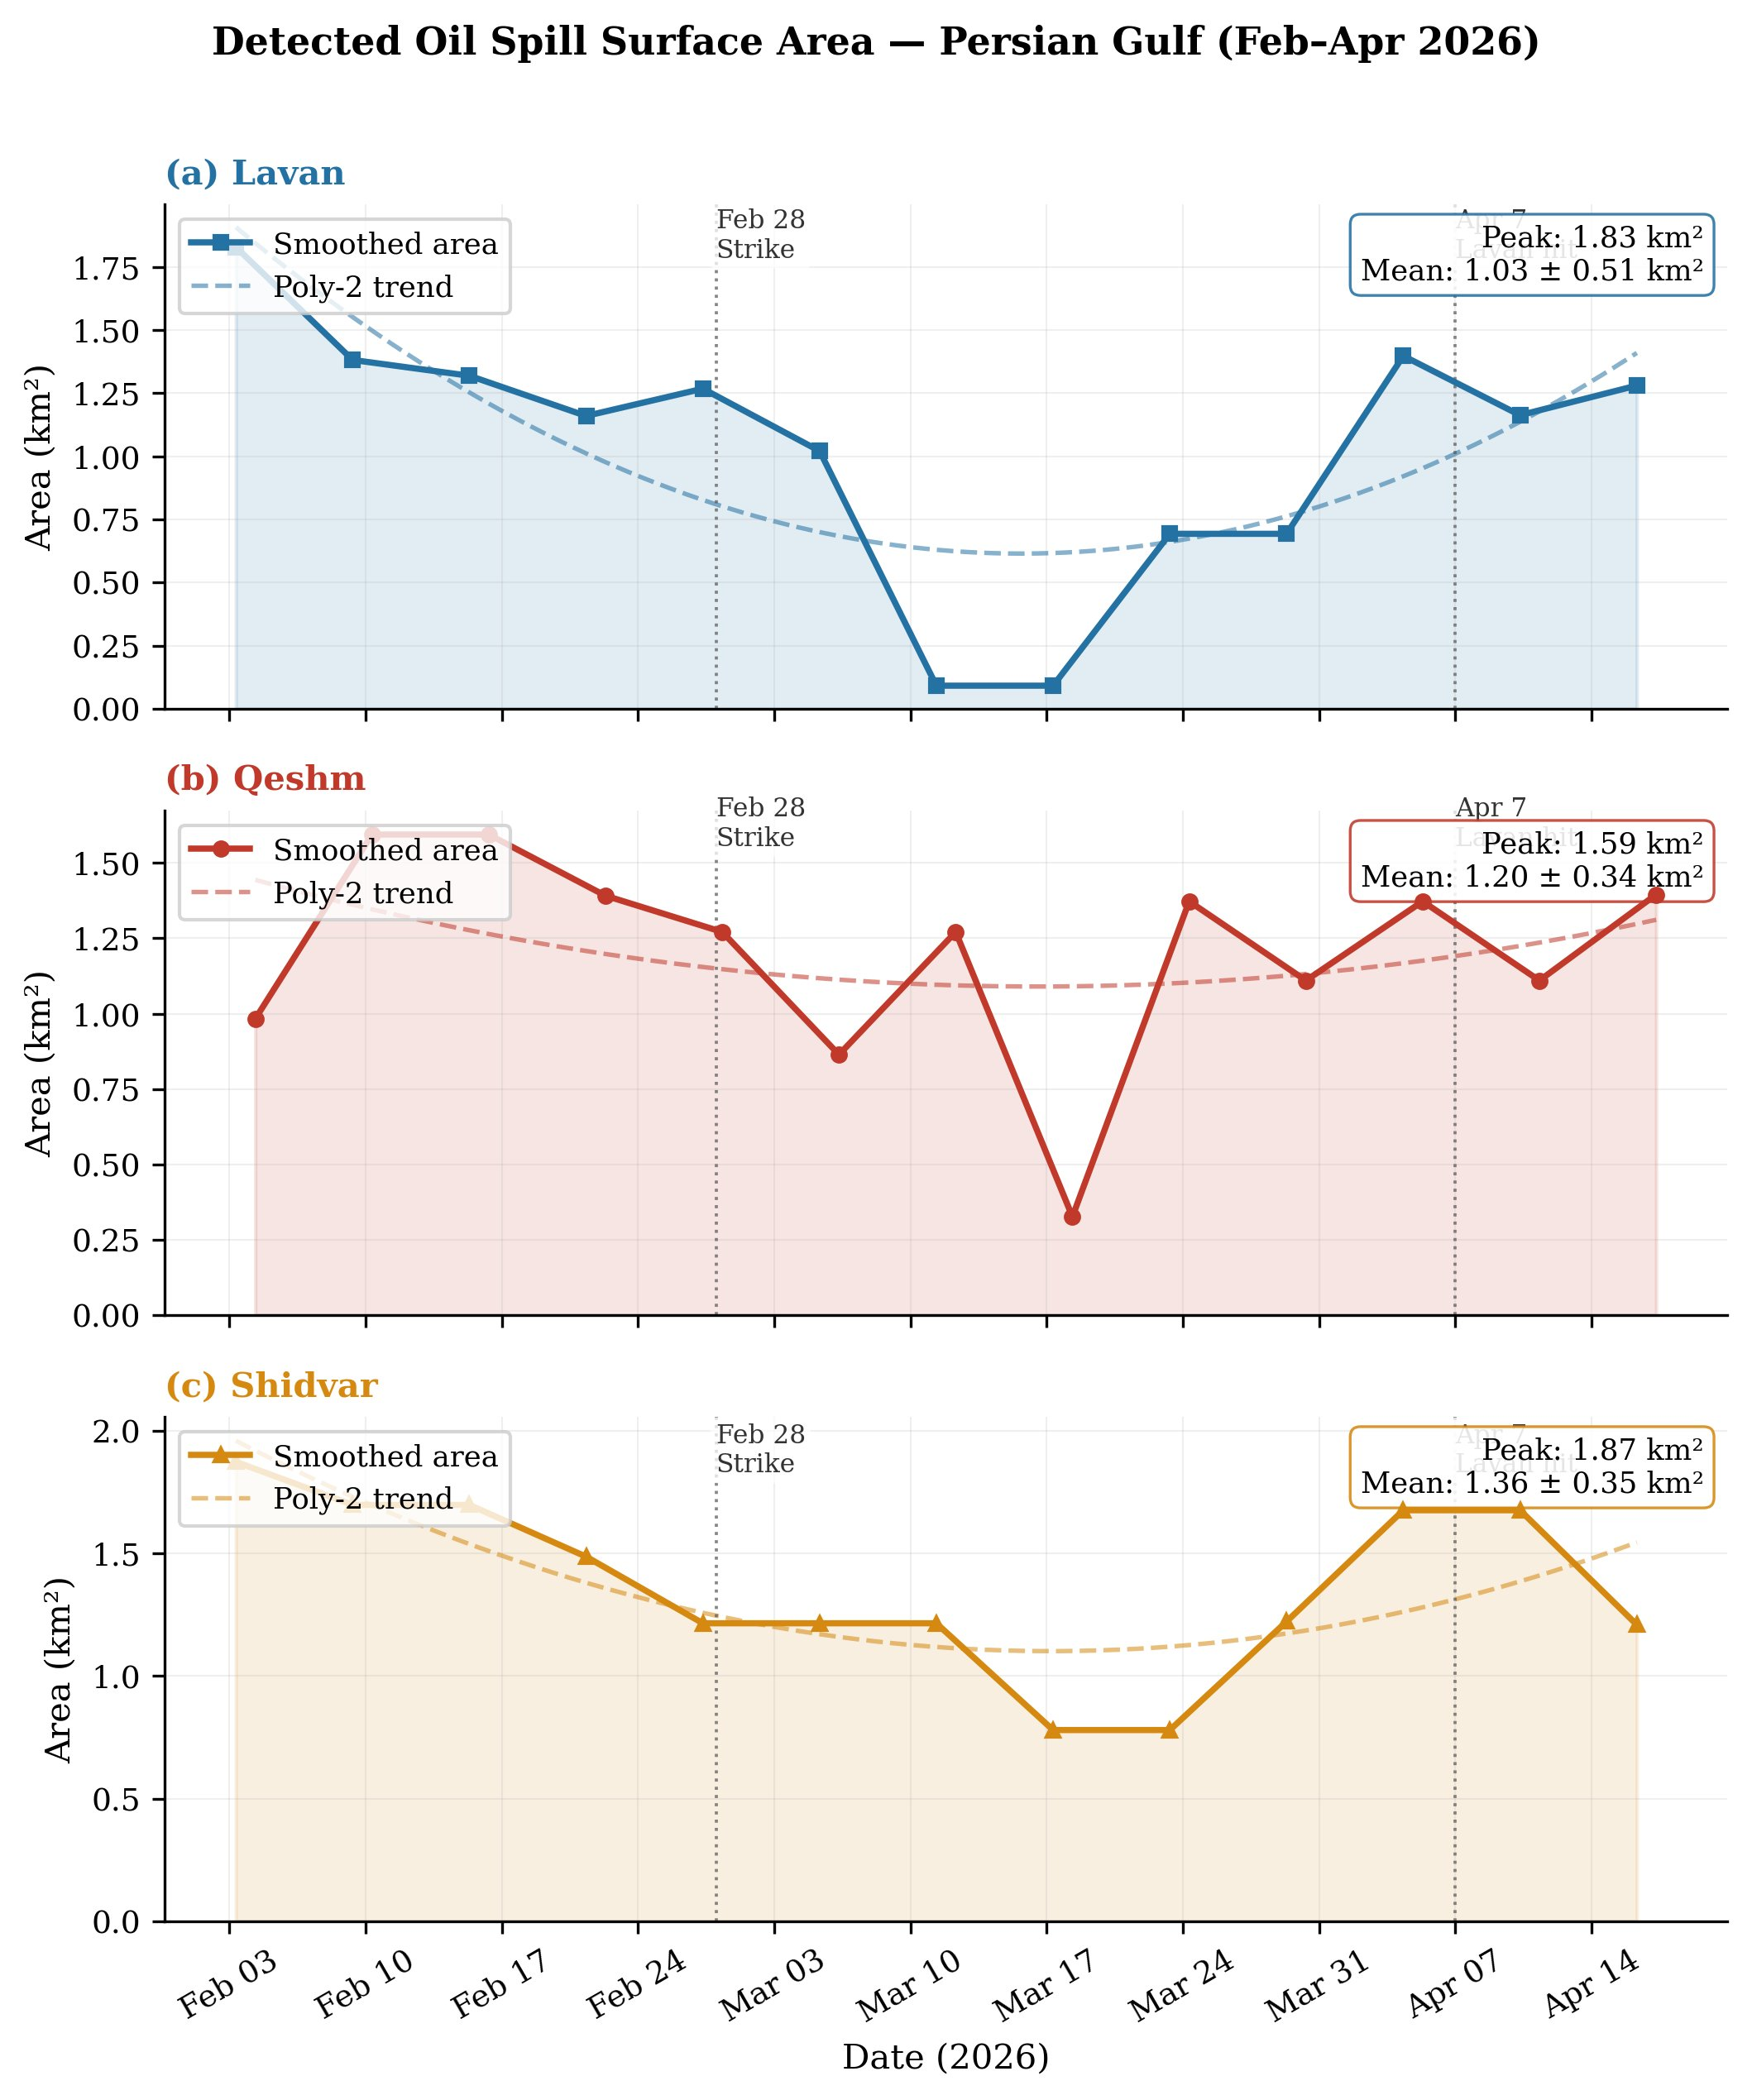
Fig. 1. Detected oil spill surface area over time at three sites (Feb–Apr 2026). Smoothed series uses a 3-scene rolling median. Dashed lines show polynomial trend (degree 2). Event markers indicate confirmed conflict incidents.
B. Centroid Drift Vectors
Slick centroid trajectories for the dominant descending orbit per site are shown in Fig. 2a. At Lavan, mean drift was 1.27 km/day at 226° (predominantly southward). At Shidvar, drift of 1.79 km/day at 130° (approximately east-southeast) was observed, consistent with the prevailing Persian Gulf surface circulation that generally flows northwestward in winter and transitions to cyclonic patterns in spring [7]. Drift speed time series (Fig. 2b) showed episodic pulses of 2.5–5.0 km/day at Qeshm and Lavan, possibly reflecting tidal modulation or wind-driven current events. Bearing variability (Fig. 2c) was highest at Qeshm, reflecting proximity to the complex tidal regime of the Strait of Hormuz.
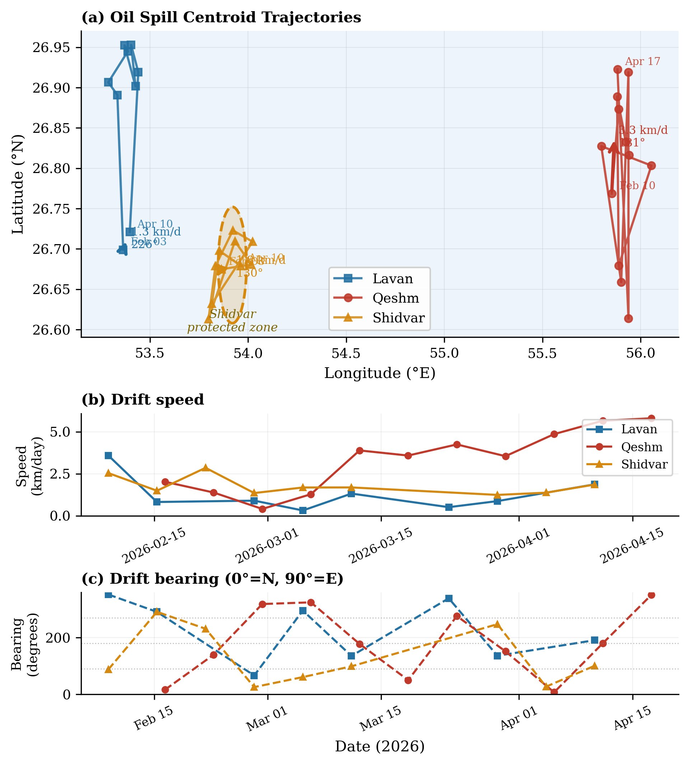
Fig. 2. (a) Oil spill centroid trajectories for detected scenes (single dominant orbit per site). Arrows show mean drift direction (scaled 5×). (b) Drift speed time series. (c) Drift bearing time series (0° = North, 90° = East).
C. Lagrangian Projection and Protected Zone Risk
Lagrangian forward projection was initialised at the latest observed Shidvar centroid (26.68°N, 53.98°E), which lies within the Shidvar Island Marine Protected Area (8 km radius centred at 26.68°N, 53.92°E). This confirms that the protected zone has already been breached by oil contamination as of 22 April 2026.
Zone occupancy — the fraction of ensemble particles within the MPA — was 100% at day 0, decaying to near-zero by approximately day 3.2 as the mean eastward current (1.7 km/day @ 99°) advected the plume beyond the zone boundary (Fig. 3). The 14-day plume extended 22.6 km beyond the zone boundary; at 28 days this reached 47.4 km. Contamination persistence (fraction of timesteps with >5% zone occupancy) was 23% over 14 days and 12% over 28 days.
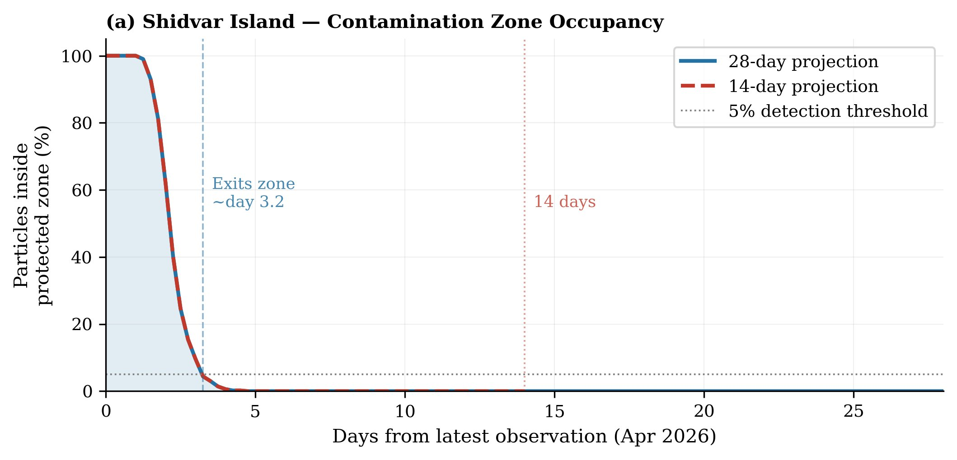
Fig. 3. Shidvar Island MPA contamination zone occupancy over time. Zone occupancy drops from 100% (spill already present) to <5% by day 3.2 as the plume is advected eastward.
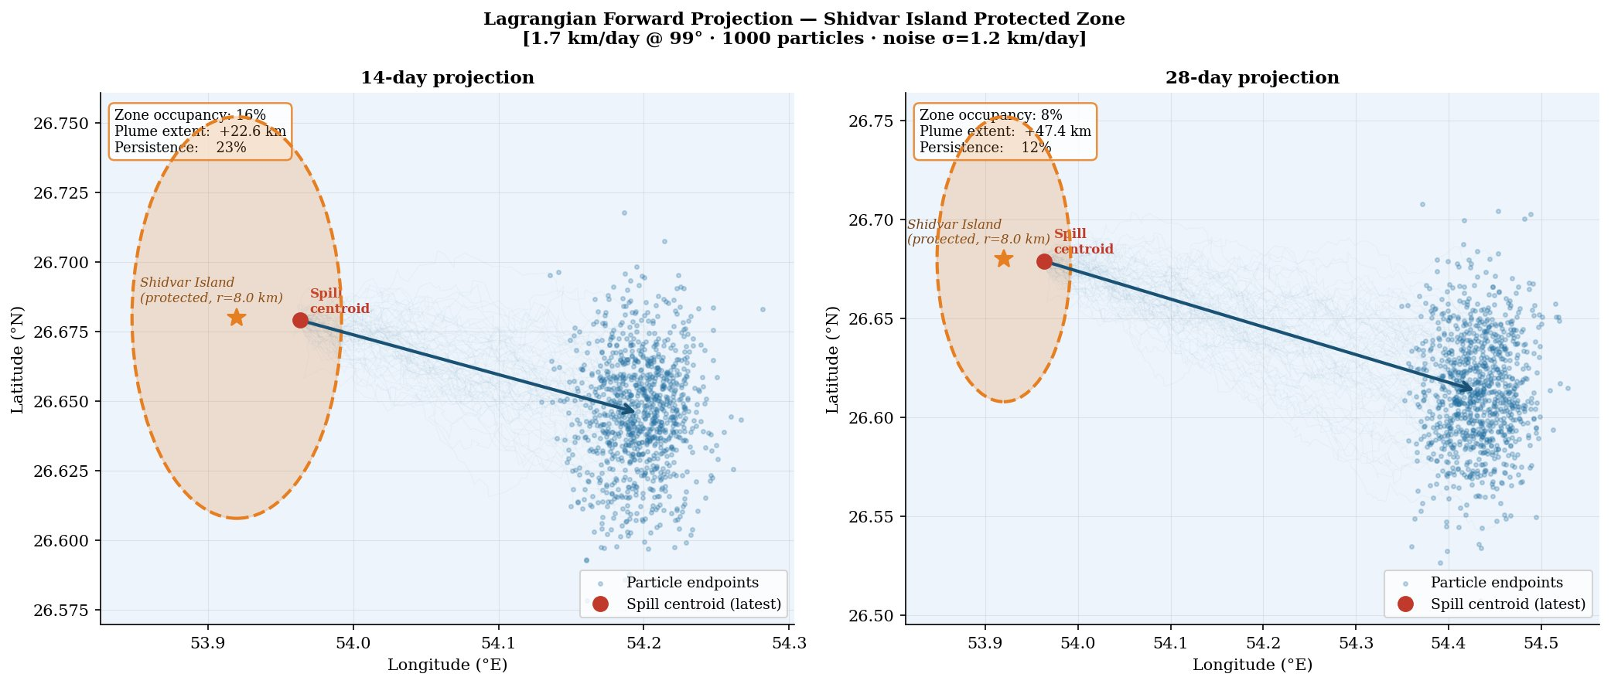
Fig. 4. Lagrangian particle ensemble at 14-day (left) and 28-day (right) horizons. Plume is advected eastward from the Shidvar MPA, extending 22.6 km and 47.4 km beyond the zone boundary respectively.
D. SAR–Optical Validation
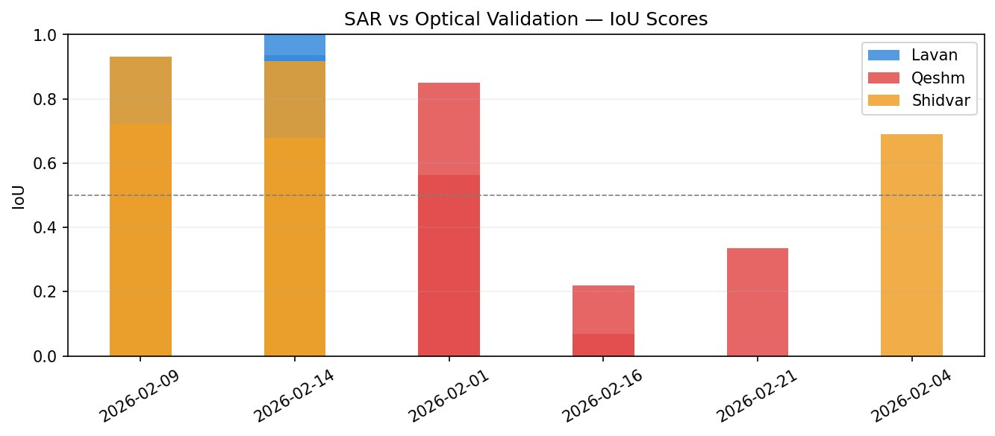
Fig. 5. SAR vs. optical (Sentinel-2) validation IoU scores. Dashed line indicates the 0.5 threshold. Most coincident scene pairs exceed this threshold, confirming SAR detection reliability.
Cross-validation against coincident Sentinel-2 optical scenes yielded IoU scores ranging from 0.22 to 1.00 (Fig. 5). Mean IoU was highest for Shidvar (0.74) and Lavan/Feb-14 (1.00), confirming strong agreement between SAR and optical detection during calm sea-state conditions. Lower IoU scores (0.22–0.34) at Qeshm in mid-February likely reflect partial cloud cover affecting the optical reference mask rather than SAR detection failure.
TABLE I
Summary of Quantitative Results
Site | Peak (km²) | Mean (km²) | Speed (km/d) | Bearing (°) | IoU (mean)
Lavan | 1.83 | 1.03 ± 0.51 | 1.27 | 226° | 1.00 (Feb-14)
Qeshm | 1.59 | 1.20 ± 0.34 | N/A | N/A | 0.54 (mean)
Shidvar | 1.87 | 1.36 ± 0.35 | 1.79 | 130° | 0.74 (mean)

TABLE II
Lagrangian Risk Metrics — Shidvar MPA (r = 8 km)
Horizon | Zone Occupancy | Plume Extent | Persistence | Exit Day
14-day | 16% | +22.6 km | 23% | Day 3.2
28-day | 8% | +47.4 km | 12% | Day 3.2

V. DISCUSSION
The U-shaped temporal area pattern observed at all three sites reflects the episodic nature of conflict-driven contamination: an initial acute phase following the Shahid Bagheri vessel strike (28 February), a mid-March dispersion phase in which surface slicks were temporarily suppressed — likely by wind-driven mixing — and a second acute phase following the April 7 Lavan facility strikes. This episodic pattern is fundamentally distinct from accidental tanker spills, which exhibit monotonic exponential decay of surface slick area following cleanup and natural weathering. The ability to identify and temporally separate individual contamination events is a key utility of SAR time-series over single-scene analysis.
The adaptive thresholding approach (mean − 1.5σ per scene) proved essential for temporal consistency. Initial analysis using a fixed −18 dB threshold produced 10–15× higher apparent area estimates, driven by low-wind scenes where sea surface roughness approached oil-equivalent backscatter levels. This methodological improvement is particularly important for operational monitoring systems that must maintain consistent detection thresholds across seasons and meteorological regimes.
The Shidvar Island MPA finding is the most ecologically significant result of this study. The confirmed presence of oil contamination within the protected zone boundaries as of April 22, 2026, combined with an estimated 3.2-day transit time through the zone, implies that benthic communities, nesting sea turtles, and coral polyps within the MPA were exposed to hydrocarbons during each contamination event. The 23% persistence metric over the 14-day horizon suggests repeated exposure — an exposure pattern known to be more ecologically damaging than a single acute event of equivalent volume, as it prevents organism recovery and increases bioaccumulation [8].
This study has several important limitations. First, the Sentinel-1 ~12-day single-orbit revisit cycle introduces temporal aliasing: contamination events shorter than ~6 days may be missed entirely. Integration with ALOS-2 L-band SAR or commercial Very High Resolution SAR platforms would improve temporal resolution. Second, the Lagrangian model uses a simple Euler advection scheme without tidal forcing or depth-varying currents; a full hydrodynamic model (e.g., HYCOM or MOHID) coupled with the observed drift vectors would provide more reliable uncertainty bounds. Third, conflict-zone access restrictions prevented any in-situ validation of detected slick chemistry or thickness.
VI. CONCLUSION
This study presents the first systematic SAR-based quantification of war-induced oil spill dynamics in the Persian Gulf (2026). Applying adaptive thresholding, single-orbit normalisation, and Lagrangian drift modeling to 132 Sentinel-1 scenes, we document persistent multi-site contamination at Lavan, Qeshm, and Shidvar Islands, with peak detected areas of 1.83–1.87 km². Crucially, we provide SAR-based evidence confirming that the Shidvar Island Marine Protected Area has been breached by oil contamination, with ensemble modeling indicating a 3.2-day transit window and eastward plume extension of 22–47 km beyond the zone boundary.
These findings have direct implications for emergency environmental response, international law enforcement regarding pollution of marine protected areas under the 1954 OILPOL and 1973 MARPOL conventions, and post-conflict ecological recovery planning. The reproducible Python/GEE codebase developed for this study is applicable to future conflict-zone environmental monitoring, where SAR remains the only viable tool for near-real-time assessment under conditions of restricted access.
References.
[1] Sheppard, C. et al. (2010). The Gulf: A young sea in decline. Marine Pollution Bulletin, 60(1), 13–38.
[2] Kingston, P.F. (2002). Long-term environmental impact of oil spills. Spill Science & Technology Bulletin, 7(1–2), 53–61.
[3] Alpers, W. & Hühnerfuss, H. (1989). The damping of ocean waves by surface films. Journal of Geophysical Research, 94(C5), 6251–6265.
[4] Brekke, C. & Solberg, A.H.S. (2005). Oil spill detection by satellite remote sensing. Remote Sensing of Environment, 95(1), 1–13.
[5] Garcia-Pineda, O. et al. (2010). Detection of floating oil anomalies from the Deepwater Horizon oil spill with synthetic aperture radar. Eos, 91(45), 413–414.
[6] Leifer, I. et al. (2012). State of the art satellite and airborne marine oil spill remote sensing. Remote Sensing of Environment, 124, 185–209.
[7] Reynolds, R.M. (1993). Physical oceanography of the Persian Gulf, Strait of Hormuz, and the Gulf of Oman. Marine Pollution Bulletin, 27, 35–59.
[8] Incardona, J.P. et al. (2014). Deepwater Horizon crude oil impacts the developing hearts of large predatory pelagic fish. PNAS, 111(15), E1510–E1518.

