

WAGENINGEN UNIVERSITY AND RESEARCH
DEPARTMENT OF AGROTECHNOLOGY AND FOOD SCIENCES
FOOD TECHNOLOGY

Master`s Thesis Report

Barrier Properties of Biobased and Biodegradable Food Plastics:
a Systematic Review

By

Sharon de Bondt

Submitted In Partial Fulfilment for the Requirements for the Degree of

Master of Food Technology

April 2026

Chair group: Food Quality and Design
Student name: Sharon de Bondt (1049429)
Supervisor name: Deniz Turan Kunter
FQD course code: FQD 80436
Date: 30 April 2026
DOI: https://doi.org/10.5281/zenodo.19350674

Abstract
Biobased and biodegradable polymers are increasingly considered as alternatives to conventional fossil-based plastics in food packaging, driven by environmental concerns and EU regulatory pressure. However, it remains unclear whether these materials can match the barrier performance required to protect food quality and ensure shelf life. This systematic review compares the barrier properties of biobased and biodegradable packaging materials with those of conventional plastics, following the PRISMA framework. In addition this study aims to investigate the suitability of different biobased and biodegradable polymers for different food categories. A structured search in SCOPUS (2024–2025) yielded 19 studies from which a FAIR dataset of 123 standardised barrier measurements was created, covering water vapour transmission rate (WVTR₁₀₀), oxygen transmission rate (OTR₁₀₀), and carbon dioxide transmission rate (CO₂TR₁₀₀) for 49 biobased and 33 conventional polymer entries.
The dataset includes five biobased material families — polysaccharides, proteins, aliphatic biopolyesters, aromatic biopolyesters, and vinyl biopolymers — with polysaccharides and proteins dominating the recent literature. Most biobased materials show WVTR values one to two orders of magnitude higher than conventional polyolefins, consistent with their hydrophilic nature. PLA and PHBV are exceptions, approaching conventional performance. For oxygen transmission, the picture is reversed: furanoate polyesters and PHBV outperform polyolefins and approach the performance of high-barrier polymers such as PET. CO₂TR data is severely underrepresented, limiting conclusions for this property.
When compared to food category requirements, most biobased materials do not meet the WVTR demands of any major food category without modification. For OTR, furanoate polyesters meet the requirements of virtually all food categories, and PHBV is suitable for several applications. However, no single biobased material meets both the WVTR and OTR requirements for the most demanding food categories, confirming a polarity-driven trade-off between gas and moisture barrier performance.
These findings indicate that biobased and biodegradable polymers cannot yet directly replace conventional plastics in most food packaging applications based on barrier performance alone. Strategies such as blending, coating, or multilayer design are likely needed to overcome the trade-off between gas and moisture barrier properties. Future research should prioritise standardised testing conditions, inclusion of CO₂TR data, and barrier characterisation of industrially processed films
Table of Contents
Abstract 2
1. Introduction 5
1.1 Plastic Use in Food Packaging 5
1.2 Bioplastics as Alternatives 5
1.3 Regulatory and Policy Context 5
1.4 Knowledge Gap 5
1.5 Aim and Research Questions 6
1.6 Hypothesis 6
2. Background Information 7
2.1 Types of Biobased and Biodegradable Polymers Used in Food Packaging Films 7
2.2 Barrier Properties and Their Role in Food Packaging 13
2.2.1 Permeation mechanisms 13
2.2.2 Mathematical modelling 13
2.2.3 Barrier parameter 14
2.3 Factors Influencing Barrier Performance of Polymer Films 15
2.3.1 Internal factors 15
2.3.2 External factors 16
2.4 Measurement Methods of Barrier Properties 18
2.4.1 Gas Transmission Rate (GTR) Methodologies 18
2.4.2 Water vapor transmission rate methods 19
2.4.3 Influence of test conditions on reported values 19
2.5 Variation in Barrier Requirements Across Food Categories 21
2.5.1 Deterioration mechanisms relevant to barrier performance 21
2.5.2 Food categories 22
3. Materials and Methods 26
1.1 Article Collection 26
2.1 Article Screening 26
3.1 Data Extraction 28
4.1 Data Analysis 28
4. Results and Discussion 29
4.1 Dataset Characteristics 29
Representation of Barrier Properties 29
4.2 Biobased and biodegradable polymers used for food packaging 33
4.3 Barrier properties of biobased and biodegradable polymers 35
4.3.1 WVTR 35
4.3.2 OTR 38
4.3.3 CO₂TR 41
4.4 Alignment of polymer barrier properties with food packaging requirements 43
4.4.1 WVTR 43
4.4.2 OTR 45
5. Conclusion 47
6. Recommendations 48
7. References 50
8. Appendix 57
8.1 Quality Assessment Rubric 57
8.2 Transmission rate unit conversion factors 58
8.3 Outlier analysis 60
8.3.1 Oxygen Transmission Rate (OTR100) 61
8.3.2 Water Vapour Transmission Rate (WVTR100) 61
8.3.3 Carbon Dioxide Transmission Rate (CO₂TR100) 62
8.4 Summary of Studies Included 64

Introduction

Plastic Use in Food Packaging
The shift toward sustainable materials is a key component of global efforts to reduce environmental impacts and promote circular economy practices across industries. Plastics are widely used in food packaging because they are durable, affordable, lightweight and provide strong oxygen and water-vapour barriers, which help prevent spoilage and reduce food waste (Hossain et al., 2024). However, most plastics are fossil-based, non-renewable and poorly degradable, contributing to land and marine pollution, ecosystem disruption, greenhouse gas (GHG) emission and microplastic accumulation—packaging represented about half of all marine litter in 2022 and 3.4% of global GHG emissions in 2019, which is expected to rise (European Commission, n.d.-b; European Parliament, 2018). These environmental concerns have intensified societal and regulatory pressure to shift toward more sustainable materials.

Bioplastics as Alternatives
Bioplastics—biobased, biodegradable, or both—are emerging as alternatives but still represent only around 0.5% of the 414 million tonnes of plastics produced annually (European Bioplastics, n.d.-b). Biobased plastics such as Bio-PE, Bio-PET and Bio-PP are derived partly or fully from renewable biomass, while biodegradable plastics such as PLA, PHA/PHB, PBAT, PBS, PCL, PVA and bacterial cellulose can break down enzymatically under defined conditions (European Bioplastics, n.d.-a). Despite their potential benefits, their use in food packaging remains limited due to higher costs, inconsistent performance, regulatory uncertainty and unclear end-of-life routes (European Commission, 2022a).

Regulatory and Policy Context
The European Union supports a shift to sustainable materials through several connected policies. The European Green Deal (2019) aims for climate neutrality by 2050, and the Circular Economy Action Plan (2020) identifies packaging as a priority for improved design and reduced fossil-based use (European Commission, n.d.-c, 2020). The proposed Packaging and Packaging Waste Regulation (PPWR) (2025) strengthens these goals with mandatory recyclability criteria, recycled-content targets and clear rules for compostable packaging (European Commission, 2025). Additional frameworks—the EU Bioeconomy Strategy (2018), the Policy Framework for Biobased, Biodegradable and Compostable Plastics (2022), and initiatives such as the EU Taxonomy and Sustainable Products Initiative—further guide material innovation, labelling and end-of-life practices (European Bioplastics, n.d.-c, 2022; European Commission, 2018, 2022b). Together, they encourage packaging that is biobased or biodegradable, safe, functional, and compatible with circular systems.

Knowledge Gap
Despite this momentum, a knowledge gap persists. Current evidence on whether biobased and biodegradable packaging materials can match the mechanical, physical, and barrier performance required for food protection is fragmented and inconsistent. Studies often assess single materials or isolated parameters, limiting systematic comparison with conventional plastics. In addition, data linking material properties to food-quality outcomes, such as shelf life, oxidation, or microbial stability, remain scattered and poorly harmonized.
A key underlying issue is the lack of methodological consistency in evaluating barrier properties. Permeability and transmission values are frequently reported under differing experimental conditions, including variations in film thickness, temperature, relative humidity, pressure gradients, and test standards (Robertson, 2016). These factors are not always clearly reported or standardized, complicating cross-study comparisons. Consequently, it remains unclear whether observed performance differences between biobased, biodegradable, and conventional plastics reflect intrinsic material properties or are primarily driven by experimental variability.
Together, these limitations highlight the need of a more systematic approach that compares bioplastics with conventional plastics in terms of performance.

Aim and Research Questions
To address this gap, this research aims to create a FAIR (Findable, Accessible, Interoperable, Reusable) dataset of biobased and biodegradable food-packaging materials(Wilkinson et al., 2016). The study systematically collects and harmonizes quantitative data on barrier properties, as well as their suitability to different food categories. The central research question is:
“How do biobased and biodegradable food-packaging materials compare to conventional fossil-based plastics in terms of barrier properties?
The sub-questions are:
- “Which biobased and biodegradable materials are used or proposed for food packaging?”
- “How do their barrier properties (gas permeability, and water-vapour permeability) compare to those of conventional plastics?”
- “How do these barrier properties of biobased and biodegradable polymers align with the requirements of different food categories?”

Hypothesis
Based on the identified knowledge gaps and the aim of comparing biobased and biodegradable packaging to conventional plastics, the following hypotheses are proposed. These hypotheses reflect expected differences in functional performance, food-quality outcomes, and sustainability.
- It is expected that most biobased, non-biodegradable polymers (e.g., bio-PE, bio-PET) will show performance comparable to conventional plastics under standard conditions, as they share similar chemical structures and are often produced to the same specifications.
- In contrast, biodegradable polymers (e.g., PLA, PHA) are likely to be more hygroscopic and therefore exhibit larger WVTR values. Their polar functional groups promote water uptake, which can plasticize the material and reduce barrier performance, potentially limiting their suitability for moisture-sensitive foods.
- Barrier variability among samples of the same biobased polymer sourced from different suppliers is also expected to be higher than among fossil-based reference materials. This is because biobased materials often rely on emerging feedstocks and processing routes that are not yet fully standardized, leading to greater heterogeneity in material properties. Additionally, these materials are more sensitive to different relative humidities due to higher polarities (Robertson, 2016).
By answering these questions, the study supports harmonized terminology and data use, strengthens evidence for industry and policymakers, and contributes to a more sustainable and circular food-packaging system aligned with EU climate and waste-reduction goals.

Background Information

Types of Biobased and Biodegradable Polymers Used in Food Packaging Films
Sustainable alternatives to fossil-based polymers for food packaging can be biobased, biodegradable, or both. A biobased origin and biodegradability are independent properties. A material can be derived from renewable sources without being biodegradable, and vice versa. Biobased means that the polymers are derived partly or fully from renewable sources (European Bioplastics, n.d.-a; European Commission, n.d.-a). Biodegradable means that the polymers can be broken down by microorganisms into CO₂, water, and biomass under specific conditions, such as home composting or industrial composting (European Bioplastics, n.d.; European Commission, n.d.-a). A classification of biobased and biodegradable materials is presented in Figure 1.
Figure 1
Classification of plastic materials used in food packaging according to their origin (biobased vs. fossil-based) and biodegradability.
The following tables provide an overview of commonly used polymers relevant to food packaging, organised into the four categories from Figure 1, based on their origin and biodegradability: biobased and biodegradable (Table 1), biobased but not biodegradable (Table 2), fossil-based but biodegradable (Table 3), and fossil based but not biodegradable (Table 4). For each material, the chemical subcategory, main monomers, thermal properties, and key characteristics are listed.

Table 1.
Overview of biobased and biodegradable polymers reported for use in food packaging films, including their abbreviation, subcategory, main monomers, glass transition temperature (Tg), melting temperature (Tm), key characteristics, and literature sources.
- Biobased - Biodegradable
Material | Abbreviation | Subcategory | Main monomer(s) | Tg (°C) | Tm (°C) | Description | Source
Alginate | — | Polysaccharide | Alginate units | — | — | Extracted from brown seaweed; forms gels with calcium; used in edible coatings and encapsulation; hydrophilic | (Robertson, 2016; Stoica et al., 2024; Vroman & Tighzert, 2009)
Cellulose | — | Polysaccharide | Glucose | — | — | Plant structural polymer; processed into films (cellophane) or modified cellulose derivatives (methylcellulose, carboxymethylcellulose, hydroxy propyl cellulose); sensitive to water | (Geueke, 2014; Oliver-Cuenca et al., 2024; Robertson, 2016; Stoica et al., 2024; Vroman & Tighzert, 2009)
Chitin | — | Polysaccharide | N‑acetylglucosamine | — | — | From crustacean shells and fungi; structural polysaccharide; insoluble in common solvents; poor biodegradability | (Oliver-Cuenca et al., 2024; Stoica et al., 2024; Vroman & Tighzert, 2009)
Chitosan | — | Polysaccharide | Glucosamine | — | — | Deacetylated chitin; soluble in acidic solutions; antimicrobial, film-forming; poor mechanical properties, hydrophilic | (Oliver-Cuenca et al., 2024; Robertson, 2016; Stoica et al., 2024; Vroman & Tighzert, 2009)
Pectin | — | Polysaccharide | Galacturonic acid | — | — | Plant cell wall polysaccharide; forms gels; used in food coatings and packaging; brittle; hydrophilic | (Robertson, 2016; Stoica et al., 2024)
Starch | — | Polysaccharide | Amylose/amylopectin units | — | — | Versatile plant storage polysaccharide; forms films and coatings; poor water resistance, poor mechanical properties | (Oliver-Cuenca et al., 2024; Stoica et al., 2024; Vroman & Tighzert, 2009)
Pullulan | — | Polysaccharide | Maltotriose units | — | — | Water-soluble polysaccharide from fungal fermentation; forms flexible, edible, and biodegradable films; often used in coatings and packaging; hydrophilic | (Oliver-Cuenca et al., 2024)
Fatty acids | — | Lipid | Fatty acid monomers | — | — | Long-chain carboxylic acids | (Oliver-Cuenca et al., 2024)
Glycerides | — | Lipid | Glycerol + fatty acids | — | — | Esters of fatty acids and glycerol; present in fats and oils | (Oliver-Cuenca et al., 2024)
Oils | — | Lipid | Glycerol + fatty acids | — | — | Triglycerides from plants or animals; used as plasticizer or precursor | (Oliver-Cuenca et al., 2024; Robertson, 2016)
Waxes | — | Lipid | Glycerol + fatty acids | — | — | Long-chain esters; from plants or animals; hydrophobic coatings | (Oliver-Cuenca et al., 2024; Robertson, 2016)
Collagen | — | Protein | Polypeptides with high concentrations of glycine, proline and hydroxyproline | — | — | Structural protein from animal connective tissue; forms strong films and gels; poor water resistance, low thermal stability | (Robertson, 2016; Stoica et al., 2024; Vroman & Tighzert, 2009)
Gelatine | — | Protein | Polypeptides with high concentrations of glycine, proline and hydroxyproline | — | — | Denatured collagen; water-soluble, forms gels and edible films; low cost; poor mechanical properties; brittle; strong sensitivity to moisture inducing swelling | (Oliver-Cuenca et al., 2024; Robertson, 2016; Stoica et al., 2024; Vroman & Tighzert, 2009)
Keratin | — | Protein | Polypeptides rich in cysteine, serine, glutamic acid glycine | — | — | Structural protein from hair, wool, feathers, or nails; rich in disulfide bonds; forms strong, biodegradable films and coatings; can be processed into fibres or blended with other biopolymers; hydrophobic | (Stoica et al., 2024)
Gluten | — | Protein | Glutenin + gliadin | — | — | Wheat protein; forms elastic, flexible films; very soluble | (Stoica et al., 2024; Vroman & Tighzert, 2009)
Whey | — | Protein | α-lactalbumin, β-lactoglobulin, serum albumin and immunoglobulins | — | — | Milk protein; used for edible films and coatings + flexible and transparent films + good gas permeability characteristics; poor water resistance | (Stoica et al., 2024)
Zein | — | Protein | Polypeptides rich in leucine, proline and alanine | — | — | Maize storage protein; hydrophobic, coating applications. α-, β-, γ-, and δ-zein; α-zein most abundant in nature; poor mechanical and thermal properties | (Robertson, 2016; Stoica et al., 2024)
Polyhydroxyalkanoate | PHA | Microbially synthesized | 3‑hydroxyalkanoic acids | 5 | 182 | Produced by bacterial fermentation of sugars or lipids; fully biodegradable, thermoplastic; poor thermal and mechanical properties | (Oliver-Cuenca et al., 2024; Robertson, 2016; Stoica et al., 2024; Ten Boer et al., 2026; Vroman & Tighzert, 2009)
Polyhydroxybutyrate | PHB | Microbially synthesized | 3‑hydroxybutyric acid | 5 | 180-182 | Homopolymer PHA; crystalline, brittle, thermoplastic; microbial synthesis | (De Beukelaer et al., 2022; Oliver-Cuenca et al., 2024; Robertson, 2016; Stoica et al., 2024; Ten Boer et al., 2026; Vroman & Tighzert, 2009)
Polyhydroxybutyrate-co-valerate | PHBV | Microbially synthesized | 3‑hydroxybutyric + 3‑hydroxyvaleric acids | -5-20 | 108-180 | Polyhydroxybutyrate-co-hydroxyvalerate; PHB copolymer with hydroxyvalerate; more flexible; lower melting point | (De Beukelaer et al., 2022; Oliver-Cuenca et al., 2024; Robertson, 2016; Stoica et al., 2024; Ten Boer et al., 2026; Vroman & Tighzert, 2009)
Polyglycolic acid | PGA | Industrially synthesized | Glycolic acid | 35-45 | 220-230 | Polyglycolic acid; aliphatic polyester; produced by polycondensation of glycolic acid; crystalline | (De Beukelaer et al., 2022; Robertson, 2016; Ten Boer et al., 2026; Vroman & Tighzert, 2009)
Polylactic acid | PLA | Industrially synthesized | Lactic acid | 51-63 | 145-180 | Polylactic acid; from fermented sugars polymerized to lactic acid by ring opening or polycondensation; thermoplastic; brittle, low gas barrier properties, thermal instability; biodegradation takes time | (De Beukelaer et al., 2022; Oliver-Cuenca et al., 2024; Robertson, 2016; Stoica et al., 2024; Ten Boer et al., 2026; Vroman & Tighzert, 2009)
Polypropylene carbonate | PPC | Industrially synthesized | Propylene carbonate + CO₂ | — | — | Polypropylene carbonate; synthesized from CO₂ and propylene oxide by copolymerization; carbonate polymer | (Robertson, 2016)
Polyvinyl alcohol | PVA | Industrially synthesized | Vinyl alcohol | — | — | Polyvinyl alcohol; produced by hydrolysis of polyvinyl acetate; water-soluble and biodegradable under specific conditions | (Geueke, 2014)

Table 2.
Overview of biobased but not biodegradable polymers relevant to food packaging, including their abbreviation, subcategory, main monomers, thermal properties, key characteristics, and literature sources.
- Biobased - Not Biodegradable
Material | Abbreviation | Subcategory | Main monomers | Tg (°C) | Tm (°C) | Description | Source
Bio-polyamide | Bio-PA (nylon) | Polyamide | Diamines + diacids | 44 | 202 | Partially biobased (vegetable oil); polymerized via condensation; strong, heat-resistant | (De Beukelaer et al., 2022; Geueke, 2014)
Bio-polyethylene | Bio-PE | Polyolefin | Ethylene | — | — | Polymerization of ethylene from bioethanol; chemically identical to conventional PE; chemically inert | (Geueke, 2014; Robertson, 2016)
Bio-polyethylene terephthalate | Bio-PET | Aromatic polyester | Ethylene glycol + Terephthalic acid | 76 | 245 | Ethylene glycol may be bio-derived (sugarcane); durable, recyclable | (Geueke, 2014; Robertson, 2016)
Bio-polypropylene | Bio-PP | Polyolefin | Propylene | -4 | 166 | Bio-derived polypropylene; chemically identical to conventional PP, combining high heat resistance, chemical durability, low density, and mechanical strength; versatile for films, fibres, and containers | (De Beukelaer et al., 2022; Geueke, 2014)
Polyethylene furanoate | PEF | Aromatic polyester | 2,5- furan dicarboxylic acid (FDCA) + Ethylene glycol | — | — | FDCA from sugars; polycondensation with EG; high barrier | (Geueke, 2014)
Polytrimethylene terephthalate | PTT | Aromatic polyester | 1,3‑Propanediol + Terephthalic acid | 46 | 232 | 1,3-PDO bio-derived; polycondensation polymer; elastic fibres | (De Beukelaer et al., 2022)

Table 3.
Overview of fossil-based but biodegradable polymers relevant to food packaging, including their abbreviation, subcategory, main monomers, thermal properties, key characteristics, and literature sources.
- Not biobased - Biodegradable
Material | Abbreviation | Subcategory | Main monomers | Tg (°C) | Tm (°C) | Description | Source
Polybutylene adipate terephthalate | PBAT | Aliphatic-aromatic copolyester | 1,4‑Butanediol + Adipic acid + Terephthalic acid | -25 | 202 | Synthesized via polycondensation; flexible, fully biodegradable under industrial composting | (De Beukelaer et al., 2022; Geueke, 2014; Oliver-Cuenca et al., 2024; Robertson, 2016; Vroman & Tighzert, 2009)
Polybutylene succinate | PBS | Aliphatic polyester | 1,4‑Butanediol + Succinic acid | -45- -10 | 90-120 | Synthesized via polycondensation from fossil succinic acid; biodegradable via hydrolysis and microbial activity | (De Beukelaer et al., 2022, p. 4; Geueke, 2014; Oliver-Cuenca et al., 2024; Robertson, 2016; Vroman & Tighzert, 2009)
Polybutylene succinate adipate | PBSA | Aliphatic polyester | 1,4‑Butanediol + Succinic acid + Adipic acid | -47 | 92 | Copolymer of PBS; more flexible; biodegradable under composting; synthesized via polycondensation | (Geueke, 2014; Vroman & Tighzert, 2009)
Polycaprolactone | PCL | Aliphatic polyester | ε‑Caprolactone | -62- -60 | 60-70 | Synthesized via ring-opening polymerization; semi-crystalline; low melting, biodegradable in soil and compost; flexible, mainly used in medical applications | (De Beukelaer et al., 2022; Geueke, 2014; Robertson, 2016)

Table 4.
Overview of fossil-based non-biodegradable polymers relevant to food packaging, including their abbreviation, subcategory, main monomers, thermal properties, key characteristics, and literature sources.
Not Biobased – Not Biodegradable
Material | Abbreviation | Subcategory | Main monomers | Tg (°C) | Tm (°C) | Description | Source
Ethylene vinyl alcohol copolymer | EVOH | Vinyl polymer | Ethylene + Vinyl alcohol | 55–62 | 158–188 | Fossil-based; ethylene copolymer; semi-crystalline; highly polar; excellent oxygen barrier under dry conditions due to dense hydrogen bonding; barrier strongly reduced at high RH; used in multilayer packaging | (Robertson, 2016; Rotstein, 1997)
High density polyethylene | HDPE | Polyolefin | Ethylene | −90 | 137 | Fossil-based; homopolymer; linear, high crystallinity (~80–90%); non-polar; better gas and water vapour barrier than LDPE; stiffer; used in bottles and rigid packaging | (Robertson, 2016; Rotstein, 1997)
Low density polyethylene | LDPE | Polyolefin | Ethylene | −110 | 115 | Fossil-based; homopolymer; branched, low crystallinity (~50%); non-polar; excellent water vapour barrier; poor gas barrier; flexible; used in films and coatings | (Robertson, 2016; Rotstein, 1997)
Polyamide | PA (Nylon 6) | Polyamide | Caprolactams | 47 | 220 | Fossil-based; homopolymer; linear, semi-crystalline (~35–45%); polar; good gas barrier under dry conditions; hygroscopic, barrier reduced at high RH; used in flexible packaging and barrier films | (Krevelen & Nijenhuis, 2009; Robertson, 2016; Rotstein, 1997)
Polyethylene terephthalate | PET | Aromatic polyester | Ethylene glycol + Terephthalic acid | 69 | 265 | Fossil-based; linear homopolymer; semi-crystalline (amorphous to ~40% depending on processing); polar; good gas barrier; widely used in bottles and films; recyclable | (Robertson, 2016; Rotstein, 1997)
Polypropylene | PP | Polyolefin | Propylene | −18 | 176 | Fossil-based; homopolymer; isotactic, semi-crystalline (~60–70%); non-polar; good water vapour barrier; moderate gas barrier; used in flexible and rigid packaging | (Robertson, 2016; Rotstein, 1997)
Polystyrene | PS | Polystyrene | Styrene | 100 | 240 | Fossil-based; homopolymer; linear, amorphous (atactic); non-polar; poor barrier properties; glassy; rigid and brittle; used in trays and cups | (Krevelen & Nijenhuis, 2009; Robertson, 2016; Rotstein, 1997)
Polyvinyl chloride | PVC | Vinyl polymer | Vinyl chloride | 87 | 212 | Fossil-based; homopolymer; linear, mostly amorphous; polar; moderate barrier properties; plasticized for flexible applications; concerns over additives and end-of-life | (Krevelen & Nijenhuis, 2009; Robertson, 2016; Rotstein, 1997)

Barrier Properties and Their Role in Food Packaging
Barrier performance describes the ability of a packaging film to resist the transmission of gases and water vapour (Krevelen & Nijenhuis, 2009; Robertson, 2016). In food packaging, these properties are critical for maintaining food quality and extending shelf life (Robertson, 2016).Oxygen transmission promotes oxidative degradation of lipids and pigments and supports microbial growth, making oxygen barrier performance particularly relevant for fatty or perishable foods (Robertson, 2016). Water vapour transmission affects moisture-sensitive products by causing drying out or sogginess (Robertson, 2016). Carbon dioxide transmission is relevant for modified atmosphere packaging (MAP), where elevated CO₂ levels are used to slow microbial activity and respiration (Robertson, 2016).

Permeation mechanisms
Gases and vapours pass through polymeric films primarily via the solution-diffusion mechanism, which occurs in three stages: the permeant dissolves into the polymer at the high-pressure surface (adsorption), diffuses through the polymer along a concentration gradient, and evaporates from the other surface (desorption) (Robertson, 2016; Rotstein, 1997; Yue et al., 2024).

Mathematical modelling
The diffusion of a permeant through a polymer under steady-state conditions is described by Fick's first law:
$J= -D\frac{δc}{δx} = -D ·\frac{Δc}{l}$·
where:
- J is the flux (cm · s⁻¹);
- D is the diffusion coefficient (cm² · s⁻¹), reflecting the mobility of the permeant through the polymer matrix;
- δc/δx is the concentration gradient across the film thickness (Krevelen & Nijenhuis, 2009; Rotstein, 1997; Stern & Fried, 2007).
Since it is difficult to measure the concentration (c) of a gas inside a solid polymer, we use Henry’s Law to relate internal concentration to the external partial pressure (p):
$$c=S ·p$$
where:
- c is the concentration of the gas dissolved in the polymer;
- p is the partial pressure of the gas;
- S is the solubility coefficient, reflecting the affinity of the polymer for that particular gas (Krevelen & Nijenhuis, 2009; Rotstein, 1997; Stern & Fried, 2007).
By combining Fick’s and Henry’s laws, we can describe the flux in terms of measurable external pressure differences (Δp). This integration yields the Permeability Coefficient (P), which is defined as the product of mobility (diffusivity) and solubility (Krevelen & Nijenhuis, 2009; Rotstein, 1997; Stern & Fried, 2007):
$$P=D · S$$
$J=D · S · \frac{Δp}{l}=P · \frac{Δp}{l}$

Barrier parameter
Barrier performance is expressed using two types of parameters: permeability and transmission rate. Transmission rate (WVTR, OTR, CO₂TR) describes the flux through a film of a given thickness under specific test conditions, expressed in g·m⁻²·d⁻¹ for water vapour and cm³·m⁻²·d⁻¹·bar⁻¹ for gases:
$$TRx=\frac{Δmx}{A·Δt}$$
$$TRx=\frac{Px· Δp}{l}$$
where:
- Δmₓ is the mass or volume (g or cm³) of permeant transmitted;
- A is the film area (m²);
- Δt is the exposure time (d);
- Δp is the partial pressure difference across the film (bar) (Krevelen & Nijenhuis, 2009; Robertson, 2016).
Permeability (P) captures how both mobility (D) and solubility (S) govern the material’s resistance to gas or vapour transmission (Robertson, 2016). Permeability (WVP, PO₂, PCO₂) is normalised for both film thickness (l, µm) and the partial pressure difference across the film (Δp, bar), expressed in:
- Unit for vapour: g·µm·m⁻²·d⁻¹·bar⁻¹
- Unit for gas: cm³·µm·m⁻²·d⁻¹·bar⁻¹
Combining the previous equations give (Krevelen & Nijenhuis, 2009; Rotstein, 1997):
$$WVP=\frac{WVTR·l}{Δp}$$
$$WVP=\frac{WVTR· l}{psat· ΔRH}$$
$$PO2=\frac{OTR·l}{Δp}$$
$$PCO2=\frac{CO2TR·l}{Δp}$$
To clarify the relationships between commonly reported barrier parameters, Figure 2 schematically presents the interconversion between transmission rate, permeance, thickness-normalised transmission rate, and permeability. This overview provides a consistent framework for comparing reported values.

Figure 2.

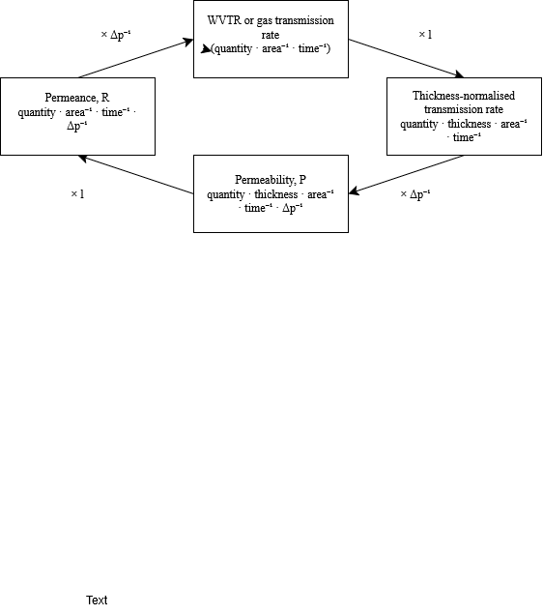
Schematic representation of the relationships beween transmission rate (WVTR, OTR, CO₂TR), permeance (R), thickness-normalised transmission rate (TR₁₀₀), and permeability coefficient (P), illustrating the conversion operations between parameters. Multiplying the transmission rate by the inverse of the partial pressure difference (Δp⁻¹) yields permeance, while multiplying by film thickness (l) yields the thickness-normalised transmission rate. Permeability is obtained by applying both conversions. Adapted from (Rotstein, 1997)

Factors Influencing Barrier Performance of Polymer Films
The barrier efficiency of a packaging film is not a static value but a dynamic property that depends on both the material's structure and the conditions it faces during use and storage (Robertson, 2016; Rotstein, 1997). These influences are categorised into internal factors — polymer-related properties that determine the permeability coefficient P = D × S and external factors, which affect the experimentally measured transmission rate.

Internal factors
The chemical structure of a polymer is the primary determinant of its barrier performance, as it governs both the mobility (D) and solubility (S) of permeant molecules (Robertson, 2016; Rotstein, 1997). At the molecular scale, diffusion occurs as a series of activated jumps between free volume elements cavities within the polymer matrix (Robertson, 2016). Any factor that reduces the number or size of these cavities lowers D and therefore reduces permeability (Robertson, 2016). Polar polymers, such as polyamides (PA) and poly(vinyl alcohol) (PVOH/EVOH), form dense, tightly packed matrices with strong intermolecular interactions, resulting in low gas permeability under dry conditions (Robertson, 2016; Rotstein, 1997). Non-polar polymers such as polyethylene (PE) and polypropylene (PP) show the opposite behaviour: they resist water vapour transmission but offer poor gas barrier performance (George & Venugopal, 2023; Robertson, 2016). This trade-off between gas and water vapour barrier performance is a recurring pattern across both conventional and biobased polymer families and is directly linked to polarity (George & Venugopal, 2023; Robertson, 2016).
Crystallinity further reduces permeability, as crystalline regions are essentially impermeable to diffusing molecules. Permeation therefore occurs predominantly through the amorphous phase, and both solubility and diffusivity decrease with increasing crystallinity. Michaels and Bixler (1961) demonstrated that for a wide range of gases the following relationships hold:
$$Ssc≈Sa·(1-x_{c})$$
$$Dsc≈Da ·(1-x_{c})$$
$$Psc≈Pa ·{(1-x_{c})}^{2}$$
where:
- Xc is the degree of crystallinity
- S_{i} the solubility in the amorphous state (cm³(STP) · cm⁻³ · bar⁻¹)
- D_{i} the diffusivity (cm² · s⁻¹)
- P_{i} the permeability (cm³ · µm · m⁻² · d⁻¹ · bar⁻¹ for gases; g · µm · m⁻² · d⁻¹ · bar⁻¹ for water vapour) (Krevelen & Nijenhuis, 2009; Michaels & Bixler, 1961).
The squared dependence in the permeability equation reflects the combined effect of crystallinity on both S and D. This explains why HDPE, with a crystallinity of ~80–90%, shows markedly lower permeability than LDPE (~50%), despite sharing the same chemical structure (Robertson, 2016).
The glass transition temperature (Tg) is a further intrinsic material property that determines barrier performance (Robertson, 2016. Below Tg, polymer chain segments have limited mobility and free volume is reduced, resulting in lower permeability (Robertson, 2016. A polymer with a high Tg is therefore more likely to exhibit good barrier properties under typical storage conditions (Robertson, 2016). Conversely, polymers with low Tg values, such as PHBV (Tg ≈ 5°C) and PBS (Tg ≈ −45°C), may already be in a rubbery state at ambient temperature, which increases free volume and chain mobility. Furthermore, water sorption can lower the Tg of polar polymers substantially: in EVOH and polyamides, even small amounts of absorbed water break hydrogen bonds and cause a pronounced reduction in Tg, further amplifying the increase in permeability at elevated humidity (Robertson, 2016).
Film orientation during processing, such as biaxial stretching, increases molecular alignment and packing density, reducing free volume and improving barrier performance. In amorphous polymers, orientation typically reduces permeability by 10–15%, while in semicrystalline polymers reductions of over 50% can be observed (Robertson, 2016). The incorporation of additives also modifies transport behaviour: plasticizers increase permeability by enhancing chain mobility and free volume, while fillers and nanocomposites may reduce permeability by increasing the tortuosity of the diffusion pathway, forcing permeant molecules to travel a longer effective path through the material (Nielsen, 1967; Rotstein, 1997; Yue et al., 2024).
Lastly, film thickness also influences barrier performance at the level of transmission rate, as it is inversely proportional to thickness, although permeability itself remains independent of this parameter (Krevelen & Nijenhuis, 2009; Rotstein, 1997; Stern & Fried, 2007).

External factors
The experimentally determined transmission rate depends not only on material properties but also on external conditions, including temperature, relative humidity (RH), and partial pressure difference across the film.
Temperature has a pronounced effect on permeation behaviour. Both the diffusion coefficient (D) and the solubility coefficient (S) are temperature-dependent, and their combined effect on permeability is described by a Van't Hoff–Arrhenius relationship:
$$P(T)=P_{0}{·e}^{-Ep/R·T}$$
$$\ln\left(P\right)=\ln{(P_{0}})-\left(\frac{Ep}{R}\right)·\frac{1}{T}$$
$$Ep=E_{D} + ΔHs$$
where:
- P is the permeability coefficient;
- ko is the collision frequency factor;
- E_{p/d}is the activation energy of permeation/diffusion (J · mol⁻¹);
- ΔHs is the heat of sorption (J · mol⁻¹)
- R is the ideal gas constant (8.314 J·K⁻¹·mol⁻¹ = 1.987 cal·K⁻¹·mol⁻¹);
- T is the absolute temperature (K) (Krevelen & Nijenhuis, 2009; Stern & Fried, 2007).
A higher Ep means more energy is required for a permeant molecule to make a diffusive jump through the polymer matrix (Krevelen & Nijenhuis, 2009; Stern & Fried, 2007). Materials with high activation energies are more sensitive to temperature fluctuations during storage or processing (Krevelen & Nijenhuis, 2009; Stern & Fried, 2007). Larger permeant molecules generally have higher activation energies, which is why CO₂ permeability is more temperature-sensitive than O₂ permeability in the same polymer (Krevelen & Nijenhuis, 2009; Stern & Fried, 2007).
Relative humidity is particularly critical for hydrophilic polymers (Krevelen & Nijenhuis, 2009). Water molecules absorbed into the polymer matrix act as a plasticizer, increasing chain mobility and free volume, which leads to higher diffusion coefficients and elevated transmission rates (Krevelen & Nijenhuis, 2009). The extent of this effect depends on the polymer's polarity and can be categorised into three types: in hydrophilic polymers such as cellulose and proteins, diffusivity increases with water content due to progressive swelling and plasticization; in moderately polar polymers, diffusivity decreases with water content due to water clustering at polar sites; and in hydrophobic polymers such as polyolefins, Henry's law holds and water vapour diffuses like a simple gas with no concentration-dependence (Krevelen & Nijenhuis, 2009).
The relationship between permeant concentration and external partial pressure is not always linear, which has important consequences for how barrier data should be interpreted. For permanent gases such as O₂ and CO₂ at moderate pressures, Henry's law generally applies, meaning permeability is independent of pressure and comparison between studies is relatively straightforward (Krevelen & Nijenhuis, 2009). However, for water vapour in hydrophilic polymers — including polysaccharides, proteins, and PVA — sorption follows a Flory–Huggins (Type III) or BET (Type IV) isotherm, where the solubility coefficient increases non-linearly with relative humidity due to penetrant clustering and polymer swelling (Krevelen & Nijenhuis, 2009). In these systems, permeability increases non-proportionally with RH, meaning that barrier values measured at different humidity conditions cannot be directly compared or reliably extrapolated (Krevelen & Nijenhuis, 2009). This non-linear behaviour is a key reason why WVTR values for hydrophilic biobased polymers vary so strongly between studies and underscores the importance of consistent reporting of measurement conditions.
The partial pressure difference (Δp) across the film acts as the thermodynamic driving force for permeation, directly influencing the measured transmission rate (Krevelen & Nijenhuis, 2009; Rotstein, 1997; Stern & Fried, 2007). Variations in experimental methodology (choice of test standard, temperature, RH, film thickness, and pressure differential) can therefore lead to substantial inconsistencies in reported barrier values between studies, which is addressed in the data harmonisation approach described in Chapter 3.
To contextualise the discussed material- and condition-dependent effects on barrier performance, Table 5 classifies common packaging polymers into five barrier grades for both oxygen and water vapour transmission, based on normalised transmission rates at standard conditions (OTR₁₀₀ at 23 °C; WVTR₁₀₀ at 38 °C/90 % RH). This overview illustrates the recurring trade-off between gas and water vapour barrier performance and highlights how polymer chemistry and morphology translate into practical barrier grades.
Table 5.
Classification of polymer packaging materials by oxygen and water vapour barrier grade, expressed as thickness-normalised transmission rates at 100 µm (OTR₁₀₀ and WVTR₁₀₀). OTR₁₀₀ values are calculated at 23–25 °C without specified RH% Δp = 1 bar (pure O₂). WVTR₁₀₀ values are calculated at 38°C / 90% RH (Δp = 0.060 bar). Table adapted from (George & Venugopal, 2023; Yue et al., 2024). Values converted using TR₁₀₀ = P × Δp / 100
Barrier grade | OTR₁₀₀ (cm³·m⁻²·d⁻¹·bar⁻¹) at 23°C | Example polymers (O₂ barrier) | WVTR₁₀₀ (g·m⁻²·d⁻¹) at 38°C/90% RH | Example polymers (water vapour barrier)
Poor | > 800 | HDPE, PP, PS, PHB, LDPE | > 180 | Silicone elastomer
Low | 400 – 800 | PVC, BOPP, PHA, PLA | 60 – 180 | PA 6, PLA
Medium | 25 – 400 | EVOH (wet), OPET, PA 6 (wet), PET | 24 – 60 | PS, PHA, PLA
High | 1 – 25 | PVdC, PA 6 (dry) | 2.4 – 24 | PAN, PVC, PET, LDPE
Very high | < 1 | EVOH (dry) | < 2.4 | HDPE, PP, PVdC, OPET, BOPP

Measurement Methods of Barrier Properties
To quantify barrier performance, transmission rates are measured under controlled and standardized conditions. These measurements characterize the permeability of materials to gases and water vapor, providing the empirical data necessary to evaluate their suitability for specific food packaging applications. An overview of all standardized test methods used in this review is presented in Table 5.

Gas Transmission Rate (GTR) Methodologies
Gas transmission rates, such as oxygen transmission rate (OTR) and carbon dioxide transmission rate (CO₂TR), are commonly determined using two primary techniques: manometric (differential pressure-based) methods and coulometric (sensor-based) methods (Robertson, 2013).
Manometric methods, as described in ASTM D1434, include both pressure increase and volume increase approaches. In the pressure increase method, a test gas is applied at a defined pressure on one side of the film, and the rate of pressure rise in a sealed receiving chamber is monitored. Conversely, in the volume increase method, gas permeation is quantified by measuring the change in volume at constant pressure. However, interlaboratory studies indicate that results from these methods are highly sensitive to specific procedures and laboratory environments, often resulting in poor reproducibility (Robertson, 2013). Consequently, these methods are generally not recommended for referee purposes.
The most widely used method for OTR determination is the concentration increase method, described in ASTM D3985. This quasi-isostatic coulometric method establishes a partial pressure gradient across the film without a total pressure difference: one side is continuously flushed with oxygen, while the other side is purged with an inert carrier gas. The permeating oxygen is detected using a coulometric sensor. A limitation of this method is that it is typically performed at 0% relative humidity (Robertson, 2013).
While ASTM D3985 is traditionally performed at 0% relative humidity (RH), modern requirements for food packaging often necessitate testing under humid conditions. To address this, ASTM F1927 is utilized to determine OTR under specified temperature and RH levels. For carbon dioxide, ASTM F2476 provides a comparable methodology (Robertson, 2013).
Regardless of the method, it is essential that steady-state permeation conditions are reached prior to reporting transmission rates, as transient effects can lead to significant inaccuracies (Robertson, 2013).

Water vapor transmission rate methods
Water vapor transmission rate (WVTR) is typically measured using either gravimetric or instrumental (sensor-based) techniques (Robertson, 2013).
Gravimetric methods, standardized in ASTM E96/E96M, involve sealing a cup containing either a desiccant (dry cup) or water (wet cup) with the test material and placing it in a controlled environment. The mass change over time is recorded, and WVTR is calculated from the slope of mass change versus time normalized by the film area. A key limitation of gravimetric methods is the relatively long measurement time (typically 2–14 days) and a detection limit of approximately 1 g·m⁻²·day⁻¹ (Robertson, 2013).
A faster and more sensitive alternative is provided by ASTM F1249, which uses a modulated infrared sensor to detect water vapor permeating through the material. Instrumental methods such as this enable continuous monitoring of water vapor flux and generally offer improved precision and shorter measurement times (Robertson, 2013).
Both approaches rely on establishing a defined relative humidity (RH) gradient across the material. However, due to strong interactions between water molecules and many polymer matrices, including sorption and swelling effects, transport behaviour may deviate from ideality. As a result, WVTR measurements are inherently more sensitive to test conditions than gas transmission measurements (Robertson, 2013).

Influence of test conditions on reported values
Reported barrier values are strongly influenced by the conditions under which measurements are performed: Temperature, relative humidity and thickness.
Increases in temperature generally enhance molecular mobility and free volume within the polymer, leading to higher permeability, as described in 2.3.2. Relative humidity is particularly critical for hydrophilic materials. Small differences in RH can lead to large differences in reported WVTR and OTR values for polysaccharide- and protein-based films also as described in 2.3.2. Lastly, transmission rates are inversely proportional to thickness.

Given the sensitivity of barrier performance to both material characteristics and environmental parameters, the use of standardized measurement protocols is required to ensure data reproducibility and comparability. Table 6 provides a comparative overview of the primary standardized methods used to quantify gas and water vapor transmission rates, highlighting their respective operating conditions and technical limitations.
Table 6.
Comparative summary of standardized analytical methods for gas and water vapor transmission rates, specifying detection mechanisms, typical operational parameters, and methodological limitations. Source: (Robertson, 2013).
Parameter | Standard | Method | Typical conditions | Limitations / notes
Gas transmission rate
 | ASTM D1434  ISO 15105-1 | Manometric: Measures pressure/volume increase in a downstream vacuum chamber. | Ambient T, 0% RH | High interlaboratory variance; low precision
 | ASTM D3985  ISO 15105-2 | Quasi-isostatic coulometric method; partial pressure difference created without total pressure difference; O₂ sweeps one side, inert gas on other; concentration measured by coulometric sensor | Ambient T, 0% RH | Operates at 0% RH only; widely used and well-validated
 | ASTM F1927 | Coulometric: Same as D3985 but with RH control. | Specified T and RH | Preferred method for humidity sensitive polymers
 | ASTM F2476 | Infrared detector method for CO₂ transmission rate; analogous to ASTM D3985 for O₂ | Specified T and RH | Important for MAP applications where CO₂
Water vapour transmission rate
 | ASTM E96  ISO 2528 | Gravimetric cup method; desiccant sealed in dish covered with test film; mass increase recorded over time; WVTR calculated from slope of mass gain ÷ film area | 23°C/50% RH, 25°C/75% RH, or 38°C/90% RH | Long test duration (2–14 days); lower detection limit ~1 g·m⁻²·d⁻¹; Δp may not remain constant if silica gel used
 | ASTM F1249 | Modulated infrared sensor method; water vapour passing through film detected by IR sensor; faster than gravimetric method | Specified T and RH | Faster alternative to ASTM E96; suitable for controlled RH conditions

Variation in Barrier Requirements Across Food Categories
The selection of an optimal packaging barrier is a complex engineering decision, dictated by the specific physicochemical requirements of the food matrix, the dominant deteriorative pathways, and the intended storage environment.

Deterioration mechanisms relevant to barrier performance
The main deteriorative reactions in foods that are directly influenced by packaging barrier properties are oxidation, moisture transfer, and microbial growth (Robertson, 2016).
Oxidative deterioration is driven by O₂ ingress through the packaging material. In lipid-containing foods, O₂ reacts with unsaturated fatty acids through a free radical chain reaction, producing hydroperoxides and secondary oxidation products responsible for rancidity and off-flavours. Oxidation also causes pigment degradation. For example, the conversion of the bright red oxymyoglobin in fresh meat to brown metmyoglobin. Additionally, oxygen promotes vitamin loss in dairy products and juices. The rate of oxidative deterioration is directly proportional to the O₂ partial pressure inside the package, making the OTR of the packaging material a key determinant of shelf life for O₂-sensitive foods. For the most sensitive products such as instant coffee and beer, maximum permissible O₂ gain is as low as 1–5 ppm, requiring very high O₂ barrier performance (Robertson, 2016).
For oxygen-sensitive foods, an expression can be derived from the steady-state permeation equation. Shelf life is reached when the cumulative O₂ ingress exceeds the maximum permissible amount Q:
$$θs​=\frac{Q}{OTR⋅A }$$

where:
- Q is the maximum permissible O₂ uptake before quality failure (cm³);
- OTR is the oxygen transmission rate of the packaging film (cm³·m⁻²·d⁻¹);
- A is the surface area of the package (m²);
- θs is the shelf life (days) (Robertson, 2016).
This expression illustrates that for a given food and package size, shelf life is directly proportional to the O₂ barrier performance of the film. A tenfold reduction in OTR yields a tenfold increase in shelf life for O₂-sensitive products.
Moisture transfer occurs whenever there is a difference in water vapour partial pressure between the food and the external environment. Moisture-sensitive dry foods gain water from the environment, leading to loss of crispness, caking, or accelerated chemical deterioration above a critical water activity. Importantly, moisture gain also promotes microbial growth: most moulds require a water activity above 0.70–0.80 aw to grow, while bacteria generally require aw > 0.90. Below these thresholds, microbial spoilage is effectively prevented regardless of other conditions. Conversely, moist foods such as fresh meat and cheese can lose water to the environment, causing desiccation, weight loss, and surface quality defects. At the same time, excessive moisture retention in moist packaged foods can promote condensation and surface mould growth if the packaging is too impermeable. The rate of moisture transfer is governed by the WVTR of the packaging film and the partial pressure difference across it, which in turn depends on the water activity of the food and the ambient relative humidity. For dry foods, the maximum permissible moisture gain before quality loss is defines the required WVTR of the packaging material for a given shelf life (Robertson, 2016).
The relationship between packaging barrier performance and food shelf life can be expressed mathematically. For moisture-sensitive foods, shelf life is determined by the rate of moisture transfer through the packaging film and the tolerance of the product to moisture gain. Assuming a linear moisture sorption isotherm, the shelf life can be estimated as):
$$\ln{\frac{{m_{e}-m}_{i}}{m_{e}-m_{c}}}​=\frac{P}{X}​⋅\frac{{A ⋅ p}_{0}}{W_{s}⋅b}⋅θs​$$

where:
- m_{e}​ is the equilibrium moisture content of the food at the external relative humidity (RH) (g H2​O / g dry solids;
- m_{i}​ is the initial moisture content of the food at the start of storage (g H₂​O / g dry solids);
- m_{c}​ is the critical moisture content at which sensory or microbiological quality becomes unacceptable (g H2​O / g dry solids);
- P/X is the water vapor permeance of the packaging film (g⋅m⁻²⋅day⁻¹⋅Pa⁻¹);
- A is the effective surface area of the package (m²);
- p₀​ is the vapor pressure of pure water at the specific storage temperature (Pa);
- W_{s}​ is the weight of the dry solids of the packaged product (g);
- b is the slope of the linear moisture sorption isotherm (m=b⋅a_{w}​+a);
- θs​ is the calculated shelf life (days) (Robertson, 2016).
This equation shows that shelf life is inversely related to the permeance of the film. halving the WVTR of the packaging material doubles the shelf life.
CO₂ transmission is relevant in two distinct contexts. In modified atmosphere packaging (MAP) of meat, seafood, and dairy products, elevated CO₂ is used to inhibit microbial growth and extend shelf life; the packaging film must therefore have a sufficiently low CO₂TR to maintain the desired headspace composition throughout shelf life. In packaging of fresh fruits and vegetables, CO₂ is produced by the respiration of the living tissue, and the packaging film must allow a controlled exchange of both O₂ and CO₂ to establish a beneficial modified atmosphere without causing anaerobic conditions (Robertson, 2016).
Microbial deterioration is influenced indirectly by barrier performance through its effects on gas atmosphere and water activity. Aerobic spoilage bacteria are inhibited by O₂ exclusion, while CO₂ inhibits both aerobic and some anaerobic spoilage organisms by extending their lag phase and reducing growth rates. Moulds require both O₂ and available water, making the combined O₂ and water vapour barrier relevant for mould-sensitive products such as cheese and bakery products (Robertson, 2016).

Food categories
Dry and Low-Moisture Foods (Cereals, Snack Foods, Nuts, Coffee). For low-moisture foods, moisture gain is the primary mode of failure. In cereals and snack foods, moisture uptake above a critical water activity — typically between 0.40 and 0.75 aw depending on the product — causes loss of crispness (Robertson, 2016). The required WVTR of the packaging material is determined by the surface area of the package, the weight of product, the initial moisture content, and the ambient humidity during storage. Lipid oxidation is a secondary concern for oat-based cereals, fried snack foods, nuts, and ground coffee, for which an additional O₂ barrier is required. For the most sensitive products such as instant coffee, maximum permissible O₂ gain is as low as 1–5 ppm (Robertson, 2016).
Meat and Seafood. For fresh and processed meat, barrier requirements depend on the packaging system. In retail display packaging, a high O₂ partial pressure of 70–80% is maintained to keep myoglobin in the oxymyoglobin state associated with bright red colour. Films for this application must therefore have a sufficiently high OTR. In contrast, vacuum packaging for distribution requires films with very low gas permeability to maintain anoxic conditions, inhibit aerobic spoilage bacteria, and allow CO₂ accumulation (Robertson, 2016). For seafood, MAP with elevated CO₂ is widely used, requiring packaging films with low CO₂TR to maintain the headspace composition throughout shelf life.
Dairy Products. Barrier requirements for dairy products vary substantially by product type. Butter requires a maximum WVTR of approximately 3 g·m⁻²·d⁻¹ to prevent surface desiccation and discoloration, combined with an O₂ barrier to prevent oxidative rancidity (Robertson, 2016). Yogurt containing probiotic bacteria requires an O₂ barrier to maintain probiotic viability, as dissolved O₂ reduces the survival of Lactobacillus acidophilus and Bifidobacterium species. Cheese requirements vary by type: hard cheeses require low OTR and WVTR to prevent drying and mould growth, while certain ripened cheeses require selective CO₂ permeability. Fluid milk is primarily sensitive to light and O₂, with both promoting vitamin degradation and off-flavour development (Robertson, 2016).
Fresh Fruits and Vegetables. Fresh produce continues to respire after harvest, consuming O₂ and producing CO₂. Unlike most other food categories, packaging for fresh produce must allow a controlled exchange of both gases to establish a modified atmosphere that slows respiration without causing anaerobic fermentation. The optimal headspace composition is typically 2–8% O₂ and 5–10% CO₂, and the packaging film must be selected to balance the respiration rate of the commodity with its OTR and CO₂TR (Robertson, 2016). An insufficient O₂ barrier provides no beneficial MAP effect, while an excessive barrier causes anaerobic conditions and off flavours. WVTR is also relevant for produce, as water loss causes wilting and weight loss, while condensation from overly low WVTR promotes microbial spoilage.
Beverages. Beverages are among the most O₂-sensitive food products. In beer and wine, even trace amounts of O₂ trigger oxidative reactions that produce off-flavours, cause colour changes, and reduce shelf life (Robertson, 2016). The packaging material must therefore provide a very high O₂ barrier to prevent ingress from the external atmosphere. CO₂ retention is equally critical for carbonated beverages: CO₂ dissolved in the product creates the characteristic mouthfeel and acidity, and any loss through a permeable package results in a flat, organoleptically unacceptable product. For this reason, both OTR and CO₂TR must be very low for beer and carbonated soft drinks. Fruit juices are primarily sensitive to O₂, which promotes vitamin C degradation and browning reactions, and to light, which accelerates photooxidation. WVTR is generally less critical for beverages than for dry or moist solid foods, as the high water content of the product means that small changes in moisture have a negligible effect on quality (Robertson, 2016)
The barrier requirements discussed above vary considerably across food categories, reflecting differences in dominant deteriorative mechanisms, critical water activity thresholds, and maximum permissible oxygen levels. Table 7 summarises these requirements by assigning WVTR, OTR, and CO₂TR barrier grades (as defined in Table 5) to each food category.
Table 7.
Overview of primary deteriorative mechanisms and packaging barrier requirements for major food categories. Barrier grades (very high, high, moderate, poor) reflect the required barrier performance of the packaging film: a very high barrier grade corresponds to a very low OTR or WVTR, and a poor barrier grade indicates that a high transmission rate is acceptable or required. Critical aw is the water activity above which quality loss accelerates. Critical O₂ is the maximum permissible O₂ gain before product failure. Sources: (Robertson, 2016)
Food category | Primary deteriorative mechanisms | Critical aw | WVTR barrier grade | Critical O₂ (ppm) | OTR barrier grade | CO₂TR barrier grade
Dry and low-moisture foods
Cereals | Loss of crispness; lipid oxidation; mould growth | 0.40–0.50 | Very high | 10–50 | High | Not critical
Snack foods (fried) | Loss of crispness; lipid oxidation; mould growth | 0.35–0.45 | Very high | <10 | Very high | Not critical
Nuts | Lipid oxidation; mould growth | 0.35–0.50 | Very high | 5–15 | Very high | Not critical
Dried powder (coffee, milk powder) | Lipid oxidation; flavour loss; caking | 0.20–0.40 | Very high | 1–5 | Very high | Low
Bakery products (biscuits, cookies) | Loss of crispness; lipid oxidation; mould growth | 0.30–0.50 | Very high | 10–100 | High to very high | Not critical
Meat and seafood
Fresh red meat (retail MAP) | Metmyoglobin formation; discoloration; microbial growth; lipid oxidation | 0.98–0.99 | High | >50,000 | Poor (high OTR required) | Moderate
Fresh red meat (vacuum packaging) | Microbial spoilage; lipid oxidation; colour loss | 0.98–0.99 | High | <500 | Very high | High
Processed meat (cured, cooked) | Lipid oxidation; colour loss; microbial spoilage | 0.94–0.97 | High | 1–5 | Very high | Moderate
Seafood | Microbial spoilage; lipid oxidation; trimethylamine (TMA) production | 0.97–0.99 | High | <1,000 | High to very high | High
Dairy
Fluid milk (pasteurised, UHT) | Lipid oxidation; vitamin degradation (A, B₂, D); microbial growth; light-induced oxidation | 0.97–0.99 | High | <100 | Very high | Not critical
Butter | Lipid oxidation; surface desiccation (prim rosing); odour absorption | 0.90–0.95 | High | <10 | Very high | Not critical
Cheese | Mould growth; desiccation; lipid oxidation; CO₂ loss during ripening | 0.90–0.98 | High | 100–1,000 | High | Variable
Yogurt (with probiotics) | Moisture loss; lipid oxidation; loss of probiotic viability due to O₂ | 0.97–0.99 | High | <50 | Very high | Not critical
Fresh fruits and vegetables
Fresh fruits and vegetables (MAP) | Respiration; senescence; anaerobic fermentation; microbial decay; water loss; wilting | 0.95–0.99 | Moderate | 20,000–80,000 | Poor to medium | Moderate
Beverages
Beer and wine | Lipid oxidation; CO₂ loss; flavour degradation | 0.95–0.99 | High | 10–50 | Very high | Very high
Fruit juice | Colour loss; vitamin losses; browning | 0.95–0.99 | High | 10–50 | Very high | Not critical

Materials and Methods
A systematic literature review on the barrier properties of biobased and biodegradable food-packaging polymers was conducted following the PRISMA framework (Page et al., 2021). The review process consisted of four stages: article collection, screening, data extraction, and data analysis. From the included studies, a FAIR (Findable, Accessible, Interoperable, Reusable) dataset was created (Wilkinson et al., 2016).

Article Collection
A structured search query was designed to capture studies on biobased or biodegradable polymers with relevant barrier properties for food packaging. The query included different spellings and synonyms to ensure that as many relevant studies as possible were found. It also filtered out topics outside the scope of this review, such as edible films, nanomaterials, active or smart packaging, antimicrobial coatings, and paper-based materials. Barrier-related keywords (e.g. OTR, WVTR, permeability) were combined with Boolean operators to specifically target studies reporting measurable barrier performance. The search was conducted in the SCOPUS database between 24 November 2025 and 4 January 2026, and was limited to::
- Publication years: 2024-2025
- Document type: peer-reviewed articles
- Language: English
- Accessibility: All open access
The full query was:
“( Biobased OR "bio based" OR "bio-based" OR biodegradable OR "bio derived" OR bioderived OR "bio-derived" OR bioplastic* OR biopolymer* OR "bio-sourced" OR compost* ) AND ( "food packaging" OR "food contact" ) AND ( "barrier properties" OR "gas permeability" OR "oxygen permeability" OR "oxygen transmission rate" OR OTR OR "water vapor transmission rate" OR "water vapor permeability" OR WVTR ) AND NOT ( edible OR nano* OR smart OR intelligent OR ACTIVE OR antimicrobial OR antibacterial OR cardboard OR modelling OR paper* )”

Article Screening
The search returned 93 unique articles. These were screened in two stages following the PRISMA framework.
- Focused on biobased or biodegradable polymers for food packaging
- Reported at least one quantitative barrier property (e.g., OTR, WVTR, or permeability)
- Published between 2024 and 2025, in English, and open access
Articles that clearly did not meet these criteria were excluded at this stage. Next, full-text screening was performed on the remaining articles to confirm relevance. During this stage, studies were excluded if they:
- Did not include test conditions for barrier properties (T, RH, thickness).
- Focused on edible films, multilayer films, composite materials, nanomaterials, smart/active packaging, antimicrobial coatings, or composites not relevant to this research
- Lacked quantitative data on barrier properties
- Were reviews, conference papers, or not original research articles
Each article that passed full-text screening was assessed for methodological quality using a seven-item appraisal rubric (Table A 1 in the Appendix). The rubric covers clarity of objectives and methods, completeness of material and experimental reporting, validity and reliability of measurements, and appropriateness of data interpretation. Each item was scored on a 0–1 scale (0 = not met, 0.5 = partially met, 1 = fully met). Articles with a quality score (QS) below 0.8 were excluded. quality score (QS) of 0.8 was chosen as the inclusion threshold. This cutoff was determined by examining the distribution of quality scores across all screened articles: studies scoring below 0.8 consistently showed incomplete reporting of materials, measurement conditions, or methods, which would prevent reliable extraction and comparison of barrier data. Applying this relatively strict cutoff is consistent with established quality appraisal frameworks, where scores above 0.8 are generally considered high quality, and helps to reduce variability arising from inconsistent methodologies in the reported transmission data (Kmet et al., 2004).
After screening, 19 studies met all inclusion criteria. A brief overview of the research focus and primary objectives for each included study is provided in Table A 3. The main reasons for exclusion were: incomplete reporting of test conditions (49 articles), focus on multilayer, composite, or active packaging materials (18 articles), and insufficient quality score (8 articles). Figure 2 provides a visual summary of the screening process:
Figure 3.
PRISMA flow diagram of the systematic literature search, screening, and data extraction process.

Data Extraction
From the 19 included studies, relevant data were extracted into a structured Excel dataset following FAIR principles. For each material entry, the following information was recorded:
- Material specifications: polymer name, type, material family, biobased and biodegradable status, additives, and processing method
- Barrier properties: oxygen transmission rate (OTR), carbon dioxide transmission rate (CO₂TR), water vapour transmission rate (WVTR), and the corresponding permeability values (PO₂, PCO₂, WVP) where reported
- Measurement conditions: temperature, relative humidity, film thickness, and test standard (e.g. ISO, ASTM)
- Reference polymer data: where studies included conventional polymers as a benchmark, the same information was extracted for those materials
The dataset was imported into Python for cleaning and standardisation. This included correcting data types, standardising terminology and formatting, and verifying values against the original publications.
Since studies included in this review report barrier values under varying thicknesses and conditions, transmission rates were standardised to a film thickness of 100 µm using:
$$WVTR100=\frac{WVTRi· li}{100}$$
Where:
- TR_{i} is the reported transmission rate
- l_{i} is the corresponding film thickness in µm.
This standardisation was applied to WVTR, OTR, and CO₂TR, referred to throughout this review as WVTR100, OTR100, and CO₂TR100. All unit conversions are documented in Table A 2 in the Appendix.

Data Analysis
The standardised dataset was analysed using exploratory data analysis (EDA). This included calculating descriptive statistics (median, minimum, maximum, and sample size per material), summarising data in tables, and visualising patterns using scatter plots, heatmaps, and bar charts. The analysis was structured around the three research questions:
The distribution of biobased material families and polymer types in the dataset was examined to identify which materials are currently being studied for food packaging (RQ1).
Barrier values (WVTR₁₀₀, OTR₁₀₀, CO₂TR₁₀₀) were compared between biobased and conventional reference polymers, grouped by material family and measurement condition (RQ2).
Median barrier values of biobased materials were compared against the barrier requirements for different food categories, as defined by the barrier grade classification in Table 5, to assess their suitability for specific packaging applications (RQ3).
All code used for data cleaning, unit conversions, and visualisation was documented to ensure reproducibility.

Results and Discussion

Dataset Characteristics
The systematic search in SCOPUS returned an initial set of articles, which, after removal of duplicates and application of the screening criteria described in Section 3, yielded a final dataset of 19 included studies. From these studies, a total of 123 standardised barrier measurements were extracted: 62 for biobased and/or biodegradable materials and 61 for conventional reference polymers, covering three barrier properties: WVTR₁₀₀, OTR₁₀₀, and CO₂TR₁₀₀.

Representation of Barrier Properties
The three barrier properties are not equally represented in the dataset, either in terms of the number of reporting studies or the total number of measurements. Figure 4 and Figure 5 show the percentage of included studies that report at least one measurement for each barrier property, for biobased and reference materials. Figure 6 and Figure 7 present the total number of standardised measurements per barrier property as a percentage of all biobased and reference measurements.

Figure 4.  Number of unique articles reporting WVTR, OTR, and CO₂TR measurements for biobased and/or biodegradable packaging films, expressed as a percentage of the total included studies (n = 19).  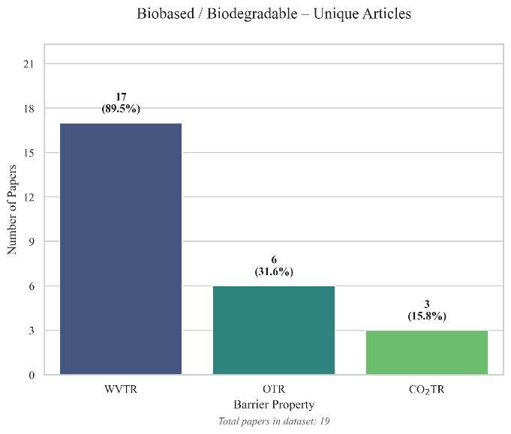 | Figure 5.  Number of unique articles reporting WVTR, OTR, and CO₂TR measurements for conventional reference polymers, expressed as a percentage of the total included studies (n = 19).  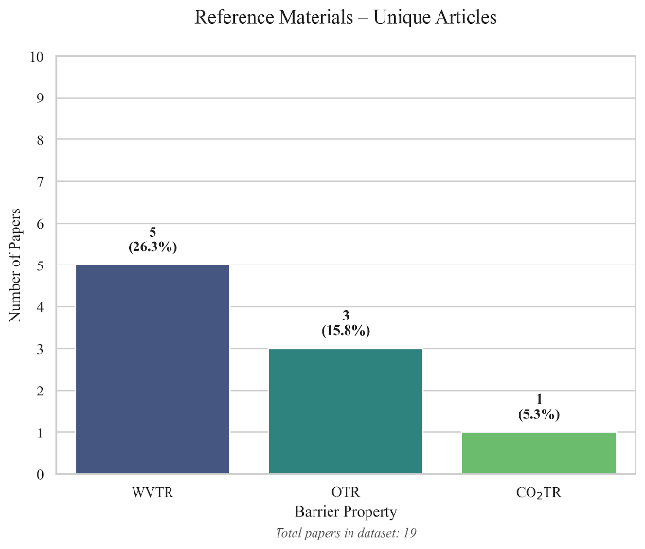
Figure 6.  Total number of standardised barrier measurements for biobased and/or biodegradable packaging films per barrier property, expressed as a percentage of all biobased/biodegradable measurements in the dataset (n = 62). 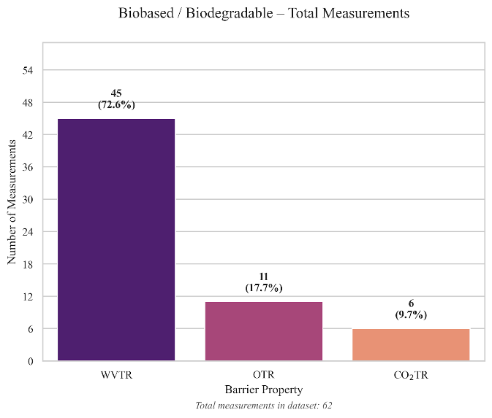 | Figure 7.  Total number of standardised barrier measurements for conventional reference polymers per barrier property, expressed as a percentage of all reference material measurements in the dataset (n = 61).  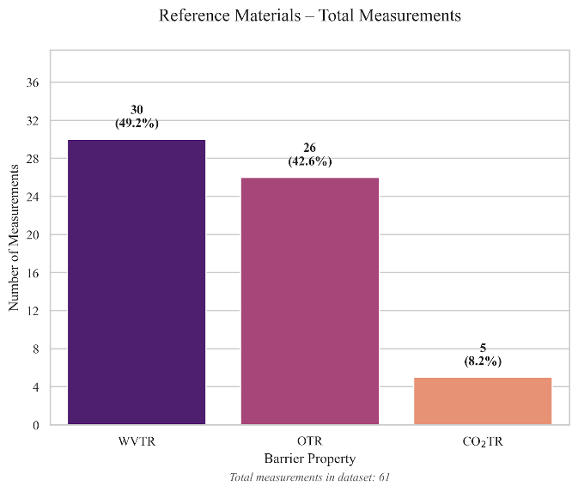

The dataset is heavily skewed towards WVTR: 17 of 19 studies report water vapour data for biobased materials, producing 45 measurements (73 % of the biobased total). OTR is covered by 6 studies (11 measurements) and CO₂TR by only 3 (6 measurements). The reference data shows a similar pattern. CO₂TR is markedly underrepresented: fewer studies report this property, which limits the scope of any conclusions drawn for carbon dioxide barrier performance.

Figure 7 presents a heatmap of temperature and relative humidity combinations for each barrier property across the included studies.

Figure 8.
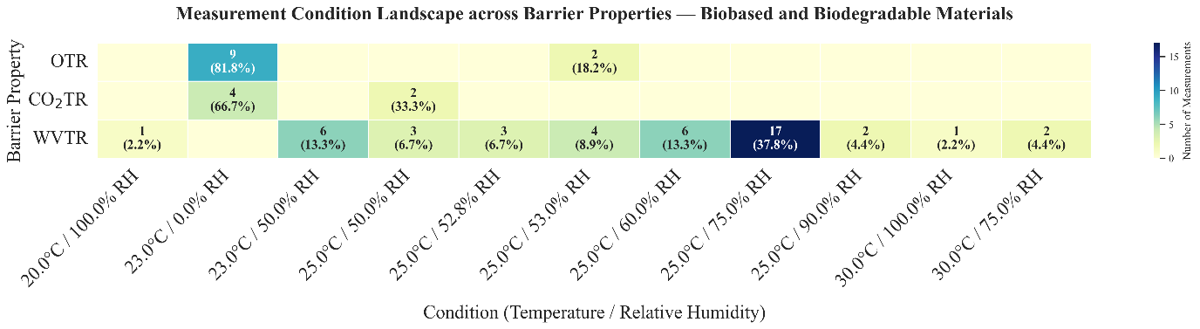
Heatmap showing the distribution of measurement conditions (temperature and relative humidity) across barrier properties (OTR, CO₂TR, and WVTR) for included studies. Each cell displays the number of measurements and the corresponding percentage of the total measurements for that barrier property. Empty cells indicate that no measurements were conducted under that condition.
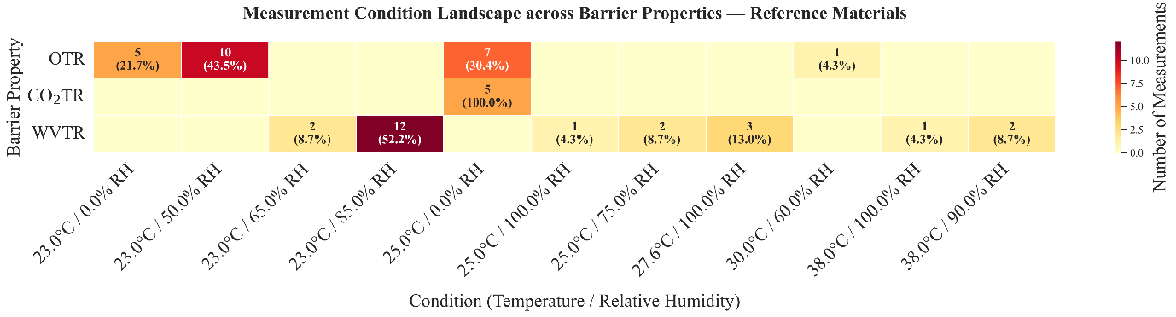
Figure 9.
Heatmap showing the distribution of measurement conditions (temperature and relative humidity) across barrier properties (OTR, CO₂TR, and WVTR) for included studies and their reference materials. Each cell displays the number of measurements and the corresponding percentage of the total measurements for that barrier property. Empty cells indicate that no measurements were conducted under that condition.

OTR and CO₂TR measurements are predominantly conducted at standard dry conditions (23 °C / 0 % RH), consistent with ISO 15105 and ASTM D3985. WVTR measurements, by contrast, show substantially more variability: the most common condition is 25 °C / 75 % RH (17 measurements), but values were also obtained at 23 °C / 50 % RH, 25 °C / 60 % RH, and several other combinations. Since both temperature and humidity affect transmission rates, of which WVTR of hydrophilic polymers increases non-linearly with humidity (Section 2.3), values measured under different conditions are not strictly comparable.

Biobased and biodegradable polymers used for food packaging
This section addresses which biobased and/or biodegradable materials are proposed for food packaging. Figure 8 shows the distribution of biobased materials in the dataset by material family and polymer type. Figure 9 shows the same breakdown for the conventional reference polymers.
  Figure 10.  Sunburst diagram showing the distribution of biobased and biodegradable polymers across material families included in this systematic review. The inner ring represents material families, and the outer ring represents individual polymer types. Values indicate the number of unique articles (n) and the percentage of the total included studies. |   Figure 11.  Sunburst diagram showing the distribution of conventional reference polymers across material families reported in the included studies. The inner ring represents material families, and the outer ring represents individual polymer types. Values indicate the number of unique articles (n) and the percentage of the total included studies.

The 49 biobased entries cover five material families, but the distribution is uneven. Polysaccharides make up the largest group (23 entries, 47 %), mainly driven by pullulan (7), starch (6), and hemicellulose (4), with smaller contributions from cellulose derivatives, chitosan, and pectin. Proteins are the second largest family (12 entries, 24 %), mostly consisting of plant-based protein concentrates from legume sources, alongside whey and gelatin. Aliphatic biopolyesters — including PLA, PBS, PBSA, and PHBV — account for 20 % of entries (10). Aromatic biopolyesters (the furanoate-based polymers PPeF and PHF) and PVA together make up the remaining 8 %. This distribution reflects the current research focus in the 2024–2025 literature: naturally derived polymers such as polysaccharides and proteins receive considerably more attention than synthetic biopolyesters, likely because they are renewable, widely available, and inherently biodegradable.
A notable gap in the dataset is the absence of biobased drop-in polymers such as bio-PE and bio-PET. aning the comparison is limited to structurally different biodegradable polymers and their conventional counterparts. In addition, the biobased dataset is dominated by lab-scale cast films rather than commercially produced materials. This may overrepresent early-stage polymers and underrepresent those that are already in industrial use. Most biobased films in the dataset were produced by solvent casting (39 of 49 entries) rather than extrusion or biaxial stretching. As discussed in Section 2.3, industrial processing techniques increase molecular orientation and crystallinity, which can substantially improve barrier performance (Robertson, 2016). The barrier values reported here may therefore underestimate what these polymers could achieve under industrial processing condition

Barrier properties of biobased and biodegradable polymers
This section addresses the second research question: “how do the barrier properties of biobased and biodegradable materials compare to those of conventional plastics?” For each barrier property, the scatter plots show individual measurements per material type and the median. The distribution of values and identified outliers for each property can be found in Figures A 1–A 6.

WVTR
To allow for a structured comparison, Table 8 summarises the median, minimum, maximum, and sample size per material type, grouped by the most common measurement conditions. Figure 11 presents the WVTR₁₀₀ values for all biobased and reference materials in the dataset.
Table 8.
Summary statistics of water vapour transmission rate (WVTR₁₀₀) values for biobased and conventional reference materials, grouped by most common measurement conditions.
Material | Family | Condition | Median | Min | Max | n
Plant protein | Protein | 25°C / 75% RH | 426 | 199 | 711 | 9
Pullulan | Polysaccharide | 25°C / 75% RH | 168 | 59.3 | 688 | 7
Starch | Polysaccharide | 25°C / 75% RH | 994 | 994 | 994 | 1
Hemicellulose | Polysaccharide | 23°C / 50% RH | 438 | 376 | 612 | 4
PBS | Aliphatic polyester | 23°C / 50% RH | 212 | 101 | 324 | 2
PLA | Aliphatic polyester | 25°C / 60% RH | 32.0 | 31.2 | 32.7 | 2
Starch | Polysaccharide | 25°C / 60% RH | 5402 | 5304 | 5615 | 4
Reference Materials
LDPE | Polyolefin | 38°C / 100% RH | 43.9 | — | — | 1
HDPE | Polyolefin | 38°C / 90% RH | 13.4 | — | — | 1
PP | Polyolefin | 23°C / 85% RH | 7.16 | — | — | 1

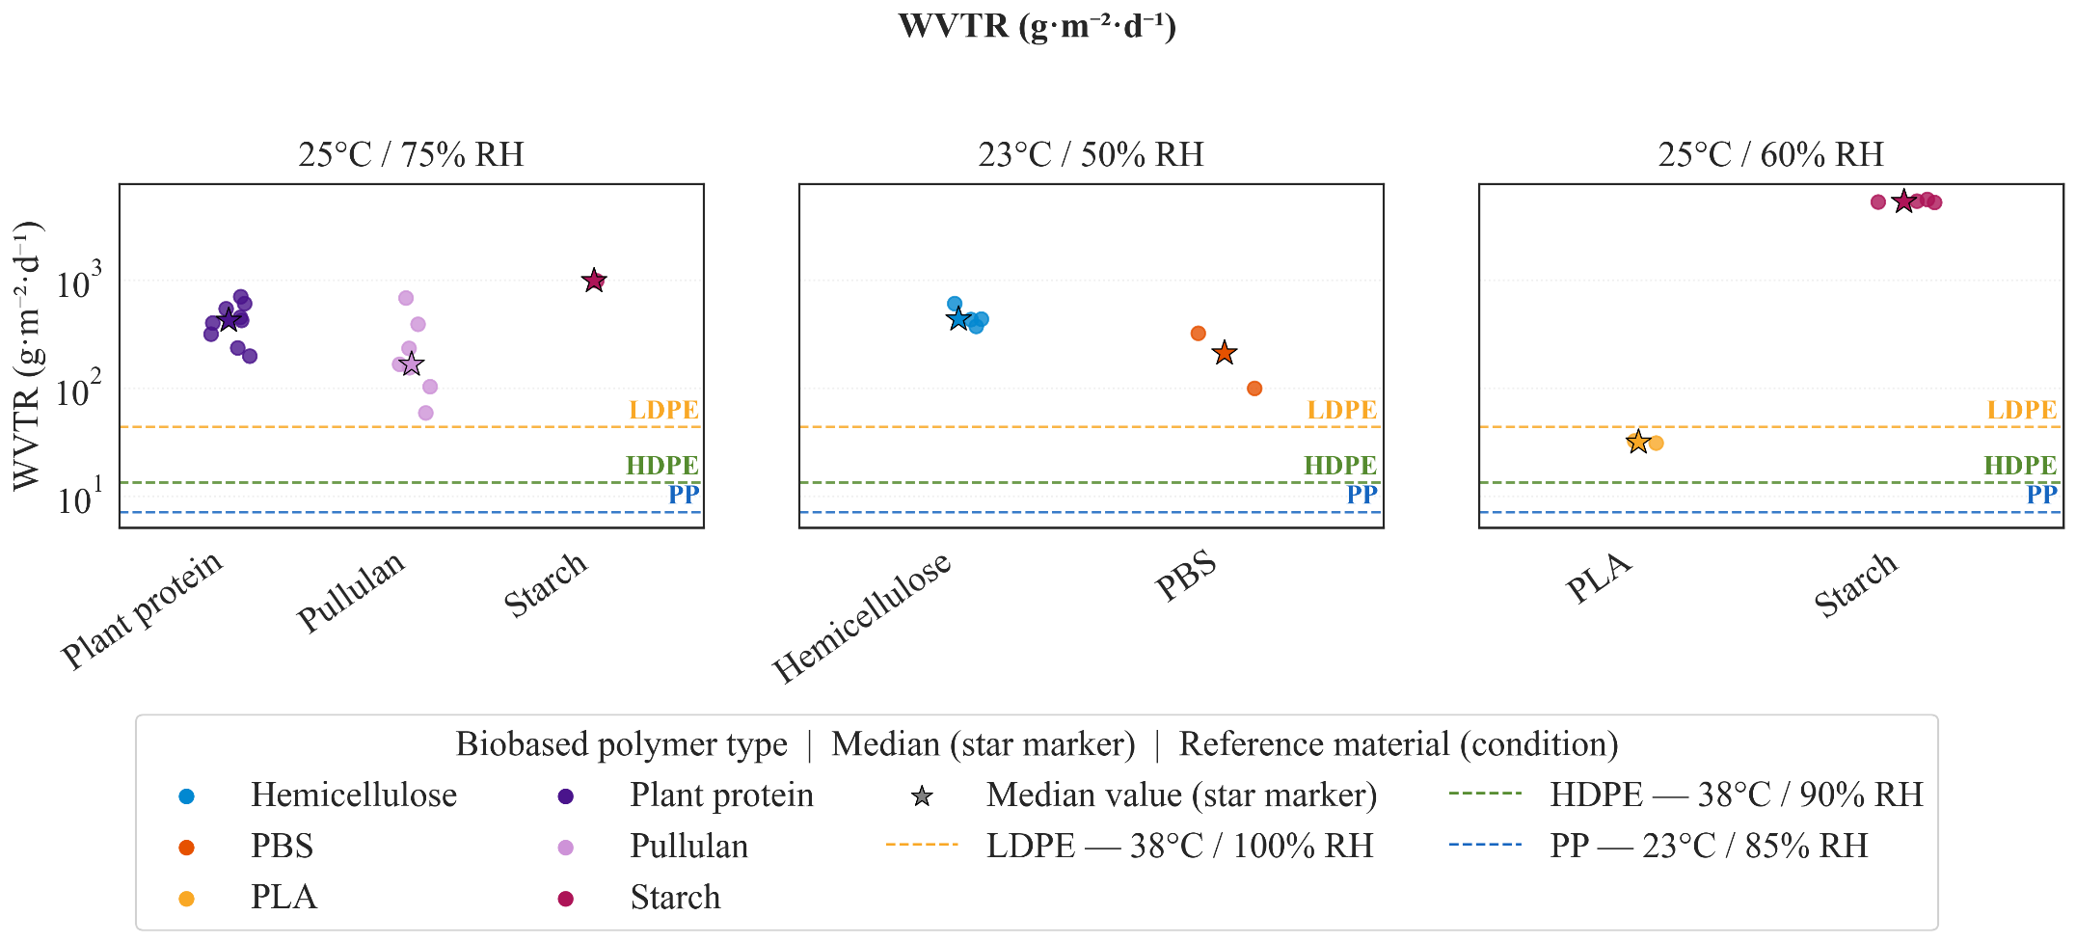
Figure 12.
Scatter plot of standardised water vapour transmission rate (WVTR₁₀₀) values for biobased and conventional reference materials, grouped by measurement conditions. Summary statistics are provided in Table 8.
The WVTR₁₀₀ values show substantial variation across material families. Polysaccharides and proteins — the two largest groups in the dataset — generally exhibit high water vapour transmission. Among the polysaccharides, pullulan shows moderate values (median 168 g·m⁻²·d⁻¹ at 25 °C / 75 % RH), but with a wide range (59.3–688), while starch films reach a median of 994 g·m⁻²·d⁻¹ under the same conditions. Protein-based films fall in a similar range, with plant protein concentrates showing a median of 426 g·m⁻²·d⁻¹ at 25 °C / 75 % RH. This high water vapour transmission is expected for these hydrophilic materials: as discussed in Section 2.3, their polar functional groups promote water sorption, which plasticises the polymer matrix and increases chain mobility, leading to higher diffusion rates (Robertson, 2016).
Aliphatic biopolyesters perform considerably better. PLA shows a median WVTR₁₀₀ of 32.0 g·m⁻²·d⁻¹ (at 25 °C / 60 % RH), which falls in the medium barrier range according to the classification in Table 5. PBS shows intermediate behaviour with a median of 212 g·m⁻²·d⁻¹ (23 °C / 50 % RH), placing it in the poor barrier range. The lower WVTR of these polyesters compared to polysaccharides and proteins can be explained by their less polar chemical structure and higher degree of crystallinity, both of which reduce free volume and restrict water vapour diffusion (Section 2.3).
Starch-based materials show particularly striking behaviour: WVTR₁₀₀ increases from 994 g·m⁻²·d⁻¹ at 25 °C / 75 % RH to over 5,400 g·m⁻²·d⁻¹ at 25 °C / 60 % RH. At first glance this seems counterintuitive, since higher humidity would be expected to increase transmission. However, the measurements at 60 % RH come from a different study and different starch formulation, illustrating how differences in material preparation and testing conditions can complicate cross-study comparison — a limitation discussed in Section 2.3 and reflected in the measurement condition variability shown in Figure 7.
By comparison, the reference polyolefins show consistently low WVTR₁₀₀ values: PP at 7.2, HDPE at 13.4, and LDPE at 43.9 g·m⁻²·d⁻¹, all falling in the high to very high barrier range. The gap between most biobased materials and these conventional benchmarks is substantial — typically one to two orders of magnitude for polysaccharides and proteins, and smaller but still meaningful for aliphatic biopolyesters other than PLA. It should be noted that the reference polyolefin values were measured at higher temperatures and humidities (38 °C / 90–100 % RH) than most biobased measurements, which means the true performance gap may be even larger than the raw numbers suggest.
Direct comparison between materials is further complicated by the limited sample sizes for several materials. For instance, the PBS, PBSA, and PHBV values each come from only one or two measurements, which reduces statistical robustness. The observed trends should therefore be interpreted as indicative rather than definitive.
Overall, while certain aliphatic biopolyesters can approach the water vapour barrier performance of conventional plastics, most polysaccharide- and protein-based materials show substantially higher WVTR values and greater sensitivity to environmental conditions. For applications requiring high water vapour barriers, such as dry and low-moisture foods (Table 6), these materials would likely require modification through blending, coating, or multilayer structures to meet packaging requirements.

OTR
To allow for a structured comparison, Table 9 summarises the median, minimum, maximum, and sample size per material type, grouped by the most common measurement conditions. Figure 12 presents the OTR₁₀₀ values for all biobased and reference materials in the dataset.
Table 9.
Summary statistics of oxygen rate (OTR₁₀₀) values for biobased and conventional reference materials, grouped by most common measurement conditions.
Material | Family | Condition | Median | Min | Max | n
Furanoate polyester | Aromatic polyester | 23°C / 0% RH | 0.20 | 0.16 | 18.8 | 3
PBS | Aliphatic polyester | 23°C / 0% RH | 68.6 | 68.6 | 68.6 | 1
PLA | Aliphatic polyester | 23°C / 0% RH | 196 | 1.30e-03 | 223 | 3
Whey | Protein | 23°C / 0% RH | 140 | 20.0 | 260 | 2
PBSA | Aliphatic polyester | 25°C / 53% RH | 688 | 688 | 688 | 1
PHBV | Aliphatic polyester | 25°C / 53% RH | 18.7 | 18.7 | 18.7 | 1
Reference materials
PP | Polyolefin | 25°C / 0% RH | 6801 | — | — | 1
HDPE | Polyolefin | 25°C / 0% RH | 6011 | — | — | 1
LDPE | Polyolefin | 25°C / 0% RH | 1.26e+04 | — | — | 1

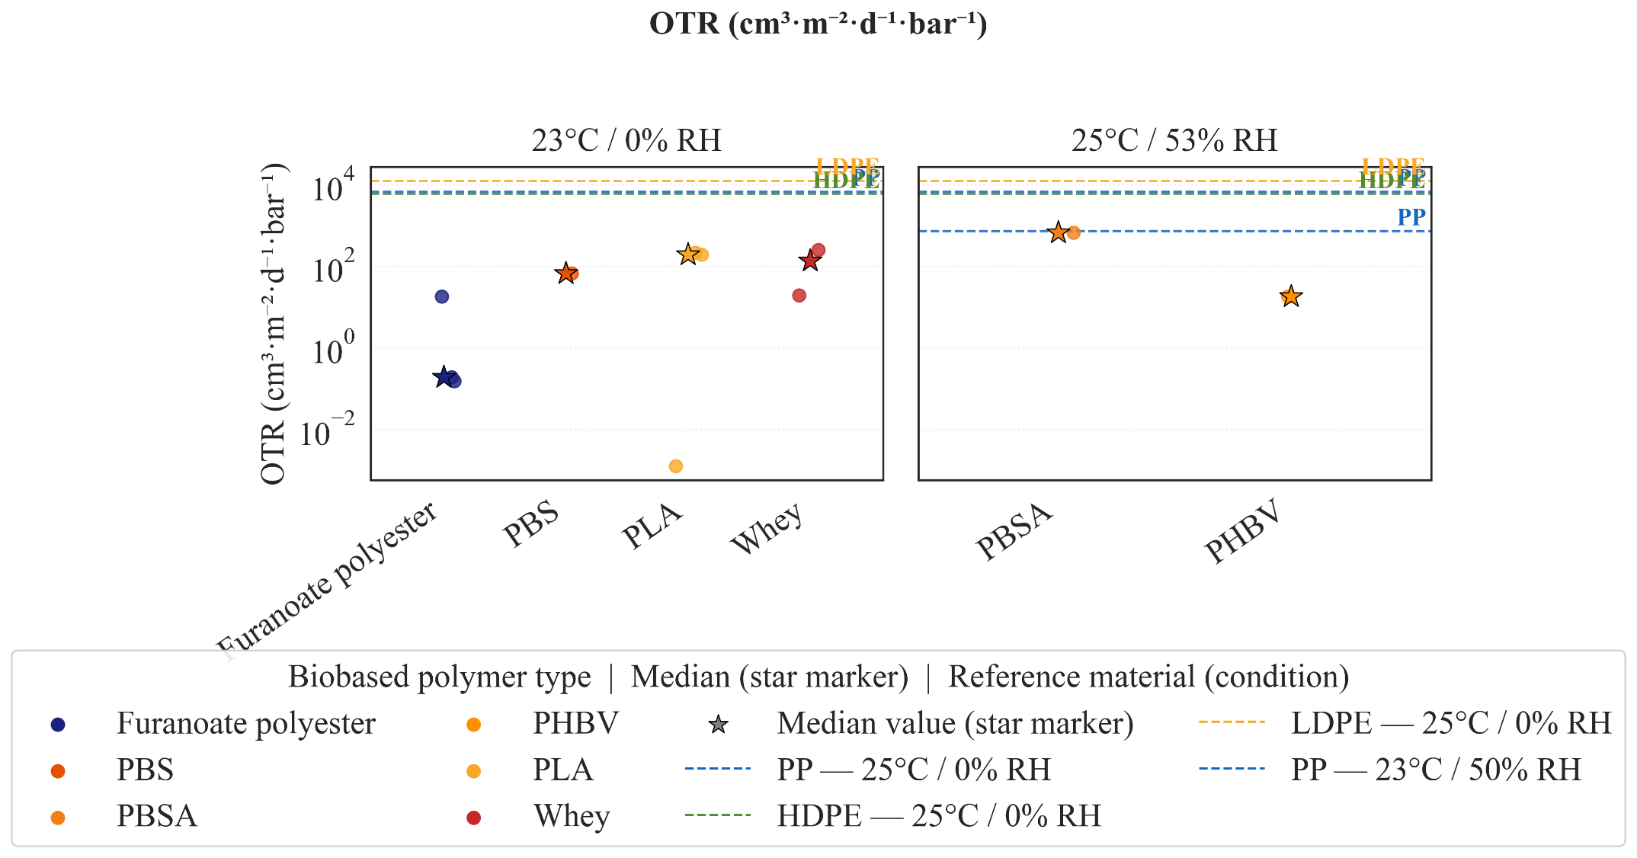
Figure 13.
Scatter plot of standardised oxygen transmission rate (OTR₁₀₀) values for biobased and conventional reference materials, grouped by measurement conditions. Summary statistics are provided in Table 9.

The OTR₁₀₀ values show a markedly different pattern compared to water vapour transmission. Where polysaccharides and proteins performed poorly as moisture barriers, the oxygen data reveals that several biobased materials can actually outperform conventional polyolefins.
The furanoate polyesters (PPeF and PHF) stand out with very low OTR₁₀₀ values — a median of 0.20 cm³·m⁻²·d⁻¹·bar⁻¹ at 23 °C / 0 % RH, which places them in the very high barrier grade according to Table 5. This is consistent with the dense aromatic ring structure of furanoate-based polymers, which restricts chain mobility and reduces free volume (Section 2.3). However, the range within this group is wide (0.16–18.8), suggesting that differences in material grade or processing can substantially affect performance. PHBV also shows good oxygen barrier performance (18.7 cm³·m⁻²·d⁻¹·bar⁻¹), falling in the high barrier range. PBS and PLA show higher and more variable values — 68.6 and a median of 196 cm³·m⁻²·d⁻¹·bar⁻¹ respectively — placing them in the low to poor barrier range. Whey protein films show intermediate performance (median 140, range 20–260), with the wide spread likely reflecting differences in film composition and processing.
The reference polyolefins (PP, HDPE, LDPE) show OTR₁₀₀ values in the range of 6,000–12,600 cm³·m⁻²·d⁻¹·bar⁻¹, confirming their well-known poor oxygen barrier performance. This means that for oxygen transmission, the polarity trade-off described in Section 2.3 works in favour of biobased materials: the same polar character that makes them poor water vapour barriers contributes to tighter molecular packing and stronger intermolecular interactions that restrict oxygen diffusion.
The influence of humidity on OTR is less pronounced than for WVTR, but still relevant. PBSA, measured at 25 °C / 53 % RH rather than 0 % RH, shows the highest OTR₁₀₀ of all biopolyesters (688 cm³·m⁻²·d⁻¹·bar⁻¹), which may partly reflect moisture-induced plasticisation. Whether the low OTR values observed for furanoate polyesters and PHBV under dry conditions would hold at higher humidity remains an open question that the current dataset cannot answer.
As with WVTR, direct comparison is limited by differences in testing conditions and small sample sizes — several materials are represented by only one or two measurements. The trends described here should therefore be considered indicative rather than definitive.

CO₂TR
Table 10 summarises the CO₂TR₁₀₀ values for biobased and reference materials. Figure 13 shows the corresponding scatter plot. This is the most limited property in the dataset, with only 6 biobased and 5 reference measurements, so the patterns described here should be treated with caution.
Table 10.
Summary statistics of oxtgen rate (CO₂TR₁₀₀) values for biobased and conventional reference materials, grouped by most common measurement conditions.
Material | Family | Condition | Median | Min | Max | n
Furanoate polyester | Aromatic polyester | 23°C / 0% RH | 1974 | 1382 | 4.93e+05 | 3
PBS | Aliphatic polyester | 23°C / 0% RH | 2.34e+06 | 2.34e+06 | 2.34e+06 | 1
Whey | Protein | 25°C / 50% RH | 5.20e+06 | 1.40e+06 | 9.00e+06 | 2
Reference materials
PP | Polyolefin | 25°C / 0% RH | 2.07e+04 | — | — | 1
HDPE | Polyolefin | 25°C / 0% RH | 2.98e+04 | — | — | 1
LDPE | Polyolefin | 25°C / 0% RH | 5.16e+04 | — | — | 1

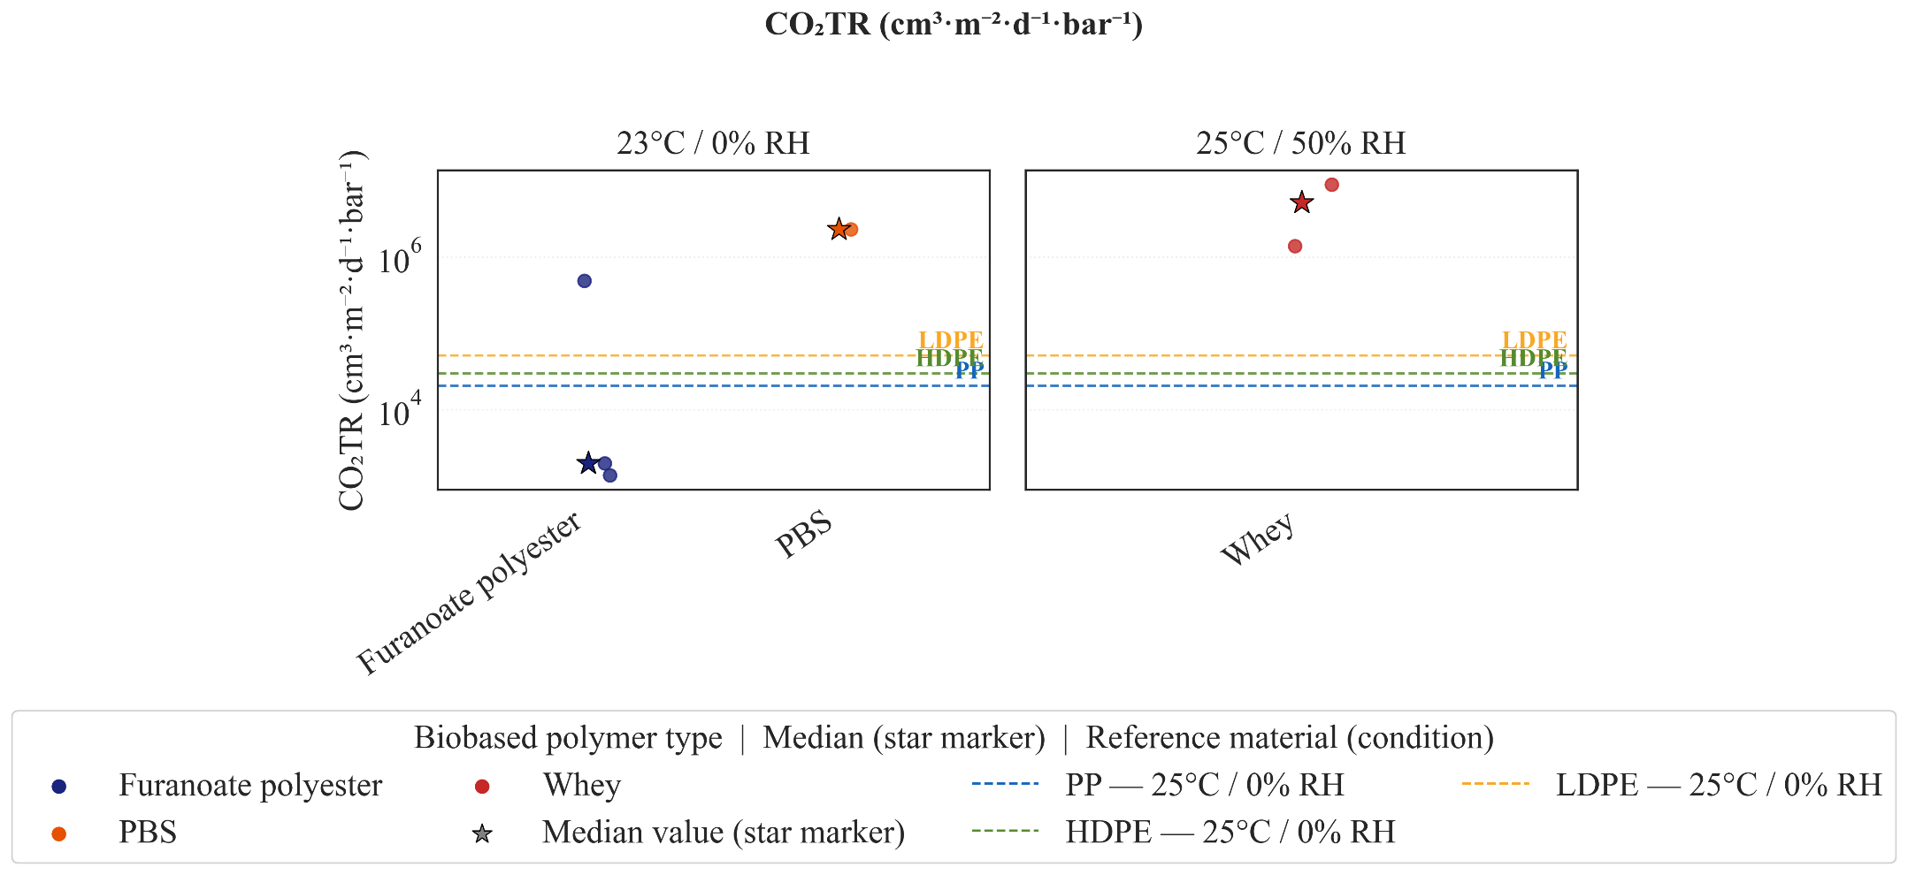
Figure 14.
Scatter plot of standardised carbon dioxide transmission rate (CO₂TR₁₀₀) values for biobased and conventional reference materials, grouped by measurement conditions. Summary statistics are provided in Table 10

CO₂TR₁₀₀ values are generally higher than OTR₁₀₀ values for the same materials, which is expected given the greater condensability and solubility of CO₂ in polymer matrices (Section 2.3).
Among the biobased materials, the furanoate polyesters again show the best performance, with a median CO₂TR₁₀₀ of 1,974 cm³·m⁻²·d⁻¹·bar⁻¹ at 23 °C / 0 % RH. However, the range is wide (1,382–493,450), which makes it difficult to draw firm conclusions. PBS and whey show very high values — 2.3 × 10⁶ and 5.2 × 10⁶ cm³·m⁻²·d⁻¹·bar⁻¹ respectively — indicating poor CO₂ barrier performance. For whey, this contrasts with its moderate OTR performance (median 140 cm³·m⁻²·d⁻¹·bar⁻¹).
The reference polyolefins show CO₂TR₁₀₀ values in the range of 20,000–52,000 cm³·m⁻²·d⁻¹·bar⁻¹. While these are not low in absolute terms, they are still one to two orders of magnitude below the PBS and whey values. The furanoate polyesters are the only biobased materials that approach or fall below the polyolefin range, suggesting that they may offer competitive CO₂ barrier performance — though the limited data makes this tentative.
The underrepresentation of CO₂TR in the literature is a clear gap. Given the importance of CO₂ barrier performance for modified atmosphere packaging of meat, seafood, and carbonated beverages (Section 2.5), future studies should prioritise reporting this property alongside OTR and WVTR

Alignment of polymer barrier properties with food packaging requirements
This section addresses the third research question: how do the barrier properties of biobased and biodegradable polymers align with the requirements of different food categories? To visualise this alignment, the median WVTR₁₀₀ and OTR₁₀₀ values of biobased materials from the dataset were overlaid onto the food category barrier requirements defined in Table 6. CO₂TR was not included in this comparison due to the very limited number of measurements available (Section 4.3.3). It should be noted that the barrier grades used to define food category requirements (Table 5) are based on standard conditions: OTR₁₀₀ at 23 °C and WVTR₁₀₀ at 38 °C / 90 % RH. The biobased materials in the dataset were not always tested under these same conditions, as shown in Figure 7. This means the alignment presented here is approximate, and actual suitability would need to be confirmed under standardised conditions.

WVTR
Figure 15 shows the WVTR requirements for each food category alongside the median WVTR₁₀₀ of the biobased materials.

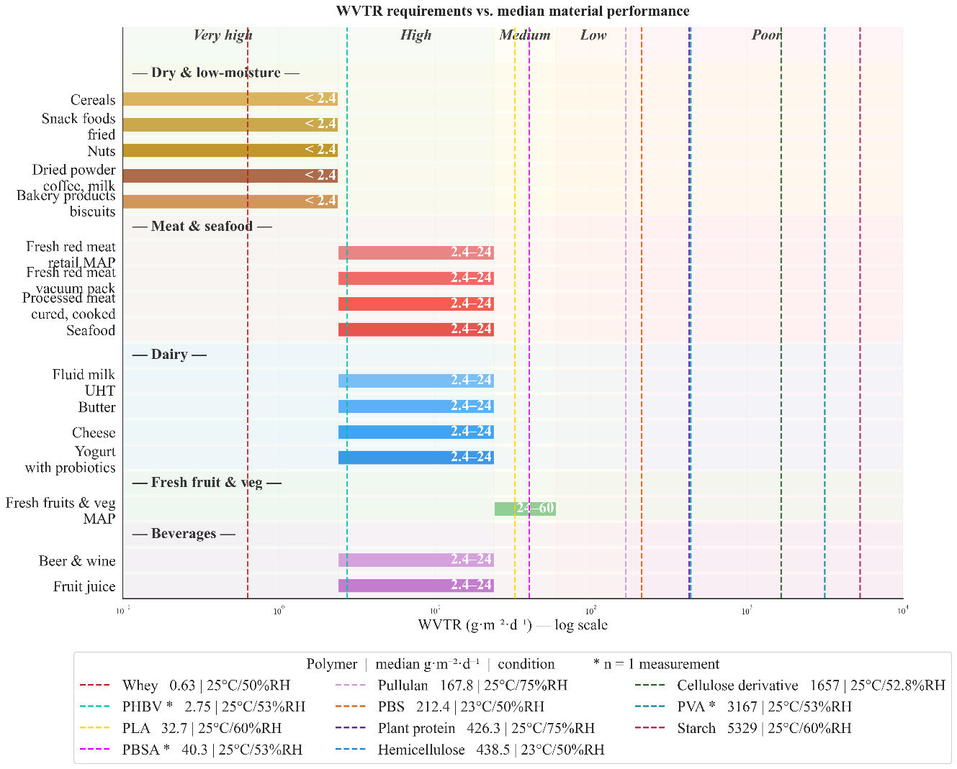

Figure 15
WVTR requirements per food category (horizontal bars, coloured by food group) compared to the median WVTR₁₀₀ of biobased materials in the dataset (dashed vertical lines). Barrier grades are indicated at the top of the figure, following the classification in Table 5. The WVTR threshold for each food category is shown inside the bar. Measurement conditions and sample sizes are listed in the legend; asterisks indicate materials based on a single measurement

The WVTR comparison reveals that most biobased materials in the dataset fall short of the barrier requirements for the majority of food categories. Dry and low-moisture foods — cereals, snack foods, nuts, dried powders, and bakery products — all require very high WVTR barriers (< 2.4 g·m⁻²·d⁻¹). Only two materials approach this range: whey (0.63 g·m⁻²·d⁻¹ at 25 °C / 50 % RH) and PHBV (2.75 g·m⁻²·d⁻¹ at 25 °C / 53 % RH). However, both values are based on a single measurement each, and were obtained at lower temperatures and humidities than the standard WVTR condition of 38 °C / 90 % RH. Under those more demanding conditions, their WVTR values would likely increase substantially, particularly for whey given the moisture sensitivity of protein-based films (Section 4.3.1).
Meat and seafood, dairy products, and beverages require high WVTR barriers (2.4–24 g·m⁻²·d⁻¹). PLA (median 32.7 g·m⁻²·d⁻¹ at 25 °C / 60 % RH) and PBSA (40.3 g·m⁻²·d⁻¹ at 25 °C / 53 % RH) come closest to this range but still fall slightly outside it. Again, these values were measured at lower temperature and humidity than the standard condition, so their performance at 38 °C / 90 % RH would likely be worse. Fresh fruits and vegetables have a less strict requirement (medium barrier, 24–60 g·m⁻²·d⁻¹), which PLA and PBSA could potentially meet under their tested conditions.
The remaining biobased materials — pullulan, plant protein, hemicellulose, PBS, cellulose derivatives, PVA, and starch — all show median WVTR₁₀₀ values well above 100 g·m⁻²·d⁻¹, placing them in the low to poor barrier range. These materials do not meet the water vapour barrier requirements for any of the food categories considered here without further modification.

OTR
Figure 16 shows the OTR requirements for each food category alongside the median OTR₁₀₀ of the biobased materials.

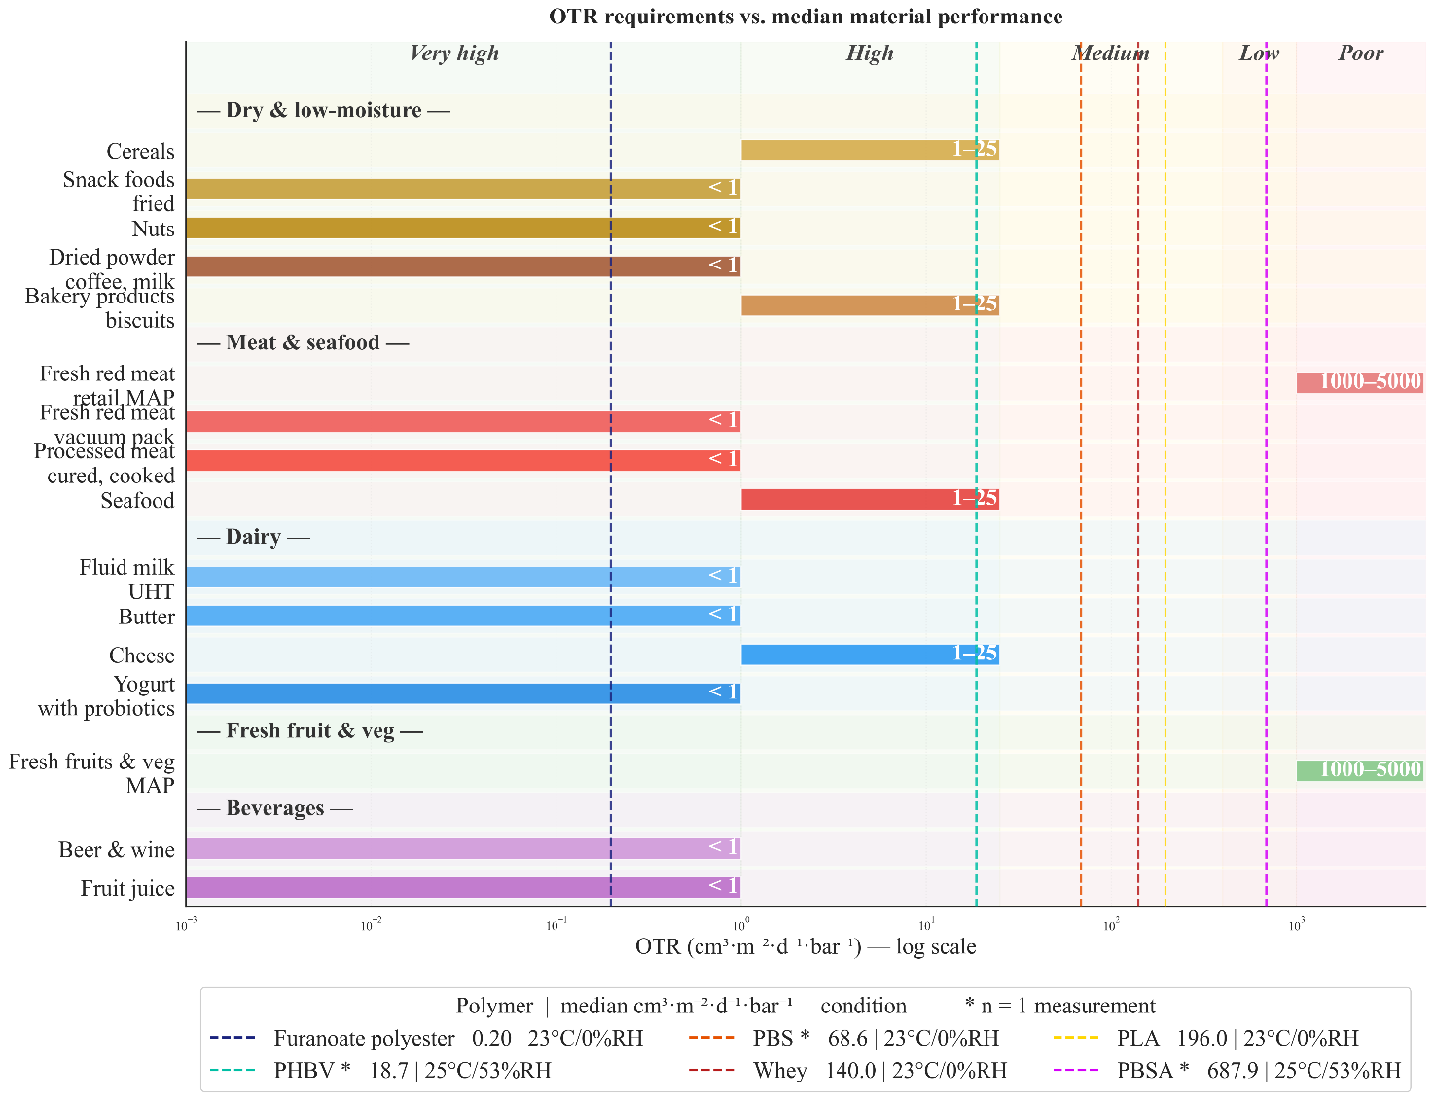
Figure 16.
OTR requirements per food category (horizontal bars, coloured by food group) compared to the median OTR₁₀₀ of biobased materials in the dataset (dashed vertical lines). Barrier grades are indicated at the top of the figure, following the classification in Table 5. The OTR threshold for each food category is shown inside the bar. Measurement conditions and sample sizes are listed in the legend; asterisks indicate materials based on a single measurement.

The OTR comparison presents a more favourable picture. The standard condition for OTR is 23 °C / 0 % RH, and most biobased OTR measurements in the dataset were indeed conducted at or near this condition, making the comparison more straightforward than for WVTR.
Furanoate polyesters show a median OTR₁₀₀ of 0.20 cm³·m⁻²·d⁻¹·bar⁻¹ at 23 °C / 0 % RH, which falls in the very high barrier range and meets the requirements for virtually all food categories — including the most demanding applications such as beer and wine, fruit juice, fluid milk, butter, and vacuum-packed fresh meat, all of which require OTR values below 1 cm³·m⁻²·d⁻¹·bar⁻¹. PHBV (18.7 cm³·m⁻²·d⁻¹·bar⁻¹ at 25 °C / 53 % RH) falls in the high barrier range and meets the requirements for cereals, bakery products, seafood, and cheese. PBS (68.6 cm³·m⁻²·d⁻¹·bar⁻¹) falls in the medium range and could be suitable for applications with less strict oxygen requirements. However, for PHBV and PBS, these values were obtained under slightly different conditions, and their performance at elevated humidity may differ.
PLA (median 196 cm³·m⁻²·d⁻¹·bar⁻¹), whey (140), and PBSA (688) show higher OTR values that place them in the low to poor barrier range. These materials would not meet the OTR requirements for most food categories without additional barrier strategies. Fresh fruits and vegetables are an exception — this category requires controlled gas exchange rather than a strict barrier, with OTR values in the range of 1,000–5,000 cm³·m⁻²·d⁻¹·bar⁻¹, which several of the higher-permeability biobased materials could provide.
Taken together, the two figures highlight a fundamental challenge for biobased and biodegradable packaging materials: no single material in the dataset meets both the WVTR and OTR requirements for the most demanding food categories. The furanoate polyesters offer excellent oxygen barrier performance but were not tested for WVTR in the included studies. PHBV shows promising performance for both properties, but is represented by only a single measurement for each. PLA offers moderate water vapour barrier performance but is a relatively poor oxygen barrier.
This confirms the polarity-driven trade-off described in Section 2.3: materials with good gas barrier properties tend to be polar and therefore moisture-sensitive, while materials with good moisture barrier properties tend to be non-polar and therefore gas-permeable. For conventional plastics, this trade-off is addressed through multilayer structures that combine complementary materials — for example EVOH for oxygen barrier with PE for moisture barrier. A similar approach is likely necessary for biobased materials to meet the barrier requirements of most food applications, though such multilayer structures were excluded from the scope of this review.

Conclusion
This systematic review aimed to compare the barrier properties of biobased and biodegradable food-packaging materials with those of conventional fossil-based plastics. A FAIR dataset was created from 19 peer-reviewed studies published in 2024–2025, containing 123 standardised barrier measurements across three properties (WVTR₁₀₀, OTR₁₀₀, and CO₂TR₁₀₀).
Regarding the first research question: which biobased and biodegradable materials are used or proposed for food packaging? The dataset captures five material families: polysaccharides, proteins, aliphatic biopolyesters, aromatic biopolyesters, and vinyl biopolymers. Polysaccharides and proteins dominate the recent literature, while commercially relevant materials such as PLA are less well represented. No biobased drop-in polymers (e.g. bio-PE, bio-PET) met the inclusion criteria. This means the first hypothesis that drop-in polymers would match conventional performance could not be tested.
Regarding the second research question: how do barrier properties compare to conventional plastics? The results confirm the second hypothesis: most biodegradable polymers show substantially higher WVTR values than conventional polyolefins, typically by one to two orders of magnitude. This is consistent with their polar, hydrophilic nature. PLA and PHBV are exceptions, approaching conventional performance for water vapour. For oxygen, the picture is reversed: several biobased materials, particularly the furanoate polyesters and PHBV, outperform polyolefins and approach the performance of high-barrier conventional polymers such as PET. The third hypothesis: that biobased materials would show greater variability, is supported by the wide ranges observed within material families, particularly for polysaccharides and proteins, though small sample sizes make it difficult to separate true material variability from differences in testing conditions.
Regarding the third research question: how do barrier properties align with food packaging requirements? The comparison with food category requirements shows that most biobased materials do not meet the WVTR demands of any major food category without modification. Only PHBV and whey approach the very high barrier range needed for dry foods, and only under mild test conditions. For OTR, the outlook is more positive: furanoate polyesters meet the requirements of virtually all food categories, and PHBV is suitable for several applications. However, no single biobased material in the dataset meets both the WVTR and OTR requirements for the most demanding food categories, confirming the polarity-driven trade-off between gas and moisture barrier performance.
A key limitation of this review is the small and uneven dataset. CO₂TR is severely underrepresented, several materials rely on single measurements, and testing conditions vary between studies, complicating direct comparison. The dominance of lab-scale cast films may also underestimate the barrier performance achievable under industrial processing conditions.
Overall, this review shows that biobased and biodegradable polymers cannot yet serve as direct replacements for conventional plastics in most food packaging applications based on barrier performance alone. To meet the barrier requirements of a wider range of food categories, strategies such as blending, coating, or multilayer design are likely needed. These approaches, along with standardised testing under consistent conditions and larger datasets, should be priorities for future research.

Recommendations
Based on the findings and limitations of this review, the following recommendations are made for future research and practice.
Standardisation of testing conditions. The variability in measurement conditions across studies — particularly for WVTR, where temperature and humidity combinations range widely — makes direct comparison between materials difficult. Future studies should report barrier properties at the standard conditions used for conventional plastics (OTR at 23 °C / 0 % RH; WVTR at 38 °C / 90 % RH) in addition to any application-specific conditions. This would allow for more meaningful comparison across studies and with conventional benchmarks.
Reporting of CO₂TR. Carbon dioxide transmission is severely underrepresented in the current literature, with only 3 of 19 studies reporting CO₂TR values for biobased materials. Given the importance of CO₂ barrier performance for modified atmosphere packaging of meat, seafood, and carbonated beverages, future studies should include CO₂TR alongside OTR and WVTR as a standard part of barrier characterisation.
Testing under industrially relevant processing conditions. The dataset is dominated by lab-scale solvent-cast films (39 of 49 entries), which may differ in crystallinity and molecular orientation from industrially extruded or biaxially stretched films. Future studies should include barrier data for films produced under industrial processing conditions to better reflect the performance that can be achieved in practice.
Expanding the dataset. Several promising materials — including PHBV, furanoate polyesters, and PLA — are represented by very few measurements, limiting the robustness of any conclusions. Larger datasets with more replicates per material would allow for more reliable statistical comparison and help separate true material differences from experimental variability.
Inclusion of drop-in biobased polymers. No biobased drop-in polymers such as bio-PE or bio-PET met the inclusion criteria of this review, meaning a direct comparison between chemically identical biobased and fossil-based polymers was not possible. Including these materials in future reviews would help establish whether the biobased origin itself affects barrier performance, or whether any differences are purely structural.
Barrier modification strategies. Since no single biobased material in the dataset meets both the WVTR and OTR requirements for the most demanding food categories, future research should focus on strategies to overcome the polarity-driven trade-off. This includes blending of complementary polymers, application of barrier coatings, and development of biobased multilayer structures. These approaches were excluded from the scope of this review but are likely essential for practical implementation.
Development of a publicly accessible barrier database. The FAIR dataset created in this review could serve as a starting point for a broader, publicly accessible database of biobased packaging barrier properties. Such a resource would support material selection by packaging engineers, reduce duplication of effort across research groups, and facilitate systematic updates as new data becomes available.

References
Abdalrazeq, M., Aref, D., Mariniello, L., & Giosafatto, C. V. L. (2025). Microbial Transglutaminase-Mediated Modification of Heat-Denatured Whey Proteins for the Preparation of Bio-Based Materials. Coatings, 15(1). https://doi.org/10.3390/coatings15010066
Athanasopoulou, E., Katsiroumpa, A., Gardeli, C., & Tsironi, T. (2025). Comparative study of packaging materials developed from fish and legume protein concentrates. Future Foods, 11, 100563. https://doi.org/10.1016/j.fufo.2025.100563
De Beukelaer, H., Hilhorst, M., Workala, Y., Maaskant, E., & Post, W. (2022). Overview of the mechanical, thermal and barrier properties of biobased and/or biodegradable thermoplastic materials. Polymer Testing, 116, 107803. https://doi.org/10.1016/j.polymertesting.2022.107803
de Lima Silva, I. D., Caetano, V. F., de Andrade, M. F., de Moraes Filho, L. E. P. T., de Almeida, Y. M. B., do Nascimento Simões, A., Brito, A. M. S. S., & Maria Vinhas, G. (2025). Evaluation of the physical–chemical properties of the blend of arrowroot starch and cactus mucilage. Polymer Engineering & Science, 65(4), 1934–1948. https://doi.org/10.1002/pen.27124
European Bioplastics. (n.d.-a). Glossary. European Bioplastics. Retrieved 18 November 2025, from https://www.european-bioplastics.org/glossary/
European Bioplastics. (n.d.-b). Market. European Bioplastics. Retrieved 18 November 2025, from https://www.european-bioplastics.org/market/
European Bioplastics. (n.d.-c). Policy. European Bioplastics. Retrieved 18 November 2025, from https://www.european-bioplastics.org/policy/
European Bioplastics. (2022, May 31). Why the EU’s Taxonomy Climate Delegated Act correctly lists bio-based plastics as “green investments”. European Bioplastics. https://www.european-bioplastics.org/why-the-eus-taxonomy-climate-delegated-act-correctly-lists-bio-based-plastics-as-green-investments/
European Commission. (n.d.-a). Biobased, biodegradable and compostable plastics. European Commission - Environment. Retrieved 19 November 2025, from https://environment.ec.europa.eu/topics/plastics/biobased-biodegradable-and-compostable-plastics_en
European Commission. (n.d.-b). Packaging waste. European Commission - Environment. Retrieved 19 November 2025, from https://environment.ec.europa.eu/topics/waste-and-recycling/packaging-waste_en
European Commission. (n.d.-c). The European Green Deal. European Commission - Environment. Retrieved 19 November 2025, from https://commission.europa.eu/strategy-and-policy/priorities-2019-2024/european-green-deal_en
European Commission. (2018). The EU Bioeconomy Strategy. European Commission. https://eur-lex.europa.eu/legal-content/EN/TXT/?uri=CELEX%3A52018DC0673
European Commission. (2020). The Circulary Economy Action Plan. European Commission. https://eur-lex.europa.eu/legal-content/EN/TXT/?qid=1583933814386&uri=COM:2020:98:FIN
European Commission. (2022a). Biobased plastic: Sustainable sourcing and content : final report. Publications Office of the European Union. https://data.europa.eu/doi/10.2779/668096
European Commission. (2022b). The Policy Framework for Biobased, Biodegradable and Compostable Plastics. European Commission. https://eur-lex.europa.eu/legal-content/EN/TXT/?uri=CELEX%3A52022DC0682&qid=1763027333862
European Commission. (2025). The proposed Packaging and Packaging Waste Regulation (PPRW). European Commission. https://eur-lex.europa.eu/eli/reg/2025/40/oj
European Parliament. (2018, December 19). Plastic waste and recycling in the EU: Facts and figures. Topics | European Parliament. https://www.europarl.europa.eu/topics/en/article/20181212STO21610/plastic-waste-and-recycling-in-the-eu-facts-and-figures
George, N., & Venugopal, B. (2023). Gas Barrier Properties of Biopolymers. In Handbook of Biopolymers (pp. 1–25). Springer, Singapore. https://doi.org/10.1007/978-981-16-6603-2_13-1
Geueke, B. (2014). Dossier – Bioplastics as food contact materials. Food Packaging Forum. https://doi.org/10.5281/zenodo.33517
Gil-Guillén, I., Gonçalves, I., Ferreira, P., González-Martínez, C., & Chiralt, A. (2025). Biodegradable Antioxidant Composites with Almond Skin Powder. Polymers, 17(16), 2201. https://doi.org/10.3390/polym17162201
Guidotti, G., Palumbo, A., Soccio, M., Gazzano, M., Salatelli, E., Siracusa, V. M., & Lotti, N. (2024). Fully Bio-Based Blends of Poly (Pentamethylene Furanoate) and Poly (Hexamethylene Furanoate) for Sustainable and Flexible Packaging. Polymers, 16(16). https://doi.org/10.3390/polym16162342
Hossain, M. T., Shahid, M. A., Akter, S., Ferdous, J., Afroz, K., Refat, K. R. I., Faruk, O., Jamal, M. S. I., Uddin, M. N., & Samad, M. A. B. (2024). Cellulose and starch-based bioplastics: A review of advances and challenges for sustainability. Polymer-Plastics Technology and Materials. (world). https://doi.org/10.1080/25740881.2024.2329980
Kim, M., & Kang, J.-H. (2024). Effects of benzalkonium chloride as a cationic surfactant on the physicochemical properties of adlay millet starch films. Food Science and Biotechnology, 33(2), 355–362. https://doi.org/10.1007/s10068-023-01383-1
Kmet, L. M., Cook, L. S., & Lee, R. C. (2004). Standard Quality Assessment Criteria for Evaluating Primary Research Papers from a Variety of Fields. https://doi.org/10.7939/R37M04F16
Krevelen, D. W., & Nijenhuis, K. te. (2009). Properties of polymers: Their correlation with chemical structure their numerical estimation and prediction from additive group contributions (4th, completely rev. ed edns). Elsevier.
Macieja, S., Mizielińska, M., El Fray, M., & Bartkowiak, A. (2025). Novel Poly(butylene succinate-dilinoleic succinate) Films in Packaging Systems for Fresh Cut Chicory. Coatings, 15(9), 1095. https://doi.org/10.3390/coatings15091095
Manfroni, M., Coatti, A., Soccio, M., Siracusa, V., Boanini, E., Salatelli, E., & Lotti, N. (2025). Eco-design of biobased poly(butylene succinate-b-pentamethylene 2,5-furanoate) copolymers with optimized mechanical, thermal and barrier properties for flexible food-packaging. European Polymer Journal, 225, 113728. https://doi.org/10.1016/j.eurpolymj.2025.113728
Michaels, A. S., & Bixler, H. J. (1961). Solubility of gases in polyethylene. Journal of Polymer Science, 50(154), 393–412. https://doi.org/10.1002/pol.1961.1205015411
Montalvo-Paquini, C., Piñeiro-García, A., Palou, E., Mani-López, E., López-Malo, A., & Hernández-Figueroa, R. H. (2025). pH-Drive on the Design and Properties of Legume Protein-Based Films. ACS Applied Polymer Materials, 7(24), 16604–16615. https://doi.org/10.1021/acsapm.5c03228
Mwita, C. S., Muhammad, R., Nettey-Oppong, E. E., Enkhbayar, D., Ali, A., Ahn, J., Kim, S.-W., Seok, Y.-S., & Choi, S. H. (2024). Chitosan Extracted from the Biomass of Tenebrio molitor Larvae as a Sustainable Packaging Film. Materials, 17(15). https://doi.org/10.3390/ma17153670
Ncube, L. K., Ude, A. U., Ogunmuyiwa, E. N., & Beas, I. N. (2025). Development and characterisation of Polylactic acid / Bambara groundnut (Vigna subterranea (L.) Verdc) shells biocomposite for food packaging application. Scientific African, 30, e03090. https://doi.org/10.1016/j.sciaf.2025.e03090
Nielsen, L. E. (1967). Models for the Permeability of Filled Polymer Systems. Journal of Macromolecular Science: Part A - Chemistry, 1(5), 929–942. https://doi.org/10.1080/10601326708053745
Ocampo-Gómez, Y. A., Rico-Rodríguez, F., González-Cuello, R., Hernández-Fernández, J., & Ortega-Toro, R. (2025). Effect of the Addition of Banana Stem Lignin (Musa acuminata ssp. Balbisiana var. Dominico-Harton) on the Physicochemical Properties of Biodegradable Composites Based on Methylhydroxyethylcellulose. Journal of Composites Science, 9(5), 244. https://doi.org/10.3390/jcs9050244
Oliver-Cuenca, V., Salaris, V., Muñoz-Gimena, P. F., Agüero, Á., Peltzer, M. A., Montero, V. A., Arrieta, M. P., Sempere-Torregrosa, J., Pavon, C., Samper, M. D., Crespo, G. R., Kenny, J. M., López, D., & Peponi, L. (2024). Bio-Based and Biodegradable Polymeric Materials for a Circular Economy. Polymers, 16(21), 3015. https://doi.org/10.3390/polym16213015
Page, M. J., McKenzie, J. E., Bossuyt, P. M., Boutron, I., Hoffmann, T. C., Mulrow, C. D., Shamseer, L., Tetzlaff, J. M., Akl, E. A., Brennan, S. E., Chou, R., Glanville, J., Grimshaw, J. M., Hróbjartsson, A., Lalu, M. M., Li, T., Loder, E. W., Mayo-Wilson, E., McDonald, S., … Moher, D. (2021). The PRISMA 2020 statement: An updated guideline for reporting systematic reviews. The BMJ, 372, n71. https://doi.org/10.1136/bmj.n71
Pech-Cohuo, S. C., Dzul-Cervantes, M. A. de A., Pérez-Pacheco, E., Rosado, J. A. C., Chim-Chi, Y. A., Ríos-Soberanis, C. R., Cuevas-Carballo, Z. B., Uc-Cayetano, E. G., Can-Herrera, L. A., Ortíz-Fernández, A., Collí-Pacheco, J. P., Mina-Hernández, J. H., & Pérez‑Padilla, Y. (2024). Effect of clays incorporation on properties of thermoplastic starch/clay composite bio-based polymer blends. Scientific Reports, 14(1), 19669. https://doi.org/10.1038/s41598-024-69092-1
Petaloti, A.-I., & Achilias, D. S. (2024). The Development of Sustainable Biocomposite Materials Based on Poly(lactic acid) and Silverskin, a Coffee Industry By-Product, for Food Packaging Applications. Sustainability, 16(12). https://doi.org/10.3390/su16125075
Robertson, G. L. (2016). Food Packaging: Principles and Practice, Third Edition (3rd edn). CRC Press. https://doi.org/10.1201/b21347
Rotstein, E. (Ed.). (1997). Handbook of food engineering practice. CRC Press.
Sabzevari, S., Farrokhzad, H., & Poorkhalil, A. (2025). Synthesis and characterization of a hydrogel film based on chitosan/carboxymethyl cellulose for food packaging applications. Carbohydrate Polymer Technologies and Applications, 11, 100983. https://doi.org/10.1016/j.carpta.2025.100983
Samaniego-Aguilar, K., Sanchez-Safont, E., Pisa-Ripoll, I., Torres-Giner, S., Flores, Y., Lagaron, J. M., Cabedo, L., & Gamez-Perez, J. (2024). Performance Enhancement of Biopolyester Blends by Reactive Compatibilization with Maleic Anhydride-Grafted Poly(butylene succinate-co-adipate). Polymers, 16(16). https://doi.org/10.3390/polym16162325
Sepúlveda-Carter, J., Faba, S., Rodríguez, M. S., & Arrieta, M. P. (2025). Reprocessing of Simulated Industrial PLA Waste for Food Contact Applications. Polymers, 17(18), 2439. https://doi.org/10.3390/polym17182439
Stern, S. A., & Fried, J. R. (2007). Permeability of Polymers to Gases and Vapors. In J. E. Mark (Ed.), Physical Properties of Polymers Handbook (pp. 1033–1047). Springer. https://doi.org/10.1007/978-0-387-69002-5_61
Stoica, M., Bichescu, C. I., Crețu, C.-M., Dragomir, M., Ivan, A. S., Podaru, G. M., Stoica, D., & Stuparu-Crețu, M. (2024). Review of Bio-Based Biodegradable Polymers: Smart Solutions for Sustainable Food Packaging. Foods, 13(19), 3027. https://doi.org/10.3390/foods13193027
Sutay, D., Yağcı, S., Yurtdaş, E., & Toptaş, M. (2024). Multiproduct biorefinery from defatted olive mill waste: Preparation of hemicellulose-based biodegradable films and instant controlled pressure drop (DIC)-assisted isolation of value-added products. Biomass Conversion and Biorefinery, 14(13), 14627–14639. https://doi.org/10.1007/s13399-023-03739-3
Ten Boer, N., Soyhan, I., Abrishami, S., Parisi, D., Krooneman, J., Siebring, J., & Van Rijn, P. (2026). Biodegradable bioplastics in healthcare: Opportunities, challenges and sustainable recycling. RSC Sustainability, 10.1039.D5SU00557D. https://doi.org/10.1039/D5SU00557D
Vroman, I., & Tighzert, L. (2009). Biodegradable Polymers. Materials, 2(2), 307–344. https://doi.org/10.3390/ma2020307
Wilkinson, M. D., Dumontier, M., Aalbersberg, Ij. J., Appleton, G., Axton, M., Baak, A., Blomberg, N., Boiten, J.-W., da Silva Santos, L. B., Bourne, P. E., Bouwman, J., Brookes, A. J., Clark, T., Crosas, M., Dillo, I., Dumon, O., Edmunds, S., Evelo, C. T., Finkers, R., … Mons, B. (2016). The FAIR Guiding Principles for scientific data management and stewardship. Scientific Data, 3(1), 160018. https://doi.org/10.1038/sdata.2016.18
Yue, S., Zhang, T., Wang, S., Han, D., Huang, S., Xiao, M., & Meng, Y. (2024). Recent Progress of Biodegradable Polymer Package Materials: Nanotechnology Improving Both Oxygen and Water Vapor Barrier Performance. Nanomaterials, 14(4), 338. https://doi.org/10.3390/nano14040338
Zamanidehyaghoubi, G., Shahidi, F., Edalatian Dovom, M. R., Mohebbi, M., & Roshanak, S. (2025). Investigating the effect of three different types and concentrations of plasticizers on physico-mechanical properties of pullulan food-packaging films. Food Packaging and Shelf Life, 51, 101590. https://doi.org/10.1016/j.fpsl.2025.101590

Appendix

Quality Assessment Rubric
Below, Table A 1 presents the quality appraisal rubric applied to all included studies. The rubric evaluates each study across multiple dimensions, including clarity, reproducibility, validity, reliability, and completeness of reporting. Each criterion was scored on a three-point scale (0 = not met, 0.5 = partially met, 1 = fully met), allowing systematic and transparent assessment of methodological quality and suitability for inclusion in the review.
Table A 1.
Quality appraisal rubric used to evaluate included studies. Each study was scored for clarity, reproducibility, validity, reliability, and completeness of reporting, with 0 = not met, 0.5 = partially met, and 1 = fully met.

Criterion | Assessment question | Score = 0 (not met) | Score = 0.5 (partially met) | Score = 1 (fully met)
General clarity | 1. Are the aim and research questions clear? | Research question and aim not mentioned | Research question and aim indirectly, vaguely or broadly mentioned | Clear, focused aim and research questions
General reproducibility | 2. Are the materials and film preparation sufficiently described? | Material composition, additives and processing conditions not reported | Material composition described but limited details on processing | Polymer type/grade, blend ratios, processing method clearly reported
Design method validity | 3. Are barrier measurements conducted using validated and standardized methods? | Method unclear | Method described but no recognized standard cited | Recognized ASTM/ISO method used or clearly justified validated alternative
Design validity | 4. Are appropriate controls or reference materials included? | No control or comparator included | Comparator included but poorly described, incomplete or inappropriate | Clear control/reference used (e.g. neat polymer, conventional plastic such as PET/PE, or baseline formulation) enabling meaningful comparison
Design reliability | 5. Are barrier properties validated through replicates? | No replicates or unclear | Replicates of barrier properties mentioned, but about thickness not clearly reported | Sufficient replicates (>3) of barrier properties and thickness measured at multiple locations per film clearly reported
Results clarity | 6. Are data reported fully and transparently in a suitable form? | Data not complete | Data shown in figures, numerical extraction limited | Numerical data clearly reported in tables or fully extractable from figures, including reporting full reporting of replicated and variability
Discussion reliability | 7. Are explanations and conclusions appropriate and supported by the data and contextualized appropriately? | Conclusions incomplete, exaggerated, not supported by literature. | Conclusions supported but limitations or comparability not discussed | Conclusions supported, limitations acknowledged, and comparability discussed

Transmission rate unit conversion factors
Barrier properties are reported in a wide variety of units across the literature. Table A 3 lists the conversion factors used to standardise all permeability and transmission rate values to the target units described in Section 3.3.

Table A 2.
Steps for deriving the conversion factors of the permeability units to:
cm³·µm·m⁻²·d⁻¹·bar⁻¹ for the oxygen and carbon dioxide permeabilities (PO₂, PCO₂);
cm³·m⁻²·d⁻¹·bar⁻¹for the oxygen and carbon dioxide transmission rates (OTR, CO₂TR);
g·µm·m⁻²·d⁻¹·bar⁻¹ for the water vapour permeabilities (WVP);
g·m⁻²·d⁻¹ for the water vapour transmission rates (WVTR)
Property | From unit | To unit (standardised) | Mass / vol. | Thickness | Area | Time | Pressure
WVP
 | g·m·m⁻²·d⁻¹·Pa⁻¹ | g·µm·m⁻²·d⁻¹·bar⁻¹ | 1 | 1000000 | 1 | 1 | 100000
 | cm³·mm·m⁻²·d⁻¹·kPa⁻¹ | g·µm·m⁻²·d⁻¹·bar⁻¹ | 1 | 1000 | 1 | 1 | 100
 | g·m·m⁻²·h⁻¹·Pa⁻¹ | g·µm·m⁻²·d⁻¹·bar⁻¹ | 1 | 1000000 | 1 | 24 | 100000
 | g·m·m⁻²·s⁻¹·Pa⁻¹ | g·µm·m⁻²·d⁻¹·bar⁻¹ | 1 | 1000000 | 1 | 86400 | 100000
 | g·mm·m⁻²·d⁻¹ (23°C, 85%RH) | g·µm·m⁻²·d⁻¹·bar⁻¹ | 1 | 1000 | 1 | 1 | 1/0.0239
 | g·mm·m⁻²·h⁻¹·kPa⁻¹ | g·µm·m⁻²·d⁻¹·bar⁻¹ | 1 | 1000 | 1 | 24 | 100
 | kg·m·m⁻²·s⁻¹·Pa⁻¹ | g·µm·m⁻²·d⁻¹·bar⁻¹ | 1000 | 1000000 | 1 | 86400 | 100000
 | m³·m·m⁻²·s⁻¹·Pa⁻¹ | g·µm·m⁻²·d⁻¹·bar⁻¹ | 1000000 | 1000000 | 1 | 86400 | 100000
WVTR
 | g·m⁻²·d⁻¹ | g·m⁻²·d⁻¹ | 1 | — | 1 | 1 | —
 | g·m⁻²·s⁻¹ | g·m⁻²·d⁻¹ | 1 | — | 1 | 86400 | —
PO₂
 | cm³·cm·cm⁻²·s⁻¹·atm⁻¹ | cm³·µm·m⁻²·d⁻¹·bar⁻¹ | 1 | 10000 | 10000 | 86400 | 0.9869
 | cm³·cm·m⁻²·d⁻¹·atm⁻¹ | cm³·µm·m⁻²·d⁻¹·bar⁻¹ | 1 | 10000 | 1 | 1 | 0.9869
 | cm³·mm·m⁻²·d⁻¹·atm⁻¹ | cm³·µm·m⁻²·d⁻¹·bar⁻¹ | 1 | 1000 | 1 | 1 | 0.9869
 | cm³·mm·m⁻²·d⁻¹·bar⁻¹ | cm³·µm·m⁻²·d⁻¹·bar⁻¹ | 1 | 1000 | 1 | 1 | 1
 | cm³·mm·m⁻²·d⁻¹·kPa⁻¹ | cm³·µm·m⁻²·d⁻¹·bar⁻¹ | 1 | 1000 | 1 | 1 | 100
 | m³·m·m⁻²·s⁻¹·Pa⁻¹ | cm³·µm·m⁻²·d⁻¹·bar⁻¹ | 1000000 | 1000000 | 1 | 86400 | 100000
 | mL·m·m⁻²·d⁻¹·Pa⁻¹ | cm³·µm·m⁻²·d⁻¹·bar⁻¹ | 1 | 1000000 | 1 | 1 | 100000
OTR
 | cm³·m⁻²·d⁻¹·(0.1 MPa)⁻¹ | cm³·m⁻²·d⁻¹·bar⁻¹ | 1 | — | 1 | 1 | 1
PCO₂
 | cm³·cm·cm⁻²·s⁻¹·atm⁻¹ | cm³·µm·m⁻²·d⁻¹·bar⁻¹ | 1 | 10000 | 10000 | 86400 | 0.9869
 | cm³·cm·m⁻²·d⁻¹·atm⁻¹ | cm³·µm·m⁻²·d⁻¹·bar⁻¹ | 1 | 10000 | 1 | 1 | 0.9869
 | cm³·mm·m⁻²·d⁻¹·kPa⁻¹ | cm³·µm·m⁻²·d⁻¹·bar⁻¹ | 1 | 1000 | 1 | 1 | 100

Outlier analysis
Boxplots illustrating the distribution of OTR₁₀₀, WVTR₁₀₀, and CO₂TR₁₀₀ values for biobased and reference materials are presented. Red markers denote outliers identified using the interquartile range (IQR) method (Q1 − 1.5×IQR; Q3 + 1.5×IQR). Descriptive statistics (minimum, Q1, median, Q3, maximum, and IQR) are provided below each plot.

A detailed overview of the detected outliers is included in Figures A1–A6 in the Appendix. The outlier analysis was primarily conducted to verify the accuracy of unit conversions and thickness normalisation, by flagging values outside the expected range for manual inspection. All identified outliers were subsequently reviewed and retained in the dataset, as they were consistent with reported values and did not reflect data processing errors.

Oxygen Transmission Rate (OTR100)
Figures A 1 and A 2 show the OTR₁₀₀ distribution for biobased and reference materials respectively.
Figure A 1.  Boxplot of OTR₁₀₀ values for biobased materials, with outliers identified by the IQR method (red dots). Descriptive statistics are shown below the plot.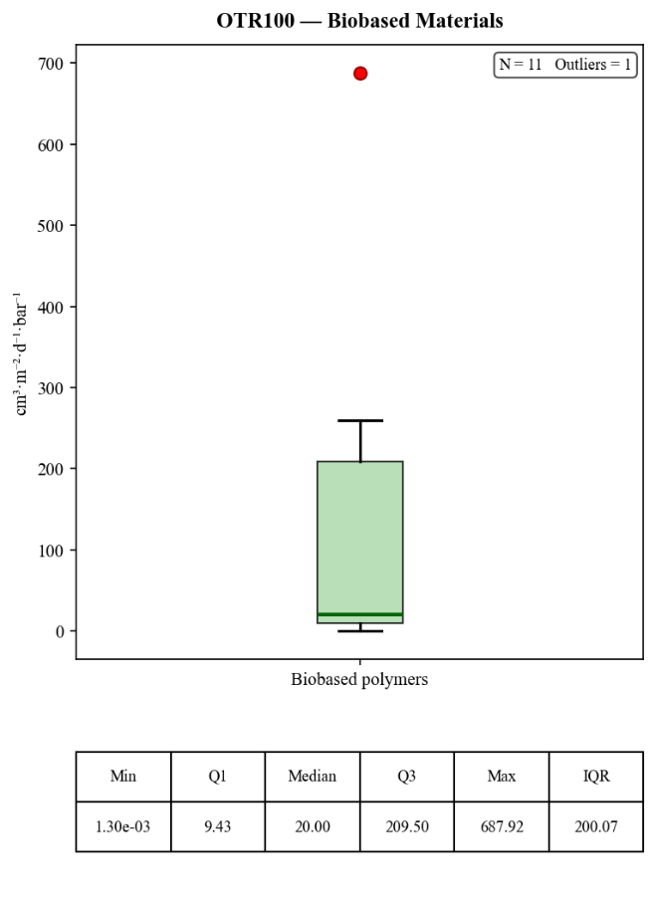 | Figure A 2.  Boxplot of OTR₁₀₀ values for conventional reference materials, with outliers identified by the IQR method (red dots). Descriptive statistics are shown below the plot.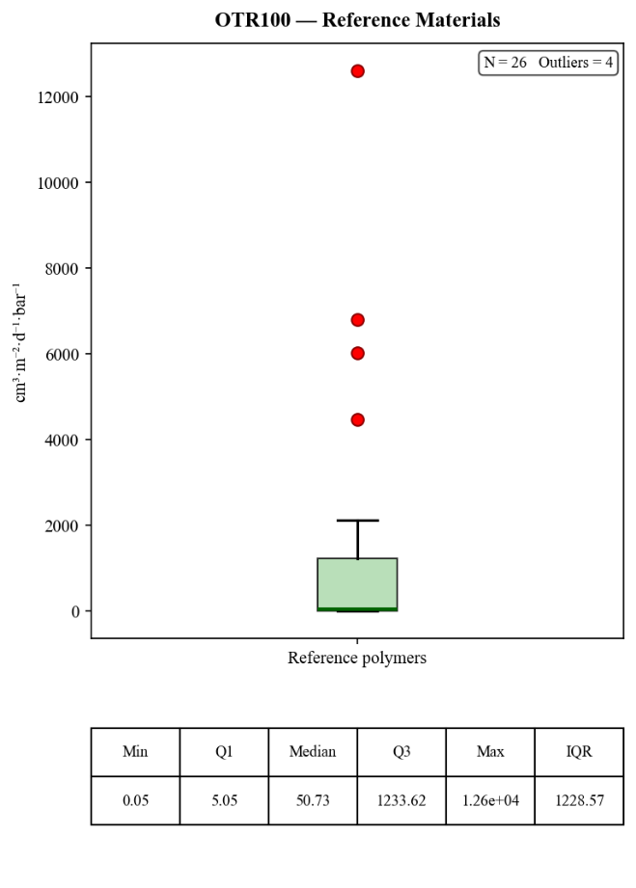

Water Vapour Transmission Rate (WVTR100)
Figures A 3 and A 4 show the WVTR₁₀₀ distribution for biobased and reference materials respectively.
Figure A 3.  Boxplot of WVTR₁₀₀ values for biobased materials, with outliers identified by the IQR method (red dots). Descriptive statistics are shown below the plot.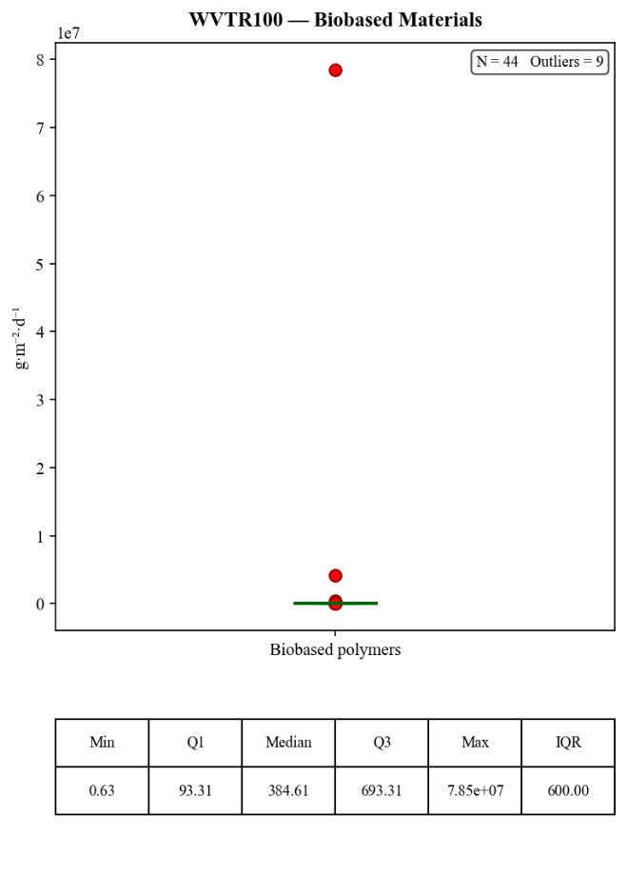 | Figure A 4.  Boxplot of WVTR₁₀₀ values for conventional reference materials, with outliers identified by the IQR method (red dots). Descriptive statistics are shown below the plot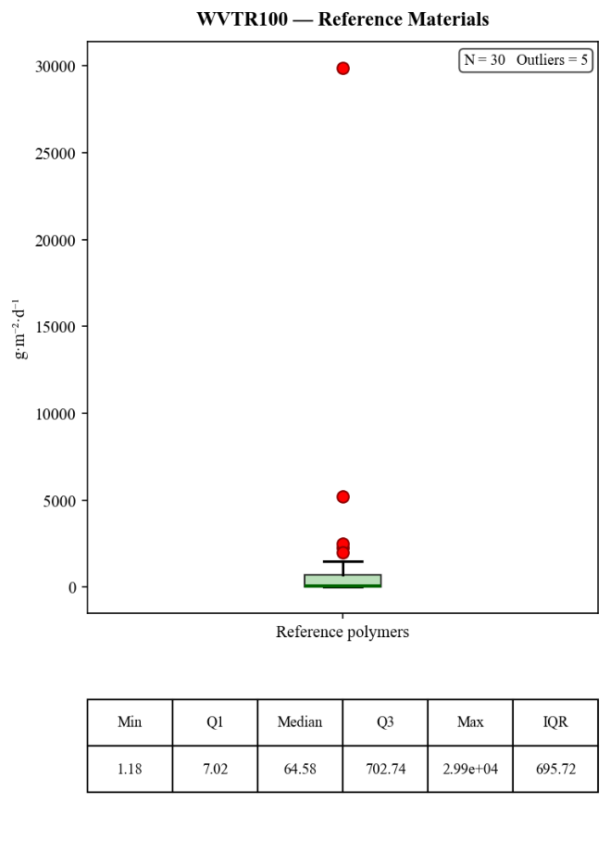

Carbon Dioxide Transmission Rate (CO₂TR100)
Figures A 5 and A 6 show the CO₂TR₁₀₀ distribution for biobased and reference materials respectively.
Figure A 5.  Boxplot of CO₂TR₁₀₀ values for biobased materials, with outliers identified by the IQR method (red dots). Descriptive statistics are shown below the plot.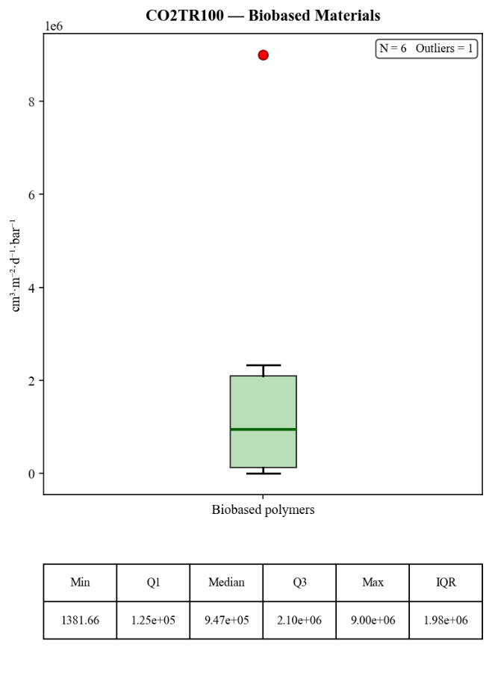 | Figure A 6.  Boxplot of CO₂TR₁₀₀ values for conventional reference materials, with outliers identified by the IQR method (red dots). Descriptive statistics are shown below the plot.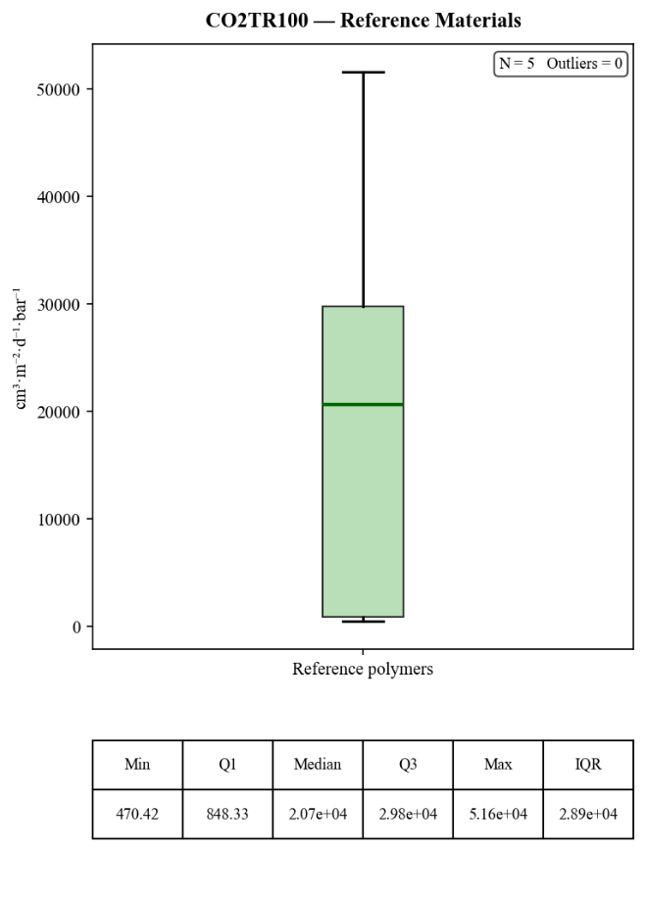

Summary of Studies Included
A brief overview of the research focus and primary objectives for each included study is provided in Table A 3.
Table A 3.
Bibliographic details and research objectives of the articles included in the systematic review and data analysis (n = 19)
Number | ID | Authors | Title | Summary
 | 1 | (Montalvo-Paquini et al., 2025) | pH-Drive on the Design and Properties of Legume Protein-Based Films | Investigates how adjusting pH levels during production affects the functional and barrier characteristics of legume-based protein films.
 | 5 | (Ncube et al., 2025) | Development and characterisation of Polylactic acid / Bambara groundnut (Vigna subterranea (L.) Verdc) shells biocomposite for food packaging application | Evaluates the reinforcement of Polylactic acid (PLA) with Bambara groundnut shells to create sustainable biocomposite packaging.
 | 18 | (Macieja et al., 2025) | Novel Poly(butylene succinate-dilinoleic succinate) Films in Packaging Systems for Fresh Cut Chicory | Examines the performance of a novel biodegradable polyester copolymer (PBS-DS) specifically for extending the shelf-life of fresh-cut chico
 | 20 | (Sepúlveda-Carter et al., 2025) | Reprocessing of Simulated Industrial PLA Waste for Food Contact Applications | Studies the feasibility of recycling industrial PLA waste back into safe, high-performance materials for food contact applications.
 | 21 | (Sabzevari et al., 2025) | Synthesis and characterization of a hydrogel film based on chitosan/carboxymethyl cellulose for food packaging applications | Focuses on the synthesis of a hybrid hydrogel film combining chitosan and carboxymethyl cellulose for enhanced packaging functionality.
 | 22 | (Zamanidehyaghoubi et al., 2025) | Investigating the effect of three different types and concentrations of plasticizers on physico-mechanical properties of pullulan food-packaging films | Tests how varying types and amounts of plasticizers influence the flexibility and strength of pullulan-based films.
 | 24 | (Gil-Guillén et al., 2025) | Biodegradable Antioxidant Composites with Almond Skin Powder | Develops biodegradable composites using almond skin powder to impart natural antioxidant properties to packaging.
 | 27 | (Athanasopoulou et al., 2025) | Comparative study of packaging materials developed from fish and legume protein concentrates | Compares the mechanical and barrier efficiency of packaging films derived from fish protein versus those from legume protein.
 | 33 | (Ocampo-Gómez et al., 2025) | Effect of the Addition of Banana Stem Lignin (Musa acuminata ssp. balbisiana var. Dominico-Harton) on the Physicochemical Properties of Biodegradable Composites Based on Methylhydroxyethylcellulose | Explores how banana stem lignin improves the physicochemical stability of methylhydroxyethylcellulose (MHEC) composites.
 | 34 | (de Lima Silva et al., 2025) | Evaluation of the physical–chemical properties of the blend of arrowroot starch and cactus mucilage | Analyzes the properties of a novel blend that combines arrowroot starch with cactus mucilage for biobased film production.
 | 39 | (Manfroni et al., 2025) | Eco-design of biobased poly(butylene succinate-b-pentamethylene 2,5-furanoate) copolymers with optimized mechanical, thermal and barrier properties for flexible food-packaging | Designs specific biobased copolymers (PBS-b-PPeF) to optimize the balance between thermal stability and barrier performance for flexible packaging.
 | 44 | (Abdalrazeq et al., 2025) | Microbial Transglutaminase-Mediated Modification of Heat-Denatured Whey Proteins for the Preparation of Bio-Based Materials | Uses enzymatic modification (transglutaminase) to improve the structural integrity of heat-denatured whey protein materials.
 | 55 | (Pech-Cohuo et al., 2024) | Effect of clays incorporation on properties of thermoplastic starch/clay composite bio-based polymer blends | Investigates the impact of different clay types on the structural and protective properties of thermoplastic starch blends.
 | 71 | (Samaniego-Aguilar et al., 2024) | Performance Enhancement of Biopolyester Blends by Reactive Compatibilization with Maleic Anhydride-Grafted Poly(butylene succinate-co-adipate) | Enhances the compatibility and performance of biopolyester blends using a reactive chemical grafting technique.
 | 72 | (Guidotti et al., 2024) | Fully Bio-Based Blends of Poly (Pentamethylene Furanoate) and Poly (Hexamethylene Furanoate) for Sustainable and Flexible Packaging | Develops fully bio-based blends of two different furanoate polyesters (PPeF and PHF) to achieve high-performance sustainable packaging.
 | 73 | (Mwita et al., 2024) | Chitosan Extracted from the Biomass of Tenebrio molitor Larvae as a Sustainable Packaging Film | Evaluates the film-forming potential of chitosan extracted from insect biomass (Tenebrio molitor larvae) as an alternative to crustacean sources.
 | 80 | (Sutay et al., 2024) | Multiproduct biorefinery from defatted olive mill waste: preparation of hemicellulose-based biodegradable films and instant controlled pressure drop (DIC)-assisted isolation of value-added products | Details a biorefinery approach to extract hemicellulose from olive mill waste for the production of biodegradable films.
 | 81 | (Petaloti & Achilias, 2024) | The Development of Sustainable Biocomposite Materials Based on Poly(lactic acid) and Silverskin, a Coffee Industry By-Product, for Food Packaging Applications | Explores the use of coffee industry by-products (silverskin) as a sustainable filler to improve PLA-based biocomposites.
 | 93 | (Kim & Kang, 2024) | Effects of benzalkonium chloride as a cationic surfactant on the physicochemical properties of adlay millet starch films | Examines how adding a specific surfactant (benzalkonium chloride) modifies the physical properties and functionality of adlay millet starch films.

Artificial Intelligence (AI) Usage
Table A 4 presents the declaration of generative AI usage as required by Wageningen University & Research. During the preparation of this thesis, generative AI tools were used for brainstorming and sparring, textual feedback (spelling and grammar), and the development of data processing and visualisation scripts in Python. All AI-generated output was critically reviewed and edited by the author prior to use.

Table A 4.
Declaration of generative AI usage in the preparation of this thesis, in accordance with the WUR policy on the use of generative AI in education.
Declaration of generative AI
I, Sharon de Bondt, have used generative AI applications for the writing of this document or parts thereof. After using this tool, I have reviewed and edited the content as needed and take full responsibility for the content of the document.
What tool(s) have you used?  List the tools that you have used including the model, version and link to the tool. | 1. Google Gemini (model: Gemini 1.5 / 2.0) – https://gemini.google.com  2. ChatGPT (model: GPT-4o) – https://chat.openai.com  3. Claude Sonnet 4.6 – https://claude.ai  4. Claude Opus 4.6 – https://claude.ai
What prompts have you used?  Provide a list of prompts you have used  Add the conversation as an appendix to this declaration. | Logs of AI-assisted sessions is available in the accompanying GitHub repository at: [insert repository URL].
Why did you use this genAI tool? | Generative AI tools were used to support three aspects of the thesis work: (1) as a sparring partner and brainstorming tool to explore ideas, refine arguments, and discuss the structure and content of the systematic review; (2) as a feedback tool for textual improvement, including spelling and grammar checking and suggestions for clarity; and (3) for the development of data processing and visualisation scripts in Python.
How did you use the output of the genAI tool? | All AI-generated output was critically reviewed and edited by the author before use. Brainstorming outputs were used as a starting point for further independent reasoning and writing. Textual suggestions were selectively incorporated after evaluation. Generated code was tested, verified, and adapted by the author. The author takes full responsibility for the final content of the thesis.
Where can your prompts and outputs be found? (e.g. appendix, separate repository etc.) | Logs of AI-assisted sessions is available in the accompanying GitHub repository at: [insert repository URL].

