Before you start
For manipulating media there are a number of open source frameworks, each with his own target. The three that I would recommend (With Delphi wrappers) are:
- FFMPEG – best for understanding and unwrapping, wrapping media streams and files from one hand and decoding encoding the streams. (Also used in all kinds of GStreamer plugins).
- OpenCV – best for unveiling what reality is actually in the media (Also used here in GStreamer plugins, filters).
- GStreamer – what is explained here, best for stream routing & filtering of media.
In my opinion, GStreamer is more complicated to master and if you can work with the above two you may be better off.

Abstract
G2D is a bridge between GStreamer framework and Pascal. G2D enables Delphi (pascal) developers to use the GStreamer framework in their pascal program. By doing so G2D enables endless manipulation and uses of multimedia on Windows, Linux, Mac, ios and Android systems. Because GStreamer was unavailable for Delphi developers, many professional multimedia project development used C, C++, Python and Java (that do have bridges to GStreamer) although in all other aspects Delphi would be their preferred choice.
This word file is in: https://github.com/sharonido/Delphi_GStreamer/tree/master/

The Tutorials
(To use the examples, you must Install the GStreamer & G2D see Installation)
The examples are in examples folder (from the above link) or:
https://github.com/sharonido/Delphi_GStreamer/tree/master/examples
The examples follow the GStreamer tutorials as in:
https://gstreamer.freedesktop.org/documentation/tutorials/basic/index.html?gi-language=c
But instead of being in the C language they are in object pascal (Delphi). They use the G2D framework that wraps the GStreamer framework so you don’t need C language.
The folder example1 follows the GStreamer tutorial 1. Folder example2 follows tutorial 2 and so on.
For me one main reason to program in Delphi Pascal is the ease of building a window GUI for Android, ios, and of course Windows. In examples 1-4 we use a console so it does not show the Delphi advantages. But in example 5 and on we use a window GUI. There you can see the power of Delphi Pascal.

Example 1 – “Hello world”
This program will show a video clip from a URL on the internet (so for this example you need an Internet connection). As you can see below the actual Video programing, is done in some 10 lines of (green) code:
program PG2DExample1;
{$APPTYPE CONSOLE}
uses
System.SysUtils,
G2D in '..\..\Delphi\G2D.pas',
G2DCallDll in '..\..\Delphi\G2DCallDll.pas',
G2DTypes in '..\..\Delphi\G2DTypes.pas';
//main -------------------------------------------------------------------------
Var
GStreamer:TGstFrameWork;
begin
try
GStreamer:=TGstFrameWork.Create(0,nil); //no parameters needed here
if GStreamer.Started then
try
//launch the gstreamer pipeline
if not GStreamer.SimpleBuildLinkPlay
('playbin uri=https://www.freedesktop.org/software/gstreamer-sdk/data/media/ sintel_trailer-480p.webm', DoForEver)
then writeln('error in the prog');
finally
GStreamer.Free;
end;
except
on E: Exception do
Writeln(E.ClassName, ': ', E.Message);
end;
write('press enter to exit');
readln;
end.
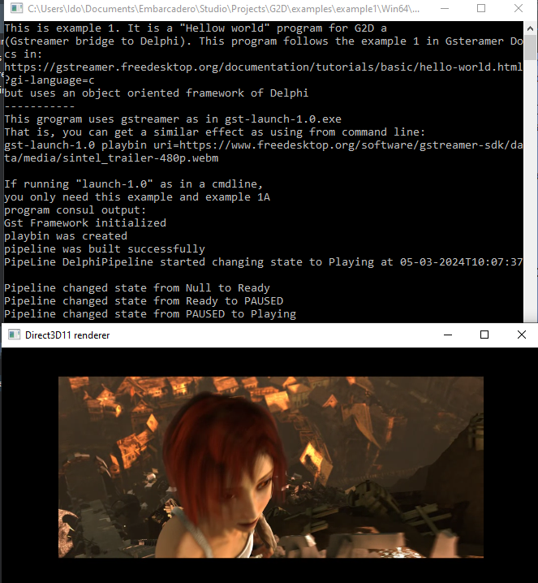
When the program runs
it should look like this:

If you did not get this->
Go back to installation.

Example 2 - Basic video test.

When running example 2 you should get two windows on your desktop that look like this:
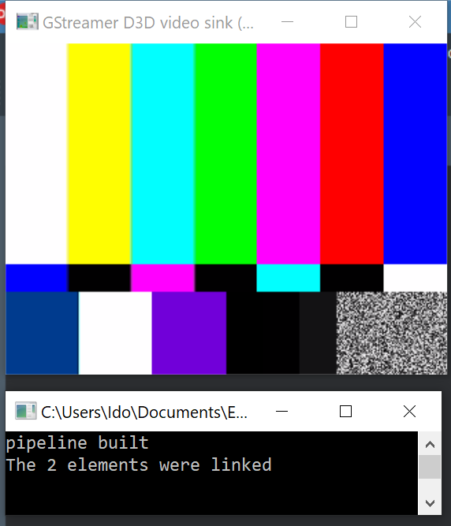
The top window (Gstreamer D3D video…) is the video output.
The bottom window (c:\users…) is a cmd line window.
If you do not get this result:
Please go back to “Installation” section and “Be Aware” section you probably did something wrong. Alternatively, your system is configured in a specific way that we did not test.

Example 2W – An Example 2, but in a Delphi window (teaser).
In folder example2 there is also a PG2DExample2W example. This is only a teaser. An actual application were the video is rendered into a Delphi window is in example 5.
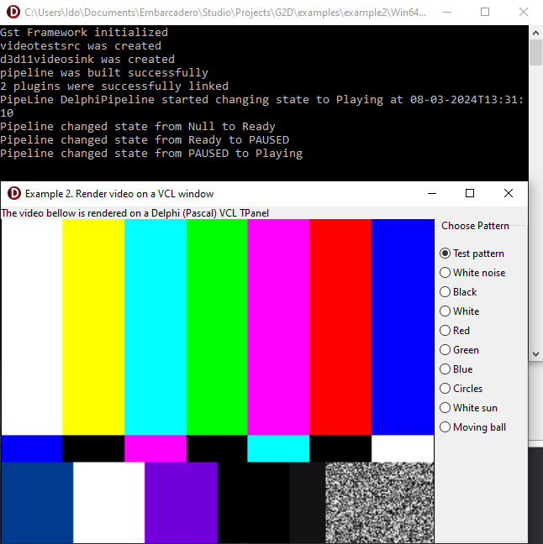
Here you can see 2 windows:
- A console window (on the top).
- A video test signal window, that is
rendered into a standard
Delphi (Pascal) MS Windows.

Example 5 – A full Delphi (pascal) app (with rendering video in a window).
In the example5 folder there are 3 programs (a, b & c). We start with a and build a b on top of it and a c on top of b. This is done only so the explanation and understanding will be easy. You can start with c:
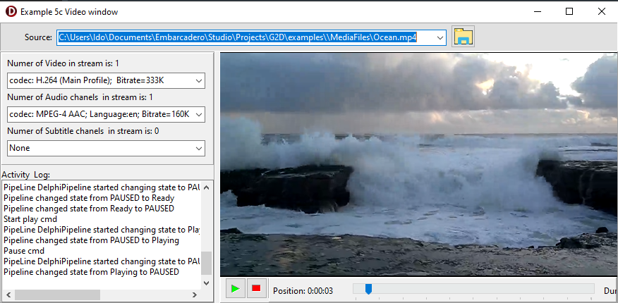

Folder Explanation
In bin directory there is “G2D.dll” file. If you are running the examples, they will find it in the bin directory. If you build your own program, you should include the G2D.dll file in the directory of your exe file.
In the Delphi directory, there are Pascal units that use the DLL files (from the bin) and build a Delphi Object oriented wrapper around the native C functions in the DLL. These files should be included in the uses of your project and in ti the units that use them like in the examples provided in the examples directory.
In the C directory, there are the C source of the G2D.dll. You can use them if you want to change the G2D.dll. Do that only if you are sure you know what you are doing.

What is GStreamer
GStreamer is an open source (LGPL license) framework written in C (not C++) for manipulating Streaming Data.
In many aspects, it might seem to be using C++. However, its underlining framework is GObject that enables pseudo object oriented in C.
Streaming Data, is data coming from an endless source. Think of a video camera that is never stopped. The data will be streaming from that camera. Multimedia, video and audio are the most common streaming data, but there can be other kinds, like seismic measurements taken 100 times a second etc.

Basic concept of GStreamer
You can think of GStreamer as a Lego game. You build whatever structure you want using all kinds of Lego Blocks. Like a Lego game, you can connect the different blocks one to the other. However, the GStreamer block is a pipe. As in Lego, you connect one piece of pipe to the other thus building the structure (pipeline) you want. Each pipe piece is called element. As an open source, there are endless types of elements. For example: An Element that shows the video on the screen, Element that receive video or audio from IP communication or from a file, Element for filtering the streaming data, Element that split and copy the stream into two streams etc. Elements sit in a Dll that your exe will load at runtime. This Dll is called a plugin. A Plugin can hold one or more Elements.
You will usually chain (link) the elements one to the other. For example, you can link a video generator element to a filter element to an element that displays the video. So on screen you will see the video generated after it was filtered. To run a chain from a command line you can use a command like:
gst-launch-1.0.exe filesrc location=thesong.mp3 ! decodebin ! audioconvert ! pulsesin
Where gst-launch-1.0 is the program (launch program), and all the other stuff in the above line are arguments to the launch program. These arguments are basically, the names of the Elements. The launch program will use these Elements as a chain (pipeline) of elements. The “!” is a sign for the launch program to connect & link the Elements as a chain of pipes for the stream of data.
The Elements are built into DLL files. Each DLL file can contain one or more Elements. If you want to master the stream of data, you need 3 abilities:
- To launch a pipeline (with a stream) from within your application.
- To connect the output of the pipe to your PC. In videos you need to render the video to a window in the PC. If It is a Delphi VCL, it can be a TPanel on a form. Or if its an audio stream you need to connect the audio to the PC speakers.
- Building your own Elements
If you can launch a pipeline from your pascal program, you can use the endless Elements that are available to manipulate the stream. On the other side if you build your own Element in Pascal, you can launch it from the command line. But you can use both abilities and run a stream through your Element all within Pascal. The main part of G2D is the ability to easily write Elements & launch pipelines in Pascal.
To understand the GStreamer framework, and how to use it, you should refer to sources on the internet. Starting point for that can be:
https://gstreamer.freedesktop.org/documentation/

Understanding an Element
As mentioned above an Element is in a plugin (DLL) and serves as a pipe (A Lego Block) for the GStreamer framework.
Element
Note: klass is a C pseudo class that is almost the equivalent of a C++, Java or Pascal class. The G2D wraps the klass into a Delphi class.
Element is a piece of pipe. As mentioned above it can be one of three basic types
- At the start of a pipeline were it gets the stream from a hardware device that can be a file on disk, a network from IP, a camera device, etc. then it is called a source Element.
- At the end of the pipeline were it sends the stream to a hardware device that can be a file on disk, a network from IP, the screen, etc. then it is called a sink Element.
- In the middle of the pipe than it is just called ab Element.

Pipeline
Pipeline is a Gst-element (klass) that holds multiple plugins. The pipeline masters the flow of the stream. (If there is only one plugin in the pipeline, you do not need the pipeline and you can use the plugin as the pipeline)

Pads
Pads are also a Gst-element (klass) that are part of an Element.
As explained above, an Element is a piece of pipe. It has two ends (called Pads). There is one pad for receiving the data stream, called “sink pad” (it is a sink for the previous Element). At the other end, a pad for sending the data stream to the next plugin called “src pad” (sink like a kitchen sink where you send the water stream to).
An Element that is capable of handling Video stream probably cannot handle a Seismic measurements stream. You might build a video plugin that can only handle raw video and not compressed video or a video that can handle only video with width of 640 pixels X and height of 480 pixels. Alternatively, some range of width and height. The receiving pad, the sink pad and the src pad should negotiate their capabilities with one another. This is called capability exchange and will be discussed later.
Note: do not confuse “src pad” with “src Element”. A “src Element” is the Element that starts the chain so “src Element” receives the data stream from some kind of hardware that can be a camera, or an IP communication or a file etc. In the same way, a “sink pad” is not a “sink Element”. A “sink Element” is the end of a chain. “Sink Element” sends the data stream to some kind of hardware that can be the speakers of the computer for an audio stream, or a file etc.

Flow (We address Video streams – but true for all streams)
The flow of the data stream is divided into buffers (chunks of memory filled with the data from the stream). For example, in a raw video plugin, a buffer is usually one frame of the video. The frame is usually arranged in a 2-dimension array (like the screen itself – or a graphic window on the screen) where each cell holds the information of one pixel of the frame. Each cell of the matrix might be 3 bytes corresponding to Red Green & Blue (RGB) of that pixel. When video is flowing in 30 frames per second the src pad should receive 30 buffers per second.
The src pad is responsible for receiving the buffers in a continuous periodic synchronized manor and the sink pad is responsible for sending the buffers in the same continuous periodic synchronized manor. So src pad and sink pads must be synchronized in their buffer exchange. That is what they are built for.
The launch program (or procedure) calls the methods that operate in the Element, usually the main thread of the program. The capability exchange methods are called before streaming starts. In contrast, the operating of data stream buffers by src/sink and others are called in a continuous periodic synchronized manor by Internal GStreamer threads. Be aware that you should not call VCL components from within these threads without synchronizing.

Be Aware
This G2D framework is in construction!!!
In this stage, it supports limited operation.
Here is a partly list of limitations:
- Support only windows (tested on windows 10, 11)
- Support only programs compiled in 64 bits.
Before you can start programing with GStreamer in Delphi, you must install two main things:
- Install the GStreamer framework.
If you do not install the GStreamer framework not all examples will work for you. That is in Tutorials you can only run examples 2, 2W,
- Install the G2D that is the bridge between Delphi and GStreamer.
Note: G2D should work with any pascal compiler but was not tested for that, only Delphi 10.3.3 was tested.

Installing GStreamer framework
Download from https://gstreamer.freedesktop.org/data/pkg/windows/1.16.2/
choose two *.msi files: “gstreamer-1.0-devel-msvc-x86_64-1.16.2.msi” & “gstreamer-1.0-msvc-x86_64-1.16.2.msi”
After downloading be sure to install them (by Double click on both). When installing do not change anything (just press next… and finish) so they will be installed in the default directories.

Installing GStreamer G2D
Open: https://github.com/sharonido/Delphi_GStreamer you should download the whole repository by the green download button, or if you have git installed in your system then from cmd line enter the clone command:
git clone https://github.com/sharonido/Delphi_GStreamer.git
It is important to maintain the G2D internal structure. It does not matter where you decide to put this directory structure in your system.

