
Department of Computer Science and Artificial Intellegence

PROBLEM-SOLVING HACKATHON (2026)
PROJECT DOCUMENTATION
CAMPUSCONNECT
Smart College Club Management System
Field |  |  | Details
Project Title |  |  | College club management system
Team Name / Team No. |  |  | 7
Year / Semester / Section |  |  | II Year B. Tech / I Sem / CSM_E
Algorithm Paradigm Used |  |  | CRUD Operations and Role-Based Access Control
Programming Language / Tools |  |  | JavaScript, React.js, Node.js, Express.js, MongoDB, Mongoose, VS Code
 | S..No | Name of the Student |  | ROLL.NO | ROLE
 | 1 | A. Srinavya |  | 25MVCSMR0367 | Team Lead & Full-  Stack Developer
 | 2 | Ch. Sahasra |  | 25MVCSMR0383 | Frontend & UI/UX  Developer
 | 3 | D. Sharonika |  | 25MVCSMR0387 | Algorithm &  Database  Developer
 | 4 | M. Pavani |  | 25MVCSMR0413 | Testing &  Documentation

1. Abstract
CampusConnect is a MERN-based college club management platform designed to centralize club, student, membership, event and activity management. The system provides role-based access for administrators, club coordinators and students. Its key innovation is an activity-points and leaderboard mechanism that encourages participation and makes student engagement measurable.

2. Introduction
College clubs play an important role in developing technical, cultural, leadership and communication skills. However, information about clubs, memberships and events is often distributed across notices, spreadsheets and messaging groups. CampusConnect provides one digital platform for discovering clubs, managing memberships, organizing events and tracking participation.

3. Problem Statement
Build a MERN-based college club management system that manages clubs, members and activities using MongoDB. React provides the user interface while Node.js and Express.js provide backend APIs. The system supports adding, viewing, updating and managing relevant records and includes authentication and role-based access where required.

4. Objectives
• Demonstrate MERN Stack development.
• Implement CRUD operations using MongoDB.
• Build REST APIs using Node.js and Express.js.
• Develop a responsive React.js frontend.
• Implement authentication and role-based authorization.
• Provide clear project information, results and analytics.
• Improve student engagement using activity points and a leaderboard.

5. Existing System & Limitations
In a typical manual or fragmented system, students may depend on notices or separate messaging groups for club information. Coordinators may maintain member lists and event records separately. This can cause duplicate records, missed announcements, difficult reporting and limited visibility into participation.

6. Proposed System
CampusConnect provides a centralized web application. Students can register, explore clubs, join clubs, view events and track activities. Coordinators can manage club members and events. Administrators can manage the complete platform and view analytics. Participation is converted into activity points and displayed through a campus leaderboard.

7. Major Modules
1. Authentication and user management
2. Club management
3. Student management
4. Membership management
5. Event management
6. Activity and points management
7. Leaderboard
8. Admin dashboard and analytics

8. Technology Stack
Frontend: React.js, HTML, CSS and JavaScript.
Backend: Node.js and Express.js.
Database: MongoDB with Mongoose.
Authentication: JWT-based authentication.
API Style: RESTful APIs.
Development: VS Code and Git/GitHub.

9. System Architecture
The React frontend communicates with the Node.js/Express backend through REST APIs. Express routes call controller logic and Mongoose models. Mongoose communicates with MongoDB collections. JWT is used to authenticate users and protect role-specific routes.

10. Database Design
Users: name, email, password hash, department, role and points.
Clubs: name, description, category, coordinator and creation date.
Memberships: studentId, clubId, joinedDate and status.
Events: title, description, clubId, date, venue and creator.
Activities: studentId, eventId/clubId, activityType, points and date.

11. REST API Design
Authentication: POST /api/auth/register, POST /api/auth/login.
Clubs: GET/POST /api/clubs, PUT/DELETE /api/clubs/:id.
Events: GET/POST /api/events, PUT/DELETE /api/events/:id.
Memberships: POST /api/memberships, GET /api/memberships, DELETE /api/memberships/:id.
Leaderboard: GET /api/leaderboard.

12. Unique Feature – Activity Points
CampusConnect rewards participation. Example rules can include joining a club (+10), attending an event (+20), volunteering (+30), organizing an event (+40) and winning a competition (+50). The points create a measurable engagement score and support a campus leaderboard.

13. User Roles
Admin: manages users, clubs, events and platform analytics.
Club Coordinator: manages the assigned club, members, events and activities.
Student: explores clubs, joins clubs, registers for events and views points/leaderboard.

14. Implementation Plan
Phase 1: Environment setup and project structure.
Phase 2: MongoDB connection and Mongoose models.
Phase 3: Express server and REST APIs.
Phase 4: Authentication and authorization.
Phase 5: React pages and API integration.
Phase 6: Activity points and leaderboard.
Phase 7: Testing, screenshots, deployment/demo preparation.

15. Testing Plan
Test registration and login, role permissions, club CRUD, student records, joining/leaving clubs, event creation, event registration, points calculation, leaderboard sorting and invalid-input handling. Test both successful and failure cases.

16. Expected Results
The completed system should provide a responsive interface, persistent MongoDB data, functional CRUD APIs, secure role-based access and a clear dashboard. Students should be able to discover and participate in clubs while coordinators and admins can efficiently manage activities.
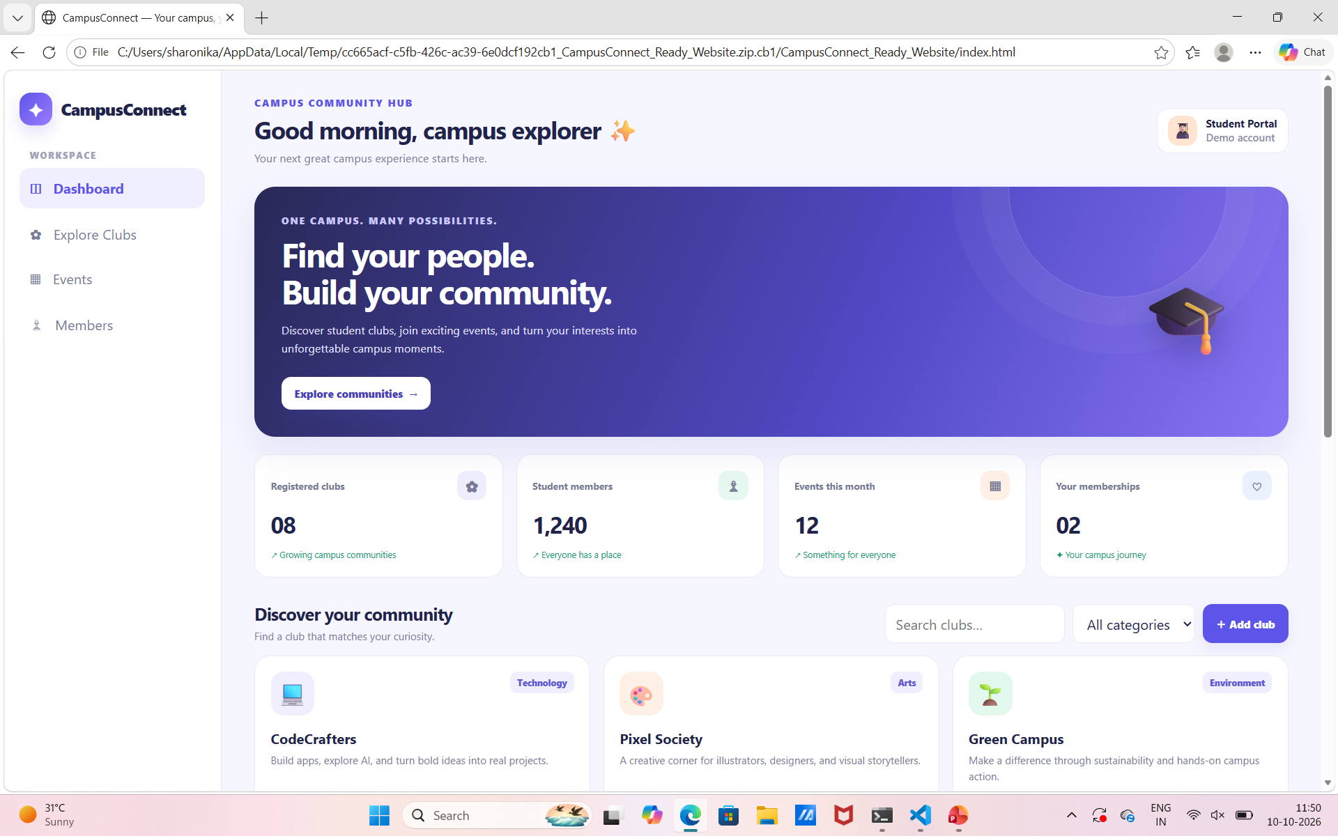

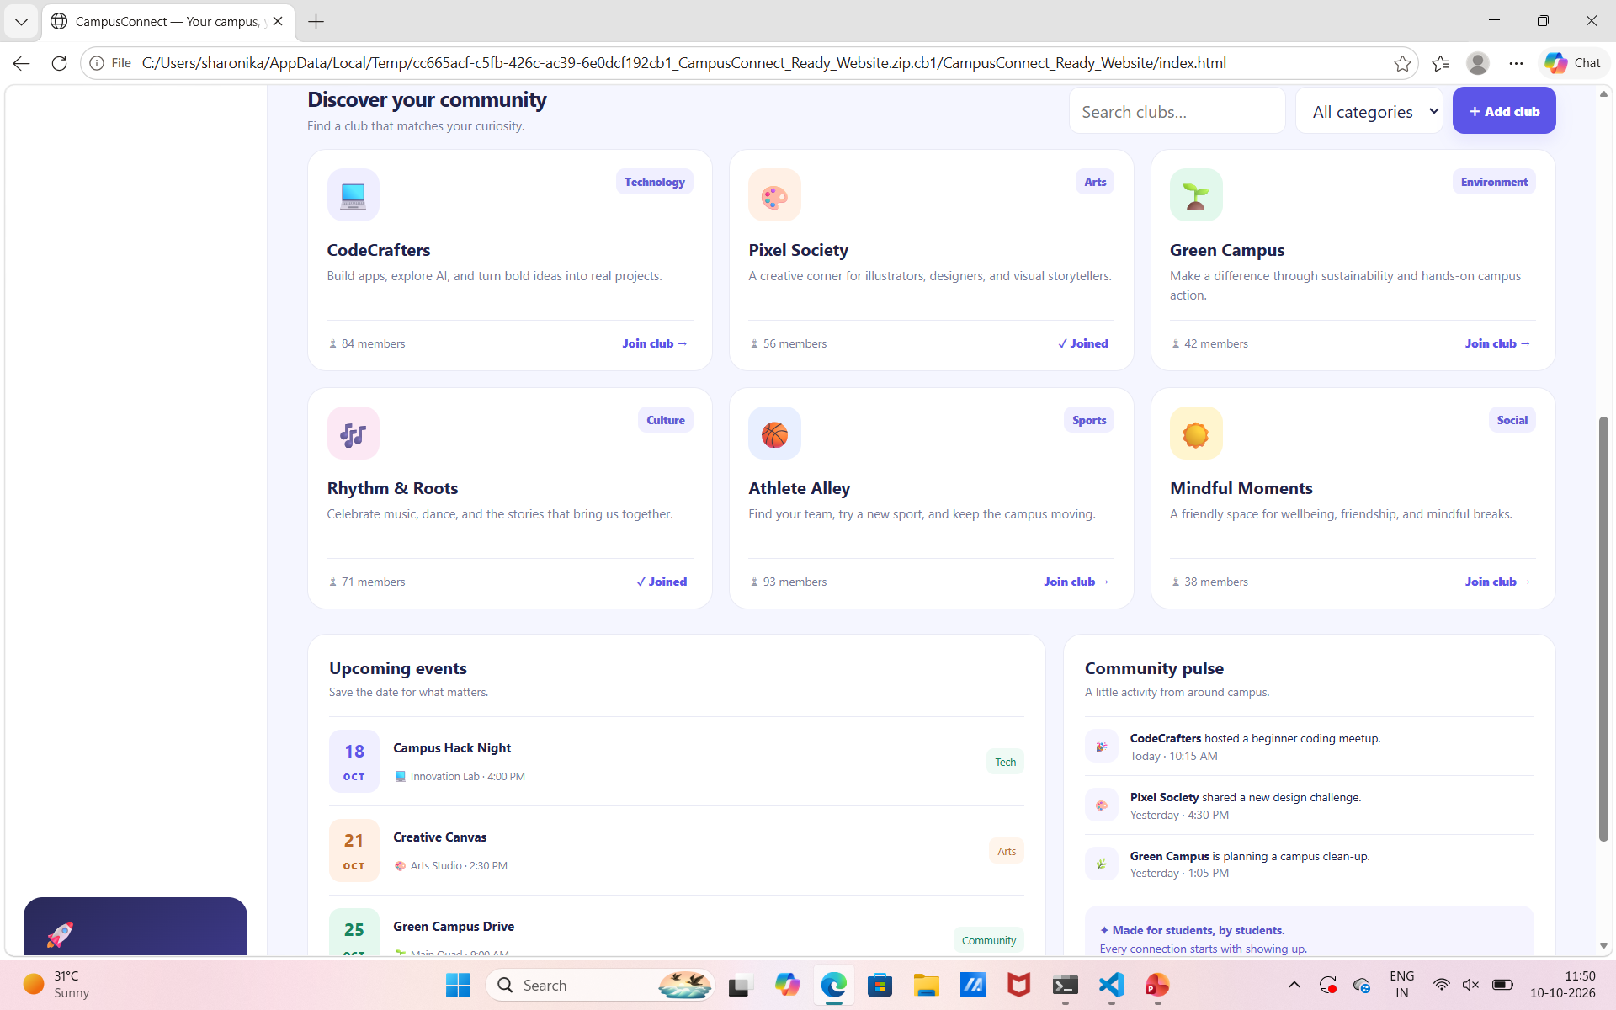

17. Future Scope
Future versions can add QR-based event attendance, automated certificates, AI-based club recommendations, push notifications, calendar integration, advanced analytics and a mobile application.

18. Conclusion
CampusConnect demonstrates how the MERN stack can solve a practical college-management problem. By combining centralized club management with measurable student engagement, the project goes beyond basic CRUD and provides a foundation for a scalable campus community platform.

19. References
MongoDB documentation; React documentation; Node.js documentation; Express.js documentation; Mongoose documentation. Accessed during project development.

