
Department of Computer Science and Artificial Intellegence

ALGORITHMIC PROBLEM-SOLVING HACKATHON (APSH 2026)
PROJECT DOCUMENTATION
Date: 03-10-2026 | Venue: 2nd Floor, A & B Blocks
Field | Details
Project Title | Garbage collection route optimizer
Team Name / Team No. | 7
Year / Semester / Section | II Year B. Tech / I Sem / CSM_E
Algorithm Paradigm Used | Dijkstra, TSP, Greedy
Programming Language / Tools | Python, Stream lit
Team Members
S..No | Name of the Student | ROLL.NO | ROLE
1 | A. Srinavya | 25MVCSMR0367 | Team Lead & Full-  Stack Developer
2 | Ch. Sahasra | 25MVCSMR0383 | Frontend & UI/UX  Developer
3 | D. Sharonika | 25MVCSMR0387 | Algorithm &  Database  Developer
4 | M. Pavani | 25MVCSMR0413 | Testing &  Documentation

1. Cover Page
Project Title: Garbage Collection Route Optimizer
Student Names & Roll Numbers: [Add names & roll numbers]
Department & College: [Add department & college]
Guide Name: [Add guide name]
Academic Year: 2026–2027

2. Abstract & Introduction

Project Overview
The Garbage Collection Route Optimizer is a prototype that plans a practical route for a garbage truck visiting multiple collection points. It models the road network as a weighted graph, uses Dijkstra’s algorithm to find least-cost paths, and uses a Greedy strategy to select the next unvisited collection point. The result is presented through route metrics and a visual map.

Problem Background
Garbage collection vehicles must visit several locations and return to a depot. Poor stop ordering can cause avoidable travel. As the number of locations grows, manually comparing route choices becomes difficult.

Proposed Solution
The proposed solution combines shortest-path calculation with a simple next-stop heuristic. Dijkstra supplies shortest travel paths through the road graph, while Greedy selects the nearest unvisited collection point from the current location. The generated route is displayed visually.

Purpose
The purpose is to demonstrate a fast, explainable graph-based solution for a practical smart-city waste-management problem.

3. Problem Statement, Objectives & Scope

Problem Statement
Develop a system that plans a route over a weighted road network, visits every selected collection point, returns to the depot, and reduces avoidable travel distance.

Project Objectives
- Represent roads and locations as a weighted graph.
- Find least-cost paths using Dijkstra’s algorithm.
- Select the next collection point using a Greedy rule.
- Return to the depot after covering all selected points.
- Visualize the route and report distance and coverage.

Project Scope
The current MVP covers one truck, a static sample road network, selected collection points, route generation, metrics and map visualization. Live GPS, traffic, multiple trucks, persistent database management and authentication are future extensions.

Target Users
- Municipal waste-management planners
- Garbage-truck operators
- Smart-city project teams
- Students/researchers demonstrating routing algorithms

4. Features & Functional Requirements

Main Features
- Weighted road graph
- Dijkstra shortest-path calculation
- Greedy next-stop selection
- Depot-to-depot route
- Interactive map visualization
- Distance and coverage metrics
- Decision log

User Functionalities
- Select collection points
- Run route optimization
- View route sequence
- View map and metrics

CRUD Operations
The current MVP does not use persistent CRUD screens. Sample locations and roads are stored in code/in memory. A future database-backed version can provide Create, Read, Update and Delete operations for collection points, roads, vehicles and route records.

Authentication & Validation
Authentication is not part of the current single-user demonstration. When user-entered data is introduced, validation should check valid graph nodes, non-negative/positive road weights, and required inputs.

System Requirements
Component | Requirement
Language | Python 3.x
UI | Streamlit
Libraries | NetworkX, Folium, streamlit-folium
Hardware | Standard laptop/desktop
Browser | Modern web browser

5. Algorithms & Methodology

System Workflow
Input depot, collection points and weighted roads → build graph → compute shortest paths → Greedy selects next unvisited point → repeat → return to depot → calculate metrics → display map.

Algorithms Used
Dijkstra’s algorithm is used for least-cost paths on a graph with non-negative edge weights. The Greedy strategy selects the unvisited collection point with the lowest current travel cost. Greedy is a heuristic and does not guarantee the globally optimal tour for every graph.

Development Methodology
The prototype follows an incremental MVP approach: define the problem, create sample graph data, implement Dijkstra, add Greedy selection, calculate route metrics, build the Streamlit interface, add visualization, and test the complete flow.

Data Flow
Road/location data → weighted graph → shortest-path calculation → next-stop selection → route sequence → return to depot → metrics → map/dashboard.

6. Technologies & Implementation

Frontend Technologies
Streamlit provides the interactive web interface. Folium/Leaflet provides the map visualization.

Backend Technologies
Python contains the route-planning logic and NetworkX provides graph structures and shortest-path functions. There is no separate API server in the current MVP.

Database
No persistent database is used in the current version. Data is stored in memory/code for demonstration. SQLite or another database can be added later.

Tools & APIs
The core routing calculation is local and uses the supplied weighted graph. Folium/Leaflet is used for mapping. No live routing API is required for the basic prototype.

Implementation Details
- Roads are represented as weighted graph edges.
- Dijkstra calculates shortest travel cost from the current location.
- Greedy selects the nearest unvisited target.
- The chosen path is appended to the route.
- After all targets are visited, a shortest path returns to the depot.
- The UI displays route, distance, coverage and map output.

7. Results, Testing & Performance

Project Results
For the included sample network, the demonstration route is Depot → D → C → E → B → A → Depot. The sample route distance is 19 km, all 5 selected collection points are covered, and the route returns to the depot.

Test Cases
Test case | Condition | Expected result
TC01 | Valid weighted graph | Graph builds successfully
TC02 | Five targets selected | All targets are included
TC03 | Sample network | Distance = 19 km
TC04 | After final target | Return to depot
TC05 | Map enabled | Route is visualized
TC06 | Metrics shown | Distance and coverage are reported

Testing Methods
- Functional testing
- Manual route and distance verification
- UI testing
- Input/validation checks

Performance Analysis
With a heap-based implementation, Dijkstra is typically O((V + E) log V). If the system runs Dijkstra repeatedly for k targets, the basic route planner is approximately O(k(V + E) log V). This is suitable for a small demonstration graph; larger deployments can use caching, precomputed shortest paths or specialized vehicle-routing algorithms.

Screenshots / Output
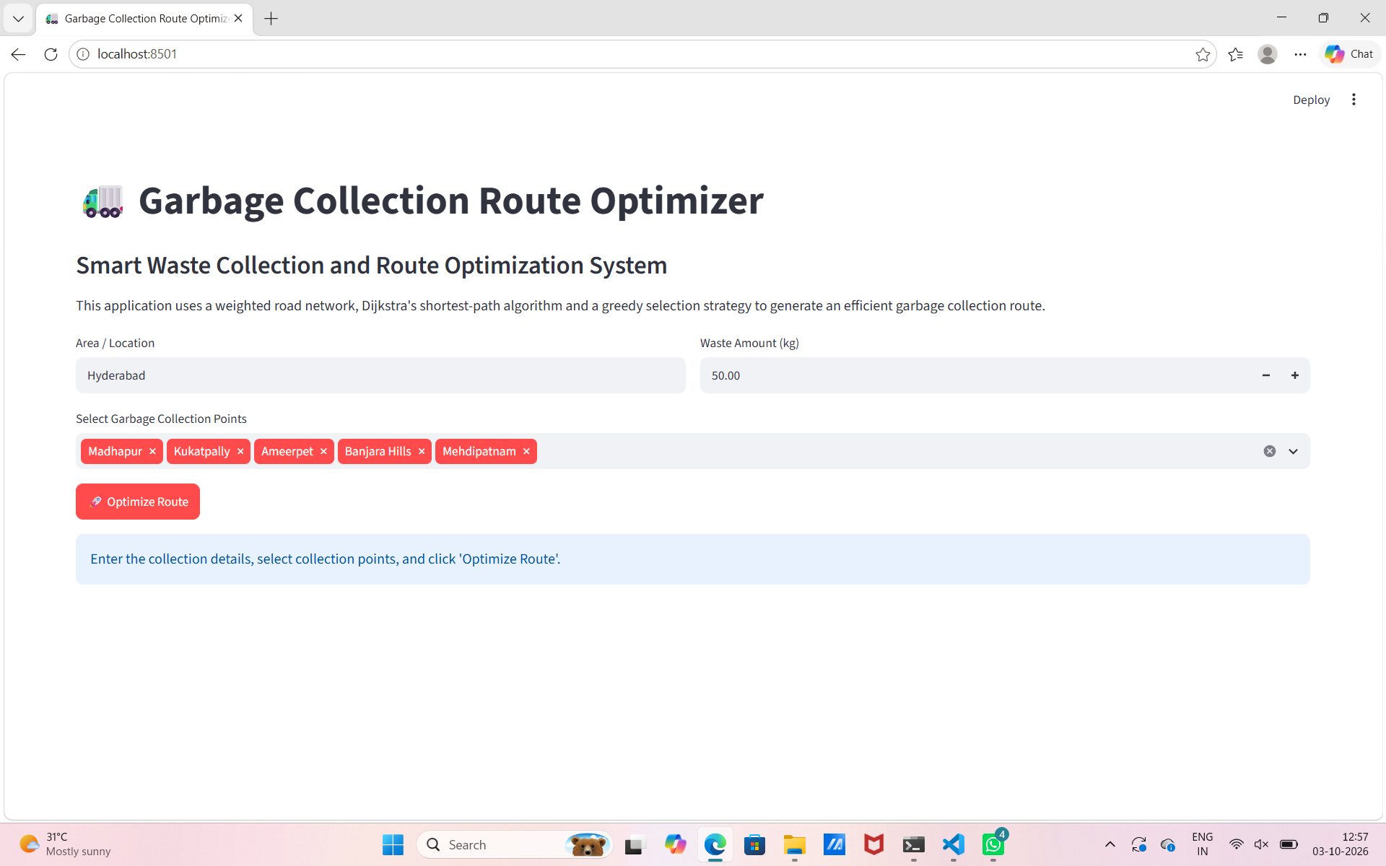
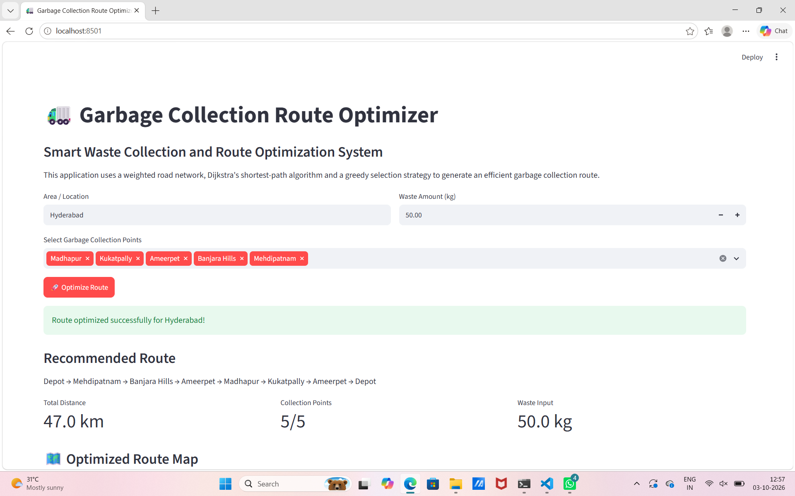
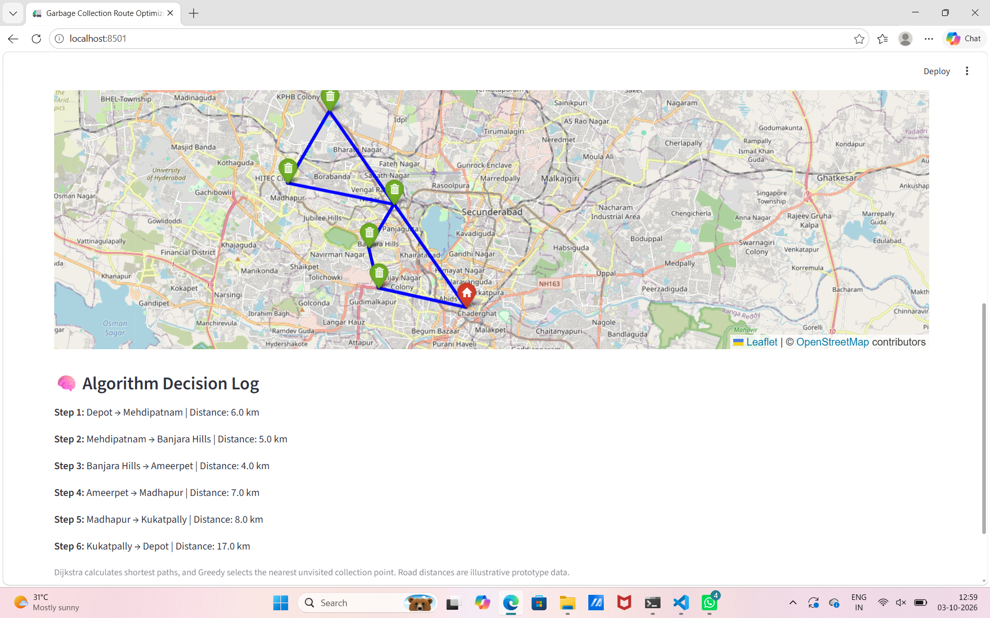

8. Conclusion, Future Scope & References

Project Conclusion
The project demonstrates a practical application of graph algorithms to garbage collection planning. Dijkstra provides shortest-path information and Greedy provides a simple, explainable order for visiting collection points. The prototype converts these calculations into a visual route and useful metrics.

Future Enhancements
- Live GPS and traffic-aware routing
- Multiple trucks and capacity constraints
- Database-backed CRUD management
- Authentication and role-based access
- Priority and time-window collection
- Historical analytics
- Cloud deployment
- Integration with real municipal road data

References / Documentation
- Python Documentation
- NetworkX Documentation
- Streamlit Documentation
- Folium Documentation
- Hackathon/project requirements provided by the coordinators
Submission reminder: replace all bracketed placeholders and add the final application screenshot before uploading the PPT, report and code to GitHub.

