

Masters of Business Informatics (MBI)

8260 – Business Transformation

Assignment 2 – Strategic Plan
Digital Transformation Strategic Plan for Sky Network Television
Words Count: 2660

First Name | Xue
Last Name | Jiang
Student ID | 109742
Submission Date | 22 Feb, 2026

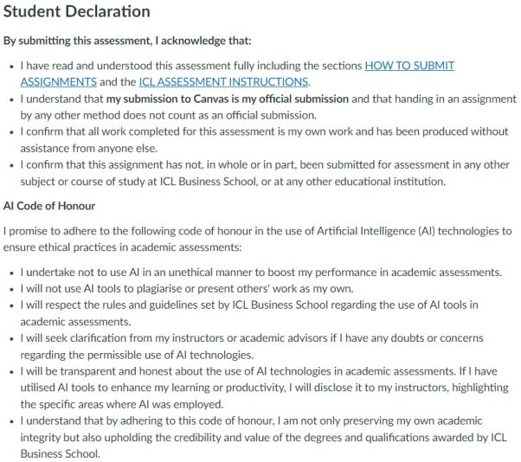

Table of Contents

Introduction 1
Where Are We Now? 3
2.1 Organisational Overview 3
2.2 Digital Disruption Analysis 3
2.3 Business Model Analysis 4
2.4 SWOT Analysis 4
● Strengths 5
● Weaknesses 5
● Opportunities 5
● Threats 6
● Strategic Implications 6
Where Are We Going? 7
3.1 Future Vision 7
3.2 Sustainable Competitive Advantage 7
3.3 SMART Objectives 8
How Will We Get There? 9
4.1 Strategic Initiatives 9
4.1.1 Digital Platform Development 9
4.1.2 Organizational Transformation 10
4.1.3 Cost Reallocation and Infrastructure Rationalization 10
4.1.4 Customer-Centric Digital Engagement Strategy 11
4.2 Implementation Roadmap 11
4.3 Communication and Change Management 12
4.4 Performance Monitoring and Governance 12
4.5 Strategic Reflection 13
Conclusion 13
Reference 14

Introduction

Distressful competition arising from streaming services globally calls for drastic transformation by Sky Network Television to enable the television company to attract consumers and remain viable in the near future. In the past, Sky TV was the only pay television service in New Zealand, but currently the Sky TV company is faced with competition globally from digital streaming services that provide consumers with on-demand television and other services that enable television to be available when needed, where needed, and how it is preferred, as reflected in (Christensen, 1997), disruptive technologies will gradually eat the lunch of the market leader. Initially low quality and less given, then the disruptive technology gained its quality and momentum and then disrupted and targeted the market of the incumbent and became the dominant player.
The digitalization of television distribution via an internet platform distribution model has resulted in disruptive changes in many areas of the television network throughout the world (Lotz, 2017; Lobato, 2020). “Platform power disrupts television markets around the world” (Evens & Donders, 2018). Sky-­TV cannot anymore remain in the traditional role of the satellite provider, and it would need to really rethink itself and its business model already as it repositions itself.
Digital transformation resulting in the enhancement of a firm's performance and innovative capabilities has been found by research (Guo & Xu, 2021; Li et al., 2022). Hence, digital disruption should not only be considered a disaster that has struck an organization. It rather puts forward a chance for transformation through which a company can emerge stronger. Digital transformation is an imperative for Sky Network to transform its model and develop digital skills. This is in order to be proactive against and also control the position of the network during the period of the industry structural change. A digital transformation strategy outlines how Sky TV might, applying digital platforms and delivery/distribution over the cloud, establish new efficiencies in its operations over the entire company, perform customer-centric activities, run on streaming customer-driven services, and be built around data analytics (e.g., loyalty with Sky). The strategy gives Sky the means to lead the way in the digital content delivery space, rather than just being a satellite broadcaster.
The strategy plan gets structured into three simple questions:

● Where Are We Now? – Assessing Sky TV’s current strategic position, strengths and weaknesses, and the impact of digital disruption on its traditional business model (Christensen, 1997; Zott et al., 2011).
● Where Are We Going? – Defining the digital capability gaps, strategic objectives, and future competitive positioning supported by dynamic capabilities theory (Teece, 2007).
● How Will We Get There? – Developing a clear and feasible roadmap that outlines strategic initiatives, resource allocation, communication planning, and key performance indicators (KPIs) to ensure successful transformation.

With this strategy, Sky Television will become New Zealand’s top digital hub for sports, streaming, and entertainment. It will also ensure sustainable profitability, enhanced value for customers, and an enduring competitive edge in the digital world.

Where Are We Now?
In order to ascertain whether Sky Network Television is ready for digital transformation, the strategic position of the company should be assessed through SWOT analysis. This includes strengths, weaknesses, opportunities, and threats that the company is likely to face at the time of digital transformation.

2.1 Organisational Overview

Sky TV's legacy business is based on satellite television and some sports rights and subscriptions. Its competitive advantage is offering premium matches and being the choice for many viewers in New Zealand. Internet television has changed so much in the watch television sector (Lotz, 2017), and customers are asking for on-demand, mobile, and flat monthly subscriptions. Digital technologies accelerate at breakneck pace because they grow on infrastructure scalability, and thus the competition is more fierce in any market segment.

2.2 Digital Disruption Analysis

According to (Christensen, 1997), such companies perish because they refuse to harness potentially disruptive technology, focusing too strictly on sustainability. Streaming services were inferior in quality but proved incredibly quickly to be a difficult model for broadcasting to deal with. Digital transformation can increase firm performance and innovation performance (Guo & Xu, 2021; Li et al., 2022), which suggests that Sky TV will either choose transformation over tradition or quite quickly lose its business model to a very superior service.

Table 1: Disruptive Innovation Pathway

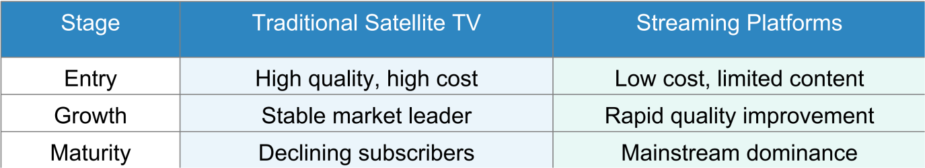

2.3 Business Model Analysis

According to (Zott et al., 2011), a business model describes how a company creates, delivers, and captures value. Sky’s traditional business model includes:
● Value creation: Exclusive content acquisition.
● Value delivery: Satellite broadcasting infrastructure.
● Value capture: Long-term bundled contracts.

However, streaming platforms operate with cloud-based delivery, flexible pricing, and data-driven personalization.

Table 2: Traditional vs Digital Business Model Comparison

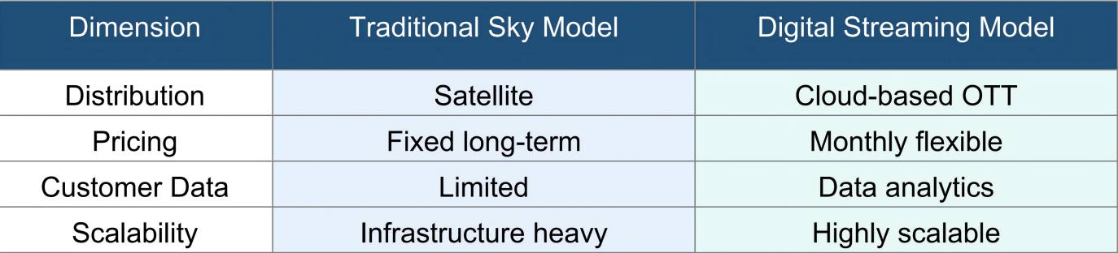

2.4 SWOT Analysis

The SWOT analysis provides a structured evaluation of Sky TV’s internal and external strategic environment. While the company retains several important strengths, significant structural weaknesses and competitive threats highlight the urgency of digital transformation.
Table 3: SWOT Analysis
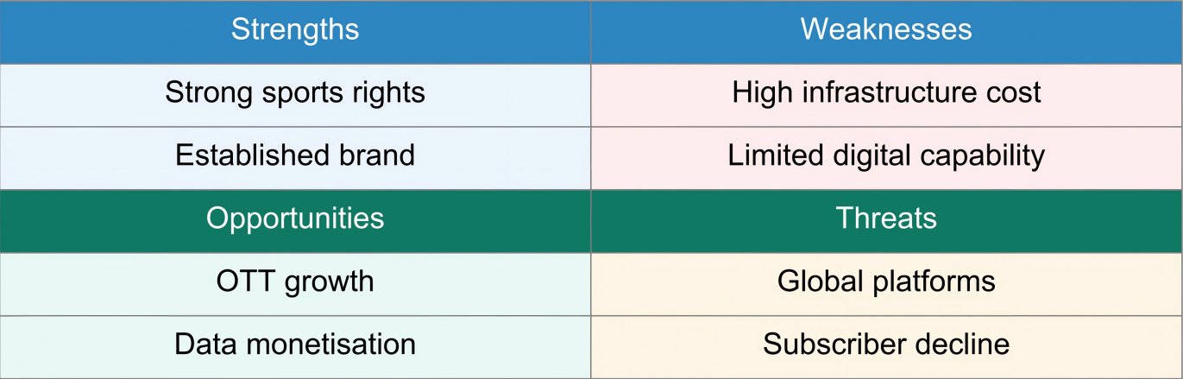

● Strengths

Sky TV’s core resource is its exclusive sports broadcasting rights in national sports. These create strong loyalty among customers and defence against competitiors in the domestic market. From a business model perspective, the premium content of sports has historically been at the heart of Sky’s value creation mechanism (Zott et al., 2011). Maintaining this content advantage has enabled Sky to maintain its subscription revenues despite increased competition. The strength of Sky’s brand and mature relationships with NZ households mean its brand equity reduces the costs to acquire customers and allows customers to trust new ventures into digital. These are strengths on which digital transformation can be built. However, in a platform industry, they may no longer be enough to win.

● Weaknesses

Sky TV has become heavily reliant on a legacy satellite infrastructure. Such a system has high fixed costs and is relatively low in scalability. It becomes a business model where adaptation to technological change takes a long time. This legacy model is inflexible and inefficient compared to those of cloud-based streaming services. Sky has failed to invest in leading digital capabilities around personalization, data, integrated digital marketing platforms, etc. As (Christensen, 1997) describes, established firms find adopting/disrupting new tech challenging because their existing technology has been optimized to serve their existing systems.- Digital Capability Gap This digital capability gap lessens Sky’s ability to compete with international streaming companies that have well-functioning digital ecosystems.

● Opportunities

The rise of OTT streaming is an opportunity for strategic renewal. Distributing content through the Internet affords advantages such as flexible pricing, multi-device access, and personalized recommendations (Lotz, 2017). This plays into growing consumer desires for content that is more convenient and costs less. Digital platforms facilitate opportunities for data monetization. Sky can improve its marketing campaigns by adopting more personalized advertising using its customer’s viewership preferences. This will also help it to make more sound content investment decisions and improve user experience. Existing research suggests that digital transformation positively affects performance and innovation efficiency if well implemented (Guo & Xu, 2021; Li et al., 2022). And if Sky succeeds at adding digital capability to its already existing content base, it can reposition itself in the market as a strong hybrid of digital service and premium high quality sports.

● Threats

Despite the aforementioned opportunities, Sky faces threats from foreign companies. Global streaming companies use scalable digital infrastructures and strong technology (Lobato, 2020). International streaming companies have more room for content libraries and can easily amass large user bases. Marginal distribution costs are smaller (Lobato, 2020). Platform power is changing traditional television into an intensified competition of flexibility and low prices for providers that Users/users can have lower switching costs so more companies compared to Skys. If Sky does not adapt to the emergence of different competitors, it may struggle with having a declining subscriber amount and stronger competitors.

● Strategic Implications

In summary, the SWOT shows that Sky has lots of power with content but it lacks both the digital capability to participate in that opportunity. Sky has strength from its legacy, and weakness more pointing to the future. According to dynamic capabilities (Teece, 2007), sustainable competitive advantage depends on the firm’s ability to sense and shape opportunities and threats, seize new technology, and transform and reconfigure the firm’s resources in its pursuit of new competitive advantage. The implication here is that Sky soon has to ramp up its digital capability.

Where Are We Going?

3.1 Future Vision

Sky TV’s future vision is:

This vision implies the reconfiguration of the content delivery. It is not to be the satellite provider that penetrated the broadcasting market, but the integrated digital content platform with the on-demand flexible and personalized content delivery . Changing the organizations from infrastructure-based to platform-based is not only about the technology. Infrastructure-based businesses are the ones, where the core bones are physical assets and long-term contracts that customers sign on. Digital platforms fall into cloud-based systems, strong analytics, and short customer contracts. As emphasized by (Christensen, 1997), businesses have been on the search for new business model propositions with the innovation disruption in the traditional line, and to Sky, it means that not to be a content owner, but to be more digital integrated, platform-based, and more focused on customer satisfaction.

The new vision therefore emphasizes three pillars:

● Digital-first content distribution
● Customer-centric service design
● Sustainable long-term growth through innovation

3.2 Sustainable Competitive Advantage

Bargaining power in the new economy has been argued to be located on capabilities rather than on assets (Teece, 2007).

For Sky TV, this requires:

● Sensing: Digital trends, tech engagement, audience habitss.
● Seizing: OTT capital, data insights, digital exc.
● Transforming: Reduced satellite, cost negotiation, digital organizing culture adoption..

Indeed, rather than having a normative competitive advantage based on transmission rights, the competitive advantage in the future will be existing in being agile and with tech advantage. Competitive advantage increasingly stems from the firm's activity system rather than from either firm-level resources or industry-level structural factors (Zott et al., 2011). Hence the platform for rethinking for Sky in general terms should be how to create value, deliver it, and capture it in the internet business ecosystem.

Table 4: Gap Analysis
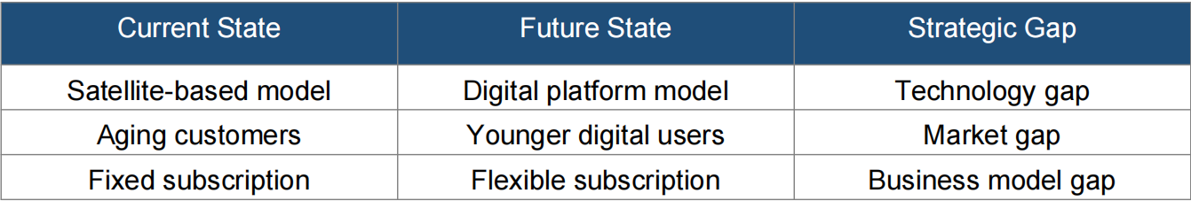

With regards to the gap analysis, the three main gaps that require transformation are:

● Firstly, the technology gap is due to the antiquated satellite technology that is used by Sky.
There is a challenge in speeding up the movement to a satellite cloud-based system as seen by Netflix.
● Secondly, the market gap constitutes a change in the target market.
The targeted population is presumed to be youthful. These people want a bit more control over what they can access on their mobile devices.
● Lastly, the business model gap is a decrease in the attractiveness of fixed bundle subscriptions.
This is seen in relation to a population that wants to be part of the subscription economy.

These gaps clearly justify intentional digital transformation.

3.3 SMART Objectives

To translate this vision into practical action, we define the following SMART objectives:

● Increase digital subscribers to 60% in 3 years.
This is a target that decreases revenue concentration of satellites and reduces structural risks.
● Reduce capex in infrastructure 30% in 2 years.
This is aimed at improving efficiency to Sky.
● Build next-gen OTT in 18 months.
One to many OTT services is the solution to compete and keep customers.
● Retention rate to 85% in 2 years.
Retained customers = customer loyalty and satisfaction of the platform.

Conclusively, the “Where are we going?” section informs us that Sky TV will be highly competitive in terms of market size not only because it is digital but because it has the attributes of a growth-oriented platform model, which is the model most copyright-based media in more digitally advanced markets are migrating to from a robust platform model.

How Will We Get There?
Sky TV’s digital transformation requires amazing scale and upside opportunities, but sky requires transformational alignment to change beyond the technology. For strategy, organisation and culture. From the dynamic perspective, dynamic dynamic: mobilise sensing, seizing and transforming (book) to the environment turbulence (Teece, 2007). For Sky, this means transformational alignment to implementation. This will include platforming, operational restructuring and performance management.

4.1 Strategic Initiatives

4.1.1 Digital Platform Development
Priority one is the establishment of a fully-integrated OTT service underpinned by a cloud platform. Leveraging cloud technologies means in the short term::
● Integrated streaming services across platforms/devices
● AI based content recommendation systems
● Customer behaviour tracking in real-time to deliver analytics
In terms of business models, this is a reconfiguration of Sky’s ‘activity system’ (Zott et al., 2011) - distribution is being opened up from satellites to an ecology driven level of digitisation, resolving the technology gap we described above. But building a platform is only meaningful if it’s left along like implantation and/or activated into a wider platform agenda of the kind discussed above.

4.1.2 Organizational Transformation
(Christensen, 1997) indicated that established firms fail when their organizational structures internally inhibit adaptation. Sky may need to altogether re-engineer their core organization to develop digital capability.
Key actions include:
● Appointing a Chief Digital Officer (CDO)
● Forming cross-functional digital teams
● Employing agile development processes
● Breaking down silo-legislated Decision-Making structures
Leadership commitment and employee engagement are part of the critical success factors for digital transformation (Mhlungu et al., 2019). Without landing on the same page internally, digital enabling runs the risk of becoming “just an IT project” versus part of a transformation process, we now arrive to the “Transforming” of dynamic capabilities (Teece, 2007).

4.1.3 Cost Reallocation and Infrastructure Rationalization
To reduce CPE on satellite infrastructure by 30%, Sky must gradually shift investment from legacy satellite assets to scale digital assets. This entails:
● Phased reduction of satellite operations
● Reinvestment into cloud technologies
● Optimization of content acquisition spending
This change in cost structure enables greater financial flexibility while enhancing sustainability.

4.1.4 Customer-Centric Digital Engagement Strategy
Retention uplift to 85% will need:
● Suggest tailored content
● Subscription terms as per your needs
● Better mobile access
● Design & interface
A shift from Sky being transactional, to saying they’re part of a relationship, a data ecosystem.

4.2 Implementation Roadmap
The transformation should follow a phased approach:
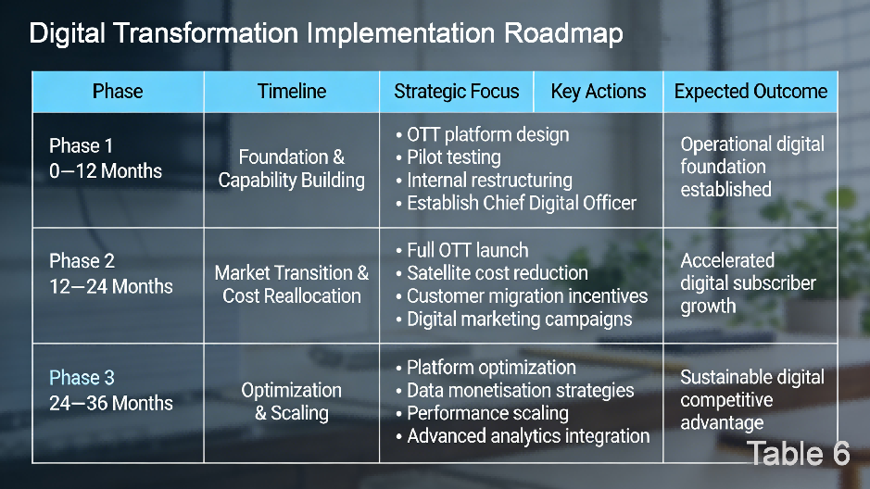
A staged roadmap that mitigates operational risks and permits service delivery.

4.3 Communication and Change Management
Reduce resistance therefore also by communicating effectively. Internally, make sure staff know:
● Strategic necessity of change
● Employee reskilling initiatives
● Exact performance expectations
Externally, Sky has to change its identity from “satellite broadcaster” into “digital sports platform”. Transparency inspires trust in stakeholders and lowers anxiety.

4.4 Performance Monitoring and Governance

To ensure accountability, quarterly board-level reviews should evaluate:
● Digital subscriber growth
● Cost reduction milestones
● Platform engagement metrics
● Retention rates
These KPIs align closely to SMART goals and provide metrics for measuing transformation progress.
Table 5: KPI Evaluation Dashboard
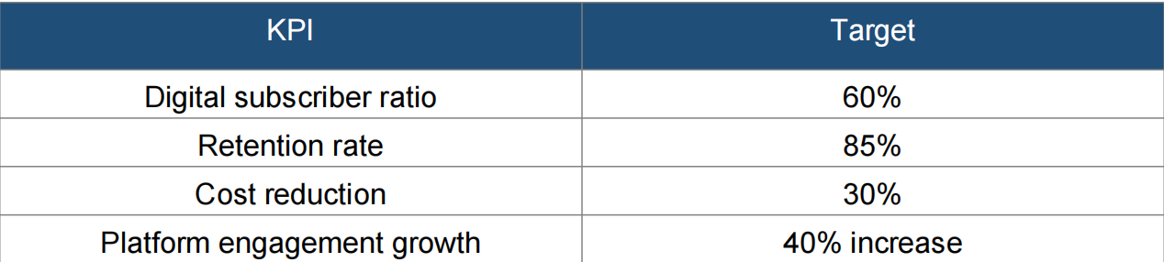

4.5 Strategic Reflection

Sky TV’s conversion is more than digital. Longevity, as per told by dynamic capabilities (Teece, 2007), from sam the content inputs with a fusion of key digital, core to user, supplants digital. Supplement chronic, but sbeidth on the whole lineage, the videogame gauntlet is the renewal of the news package (news) hybrid a broadside sky game, not reality. Comprehensive well organized set strategy, discipline and user engagement is the intermediate link that getting to help trick from a stand-alone videogame gauntlet industry character to a dominating game structure character online media.

Conclusion

Digital disruption forced the television industry to shift from traditional linear patterns of viewing. The digital streaming will force Sky TV to migrate from satellite to digital streaming. Using disruptive innovation (Christensen, 1997), Dynamic Capabilities (Teece, 2007) and Business Model (Zott et al., 2011), this report is a clear transformational plan in coherence. Measurable and achievable SMART goals, clear creative focus and effective capability performance management processes will make Sky TV achievement sustainable competitive advantage a success. Transformational activity is the only option for success.

Reference

Clayton, C. (1997). The Innovator’s Dilemma When New Technologies Cause Great Firms to Fail.
Evens, T., & Donders, K. (2018). Platform power and policy in transforming television markets. https://doi.org/10.1007/978-3-319-74246-5
Guo, L., & Xu, L. (2021). The Effects of Digital Transformation on Firm Performance: Evidence from China’s Manufacturing Sector. Sustainability, 13(22), 12844. https://doi.org/10.3390/su132212844
Li, T., Wen, J., Zeng, D., & Liu, K. (2022). Has enterprise digital transformation improved the efficiency of enterprise technological innovation? A case study on Chinese listed companies. Mathematical Biosciences & Engineering, 19(12), 12632–12654. https://doi.org/10.3934/mbe.2022590
Lobato, R. (2020). Netflix Nations. In New York University Press eBooks. https://doi.org/10.18574/nyu/9781479882281.001.0001
Lotz, A. (2017). Portals. https://doi.org/10.3998/mpub.9699689
Mhlungu, N. S., Chen, J. Y., & Alkema, P. (2019). The underlying factors of a successful organisational digital transformation. South African Journal of Information Management, 21(1). https://doi.org/10.4102/sajim.v21i1.995
M.Christensen, C. (1994). The innovator’s dilemma When new technologies cause great firms to fail.
Teece, D. J. (2007). Explicating dynamic capabilities: the nature and microfoundations of (sustainable) enterprise performance. Strategic Management Journal, 28(13), 1319–1350. https://doi.org/10.1002/smj.640
Zott, C., Amit, R., & Massa, L. (2011). The business model: recent developments and future research. Journal of Management, 37(4), 1019–1042. https://doi.org/10.1177/0149206311406265

