

Program: MM2603
Subject: 8271 Maori Business Leadership Models
Assessment 02 – Individual

Assignment Title: Navigating Global Expansion Through Māori Leadership: A Case Analysis of Te Kete Aronui’s Organisational Challenges and Strategic Opportunitie

Student Name: Xue Jiang
Student ID: 109742
Instructor: Meripa Toso
Word Count: 2585
Due Date: 20.06.2026

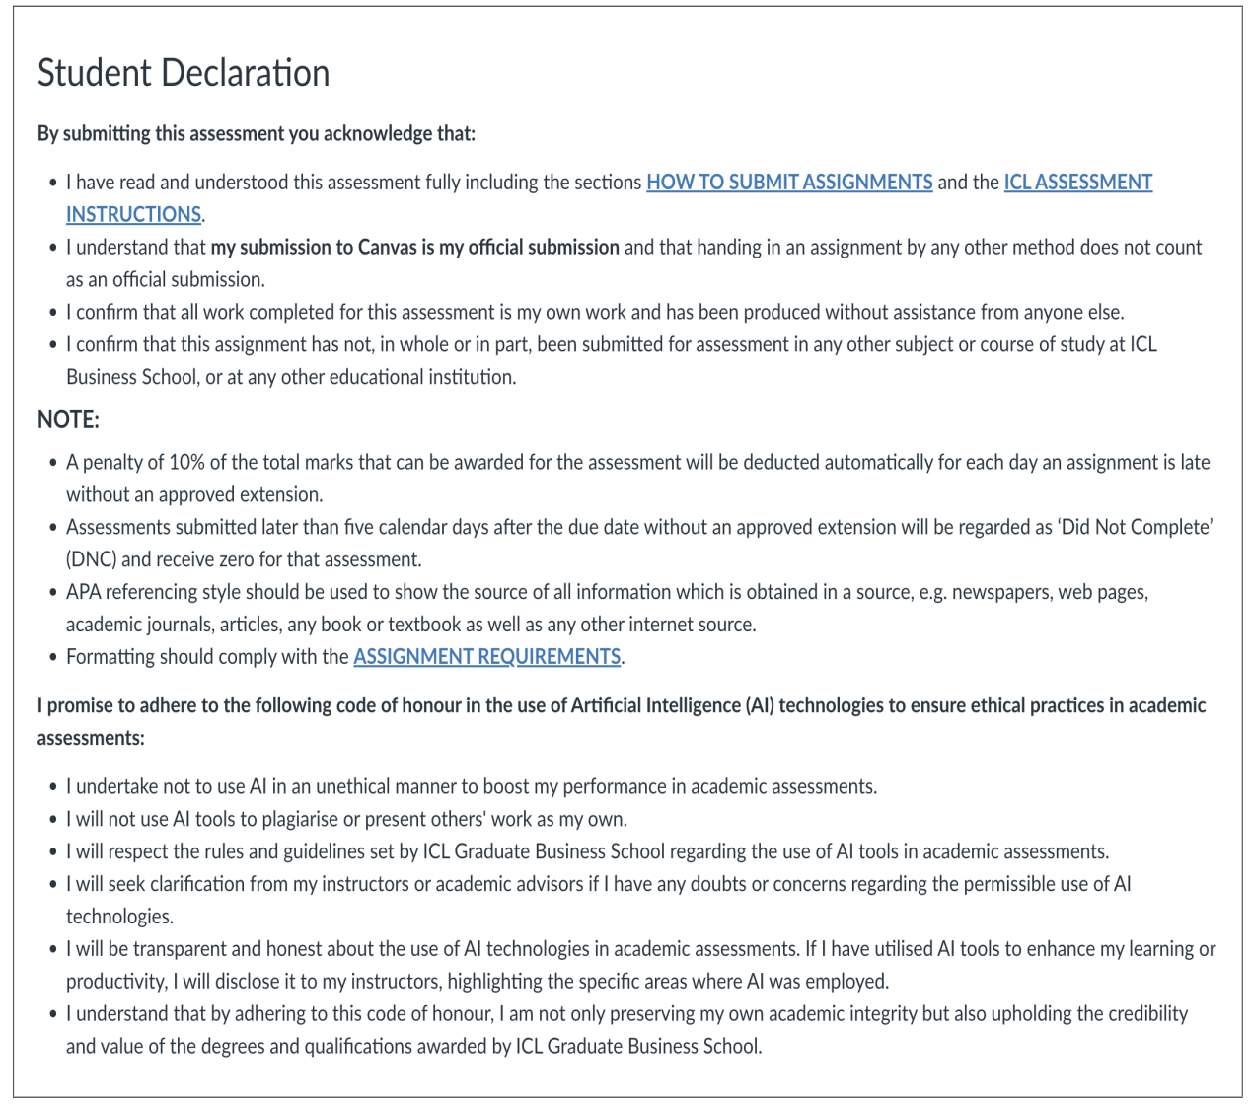

Table of contents

1. Introduction 1
2. Part 1: Diagnosing the Organisational Problem Through a Māori Lens 2
3. Part 2: Benefits of a Māori Approach to Leadership 4
4. Part 3: Application: Solving the Organisational Problem 6
5. Part 4: Critical Reflection 8
6. Conclusion 9
References 11

Navigating Global Expansion Through Māori Leadership: A Case Analysis of Te Kete Aronui’s Organisational Challenges and Strategic Opportunities

Introduction

Te Kete Aronui (TKA) is on a journey of strategic organisational growth as it embarks on expanding from being a successful local business to becoming a significant player in the international market. Although the new contract with a major retailer in the United States of America appears to be a positive opportunity, it has brought to the surface the tension between profit and the values that have defined the company's modus operandi. Even though the tension in the case is presented in the guise of operational issues, such as the excessive demand on the production line, a lack of staff morale, and problems with the supply chain, these are problems that are a result of a disjunction between the operational systems of the business and the Mori values that shape, inform, and define the organisational culture.

Mori principles of leadership deal with the common good, with relationships being the major point, care for the world, and priorities of long-term ecological and economic results as compared with short-term profits (Henry & Pene, 2001; Walker et al., 2006). Given that TKA is scaling up production and creating a culture of efficiency to meet the needs of the global market, it appears that the company is gradually sidelining these principles in the course of its decision-making. For this reason, the focus of the National Security Agency has shifted, and myriad problems are now being faced by the company, not only one of the personnel problems, encompassing the wellbeing and the engagement of the personnel, but also concerning its legitimacy as a company with recognizable identity of social and ecological sustainability.

This article holds that the current main problems of TKA are the leadership and values alignment issues on the one hand, and business issues on the other hand. Through the analysis that employs the notions of Mori leadership, whanaungatanga, and kaitiakitanga, one can conclude that the two main concepts have indeed contributed to the weakening of the bonding, and also to the reputational risk, both internal and external. Moreover, this study also claims that practicing authentic Mori leadership is a practical method for adding support to the internationalisation process and, at the same time, building trust, legitimacy, and sustainability of the organisation.

Part 1: Diagnosing the Organisational Problem Through a Māori Lens
The issues at Te Kete Aronui (TKA) may be apparent from the roadmap of Mori leadership rather than a business management and operational plan focusing on efficiency and profit maximization. Whanaungatanga and kaitiakitanga are two concepts that the Mori seem to have neglected during the hasty expansion of the business. The decline of both values has spawned the unrest within the company’s ranks and the risky status of reputation right now.

Whanaungatanga
Whanaungatanga refers to the development of meaningful relationships, mutual obligations, and a shared sense of belonging. Within Mori leadership traditions, organisational success is built upon strong relationships and collective participation rather than hierarchical authority alone (Henry & Pene, 2001). Effective leadership therefore requires ongoing engagement between leaders and employees.

The case shows that one of the most important ways of strengthening whanaungatanga at TKA has considerably weakened. Responding to the employee survey showed the decrease of morale and sense of growing disconnection between senior management and production staff. Long-serving staff members believe that the organisational values are being set aside in order to reach production targets and for commercial purposes. From an indigenous perspective, this represents a fracture of the relational trust, not just a communication issue.

The impact is wider than employee dissatisfaction. The Mori leadership principles suggest employees’ involvement in decision-making and ownership of goals (Walker et al., 2006). Trust and commitment are compromised when staff believe they are being left out of decisions that impact them. This is warranted by research that employees’ connection to organisational goals improves their commitment towards the institution (Kahn, 1990; Saks, 2006). The collapse of Whanaungatanga is therefore a strategic risk as it undermines engagement and commitment at a time when collaboration and working together are crucial to Woolworths’ global growth.

Kaitiakitanga
Kaitiakitanga is the trusts’ stewardship, the guardianship of their resources, their relationships, and the community well-being for the future (Harmsworth & Awatere, 2013). Kaitiakitanga is linked to environmental and ethics and integrity for the organisation.

TKA has done quite a good job in sustainability and ethical sourcing. Still, TKA may find itself in a situation where its commercial goals are being met, although at the cost of company values, so that there is a greater gap between the two; this is due to the labor exploitation in the overseas supply chain. Even if these are unproven claims, they still represent a real danger to TKA's image. They are mostly true because the community perceives TKA as a good international corporate citizen that handles its environment well. Thus, this has given TKA an advantage over its competitors in the international market.

Through this Mori lens, kaitiakitanga extends beyond the physical and financial attributes to include also non-physical attributes like reputation and stakeholder trust. Research has found that unethical supply chain practices can rapidly diminish legitimacy (Seuring & Müller, 2007). Similarly, stakeholders’ long-term perspectives are highlighted by the stakeholder theory which posits that building trust with customers, staff, suppliers, and the community, rather than profitability, is crucial for survival (Jones, 1995; Freeman, 1984).

The dilution of kaitiakitanga creates a major strategic dilemma for TKA . By focusing more on the speed of growth than appropriate governance of ethical standards, TKA’s leaders may create a situation where the unique selling proposition of the organisation is significantly compromised. As such, possible reputational risks faced by TKA should not be restricted to the potential outcomes of dealing with bad publicity. Rather, risks could be seen as linked to poor governance making the future of the organisation in a global marketplace unsecure.

Part 2: Benefits of a Māori Approach to Leadership
A consistent Mori approach to leadership provides specific benefits for organizations in complex international markets. Internationalization has raised a number of issues regarding employee participation, confidence of stakeholders and future viability for Te Kete Aronui (TKA). Mori leadership values offer means for resolving these concerns while also consolidating the organization’s competitive position. Improved employee involvement through whanaungatanga, higher credibility of the organization to kaitiakitanga, and better devised internal position in the market to rangatitiratanga are three specific the advantages.

Strengthening Employee Engagement Through Whanaungatanga
The first advantage of Mori leadership is the enhancement of employee engagement through whanaungatang. Mi leadership fosters a sense of whanaungatanga, which prioritises building relationships, a sense of community, and collective responsibility instead of perceiving employees merely as economic assets (Henry & Pene, 2001). Therefore, it is a suitable approach to tackle the issues of dwindling morale and the widening rift between management and the production team at TKA.

Research suggests that employees are more committed when they feel valued, heard, and connected to organisational goals (Kahn, 1990; Saks, 2006). Mori leadership promotes this through participation, dialogue, and collective ownership of organisational outcomes. Walker et al. (2006) similarly highlight the importance of collaboration and shared decision-making. For TKA, greater consultation between leaders and employees would help rebuild trust, improve organisational alignment, and strengthen resilience during expansion. Consequently, whanaungatanga provides both cultural and strategic benefits by supporting workforce commitment and organisational cohesion.

Strengthening Organisational Legitimacy Through Kaitiakitanga
A second advantage is the strengthened legitimacy of the organisation through kaitiakitanga. The principle of stewardship requires leaders to act with integrity and accountability while respecting resources, nurturing relationships, and enhancing the wellbeing of all stakeholders (Harmsworth & Awatere, 2013).

The principle focuses on the international supply chain issues of TKA. While the claims of unethical labor practices through power abuse are not proven yet, if they turn true, TKA's reputation will be under pressure. TKA is known for its sustainable practices and ethical standards. The same thing happens when cultural Mori legitimacy is inappropriately expressed, where TKA values can be lost. The in-depth research and results published about sustainable supply chains have termed businesses with inoperable ethics as having low stakeholder trust, and so, public relations is at stake (Seuring & Müller, 2007). As per stakeholder theory, a corporation will prosper as an organization if it focuses more on creating value for stakeholders rather than short-term profits (Jones, 1995; Freeman, 1984). For TKA, the preservation of a good reputation and competitive edge might be done through enshrining high standards of reliable and fair sourcing.

Enhancing Strategic Sustainability Through Rangatiratanga
The third advantage is that sustainable strategy can be delivered through rangatiratanga. Usually related to quality governance and self-determination, rangatiratanga enforces the leaders' comprehension of both short-term business goals and long-term community interests (Mutu, 2018; Mutu, 2019).

Such an idea is particularly crucial for TKA's growth trajectory. The gains from expansion, despite being immediate, may also ruin the basis of trust, company culture, and ethics. Mori's research on business suggests that the companies achieving success have a manifold goal, which includes social, cultural, environmental, as well as economic objectives (Spiller et al., 2004). Similarly, the Indigenous perspectives of leadership include the principle of stewardship and the wellbeing of the community as the key tenets of good leadership (Pio & Waddock, 2016). It is through the concept of rangatiratanga that TKA will be able to achieve its pursuit of overseas expansion while ensuring that the company's values and culture are protected, thus holding a sustainable competitive advantage.

Part 3: Application: Solving the Organisational Problem
In order to solve the international scale challenges, Te Kete Aronui (TKA) needs more than operational amendments. TKA needs a leadership approach to bring business practices back in line with Mori values that established TKA’s identity and competitive advantage. Out of the many Mori business practices, whanaungatanga and kaitiakitanga are two that provide a practical application to both internal morale and external reputational issues.

Principle 1: Whanaungatanga – Rebuilding Internal Alignment and Employee Engagement
In response to the waning enthusiasm and the widening gap between the workforce and the administration, TKA should establish a formal Employee-Management Hui process. This initiative would establish recurring hui involving executive leaders, managers, and employees to address operational challenges, organizational priorities, and decisions regarding international expansion.

The center of the program is the relationship based on trust and responsibility rather than communication. The leadership of Mori states that the decisions-making process can only be done using the participation and collaboration of people instead of the use of power (Henry & Pene, 2001; Walker et al., 2006). The present manifestation of staff complaints is that many of them do not think that they have participated in the decisions which refer to their work and the future of the institute.

The hui process offers a platform for employees to express their views about pressures relating to workload, production methods, and organisational values, fostering the basis of trust and ameliorating the gap between leadership decisions and employee expectations. When employees perceive their contributions as valued and impactful, they become more engaged and productive (Kahn, 1990; Saks, 2006). With TKA’s progress towards international expansion, particularly with those employees who may experience limited mobility away from their home country, the need for strong internal relationships is bolstered to ensure organizational alignment with long-term objectives.

Principle 2: Kaitiakitanga – Strengthening Ethical Stewardship and Reputation Management
To proactively address reputational risks surrounding ethical sourcing matters, TKA should create a framework of 'Kaitiakitanga' as an Ethical Supply Chain Assurance Framework whereby there exists features such as independent suppliers, strict oversight on labour conditions, compliance requirements for suppliers, and public reporting on a yearly basis of ethical source performance.

The idea is to ensure that the growth takes place in accordance with the collective principles of stewardship and ethics. Kaitiakitanga calls for every leader to not only safeguard resources and relationships with stakeholders at present but also to buy the reputation and trust of the future (Harmsworth & Awatere, 2013). Since TKA's brand on a global level is established on sustainability and ethics, any nonconformity to it could risk a relationship with its stakeholders.

Supply chain governance can lower reputation risk and enhance stakeholder confidence (Seuring & Müller, 2007). In addition, stakeholder theory identifies the need for customer, employee, community, and supplier consensus for long-term success (Jones, 1995; Freeman, 1984). By incorporating kaitiakitanga in supplier governance, TKA may lower its reputation risk, enhance its legitimacy, and improve its competitive advantage in the market.

Part 4: Critical Reflection
While Mori perspectives to leadership contribute to the fields of ethical leadership, stakeholder engagement, and sustainable development, they are challenged in their relevance in business contexts, particularly in the global marketplace. Te Kete Aronui (TKA) operates in the global marketplace where Western business values such as efficiency, speed of growth, and near-term profit-making are sometimes prioritized. There is a possibility for conflicting values between Western and Mori leadership in a business context as the latter relates to short-term profit-making as the primary reward.

One of the central causes of miscommunication is either fast profit or long-term sustaining. Mori governing system is based on the idea of communal well-being, obligations to the following generations, and the balance of concepts and tools for an extended period (Mutu, 2018; Mutu, 2019). Moreover, Mori economies notion of success is rather wide, which implies that socio-economic and general cultures and environmental and financial rewards should be taken into account, too. However, the product’s position in the international market necessitates fast reacting to the market’s demands and demands, as well as fast reaction time, and the stakeholders’ necessity to be pleased.

The pressure associated with TKA’s United States contract illustrates this challenge. Decisions that maximise short-term profitability, such as accelerating production or reducing oversight costs, may appear commercially rational, yet these actions can undermine employee trust, ethical standards, and organisational legitimacy, ultimately weakening long-term performance. Research on Indigenous leadership suggests that sustainable organisational success depends upon maintaining balance between economic objectives and collective wellbeing rather than privileging one at the expense of the other (Pio & Waddock, 2016).

It seems rather apparent that notions of Mori leadership and western leadership are incompatible. Yet, an appropriate contemporary leader may have to fuse the advantages of all fronts. The business discipline is essential for the survival of an organization yet Mori leadership encompasses a fuller conception of value-centric ideology in order to establish trust and resilience with its stakeholders, hence sustainability. Therefore, the dilemma for TKA is to realize that neither profit nor Mori leadership principles should rise to priority but an archetype of a model that can be depended upon both externally and internally based on the influenced whole of the respective organization and the represented legitimacy of other stakeholders.

Conclusion
This analysis has demonstrated that the Te Kete Aronui current issues are more about leadership and values than about business operations. Exploring TKA’s challenges using a Mori leadership lens, tensions and threats against TKA’s legitimacy are more linked to internal conflicts, with observable flaws in whanaungatanga and kaitiakitanga following a steep growth curve. This paper has shown that Mori leadership frameworks offer powerful, bold, and alternative solutions to enhance employee voice, assert the organisation’s legitimacy and ensure global scaling can be achieved sustainably. Even with recognised conflicts between Mori principles and global capitalism’s short-termism, Mori leadership is not a hindrance to TKA business performance. On the contrary, Mori leadership allows TKA to achieve business results without undermining the legitimacy of its existence, its stakeholder engagement, and its sustainability offering. Doing the right thing by implementing Mori leadership is critical for TKA to navigate an increasingly unwieldy global landscape.

References

Alexander, J. M., & Buckingham, J. (2011). Common good leadership in business management: An ethical model from the Indian tradition. Business Ethics: A European Review, 20(4), 317–327. https://doi.org/10.1111/j.1467-8608.2011.01632.x

Came, H., O’Sullivan, D., Kidd, J., & McCreanor, T. (2016). The Waitangi Tribunal’s WAI 2575 report and institutional racism. International Journal for Equity in Health.

Dinh, J. E., Lord, R. G., Gardner, W. L., Meuser, J. D., Liden, R. C., & Hu, J. (2013). Leadership theory and research in the new millennium: Current theoretical trends and changing perspectives. The Leadership Quarterly, 25(1), 36–62. https://doi.org/10.1016/j.leaqua.2013.11.005

Dorfman, P., Javidan, M., Hanges, P., Dastmalchian, A., & House, R. (2012). GLOBE: A twenty year journey into the intriguing world of culture and leadership. Journal of World Business, 47(4), 504–518. https://doi.org/10.1016/j.jwb.2012.01.004

Freeman, R. E. (1984). Strategic management: A stakeholder approach. Pitman.

Harmsworth, G. R., & Awatere, S. (2013). Indigenous Māori knowledge and perspectives of ecosystems. AMBIO.

Henry, E., & Pene, H. (2001). Kaupapa Maori: Locating Indigenous ontology, epistemology and methodology in the academy. Organization, 8(2), 234–242. https://doi.org/10.1177/1350508401082009

Jones, T. M. (1995). Instrumental stakeholder theory: A synthesis of ethics and economics. Academy of Management Review, 20(2), 404–437. https://doi.org/10.5465/amr.1995.9507312924

Judge, T. A., & Piccolo, R. F. (2004). Transformational and transactional leadership: A meta-analytic test of their relative validity. Journal of Applied Psychology, 89(5), 755–768. https://doi.org/10.1037/0021-9010.89.5.755

Kahn, W. A. (1990). Psychological conditions of personal engagement and disengagement at work. Academy of Management Journal, 33(4), 692–724. https://doi.org/10.5465/256287

Mutu, M. (2018). Behind the smoke and mirrors of the Treaty of Waitangi claims settlement process in New Zealand: No prospect for justice and reconciliation for Māori without constitutional transformation. Journal of Global Ethics, 14(2), 208–221. https://doi.org/10.1080/17449626.2018.1507003

Mutu, M. (2019). The treaty claims settlement process in New Zealand and its impact on Māori. Land, 8(10), 152. https://doi.org/10.3390/land8100152

Ormond, A., Cram, F., & Carter, L. (2006). Researching our relations: Reflections on ethics and marginalisation. AlterNative: An International Journal of Indigenous Peoples, 2(1), 174–193. https://doi.org/10.1177/117718010600200108

Pio, E., & Waddock, S. (2016). Indigenous wisdom and collective leadership. Journal of Organizational Change Management.

Reid, P., Cormack, D., & Paine, S. J. (2019). Colonial histories, racism and health—The experience of Māori and Indigenous peoples. Public Health, 172, 119–124. https://doi.org/10.1016/j.puhe.2019.03.027

Saks, A. M. (2006). Antecedents and consequences of employee engagement. Journal of Managerial Psychology, 21(7), 600–619. https://doi.org/10.1108/02683940610690169

Seuring, S., & Müller, M. (2007). Core issues in sustainable supply chain management: A Delphi study. Business Strategy and the Environment, 17(8), 455–466. https://doi.org/10.1002/bse.607

Sims, R. R., & Sims, S. J. (1991). Increasing applied business ethics courses in business school curricula. Journal of Business Ethics, 10(3), 211–219. https://doi.org/10.1007/BF00383158

Spiller, C., Erakovic, L., Henare, M., & Pio, E. (2004). Relational well-being and wealth: Māori businesses and an ethic of care. Business Ethics: A European Review.

Walker, S., Eketone, A., & Gibbs, A. (2006). An exploration of kaupapa Māori research, its principles, processes and applications. International Journal of Social Research Methodology, 9(4), 331–344. https://doi.org/10.1080/13645570600916049

