AI Evolution Capstone Project

- Module – AI Evolution
- Project Title – Coffee for the journey home
- Date – 7th November 2026 – To be updated throughout
- Name – Sharon Maye (Student Number 20122716)
- Repository Link – https://github.com/sharonjmaye/ai-evolution-2026-capstone
- Commit/Tag for final Version – TODO when complete
- Word Count – TODO when complete
Table of Contents
1. The Person and the Problem 2
2. The Law 3
Law in words 3
Equation 3
Law’s Shape 3
What the law leaves out 3
Values 3
Starting Value 3
Range 3
Table 1 - Constants 3
3. The Answer Sheet 5
Exact Formula 5
Solver 5
Figure – Answer Sheet 5
4. The Model - TODO 5
5. The Comparison - TODO 6
6. Checks and Limits - TODO 6
7. Large Language Models and this Problem - TODO 7
8. How I worked – AI Tools in my Workflow - TODO 7
9. Where this is heading - TODO 7
10. Conclusion - TODO 7
References – In Progress 8
Appendix A – In progress 8
Notebooks within Repo 8
Appendix B – In progress 8
Table 4 – AI Use Log 8

1. The Person and the Problem
From sample report
▪ Who would use your answer, and how they work today.
▪ What your model would change for them.
▪ Your question in one sentence, and your success test as a number.
Class example: A home baker deciding when the starter is ready to bake with; success: the height at 8 hours within 0.1 cm of the exact formula.

This project aims to determine if a coffee purchased in a takeaway cup would still be hot enough for a commuter to enjoy when they get home. It will help them determine if the coffee will still be at an enjoyable temperature when they get home or if they should drink it before leaving the coffee shop as it will be too cold then they finish their commute.
The question it aims to answer is - Can a model that learns only from Newton's law of cooling, with no measured data, predict the time to reach your target temperature for a commuter deciding whether a takeaway coffee will still be enjoyable at home?
Success would be actual temperature when they get home being within 1 degree Celsius of the predicted temperature.

2. The Law

Law in words
Newton’s Law of Cooling says that the hotter an object (coffee in our case) is compared with its surroundings , the faster it cools

Equation
How fast the temperature falls = k × (T – Ta)

Law’s Shape
One thing changes over time

What the law leaves out
The law does not consider the following
- Type of coffee cup
- If there is a lid or not
- What type of coffee eg more milk may adjust temperature
- Changing ambient temperature eg car temperature may rise throughout the journey
- Coffee may cool quicker if aircon is on and blowing towards the coffee cup

Values

Starting Value
55 Degrees Celcius

Range
We will look at the temperature drop from 0 to 60 minutes

Table 1 - Constants
What | Value | Unit | Source
Cooling Rate (k) | 0.03 | Per minute | U. H. Kurzweg (2017),"Cooling of a Cup of Coffee", University of Florida, p. 3  https://web.mae.ufl.edu/uhk/COOLING-COFFEE.pdf
Starting Coffee Temperature (T) | 55 | Degree Celcius | According to https://mtpak.coffee/2022/08/takeaway-cups-coffee-temperature-ideal-serving/  The ideal temperature for coffee in takeaway cups is 49 to 60 degrees Celsius so we will use 55 for testing purposes  Can be requested by commuter to barista when the coffee is served
Ambient room temperature (Ta) | 20 | Degree Celcius | Average internal temperature of my person car while driving
Table 1 – Your constants: value, unit, source

3. The Answer Sheet

Exact Formula
This is based on OpenStax, Calculus Volume 2, Section 2.8, "Exponential Growth and Decay", Example 2.45- https://openstax.org/books/calculus-volume-2/pages/2-8-exponential-growth-and-decay
Ta + (T - Ta) * np.exp(-k * t)

Solver
This is based on the formula provided by lecturer in initial project feedback
-k * (y - Ta)

Figure – Answer Sheet
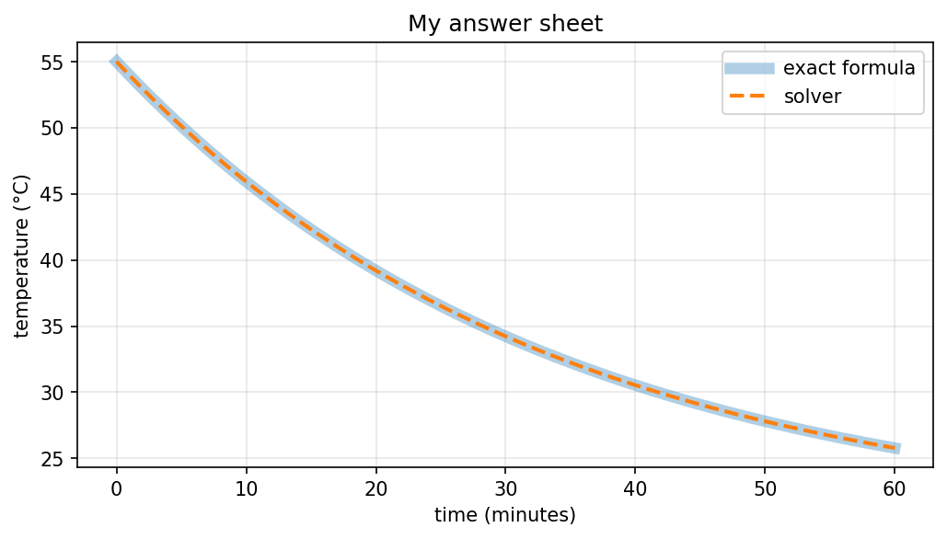

4. The Model - TODO
From sample report
How it learns from the law: guess, check against the law at the checking points, blame, nudge; no data.
▪ How the start is built in; the size of the network; the training settings.
▪ Figure: the loss curve. Figure: the model against the answer sheet.
▪ The error, and whether it passes your success test. Any problem you hit and how you fixed it.
Figures & Tables – Figure 2 – The Loss curve, Figure 3 – Your model against the answer sheet

5. The Comparison - TODO
From Sample report
How the example-learner was set up: points from your answer sheet with a little noise; same size and training time.
▪ Table: accuracy, time per answer and size for your model and each example-learner.
▪ Figure: error against the number of examples.
▪ The outside-the-range test, and the smallest version of your model that still passes your success test.
▪ Your answer to your comparison question, in one sentence with a number.
Figures & Tables – Table 2 – The comparison, accuracy, time per answer and size, Figure 4 – Error against the number of examples

6. Checks and Limits - TODO
From sample report
Table: the three checks (new points; something that must always be true; the 20% wrong-law test) with
their results.
▪ What each result means for your person.
▪ What the law leaves out, and what that means for someone relying on your model.
Class example: Must always be true: the starter never rises above the top of the jar and never shrinks.
Figures & tables – Table 3 – The three checks and their results

7. Large Language Models and this Problem - TODO
From sample report
How a large language model works, in your own words.
▪ What it would take to do your job with one: data, size, cost, accuracy; consider smaller and faster models
(Weeks 8 and 9).
▪ When an LLM would be the better choice, and when your model would.

8. How I worked – AI Tools in my Workflow - TODO
From sample report
Which AI tools you used, and for what: understanding the law, writing and fixing code, tests, the README.
▪ One example where a tool helped, and one where it was wrong, and how you found out.
▪ How these tools changed the way you worked. This must match your AI-use log.

9. Where this is heading - TODO
From sample report
Is science-inspired AI real progress or hype for your person? Use Week 1′s seven questions.
▪ Assess at least one of edge computing, federated learning or quantum approaches for your use.

10. Conclusion - TODO
From sample report
▪ Your answer to your question, the main limit, and one thing you would do next.

References – In Progress
Number/Claim | Reference
Cooling Rate per minute | U. H. Kurzweg (2017),"Cooling of a Cup of Coffee", University of Florida
Starting Coffee Temperature | https://mtpak.coffee/2022/08/takeaway-cups-coffee-temperature-ideal-serving/
Exact Formula | Strang, G., & Herman, E. (2016). Calculus Volume 2. OpenStax. Section 2.8: Exponential Growth and Decay. https://openstax.org/books/calculus-volume-2/pages/2-8-exponential-growth-and-decay

Appendix A – In progress
Repository - https://github.com/sharonjmaye/ai-evolution-2026-capstone
Final Commit – TBC

Notebooks within Repo
Notebook within Repo | Purpose, how to run and other important information eg random seeds
notebooks/capstone_step1.ipynb | Purpose - Generate answer sheet using solver and exact formula  Run – Using Google Colab

Appendix B – In progress

Table 4 – AI Use Log
Date | AI Assistance Provided, my actions and verification
7th November | AI Assistance – Used chatgpt to find citations for exact formula  Actions & Verification – Verified the citations referenced and that the formula was correct using notebooks/capstone_step1.ipynb
7th November | AI Assistance – Used chatgpt to help me find cooling constant and citation  Actions & Verification – Used the reference value in notebooks/capstone_step1.ipynb as cooling rate

