**TASK-2**

**REST API CLIENT**

**STEP 1:** Setup Your Java Environment

* Java 11 or higher is recommended.
* Create a file: WeatherFetcher.java
* Add the following external library to parse JSON:
  + Download [org.json](https://repo1.maven.org/maven2/org/json/json/20231013/json-20231013.jar)
  + Add to your classpath.

**STEP 2:** Choose an API (OpenWeatherMap)

**STEP 3:** Java code

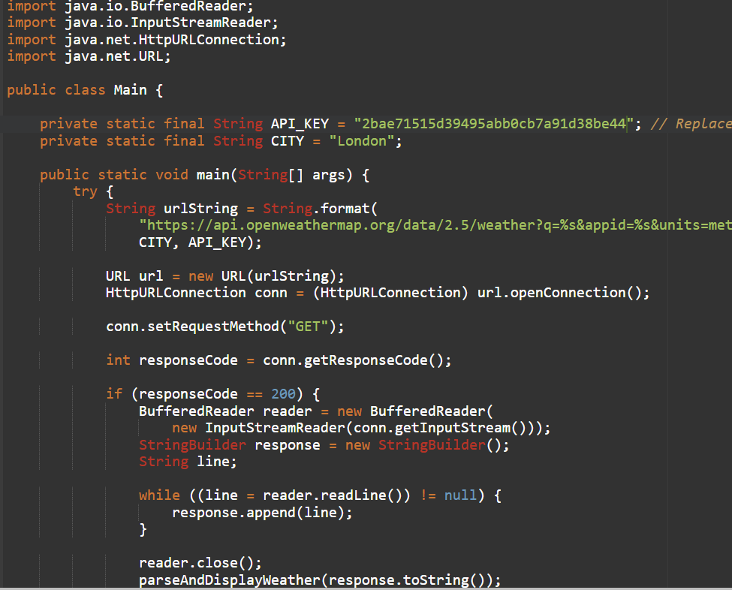

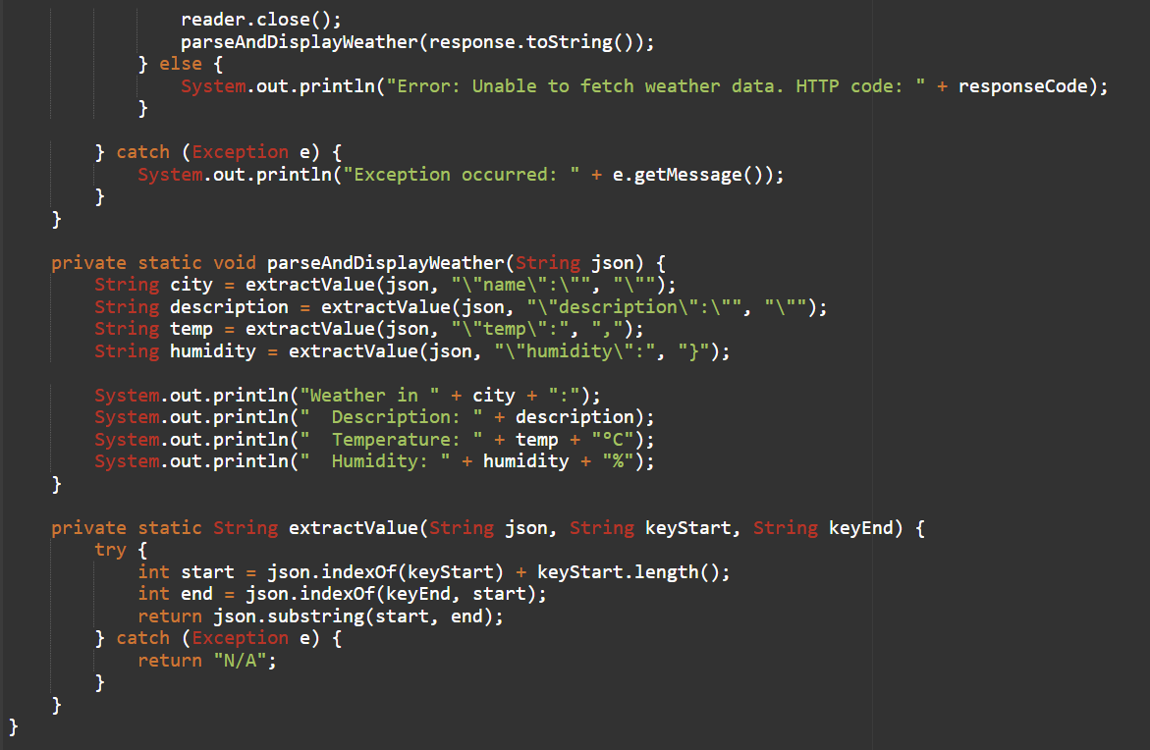

**STEP 4:**

Output 1

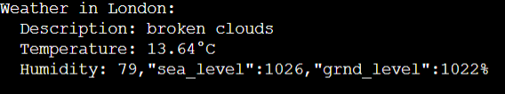

Output 2

