**TASK 4**

**AI-BASED RECOMMENDATION SYSTEM**

**STEP 1:** Create a New Java Project

Open a terminal and run:

mvn archetype:generate -DgroupId=com.recommender -DartifactId=recommender-app -DarchetypeArtifactId=maven-archetype-quickstart -DinteractiveMode=false

Go into your new project folder:

cd recommender-app

**STEP 2: Ad**d Mahout Library to Your Project

1. Open the file called pom.xml (inside your project folder).
2. Replace the <dependencies> part with this:

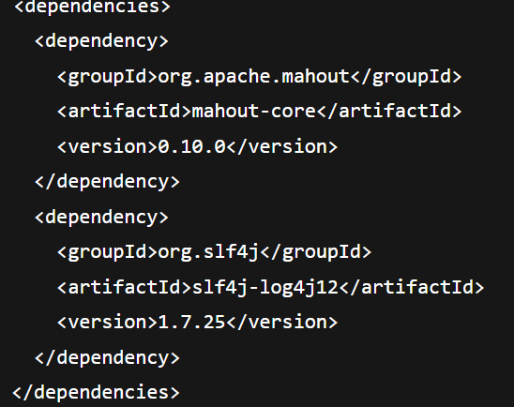

This tells Maven to download Mahout and logging libraries.

**STEP 3:** Add Sample Data

1. In the **main project folder** (where pom.xml is), create a new file called:

data.csv

1. Add this sample data to the file:

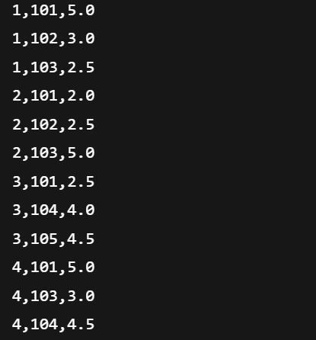

**STEP 4:** Write the Java Code

1. Open this file:

src/main/java/com/recommender/App.java

1. Delete what's inside and paste this:

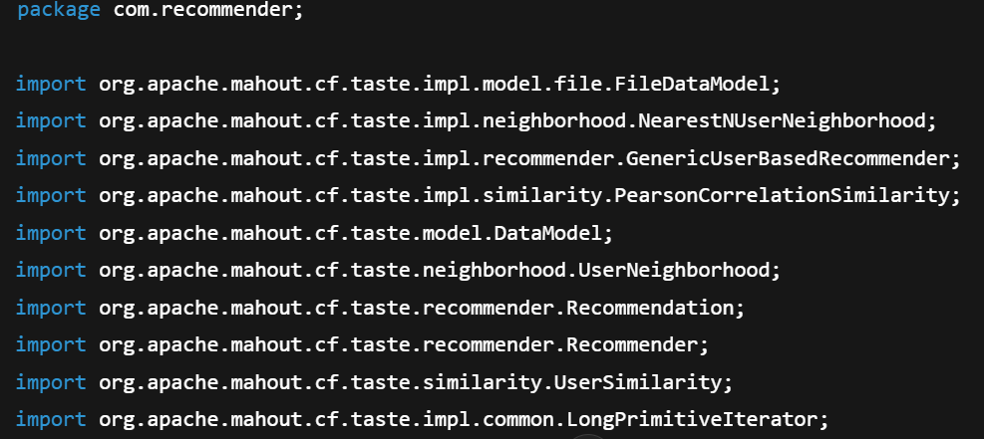

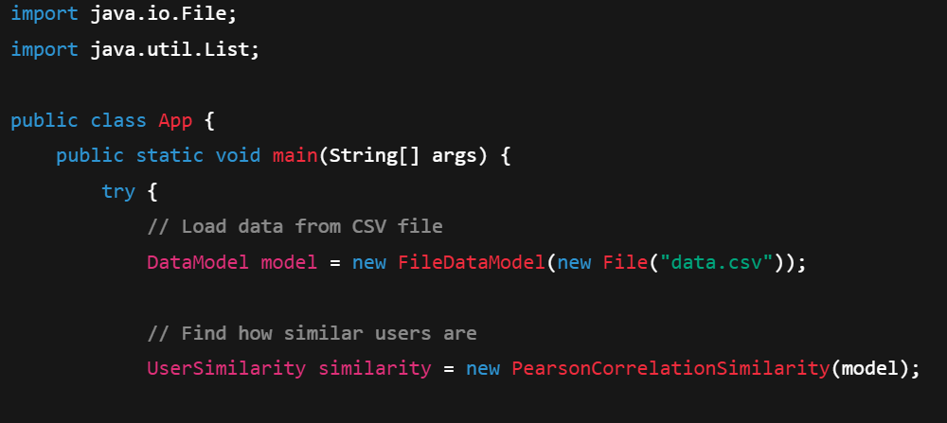

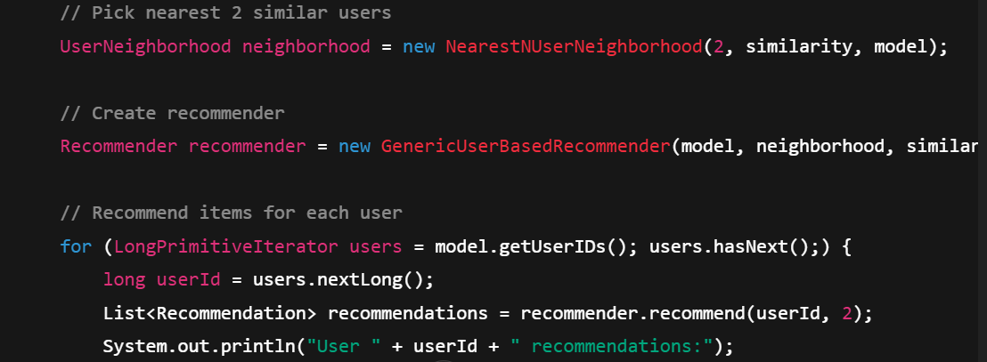

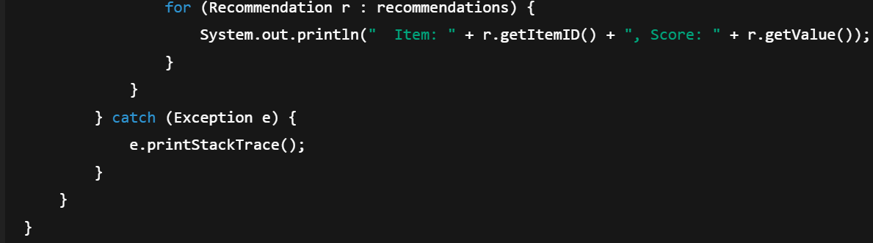

**STEP 5:** Run Your Program

1. Open terminal in the project folder.
2. First, compile the project:

mvn compile

1. Then run it:

mvn exec:java -Dexec.mainClass="com.recommender.App"

**STEP 6:** Output

