- copy "techExCpp.zip" to "E:\", and unzip it
As a result, we have "E:\techEx" folder, including eclipse (IDE), practice (source code), CppUTest (UT framework) and cygwin (C++ compiler)
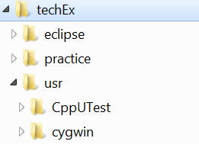
- Add E:\techEx\usr\cygwin\bin to Environment Variable "Path"
right click "Computer"
click "change settings" in the section "Computer name, domain, and workgroup settings"
click "advanced" tab
click "Environment Variables"
Find "Path" in "System variables"
click "Edit..."
append ";E:\techEx\usr\cygwin\bin" to the end
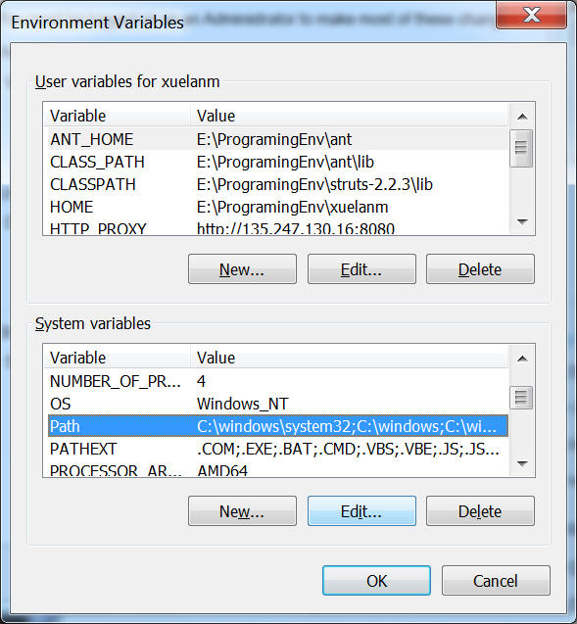

Verify Path is set correctly
open cmd.exe
e:
cd \
make -version
the output will be "GNU Make 3.82.90 ..."

- Compile CppUTest
open cygwin terminal by double click "cygwin.bat" in "E:\techEx\usr\cygwin"
cd /cygdrive/e/techEx/usr/CppUTest/
./makeAll.sh

Verify UT environment is OK

in cygwin terminal
cd /cygdrive/e/techEx/practice/UTBasic
make
the output will be "... OK (1 tests, 1 ran, 1 checks, 0 ignored, 0 filtered out, 1 ms)"

The environment for coding practice is ready unless you'd like to use eclipse as IDE

- Import practice source code in Eclipse
Depends on your system, 32bit or 64bit, go "e:\techEx\eclipse32" or "e:\techEx\eclipse64"
double click "elcipse"
input "e:\techEx\workspace" as workspace

"File" -> "New" -> "Makefile Project with Existing Code"
"Existing Code Location" -> "Browse" -> "e:\techEx\practice\UTBasic"
Choose "Cygwin GCC" as toolchain
click "Finish"

Add other project one by one the same way:
- UTAdvanced
- ShapeNBorders
- Timer
- BubbleSort

