Week 3
Seller & Inventory Management System
E-Commerce Order Management Database System
Database: amazon | MySQL

1. Seller & Inventory Table Design
Week 3 adds two tables, Seller and inventory, to the amazon database and links them to the existing Product table. The Seller table stores supplier details. The inventory table records how many units of each product a seller holds and its stock status.

1.1 Seller table
Column | Data type | Constraints | Description
Seller_ID | INT | PRIMARY KEY, NOT NULL | Unique seller identifier
Seller_Name | VARCHAR(50) | NOT NULL | Name of the seller
Phone | BIGINT | NOT NULL, UNIQUE | Contact number (10 digits)
Email | VARCHAR(50) | NOT NULL, UNIQUE | Contact email address
Address | VARCHAR(150) | NOT NULL | Seller address

1.2 Inventory table
Column | Data type | Constraints | Description
inventory_id | INT | PRIMARY KEY, AUTO_INCREMENT | Unique inventory record
product_id | INT | NOT NULL, FOREIGN KEY | References Product(Product_ID)
seller_id | INT | NOT NULL, FOREIGN KEY | References Seller(Seller_ID)
stock_quantity | INT | NOT NULL, DEFAULT 0, CHECK (stock_quantity >= 0) | Units in stock
stock_status | VARCHAR(100) | NOT NULL, DEFAULT 'Out of stock', CHECK IN ('In stock','Low stock','Out of stock') | Availability label
last_updated | DATE | DEFAULT (current_date()) | Date of last change
The pair (product_id, seller_id) is also UNIQUE, so a seller has only one inventory record for each product.

1.3 Product table (change in Week 3)
Column | Data type | Constraints | Description
Seller_ID | INT | NULL allowed, FOREIGN KEY | References Seller(Seller_ID); the seller who supplies the product

1.4 Relationships
Relationship | Type | Implemented by | Constraint name
Seller → Product | One to many | Product.Seller_ID references Seller.Seller_ID | product_seller_link
Product → Inventory | One to many | inventory.product_id references Product.Product_ID | IS_link
Seller → Inventory | One to many | inventory.seller_id references Seller.Seller_ID | IS_seller_link
All foreign keys use the default rule, so a seller or product that is still referenced cannot be deleted.

1.5 Constraints used
Constraint | Where it is applied
PRIMARY KEY | Seller.Seller_ID, inventory.inventory_id
FOREIGN KEY | Product.Seller_ID, inventory.product_id, inventory.seller_id
NOT NULL | Seller_Name, Phone, Email, Address, product_id, seller_id, stock_quantity, stock_status
UNIQUE | Seller.Phone, Seller.Email, inventory (product_id, seller_id)
CHECK | stock_quantity >= 0; stock_status must be 'In stock', 'Low stock' or 'Out of stock'

2. Updated ER Diagram
The diagram shows the Week 3 additions (highlighted) connected to the existing Category and Product tables.
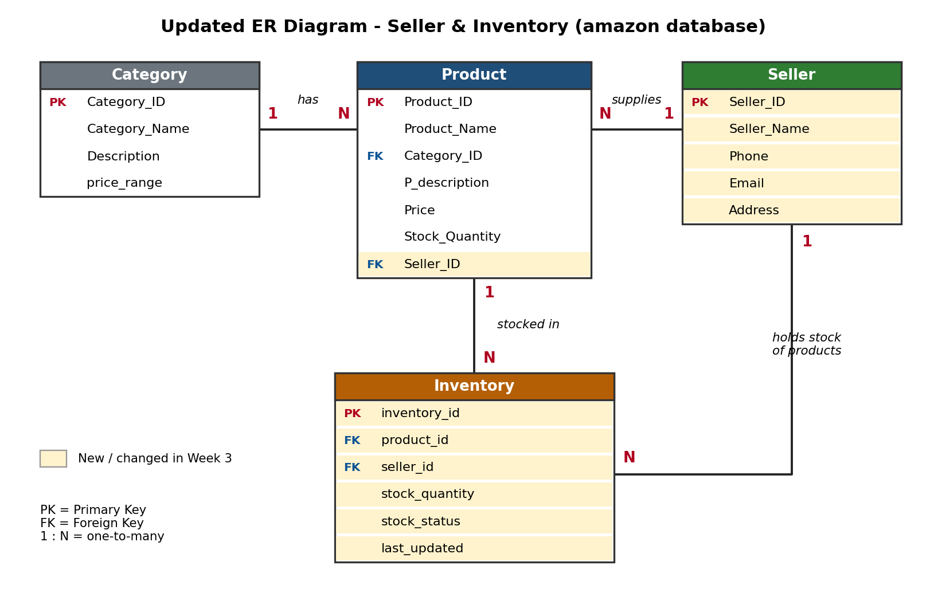
- Category to Product: one category has many products (Week 1).
- Seller to Product: one seller supplies many products, through the new Seller_ID column in Product.
- Product to Inventory: one product can have many inventory records, one per seller.
- Seller to Inventory: one seller holds stock in many inventory records.

3. Sample Seller & Inventory Data

3.1 Seller records
Seller_ID | Seller_Name | Phone | Email | Address
1 | TechZone Retailers | 9876543210 | contact@techzone.com | Chennai, Tamil Nadu
2 | GadgetHub India | 9876543211 | support@gadgethub.com | Bengaluru, Karnataka
3 | SnapMart | 9876543212 | sales@snapmart.com | Mumbai, Maharashtra
4 | Gadget World | 9876543213 | hello@gadgetworld.com | Hyderabad, Telangana
5 | Coimbatore Electronics | 9876543214 | info@cbeelectronics.com | Coimbatore, Tamil Nadu
Seller 1 is updated later (new phone and address) as part of the seller operations.

3.2 Products assigned to sellers
Product_ID | Product_Name | Price | Seller
1 | Samsung S21 | 45000 | 1 - TechZone Retailers
6 | iPhone 13 | 59900 | 1 - TechZone Retailers
7 | OnePlus 11 | 56999 | 1 - TechZone Retailers
2 | Asus Vivobook 15 | 95000 | 2 - GadgetHub India
11 | HP Pavilion 14 | 68000 | 2 - GadgetHub India
12 | Noise ColorFit Pro | 4999 | 2 - GadgetHub India
3 | Fastrack | 27000 | 3 - SnapMart
4 | Canon R10 | 78000 | 3 - SnapMart
5 | PlayStation 5 | 49900 | 3 - SnapMart
8 | Redmi Note 12 | 15999 | 4 - Gadget World
9 | Realme 11 Pro | 23999 | 4 - Gadget World
10 | Vivo V27 | 32999 | 4 - Gadget World
Seller 5 (Coimbatore Electronics) has no products assigned yet.

3.3 Inventory records
inventory_id | product_id | seller_id | stock_quantity | stock_status | Product
1 | 1 | 1 | 50 | In stock | Samsung S21
2 | 6 | 1 | 35 | In stock | iPhone 13
3 | 7 | 1 | 8 | Low stock | OnePlus 11
4 | 2 | 2 | 25 | In stock | Asus Vivobook 15
5 | 11 | 2 | 0 | Out of stock | HP Pavilion 14
6 | 12 | 2 | 60 | In stock | Noise ColorFit Pro
7 | 3 | 3 | 45 | In stock | Fastrack
8 | 4 | 3 | 0 | Out of stock | Canon R10
9 | 5 | 3 | 6 | Low stock | PlayStation 5
10 | 8 | 4 | 120 | In stock | Redmi Note 12
11 | 9 | 4 | 0 | Out of stock | Realme 11 Pro
12 | 10 | 4 | 15 | In stock | Vivo V27
This is the data as first inserted. Later operations restock HP Pavilion 14 to 30 units and delete the discontinued Realme 11 Pro record, so the analysis below uses the final 11 records.

4. Inventory Analysis Report
This report is based on the final inventory data, after the stock update and the deletion of discontinued inventory.

4.1 Key figures
Measure | Result
Inventory records | 11
Total units in stock | 394
Average inventory quantity | 35.82
Available products (stock > 0) | 10
Out-of-stock products | 1 (Canon R10, SnapMart)
Products with stock less than 10 | 3 (OnePlus 11, Canon R10, PlayStation 5)
Highest stocked product | Redmi Note 12 - 120 units (Gadget World)

4.2 Stock availability
Stock status | Products | Share of records
In stock | 8 | 72.7%
Low stock | 2 | 18.2%
Out of stock | 1 | 9.1%

4.3 Seller-wise summary
Seller | Products supplied | Inventory records | Total units | Average stock
TechZone Retailers | 3 | 3 | 93 | 31.00
GadgetHub India | 3 | 3 | 115 | 38.33
SnapMart | 3 | 3 | 51 | 17.00
Gadget World | 3 | 2 | 135 | 67.50
Coimbatore Electronics | 0 | 0 | 0 | -
Gadget World has 3 products but 2 inventory records because the Realme 11 Pro record was deleted as discontinued.
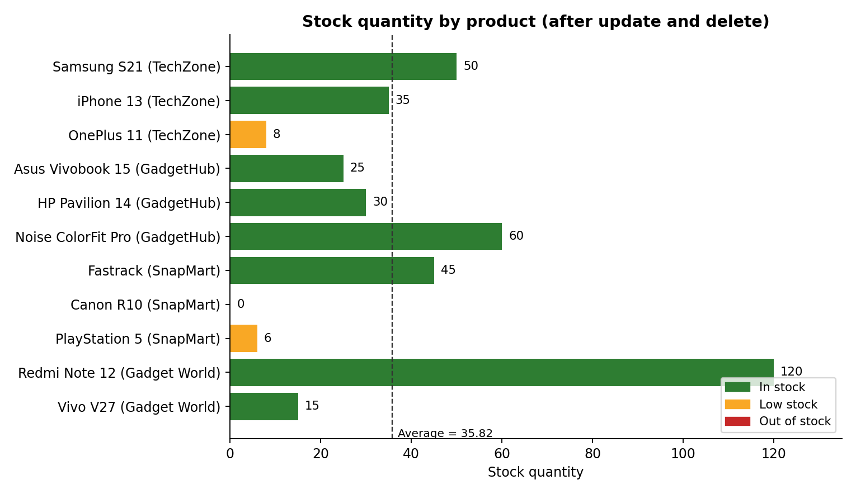
Chart: stock quantity by product, coloured by stock status.

4.4 Findings
- Gadget World holds the most stock (135 units), and Redmi Note 12 alone is about 30% of all units.
- SnapMart has the lowest average stock (17.00). It has the only out-of-stock product, Canon R10, and PlayStation 5 is low at 6 units.
- OnePlus 11 (TechZone Retailers) is low at 8 units.
- Coimbatore Electronics has no products or inventory records.

4.5 Recommendations
- Restock Canon R10, PlayStation 5 and OnePlus 11 first.
- Use a reorder level of 10 units, as in the low-stock query, to flag items early.
- Assign products to Coimbatore Electronics or review whether the seller is active.

5. Query Output Screenshots
All outputs below were produced by running the Week 3 SQL script on the amazon database, in the order the statements appear in the script. Queries run before the stock update and the delete show the earlier data.

5.1 Relationships and table structure
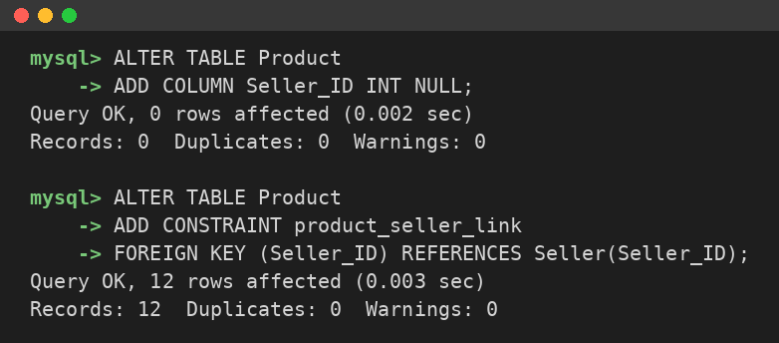
Figure 1: Seller to Product relationship (Seller_ID foreign key)
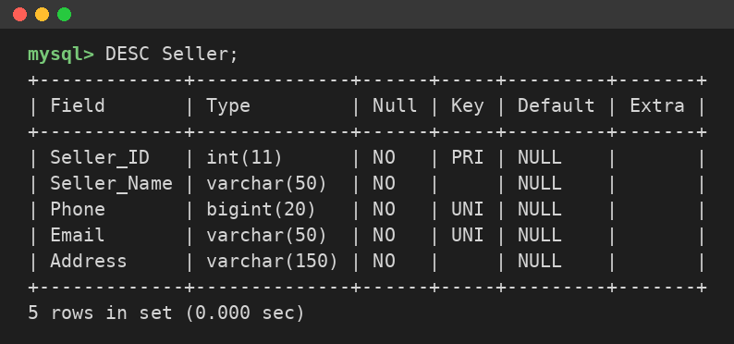
Figure 2: Structure of the Seller table
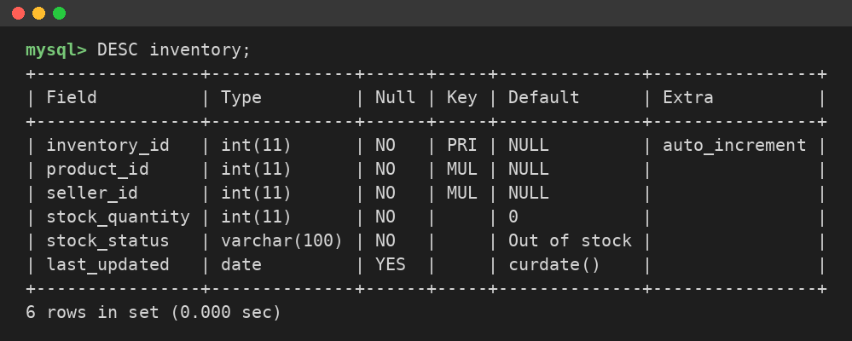
Figure 3: Structure of the inventory table

5.2 Seller & product operations
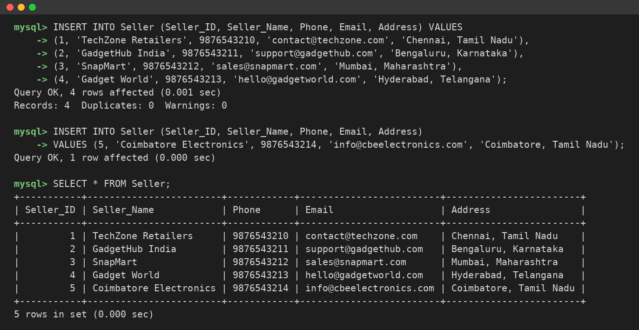
Figure 4: Add seller details
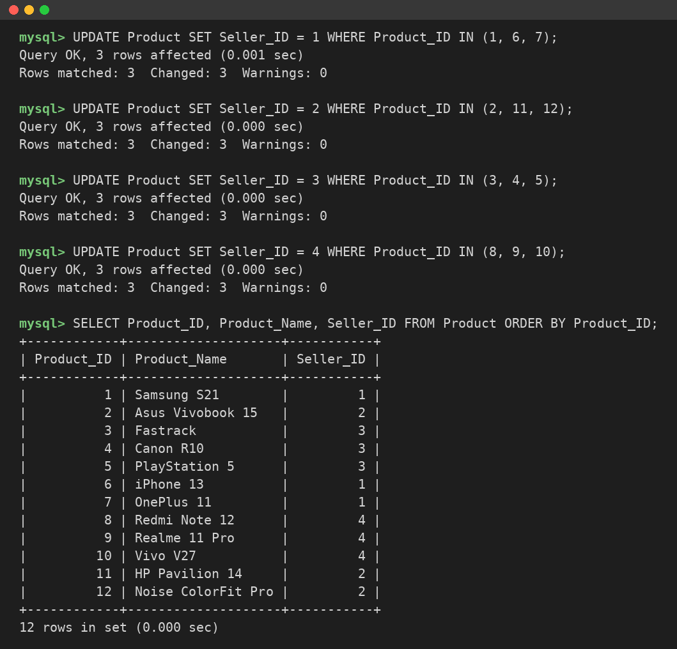
Figure 5: Assign products to sellers
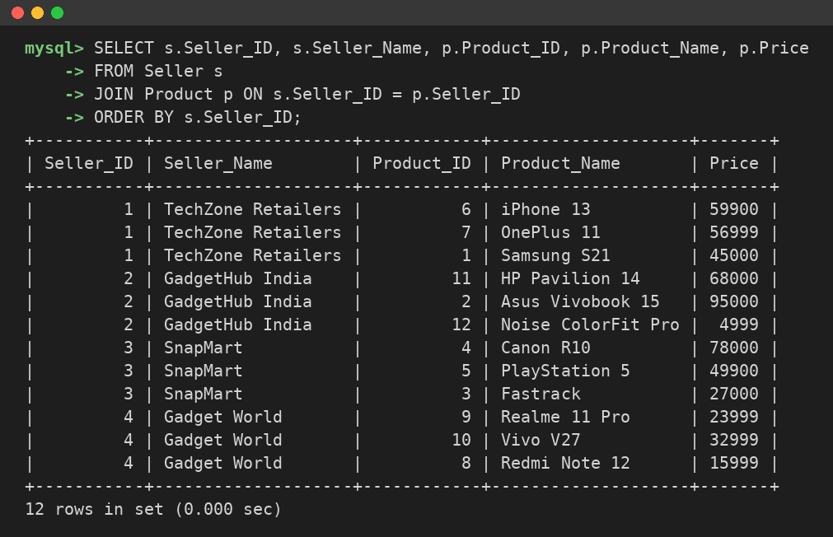
Figure 6: Display products supplied by each seller
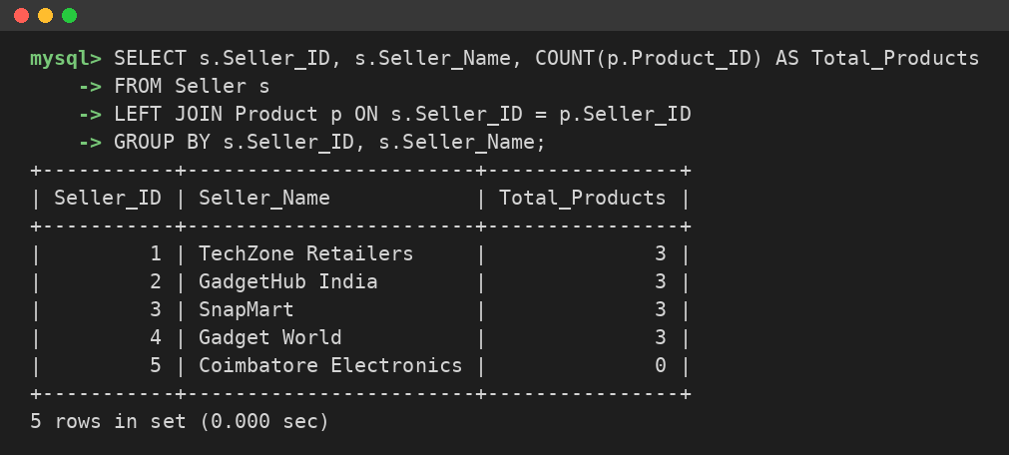
Figure 7: Count products supplied by each seller
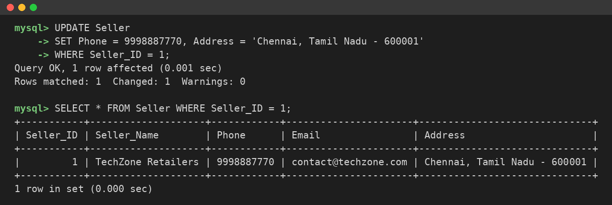
Figure 8: Update seller details

5.3 Inventory operations
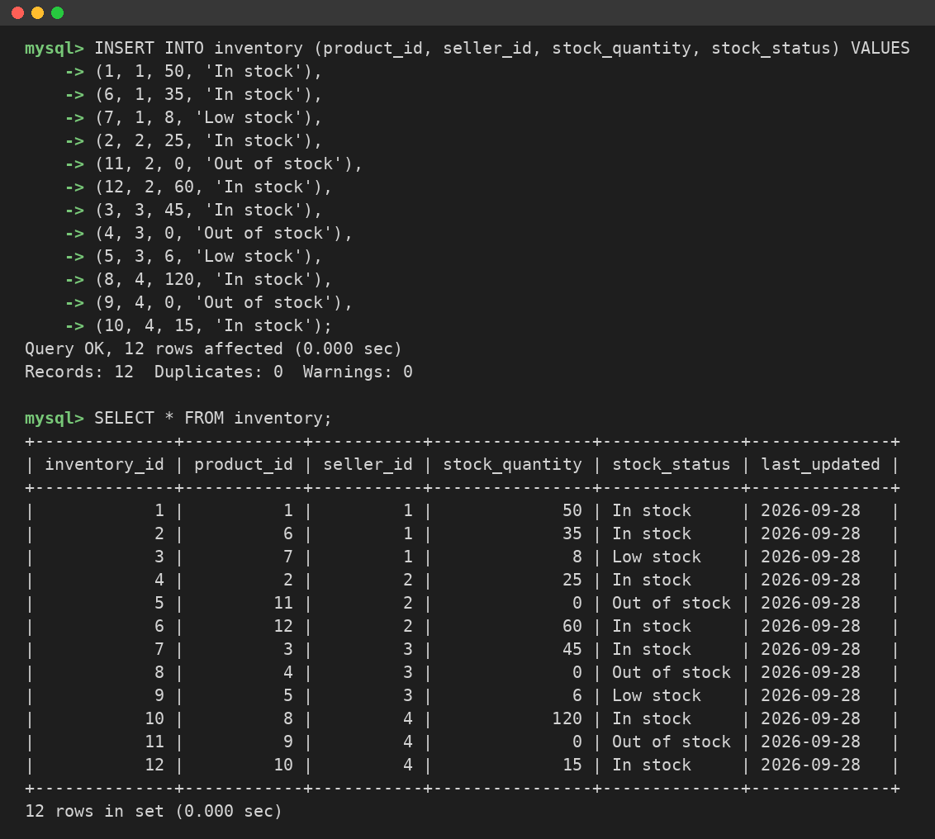
Figure 9: Insert inventory records
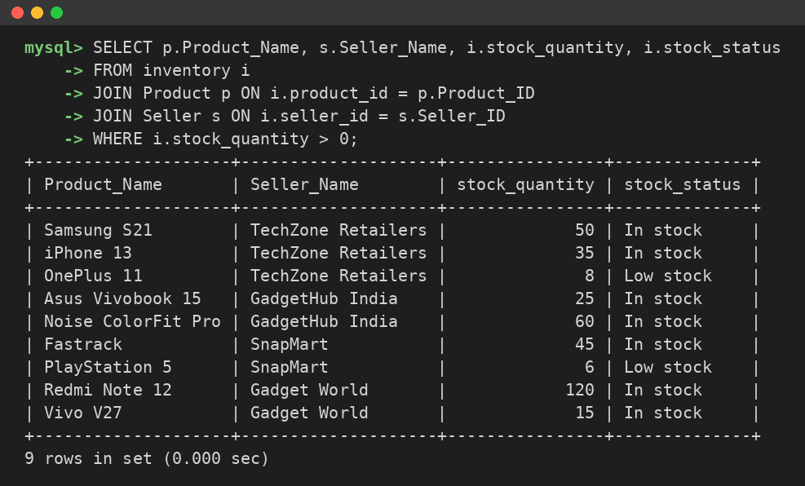
Figure 10: Display available products
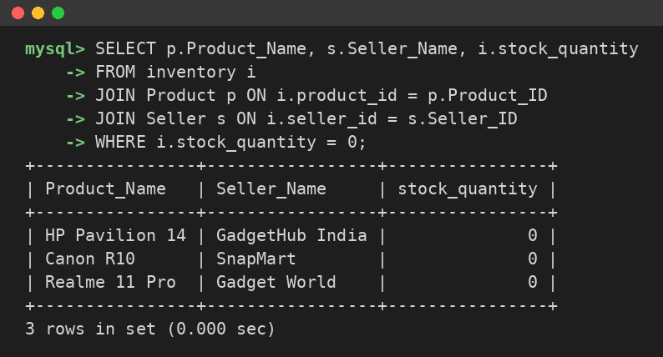
Figure 11: Find out-of-stock products
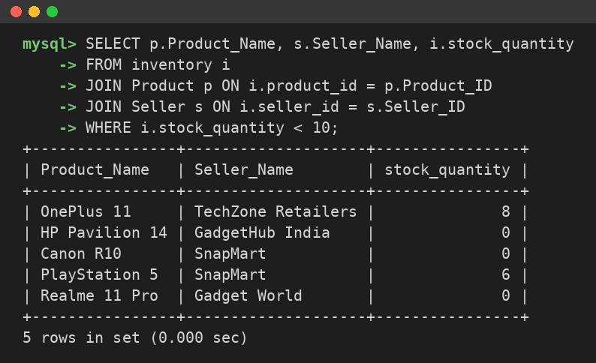
Figure 12: Find products with stock less than 10
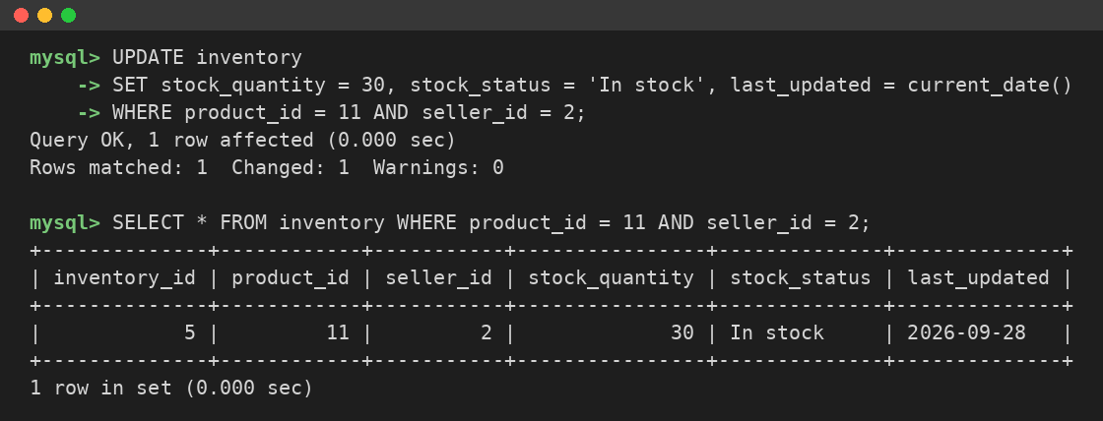
Figure 13: Update stock quantity
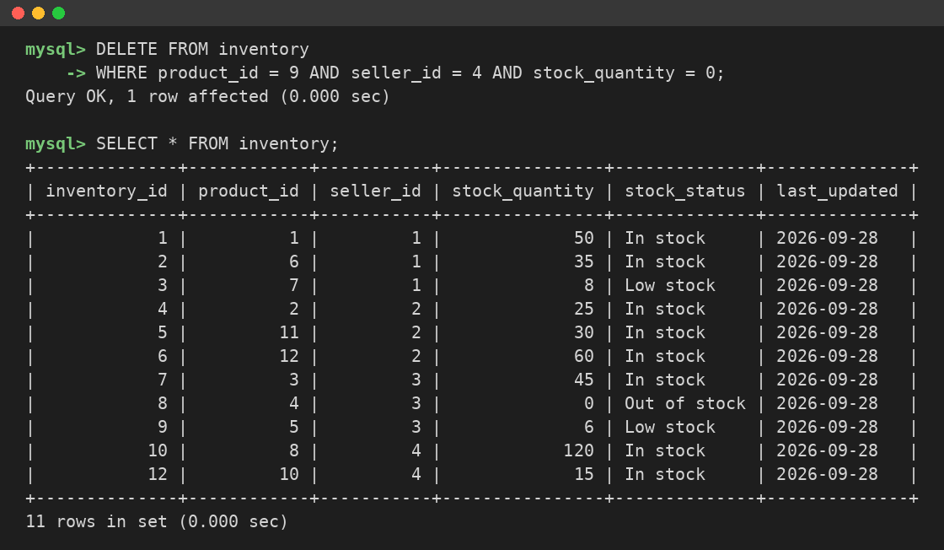
Figure 14: Delete discontinued inventory

5.4 Inventory reports
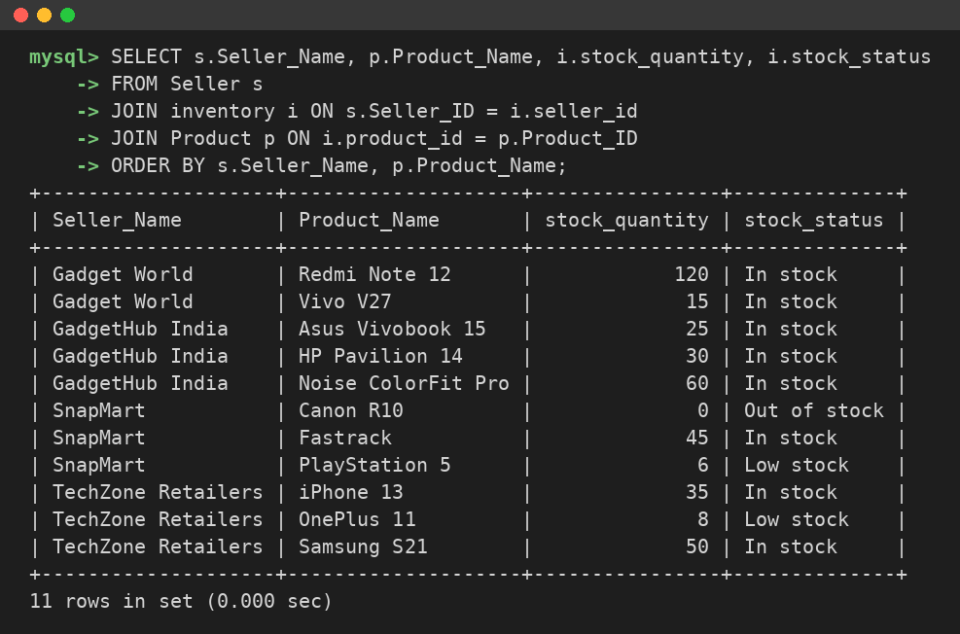
Figure 15: Seller-wise product report
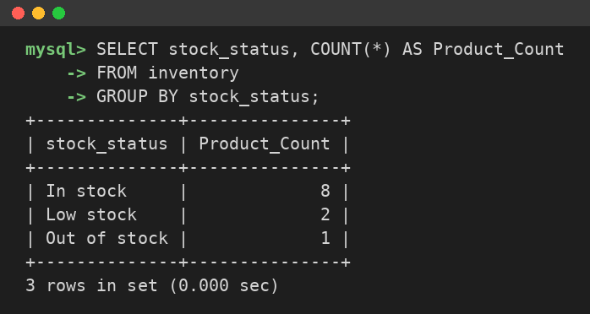
Figure 16: Stock availability report
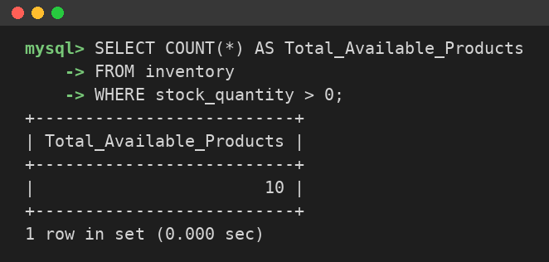
Figure 17: Total available products
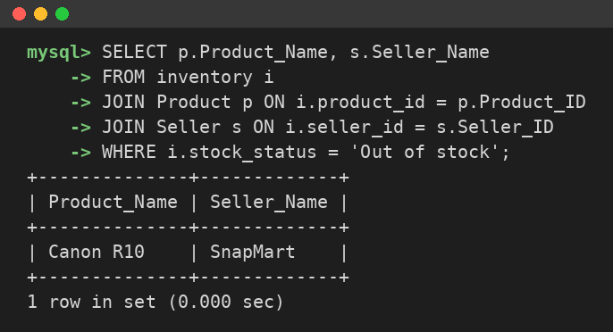
Figure 18: Out-of-stock products
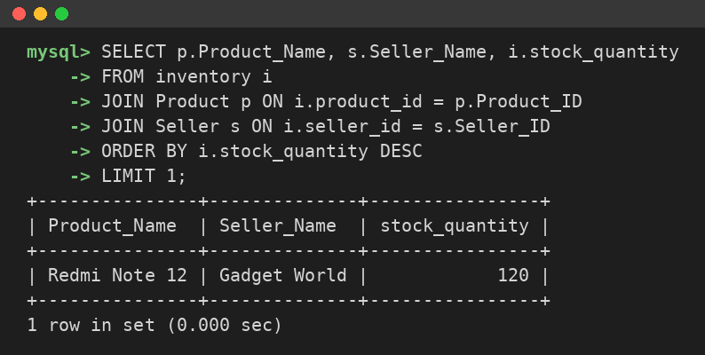
Figure 19: Highest stocked product
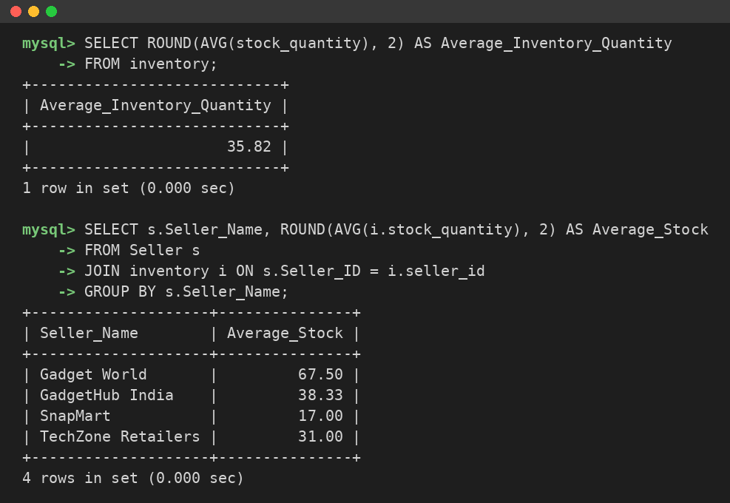
Figure 20: Average inventory quantity (overall and per seller)

