E-Commerce Order Management Database System
Orders & Order_Details Module Documentation
1. Orders & Order_Details Table Design
1.1 Orders Table
Column | Data Type | Constraints
Order_ID | INT | PRIMARY KEY, AUTO_INCREMENT
Customer_ID | INT | NOT NULL, FOREIGN KEY -> Customers(Customer_ID)
Order_Date | DATE | NOT NULL, DEFAULT CURRENT_DATE
Total_Amount | DECIMAL(10,2) | NOT NULL, DEFAULT 0.00, CHECK (Total_Amount >= 0)
Order_Status | VARCHAR(20) | NOT NULL, DEFAULT 'Pending', CHECK IN ('Pending','Shipped','Delivered','Cancelled')

1.2 Order_Details Table
Column | Data Type | Constraints
Order_Detail_ID | INT | PRIMARY KEY, AUTO_INCREMENT
Order_ID | INT | NOT NULL, FOREIGN KEY -> Orders(Order_ID), ON DELETE CASCADE
Product_ID | INT | NOT NULL, FOREIGN KEY -> Products(Product_ID)
Quantity | INT | NOT NULL, CHECK (Quantity > 0)
Price | DECIMAL(10,2) | NOT NULL, CHECK (Price >= 0)
(Order_ID, Product_ID) | — | UNIQUE — a product can appear only once per order

1.3 Constraints Summary
- PRIMARY KEY — Order_ID and Order_Detail_ID uniquely identify each row
- FOREIGN KEY — Orders.Customer_ID references Customers; Order_Details.Order_ID references Orders (ON DELETE CASCADE); Order_Details.Product_ID references Products
- UNIQUE — (Order_ID, Product_ID) in Order_Details prevents the same product being added twice to one order
- NOT NULL — required on Customer_ID, Order_Date, Total_Amount, Order_Status, Order_ID, Product_ID, Quantity, Price
- CHECK — Total_Amount >= 0; Order_Status restricted to Pending/Shipped/Delivered/Cancelled; Quantity > 0; Price >= 0
- DEFAULT — Order_Date defaults to CURRENT_DATE; Total_Amount defaults to 0.00; Order_Status defaults to 'Pending'

2. Updated ER Diagram
Customers place Orders (1:N). Each Order can contain multiple Order_Details line items (1:N), and every Order_Detail references exactly one Product (N:1). Orders and Products are therefore connected only through the Order_Details junction table, which also carries the per-line Quantity and Price.
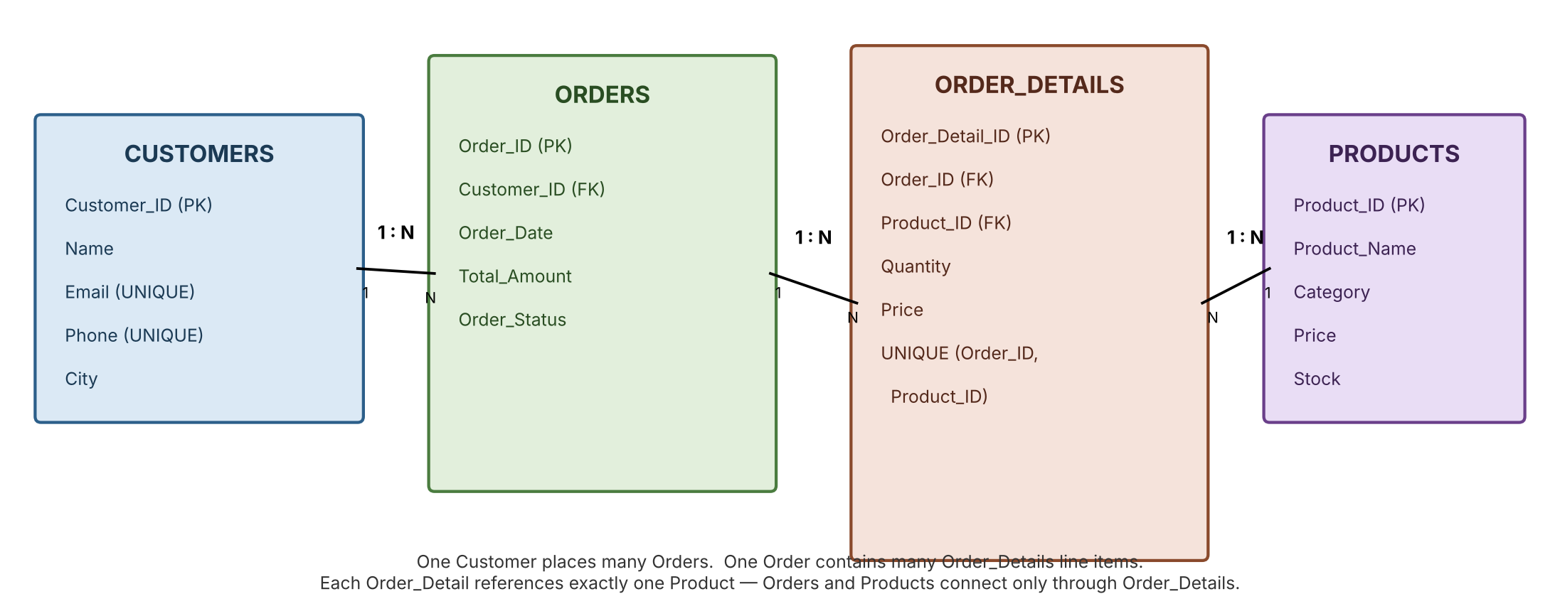

3. Sample Customer, Order & Order_Details Data
3.1 Customers
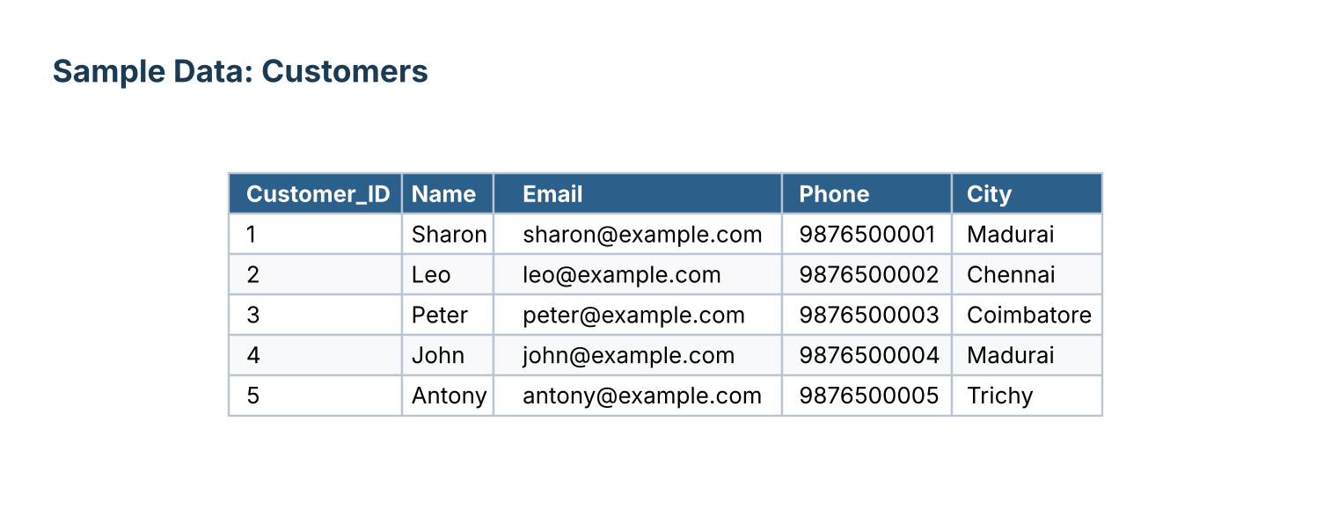
3.2 Products
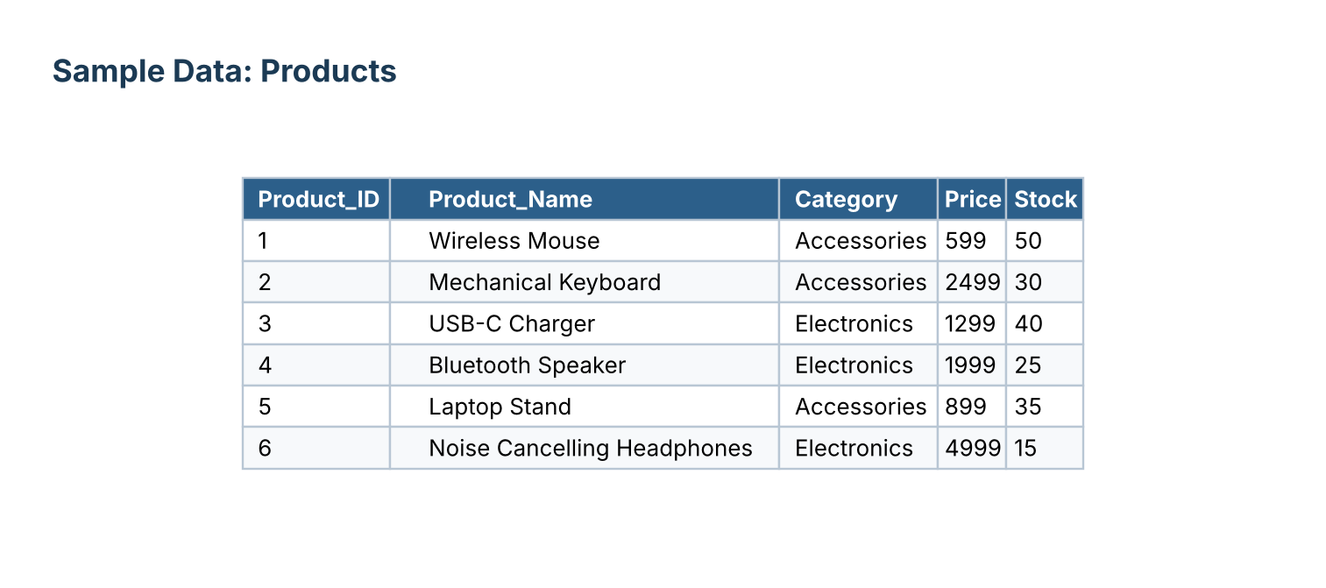
3.3 Orders
Order 8 (Cancelled) was removed by the DELETE step; Order 9 was created afterward via the INSERT...SELECT workflow for Customer 4.
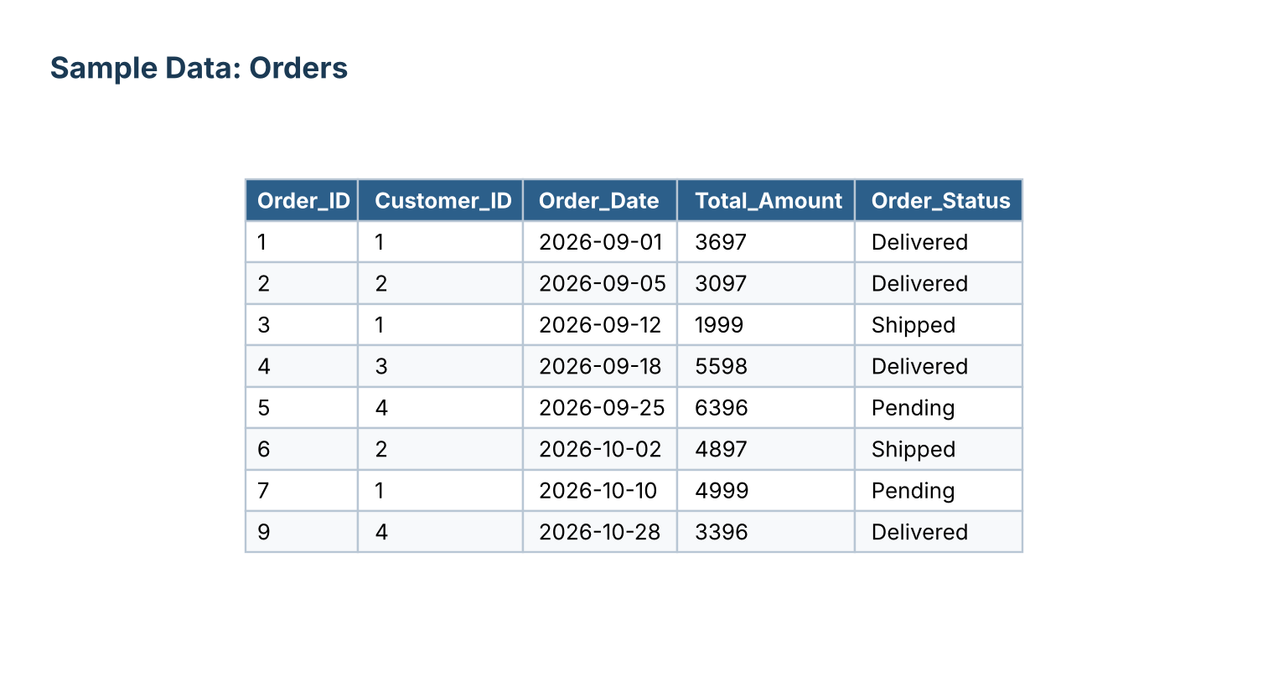
3.4 Order_Details
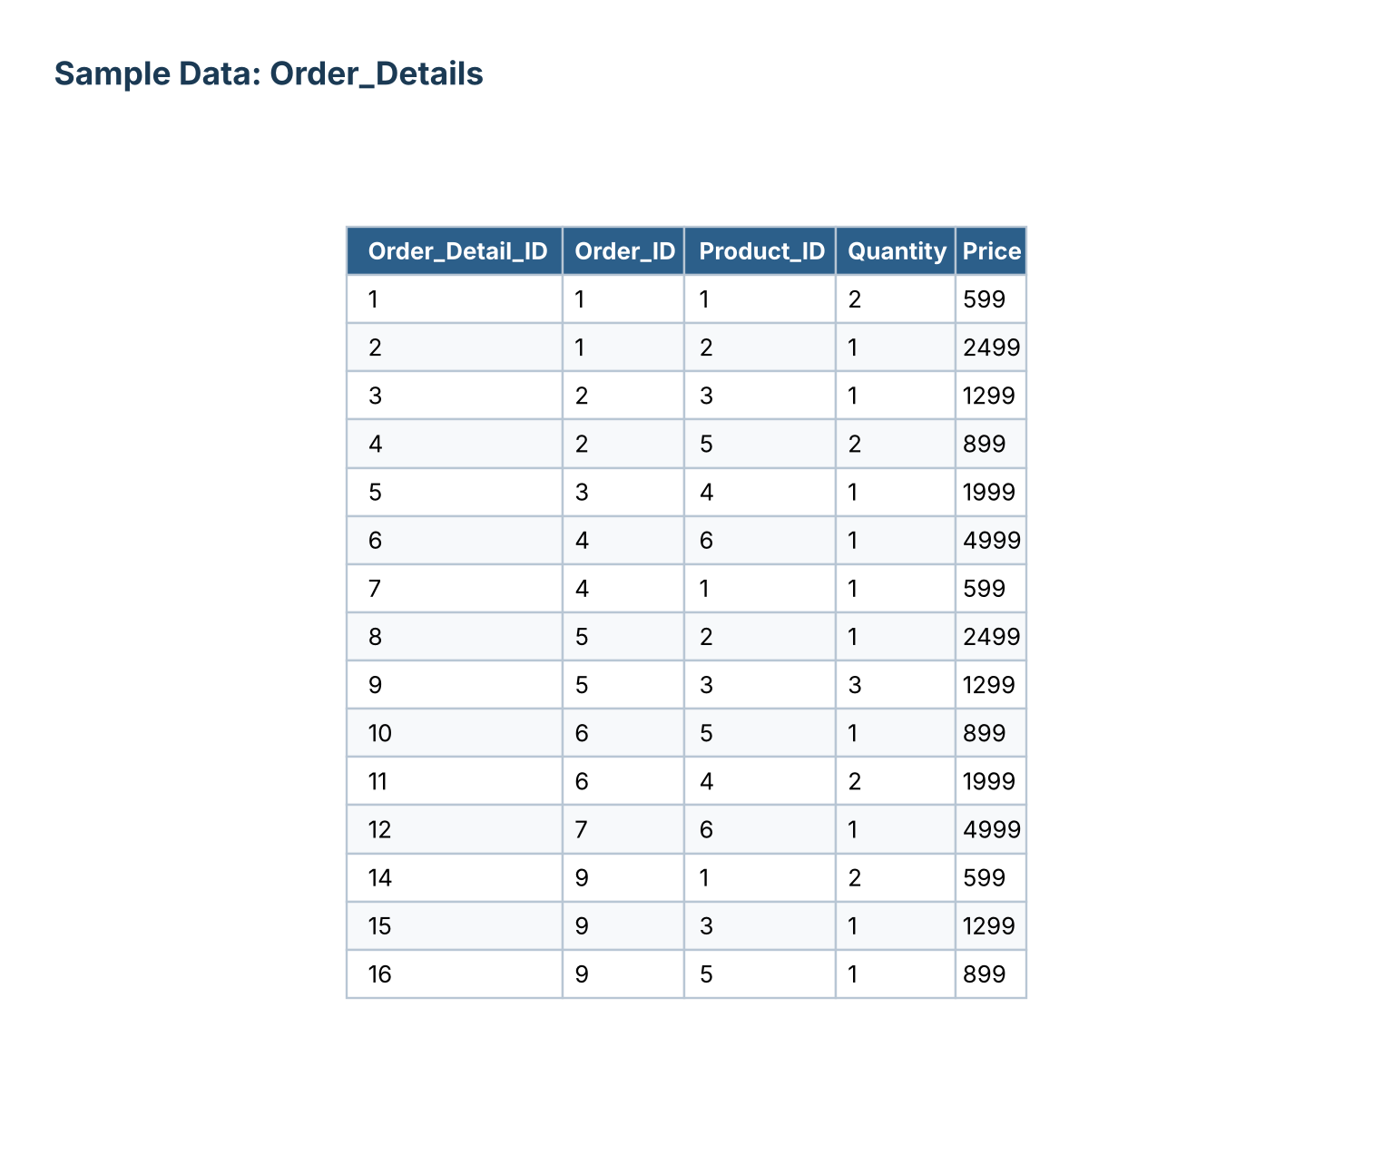

4. Customer Order History & Purchase Analysis Report
4.1 Customer Order History
Every order placed by each customer, with date, status and order total.
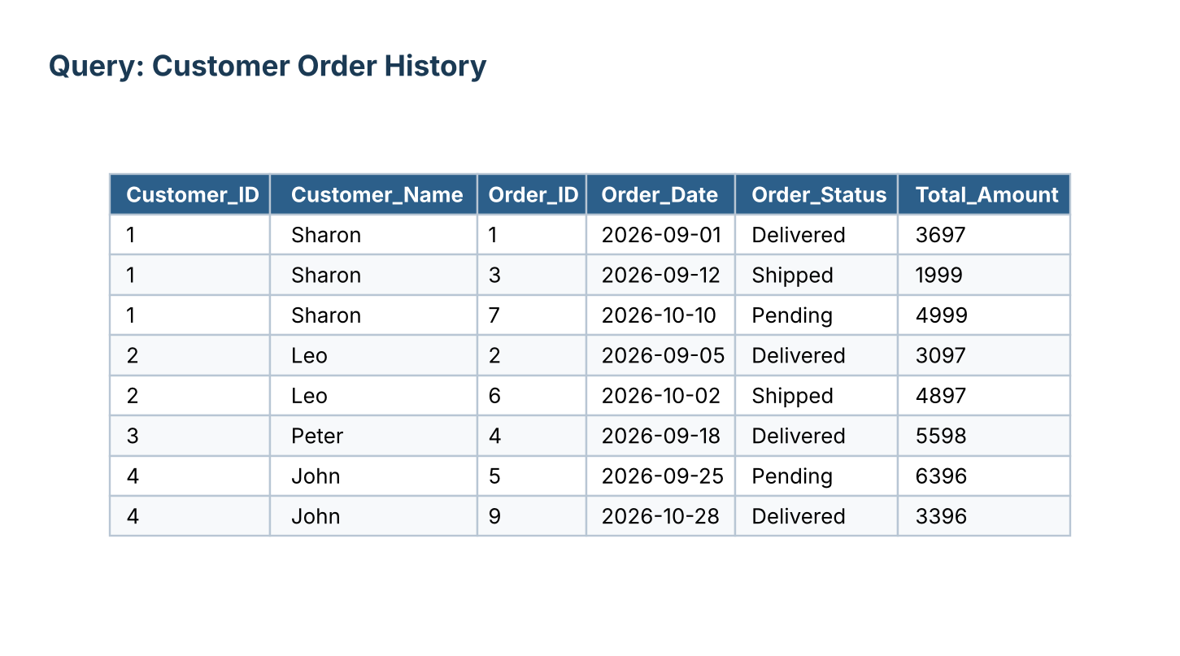
4.2 Product Order History
Every line item sold, grouped implicitly by product and ordered by date.
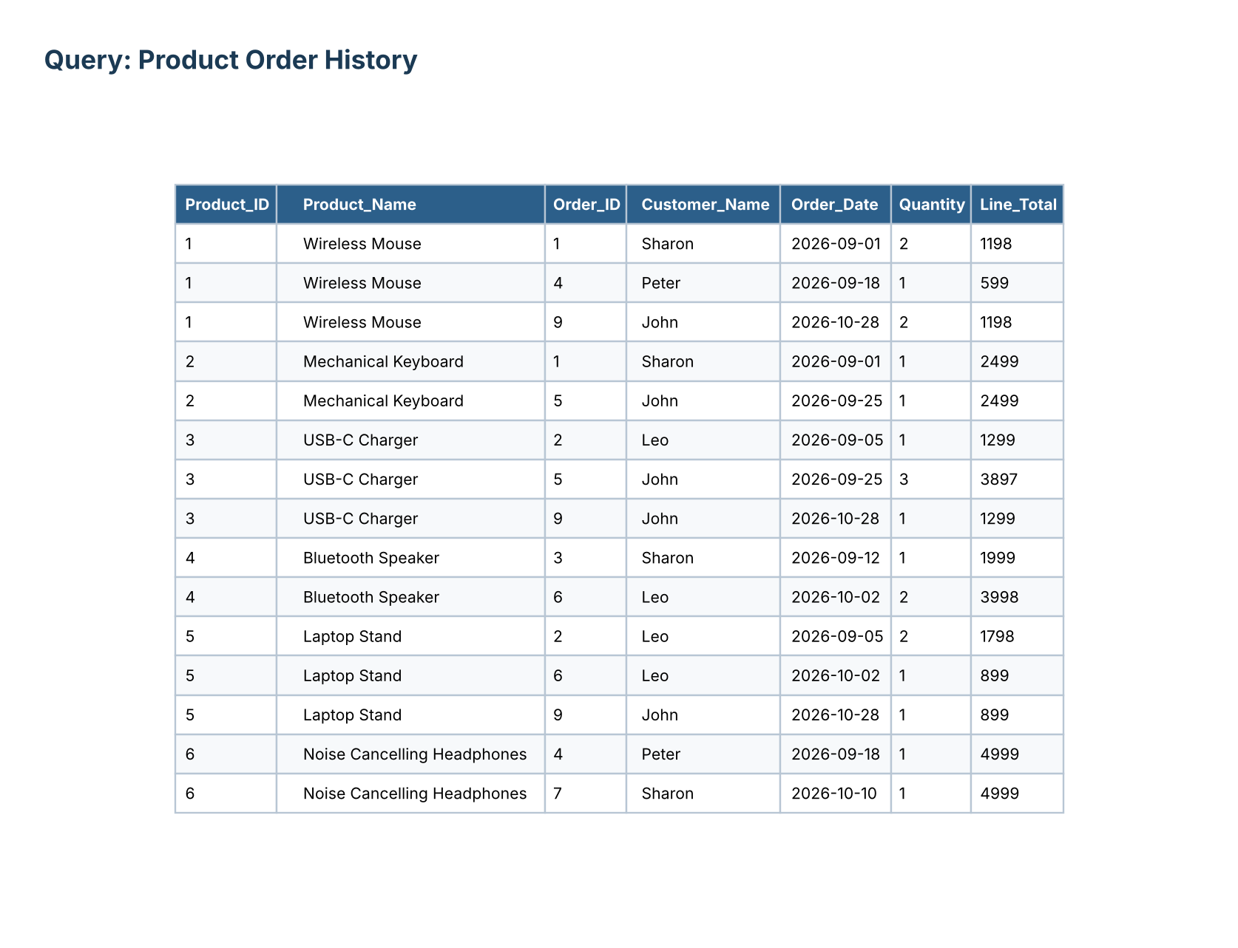
4.3 Times Each Product Was Ordered
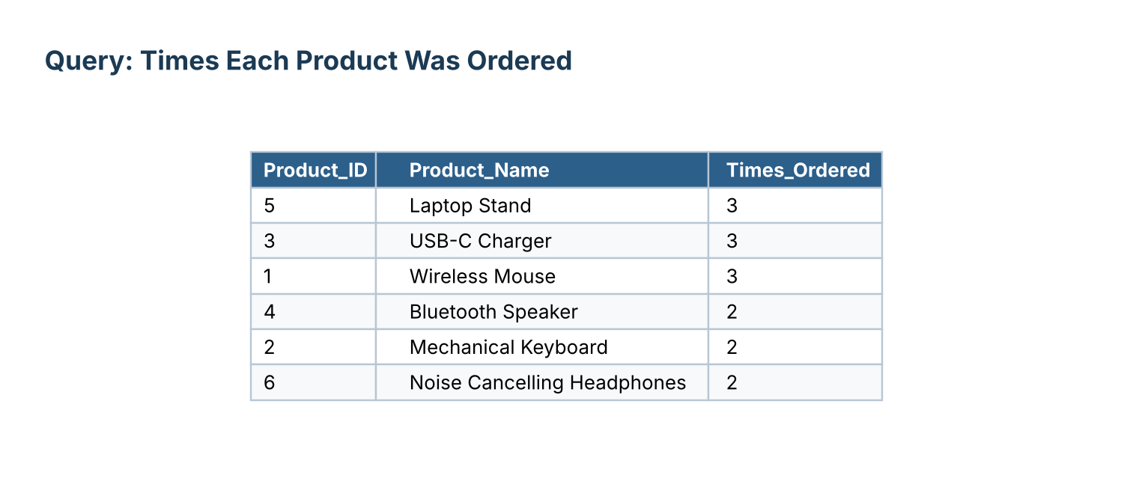
4.4 Total Quantity Sold per Product
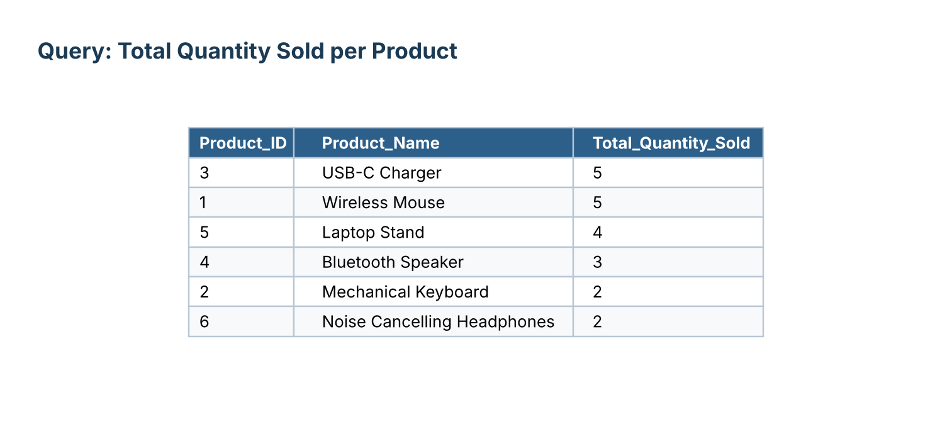
4.5 Most Frequent Customer(s)

4.6 Customer-wise Order Count & Total Spending
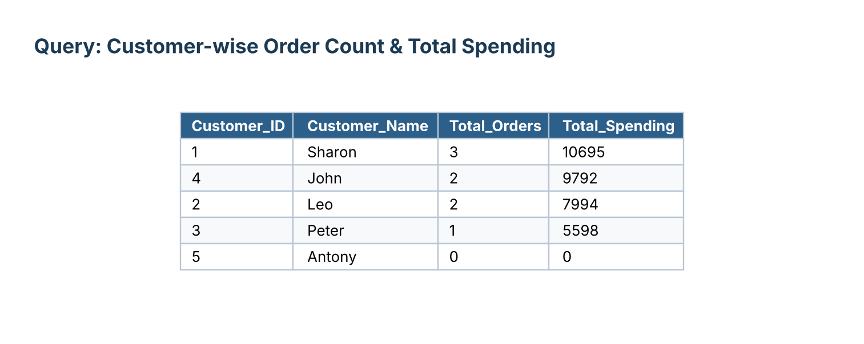
4.7 Average Order Value
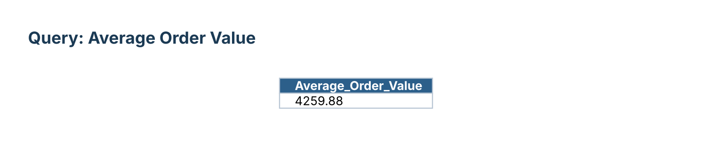
4.8 Total Sales Amount
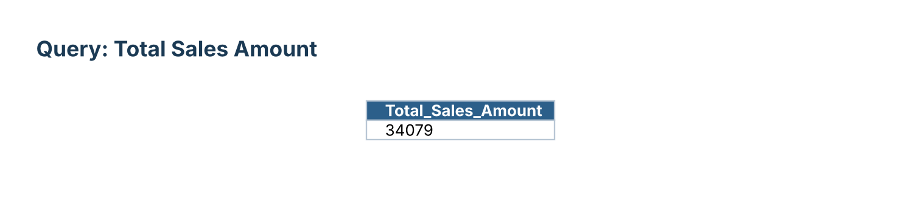

5. Query Output Screenshots
5.1 Full Order Detail (Order + Customer + Product)
Combined view joining Orders, Customers, Order_Details and Products — one row per line item.
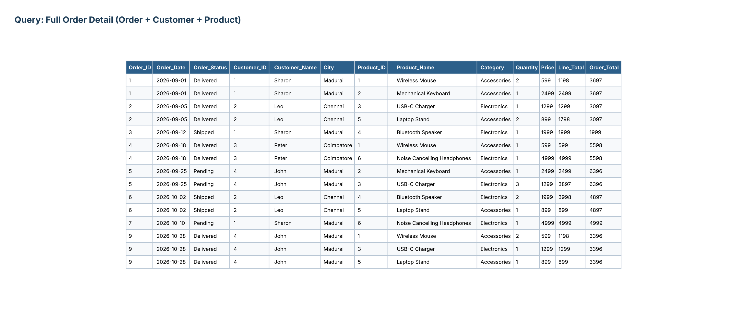
5.2 Order_ID = 1 — Itemized Detail
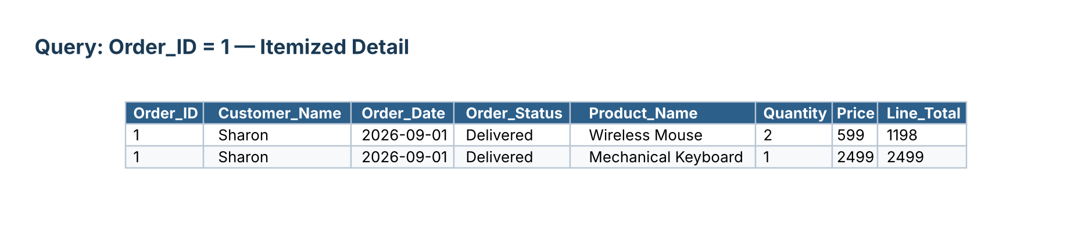

6. Review Summary
- Orders and Order_Details tables created with PRIMARY KEY, FOREIGN KEY, UNIQUE, NOT NULL, CHECK and DEFAULT constraints, including a composite UNIQUE (Order_ID, Product_ID) and ON DELETE CASCADE.
- 5 customers, 6 products, 8 initial orders and 13 order-line items inserted; totals computed with correlated UPDATE subqueries.
- A full order lifecycle demonstrated: INSERT...SELECT to build a new order from selected products, status progression (Pending -> Shipped -> Delivered), a quantity correction with recalculated total, and deletion of all Cancelled orders.
- Purchase analysis queries implemented: customer order history, product order history, times-ordered and quantity-sold per product, most frequent customer, customer-wise spending, average order value and total sales.

