1. Payment Table Design
Column | Data Type | Constraints
Payment_ID | INT | PRIMARY KEY, AUTO_INCREMENT
Order_ID | INT | NOT NULL, UNIQUE, FOREIGN KEY -> Orders(Order_ID), ON DELETE CASCADE
Payment_Date | DATE | NOT NULL
Payment_Mode | VARCHAR(20) | NOT NULL, CHECK IN ('UPI','Credit Card','Debit Card','Net Banking','Cash on Delivery')
Payment_Status | VARCHAR(10) | NOT NULL, DEFAULT 'Pending', CHECK IN ('Pending','Success','Failed')
Transaction_Amount | DECIMAL(10,2) | NOT NULL, CHECK (Transaction_Amount > 0)

1.1 Constraints Summary
- PRIMARY KEY — Payment_ID uniquely identifies each payment record
- FOREIGN KEY — Payment.Order_ID references Orders.Order_ID, with ON DELETE CASCADE so payment records are removed if the parent order is deleted
- UNIQUE — Order_ID in Payment ensures each order has at most one payment record (1:1 relationship)
- NOT NULL — required on Order_ID, Payment_Date, Payment_Mode, Payment_Status, Transaction_Amount
- CHECK — Payment_Mode restricted to five valid modes; Payment_Status restricted to Pending/Success/Failed; Transaction_Amount must be greater than 0
- DEFAULT — Payment_Status defaults to 'Pending' when not specified

2. Updated ER Diagram (Order–Payment Relationship)
Customers place Orders in a one-to-many relationship. Each Order is linked to exactly one Payment record: the UNIQUE constraint on Payment.Order_ID enforces this one-to-one relationship, and ON DELETE CASCADE keeps the payment consistent with its parent order.
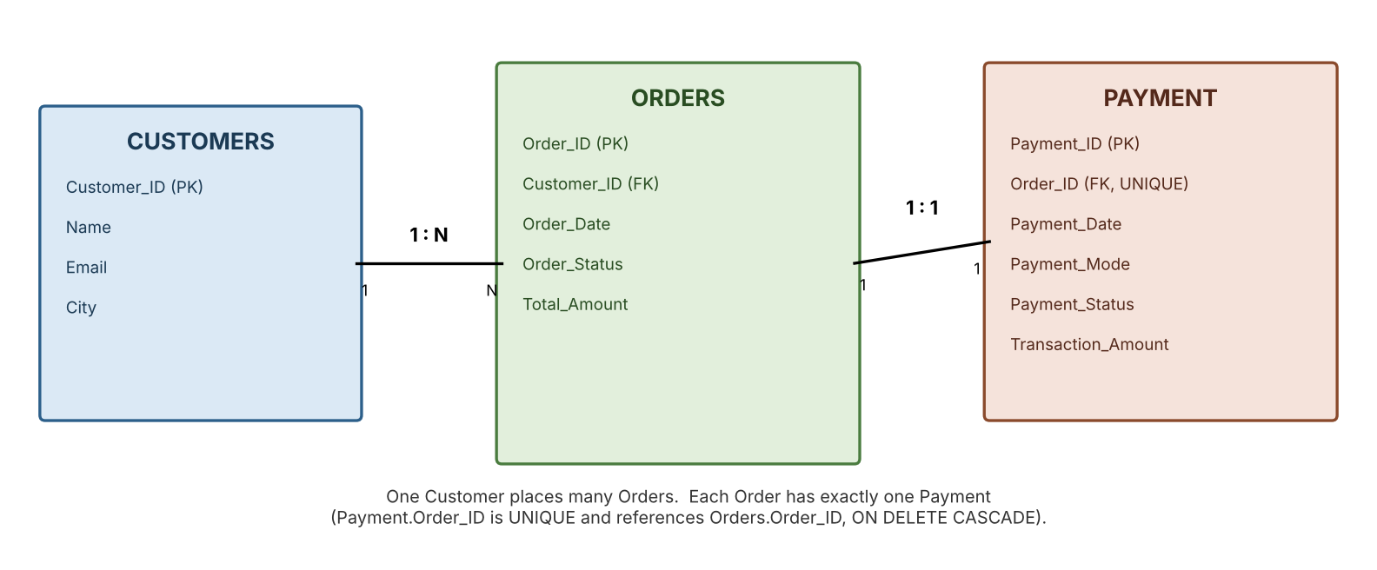

3. Sample Customer, Order & Payment Data

3.1 Customers
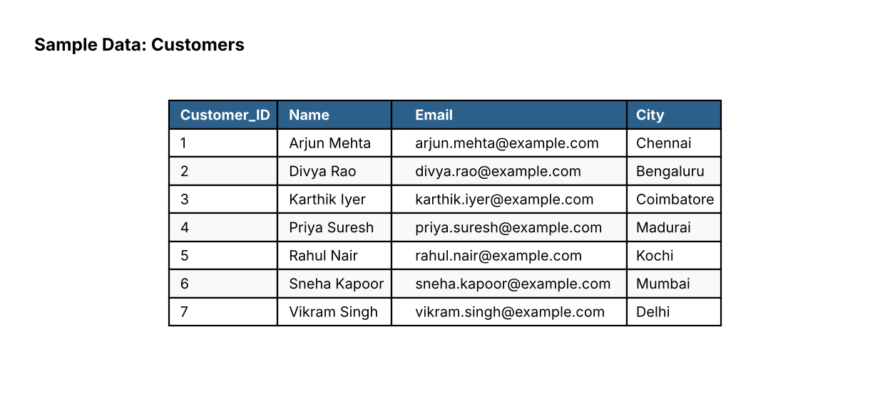

3.2 Orders
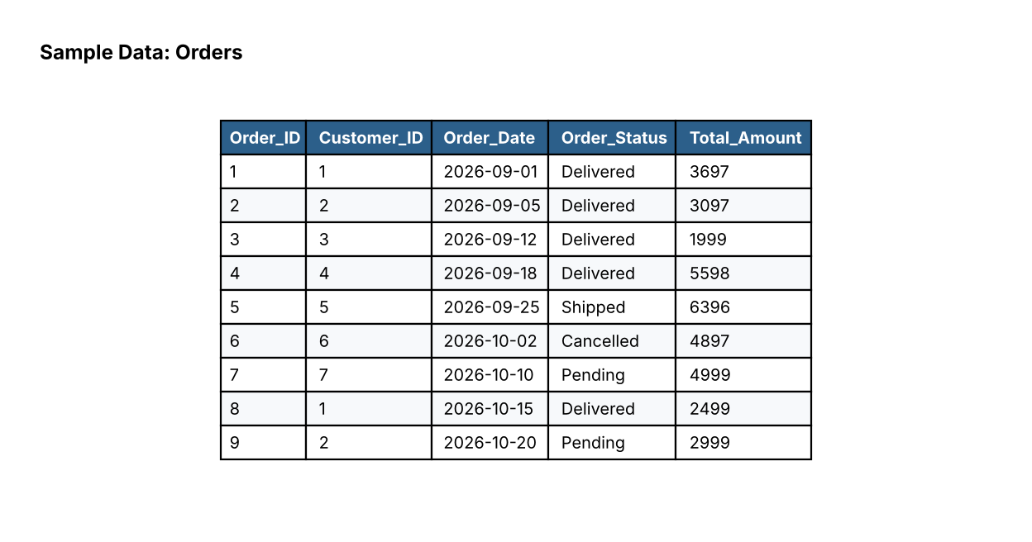

3.3 Payment
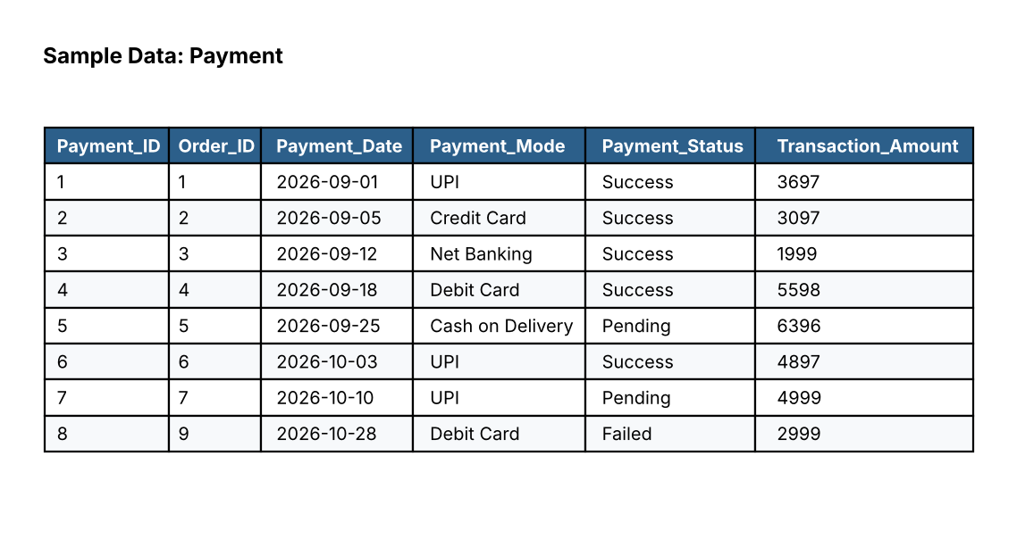

4. Payment Transaction & Revenue Analysis Reports

4.1 Payment Count by Status (Success / Failed)
Result captured after updating Order 6's payment status from Failed to Success.


4.2 Transaction Amount vs Order Total — Mismatch Check
No mismatches were found between Payment.Transaction_Amount and Orders.Total_Amount, confirming data consistency across the two tables.


4.3 Transaction Count by Payment Mode
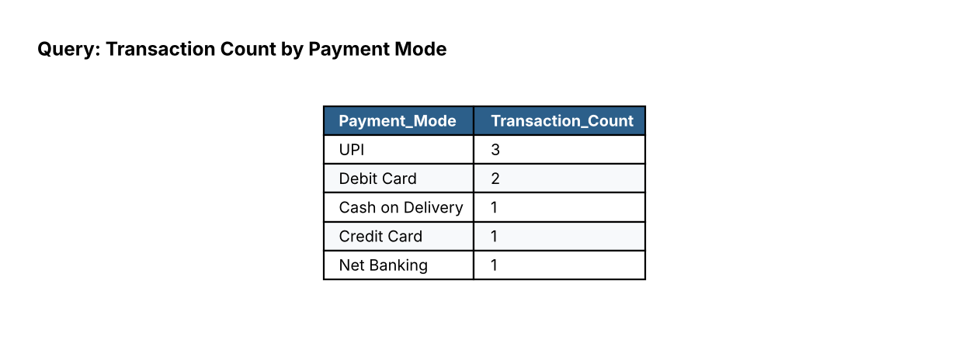

4.4 Most-Used Payment Mode


4.5 Total Successful Revenue


4.6 Revenue by Payment Mode
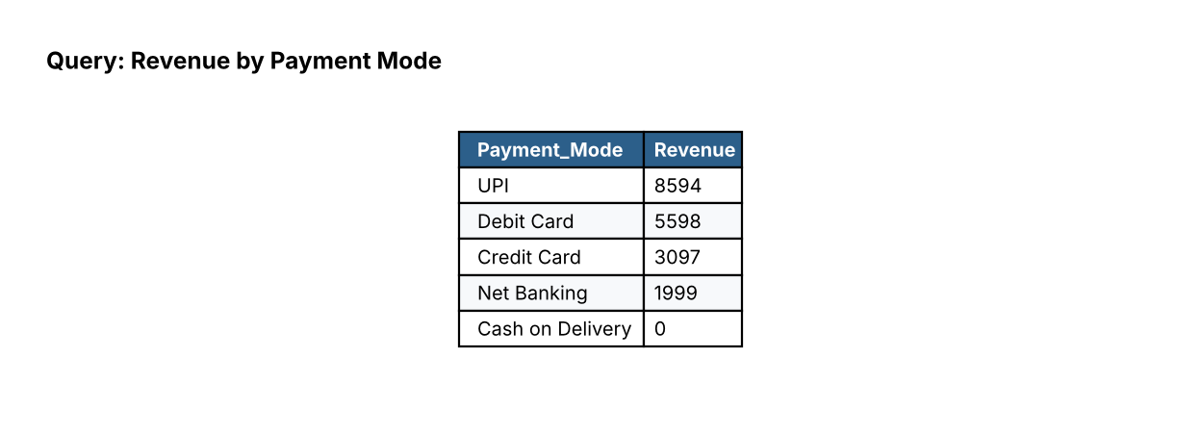

4.7 Average Transaction Amount (All vs Successful Only)


4.8 Overall Payment Status Summary
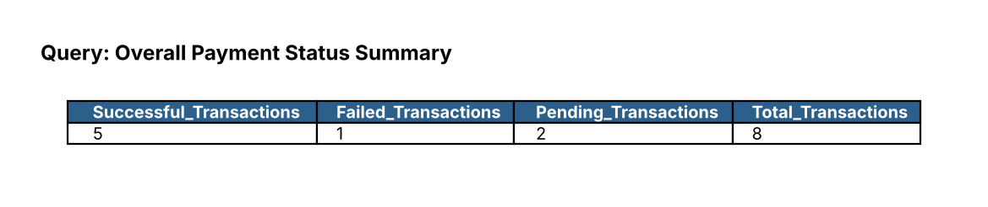

4.9 Orders Needing Payment Follow-up (Failed / Pending)
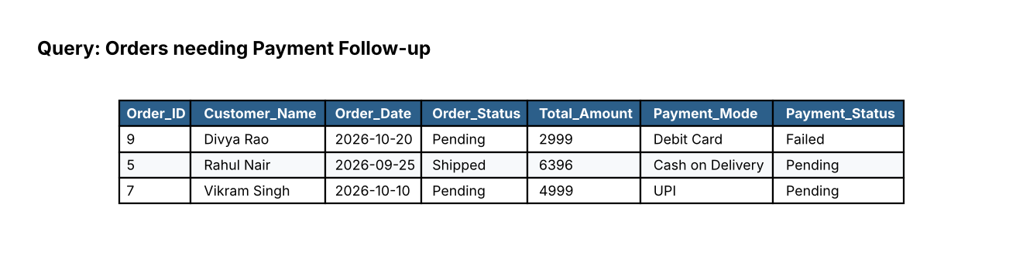

5. Query Output Screenshots

5.1 Payment Details for a Specific Order (Order_ID = 1)
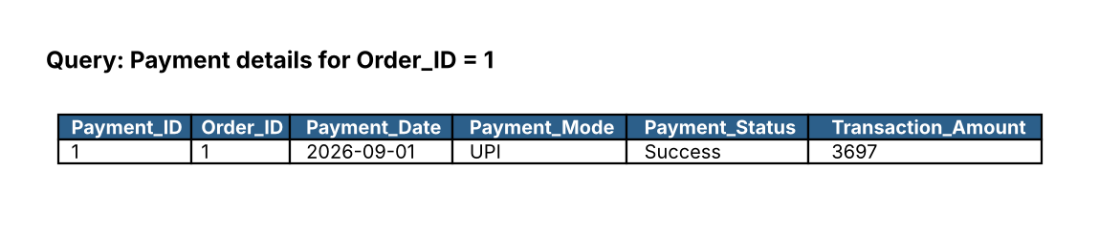

5.2 All Successful Payments
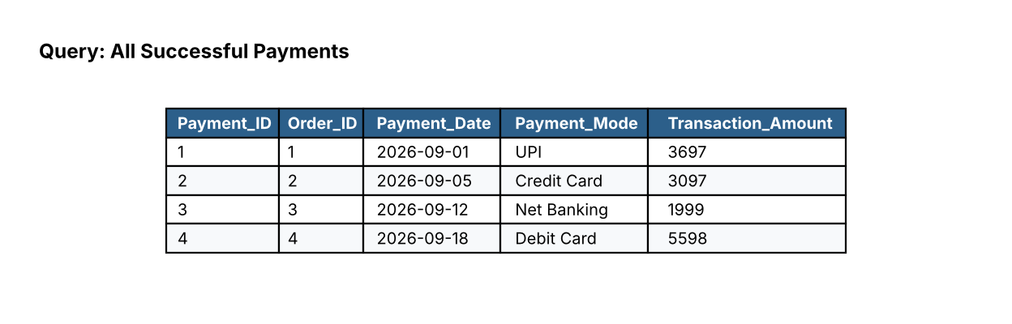

5.3 Failed / Pending Payments
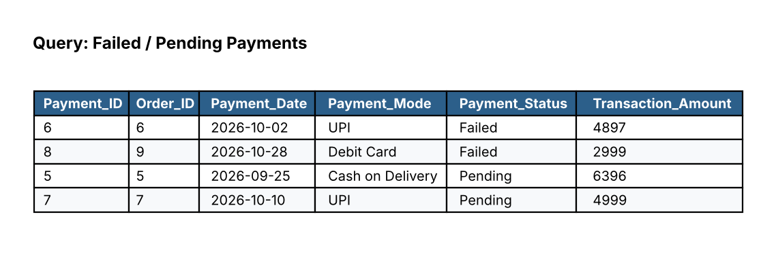

5.4 Customer + Order + Payment (Combined View)
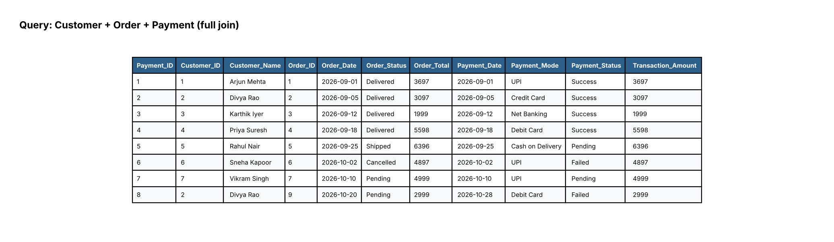

5.5 Customer-wise Payment History
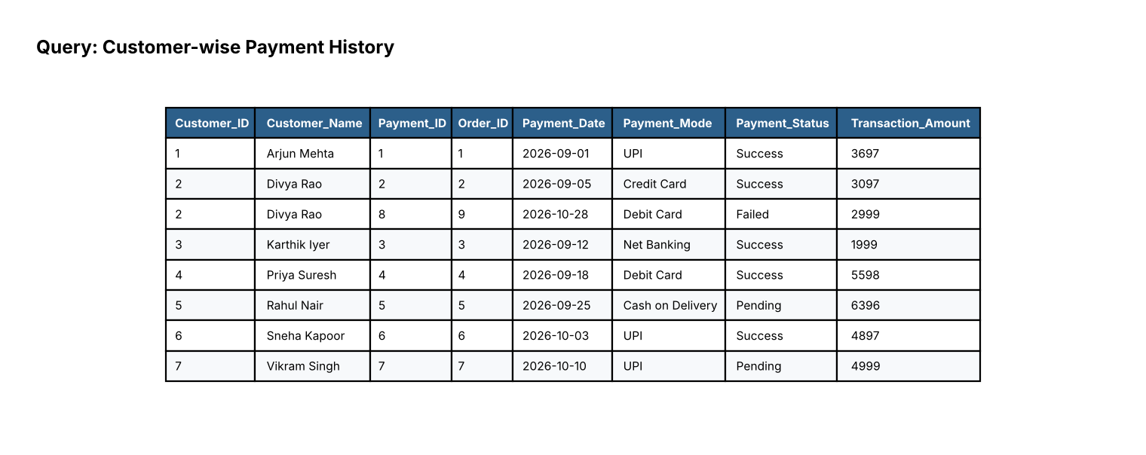

6. Review Summary
- Payment table created with PRIMARY KEY, FOREIGN KEY, UNIQUE, NOT NULL, CHECK and DEFAULT constraints, enforcing a 1:1 relationship with Orders.
- 8 payment records inserted (7 direct inserts plus 1 derived via INSERT...SELECT from Orders), spanning all three payment statuses and five payment modes.
- All CRUD-style operations demonstrated: INSERT (including INSERT...SELECT), SELECT, and UPDATE (status correction on Order 6).
- Revenue and transaction analysis queries implemented: status counts, mode-wise transaction counts and revenue, most-used mode, average transaction amounts, and an amount-mismatch consistency check.
- Combined Customer-Order-Payment queries verified, including a follow-up report for orders with Failed or Pending payments.

