FLIPKART
E-Commerce Order Management Database System
Database Design Documentation
Prepared by: Sharon N

1. Understanding the E-Commerce Business Process
Flipkart is an online marketplace that connects customers with third-party sellers and Flipkart-owned inventory. The platform must reliably capture every step of the shopping journey inside a database so that browsing, ordering, payment, delivery, and after-sales support all stay consistent and auditable.

1.1 End-to-End Process Flow
- Customer registers or logs into their Flipkart account.
- Customer browses/searches the product catalog, filtered by category, price, brand, or ratings.
- Customer adds one or more products (from one or more sellers) to the cart.
- Customer selects/enters a delivery address and proceeds to checkout.
- An order record is created, splitting the cart into order items linked to individual sellers.
- Customer completes payment (UPI, card, net banking, wallet, or Cash on Delivery).
- Seller confirms and packs the order; inventory (stock_quantity) is decremented.
- Order is shipped, tracked, and delivered; order_status is updated at each stage.
- Customer may rate/review the product or request a return/refund.

1.2 Why This Process Needs a Well-Designed Database
- Thousands of simultaneous customers, orders, and payments must be tracked accurately.
- Data such as stock levels and order status changes constantly and must stay consistent.
- Relationships between customers, sellers, products, and orders are complex and interlinked.
- Historical data (past orders, payments, reviews) must be retained for support, analytics, and returns.

2. Data Required for Customer Management
Customer management covers everything needed to identify a shopper, communicate with them, deliver orders to them, and personalize their experience.

2.1 Core Customer Data
- Personal identity: customer_id, full name, gender, date of birth.
- Contact details: email address, mobile number (used for OTP login and order updates).
- Authentication: password_hash, login provider (email/Google/Facebook), account status.
- Delivery details: one or more saved addresses (home, work), each tagged as default or not.
- Account metadata: registration date, last login date, loyalty/membership tier (e.g., Flipkart Plus).
- Preferences: wishlist items, saved payment methods, preferred language.
- Behavioural/history data: order history, cart contents, product reviews submitted, support tickets raised.

2.2 Why It Matters
This data enables account security, accurate delivery, personalized recommendations, targeted offers, and customer support — all of which depend on the customer record being complete and current.

3. Major Entities
The system is modeled around five core entities — Customer, Product, Order, Payment, and Seller — supported by Address, Order_Item, and Review as linking/detail entities.

3.1 Customer
Represents a registered shopper on the platform.
Field | Type | Key | Description
customer_id | INT | PK | Unique identifier for each customer
full_name | VARCHAR(100) |  | Customer's full name
email | VARCHAR(100) | UQ | Unique email used for login and notifications
phone_number | VARCHAR(15) | UQ | Mobile number for OTP and delivery updates
password_hash | VARCHAR(255) |  | Encrypted password
registered_date | DATE |  | Date the account was created

3.2 Address
Stores one or more delivery/billing addresses per customer.
Field | Type | Key | Description
address_id | INT | PK | Unique identifier for each address
customer_id | INT | FK | Links the address to a customer
address_line | VARCHAR(255) |  | House/street/locality details
city | VARCHAR(50) |  | City name
state | VARCHAR(50) |  | State name
pincode | VARCHAR(10) |  | Postal code
address_type | VARCHAR(10) |  | Home / Work / Other

3.3 Seller
Represents a third-party or Flipkart-owned seller that lists products.
Field | Type | Key | Description
seller_id | INT | PK | Unique identifier for each seller
seller_name | VARCHAR(100) |  | Registered business/seller name
gstin | VARCHAR(20) | UQ | Tax registration number
rating | DECIMAL(2,1) |  | Average seller rating
warehouse_location | VARCHAR(100) |  | Primary dispatch location

3.4 Product
Represents an item listed for sale by a seller.
Field | Type | Key | Description
product_id | INT | PK | Unique identifier for each product
seller_id | INT | FK | Seller who lists the product
product_name | VARCHAR(150) |  | Name/title of the product
category | VARCHAR(50) |  | Product category, e.g., Electronics, Fashion
price | DECIMAL(10,2) |  | Selling price
stock_quantity | INT |  | Units currently available

3.5 Order
Represents a purchase transaction initiated by a customer.
Field | Type | Key | Description
order_id | INT | PK | Unique identifier for each order
customer_id | INT | FK | Customer who placed the order
address_id | INT | FK | Delivery address for the order
order_date | DATETIME |  | Date and time the order was placed
order_status | VARCHAR(20) |  | Placed / Shipped / Delivered / Cancelled
total_amount | DECIMAL(10,2) |  | Total payable amount for the order

3.6 Order_Item
Bridges Order and Product for a many-to-many relationship (one order can contain many products, one product can appear in many orders).
Field | Type | Key | Description
order_item_id | INT | PK | Unique identifier for each line item
order_id | INT | FK | Parent order
product_id | INT | FK | Product purchased
quantity | INT |  | Number of units ordered
unit_price | DECIMAL(10,2) |  | Price per unit at the time of order

3.7 Payment
Represents the payment made against an order.
Field | Type | Key | Description
payment_id | INT | PK | Unique identifier for each payment
order_id | INT | FK | Order the payment belongs to
payment_mode | VARCHAR(20) |  | UPI / Card / Net Banking / COD
payment_status | VARCHAR(20) |  | Pending / Success / Failed / Refunded
transaction_date | DATETIME |  | Date and time of transaction
amount_paid | DECIMAL(10,2) |  | Amount actually paid

3.8 Review
Stores customer feedback on purchased products.
Field | Type | Key | Description
review_id | INT | PK | Unique identifier for each review
customer_id | INT | FK | Reviewer
product_id | INT | FK | Product being reviewed
rating | INT |  | Star rating (1–5)
comment | TEXT |  | Written feedback

4. Entity-Relationship (ER) Diagram
The diagram below shows the eight core entities and their relationships. Primary keys (PK) uniquely identify each row; foreign keys (FK) link related entities.
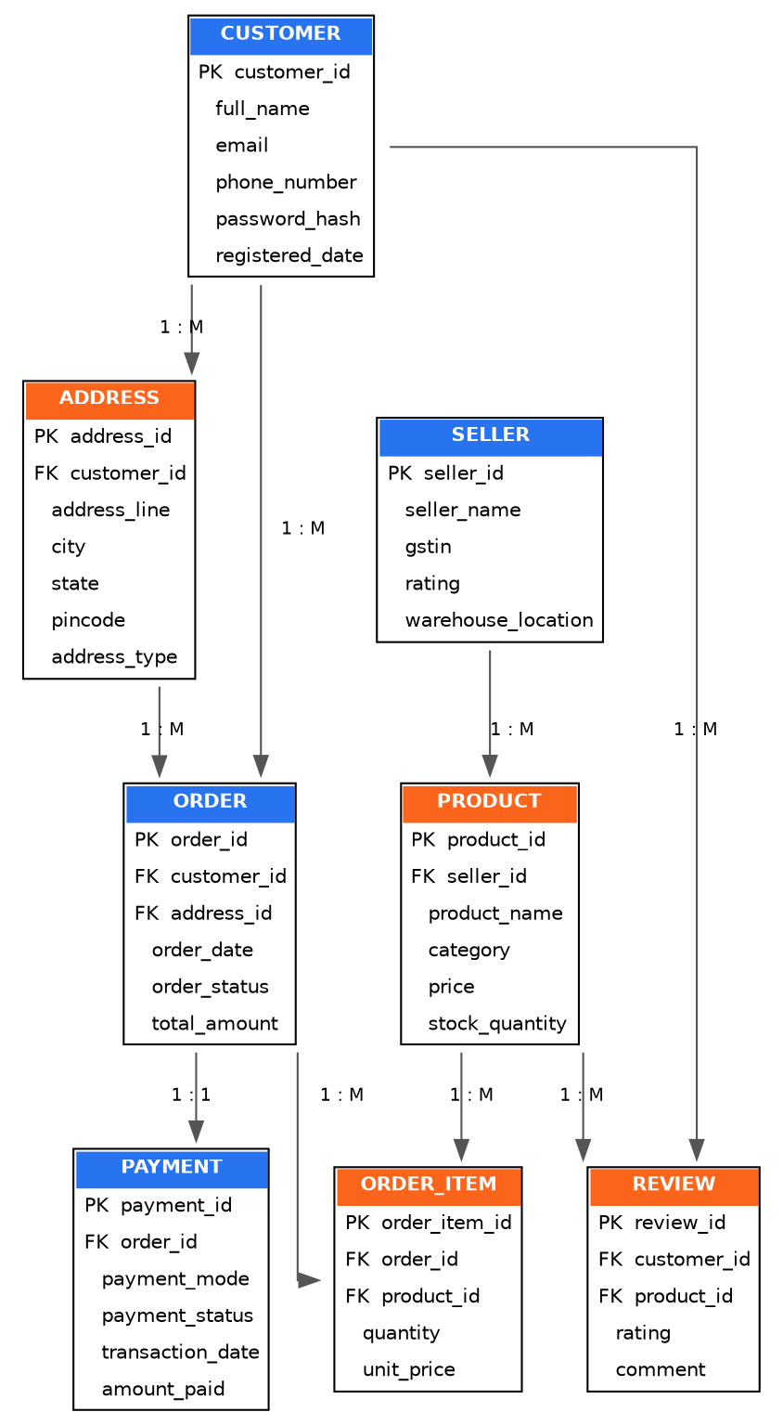

4.1 Relationship Summary
- Customer (1) — (M) Address: a customer can save multiple addresses.
- Customer (1) — (M) Order: a customer can place many orders.
- Customer (1) — (M) Review: a customer can write many reviews.
- Seller (1) — (M) Product: a seller can list many products.
- Order (1) — (M) Order_Item: an order can contain many line items.
- Product (1) — (M) Order_Item: a product can appear in many order items.
- Order (1) — (1) Payment: each order has one corresponding payment record.
- Product (1) — (M) Review: a product can receive many reviews.
- Address (1) — (M) Order: an address can be used for multiple deliveries.

5. Answers to Review Questions

Q1. Why does an e-commerce system require a database?
An e-commerce platform like Flipkart deals with massive, constantly changing, and tightly interrelated data — millions of customers, products, sellers, orders, and payments happening simultaneously. A database is required because it provides:
- Structured storage: organizes customer, product, order, and payment data into well-defined tables instead of scattered files.
- Data integrity: primary/foreign keys and constraints ensure orders always link to a valid customer and product, preventing orphaned or inconsistent records.
- Concurrency handling: supports thousands of simultaneous reads and writes (browsing, cart updates, checkouts) without conflicts.
- Fast retrieval: indexing and query optimization let the platform search and filter huge product catalogs in real time.
- Transaction safety: ensures operations like 'place order → deduct stock → record payment' either complete fully or not at all (ACID properties), preventing issues like double-charging or overselling stock.
- Scalability and reporting: supports business analytics such as sales trends, best-selling products, and inventory forecasting.
- Security: enables controlled access to sensitive data such as passwords and payment details.

Q2. What customer details need to be stored?
To support registration, ordering, delivery, and personalization, the system needs to store:
- Identity details: name, gender, date of birth, unique customer_id.
- Contact information: email address and mobile number.
- Login credentials: encrypted password / authentication tokens.
- Delivery addresses: one or more addresses with city, state, and pincode.
- Order and purchase history: past and current orders.
- Payment preferences: saved cards/UPI IDs (tokenized, not stored in plain text).
- Account metadata: registration date, account status, loyalty tier.
- Engagement data: wishlist, cart items, reviews and ratings submitted.

Q3. What operations should be performed on customer data?
The system should support the standard CRUD operations plus a few e-commerce-specific ones:
- Create: register a new customer account and add new addresses.
- Read/Retrieve: fetch profile details, order history, and saved addresses for display or checkout.
- Update: edit profile information, change password, update or add a delivery address, update loyalty tier.
- Delete/Deactivate: remove a saved address, deactivate or delete an account on request (with data retention rules for legal/tax compliance).
- Search and filter: look up customers by email/phone for support, or segment customers for marketing.
- Validation: verify email/phone uniqueness and format before insert or update.
- Authentication and authorization: verify login credentials and control access to the account.
- Aggregation/reporting: compute metrics such as total orders placed, total amount spent, or average rating given.

