Reference : <https://www.cloudiqtech.com/integrating-azure-data-lake-storage-with-databricks/>

Step1: Create a Storage account as below

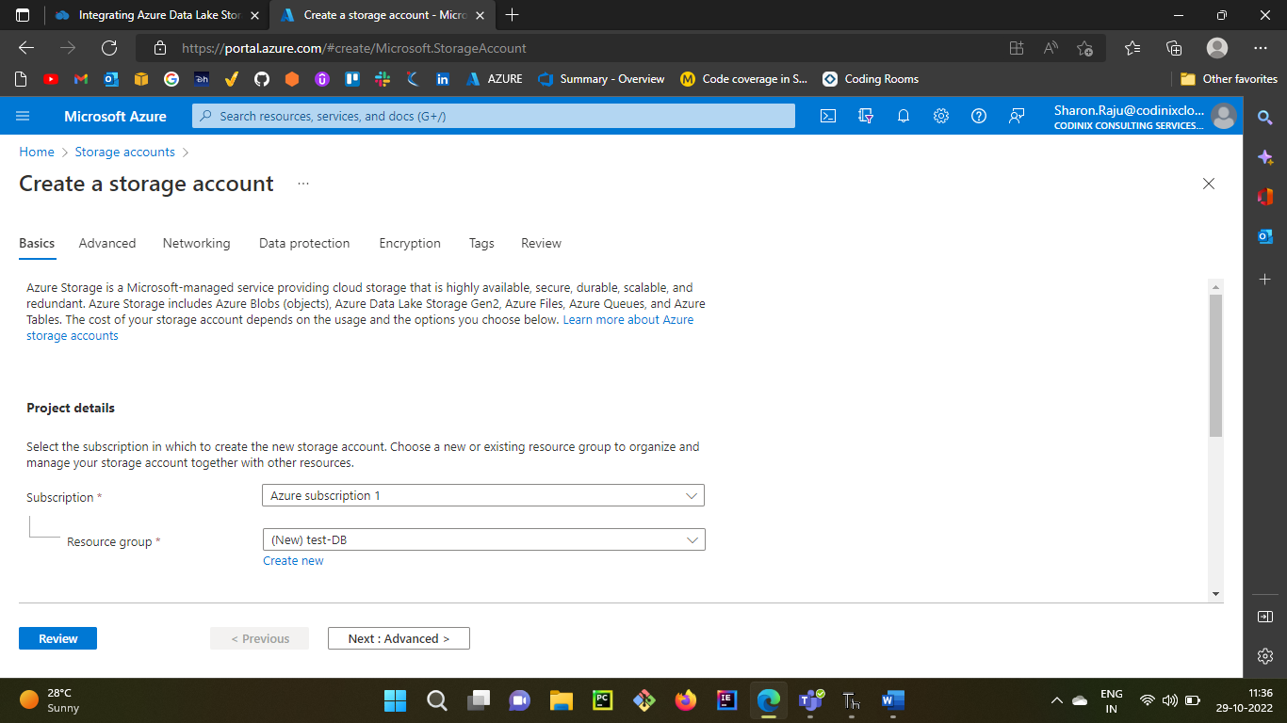

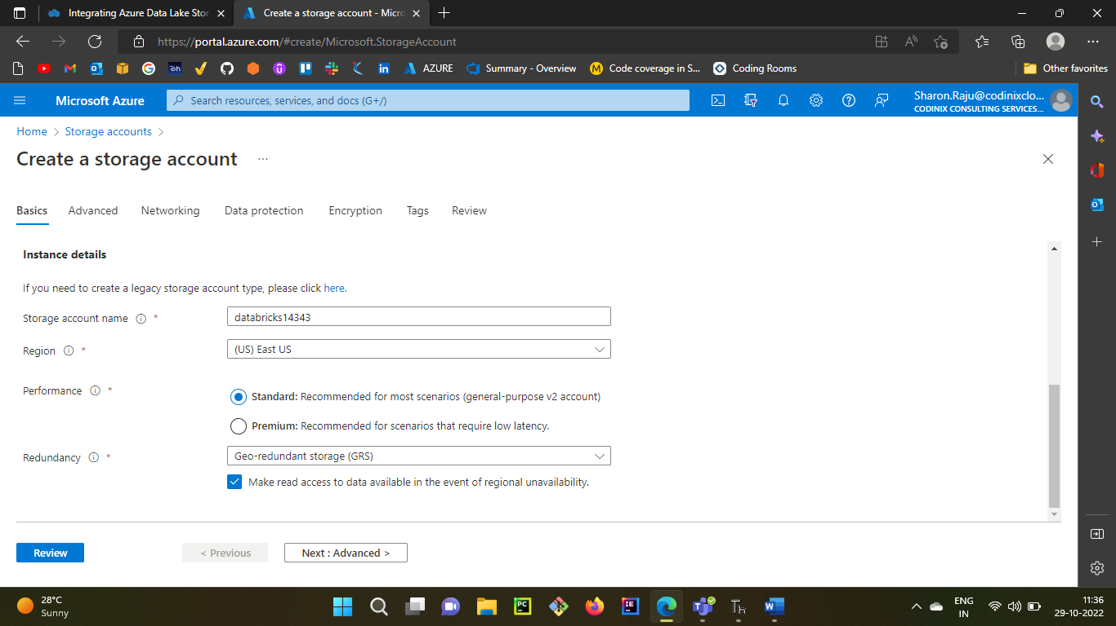

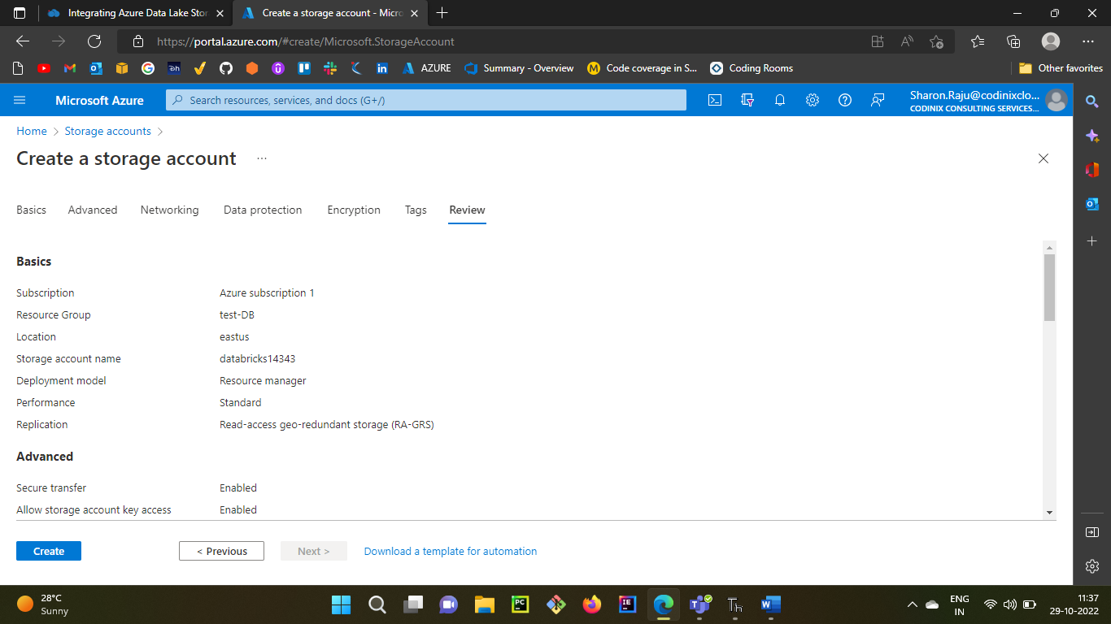

**Microsoft Azure Storage Explorer**

Microsoft Azure Storage Explorer is a standalone app that makes it easy to work with Azure Storage data on Windows, macOS, and Linux.

<https://azure.microsoft.com/en-us/products/storage/storage-explorer/>

Sign into the **Microsoft Azure Storage Explorer** with your azure sign indetails

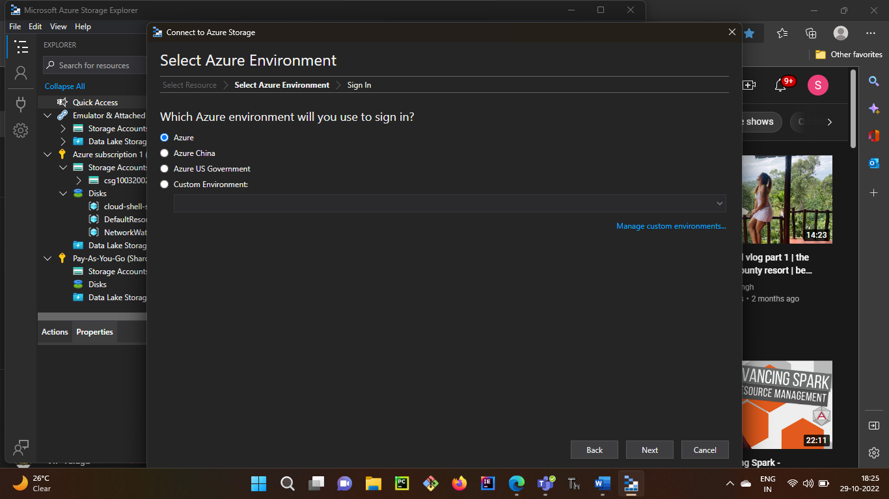

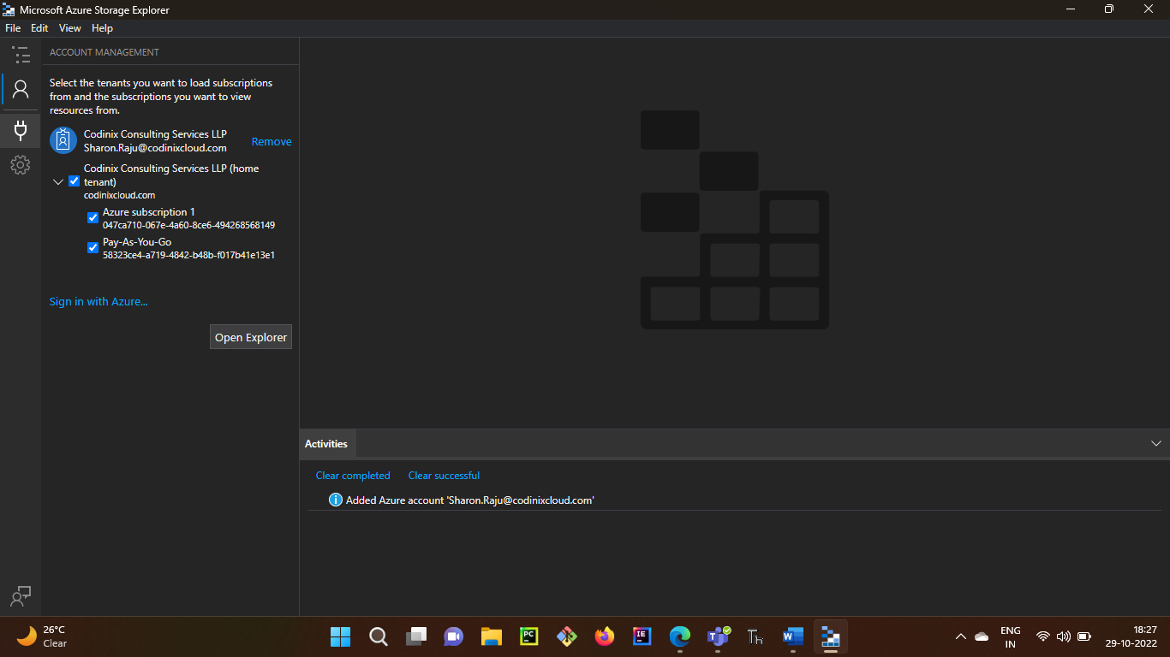

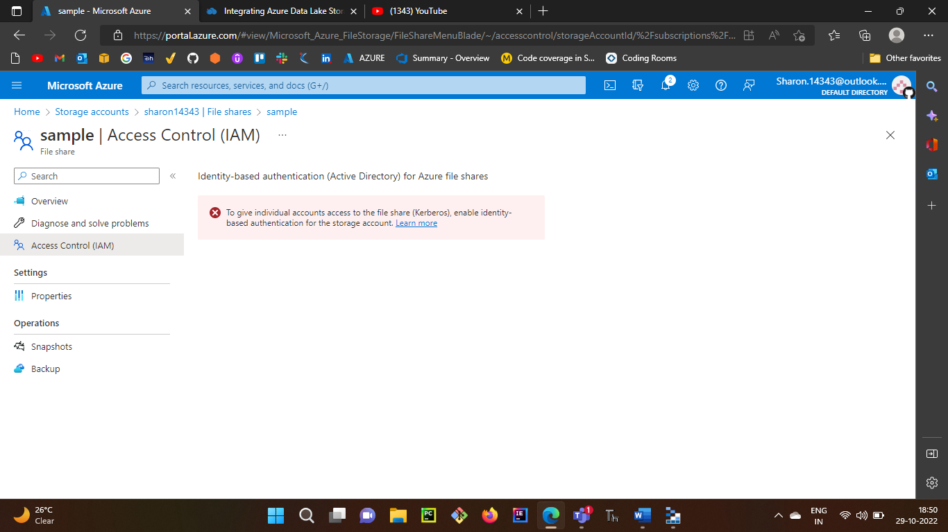

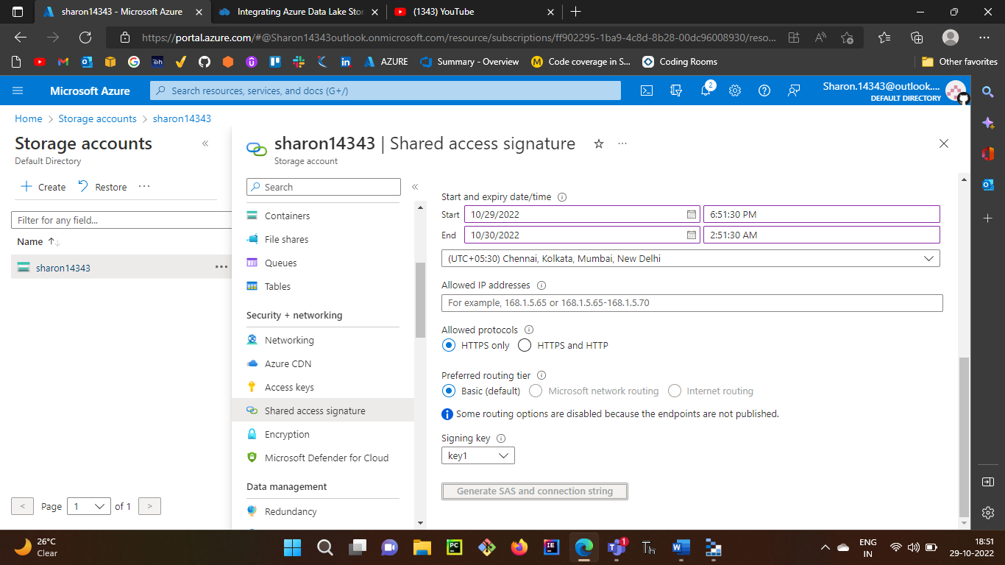

Not able to generate File share SAS but while connecting through below to connect Azure Storage Explorer it is asking for SAS key

