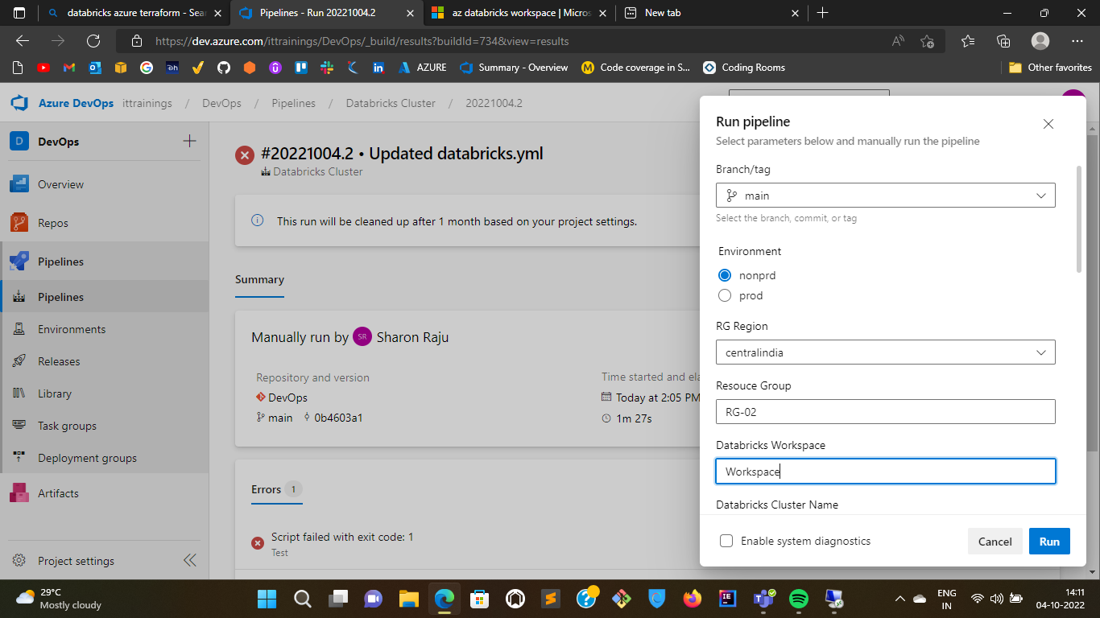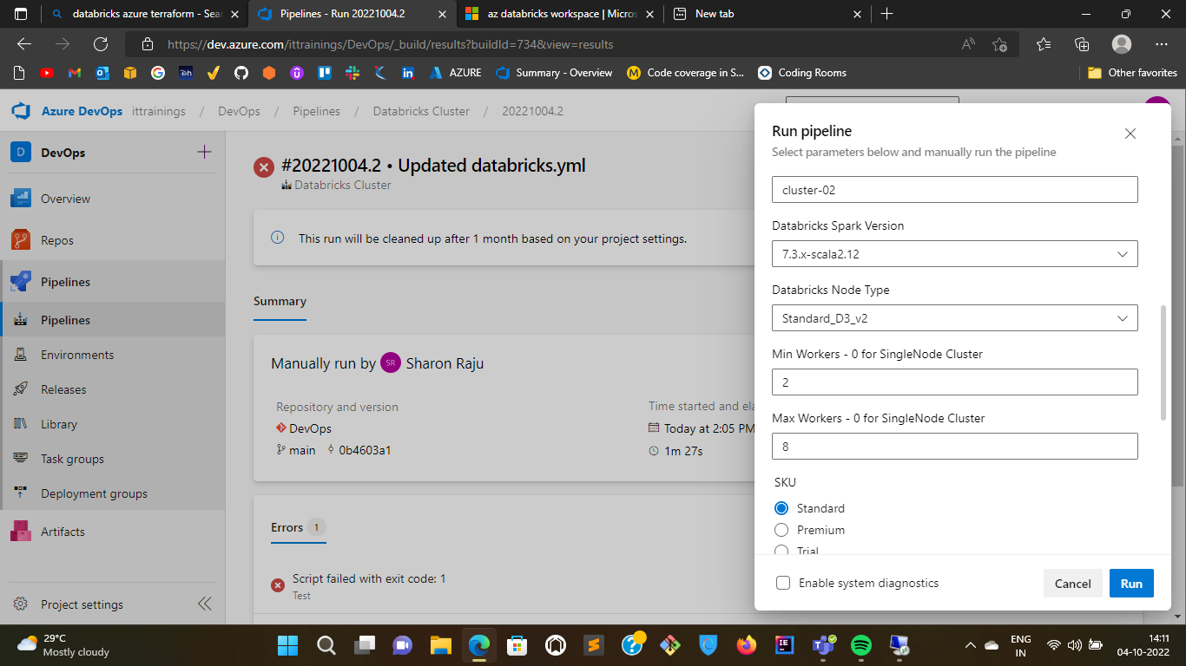

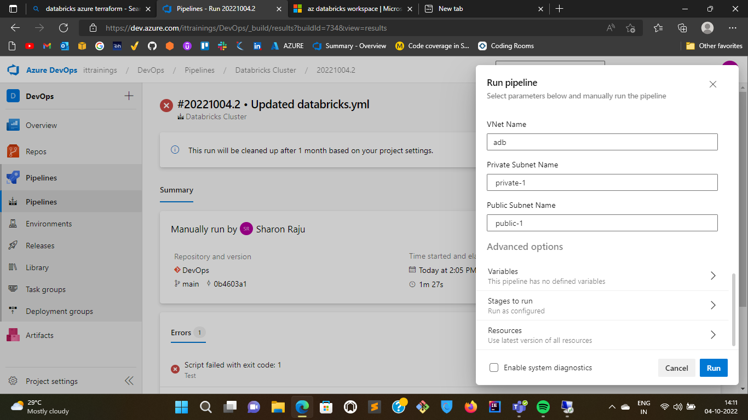

1. WARNING: The command requires the extension databricks. It will be installed first.

ERROR: (InvalidVirtualNetworkId) The custom Virtual Network Id '/subscriptions/047ca710-067e-4a60-8ce6-494268568149/resourceGroups/RG-03/providers/Microsoft.Network/virtualNetworks/adb' provided is either invalid or does not exist. Please make sure the virtual network exists

Code: InvalidVirtualNetworkId

Message: The custom Virtual Network Id '/subscriptions/047ca710-067e-4a60-8ce6-494268568149/resourceGroups/RG-03/providers/Microsoft.Network/virtualNetworks/adb' provided is either invalid or does not exist. Please make sure the virtual network exists

Workspace ID: /subscriptions/047ca710-067e-4a60-8ce6-494268568149/resourceGroups/RG-03/providers/Microsoft.Databricks/workspaces/Workspace

Workspace URL:

PAT URL: <https://eastus.azuredatabricks.net/api/2.0/token/create>

Error 404 The workspace with resource ID /subscriptions/047ca710-067e-4a60-8ce6-494268568149/resourceGroups/RG-03/providers/Microsoft.Databricks/workspaces/Workspace could not be found.

HTTP ERROR 404

Problem accessing /api/2.0/token/create. Reason:

The workspace with resource ID /subscriptions/047ca710-067e-4a60-8ce6-494268568149/resourceGroups/RG-03/providers/Microsoft.Databricks/workspaces/Workspace could not be found.

An error occurred creating Databricks Workspace/ Cluster

##[error]Script failed with exit code: 1

/usr/bin/az account clear

Finishing: Test