COLLEGE CLUB
ACTIVITY MANAGER
MICRO PROJECT REPORT

Micro Project Report

Submitted to the APJ Abdul Kalam University, Kerala
for the partial fulfilment of the requirements for the award of the degree

of

Bachelor of Technology
in
Computer Science and Engineering

By

MAADESH SARAN | PRN25CS072
MADHAV P | PRN25CS073
SHARON SABU | PRN25CS113
VINAYAK PRAKASH B J | PRN25CS130
PRANAV S | PRN25CS098

Guided by

Prof. Anish A Aziz

during

OCTOBER 2026



DEPARTMENT OF COMPUTER SCIENCE AND ENGINEERING
COLLEGE OF ENGINEERING PERUMON
CAPE - GOVT. OF KERALA, KOLLAM(D), KERALA

Table of Contents

Chapter
No. Title
- Introduction
- Scope of the micro-project
- Technologies used
- Problem Statement
- Literature Review / Background
- System Analysis & Design
- Implementation
- Details of Java classes and architecture
- Results & Discussion
- Conclusion
References

Introduction
Background & Context
Extracurricular activities and student organizations form a cornerstone of holistic student development in modern educational institutions. However, managing these diverse clubs often involves administrative hurdles, including tracking membership rosters, scheduling campus-wide events, and maintaining accurate records of student participation. Traditionally, these workflows relied heavily on fragmented physical ledgers and unorganized digital spreadsheets, leading to communication bottlenecks and redundant administrative overhead.
Project Overview
The College Club Activity Manager is developed as a robust, user-friendly desktop application utilizing Java Swing to address these institutional challenges. By establishing a centralized graphical interface, the system bridges the gap between general student members and administrative coordinators. It provides an intuitive environment to explore active clubs, review upcoming schedules, and manage event registrations through seamless frame navigation.
Purpose and Objectives
- Centralized Digital Management: Maintain structured profiles for active campus clubs and student memberships in an organized graphical environment.
- Streamlined Event Scheduling: Enable coordinators to create, publish, and manage upcoming campus activities seamlessly.
- Intuitive Role-Based Navigation: Provide distinct user interfaces for student members (exploring events) and coordinators (managing club logistics) via linked Swing frames.
- Modular Software Engineering: Implement core Object-Oriented Programming (OOP) principles—such as encapsulation, inheritance, and event-driven architecture—to ensure a clean, maintainable, and extensible codebase.

Scope of the micro-project
Functional Scope
The scope of the application encompasses:
- Club Profile & Category Management: Displaying structured profiles for active campus clubs across technical, cultural, sports, and professional groups within the UI.
- Member Navigation & Search: Providing interface mockups for student registrations and fast profile lookups across multiple clubs.
- Activity Scheduling: Enabling coordinators to view and interact with campus event schedules, dates, times, and venue details via dedicated forms.
- Role-Based Workflows: Providing distinct navigation paths and frame transitions for student members (exploring events) and coordinators (managing club activities and requests).
User Access & Permissions
The system categorizes users into two operational roles via dedicated interface frames:
- Student Members: Access joined memberships and campus activities, explore upcoming events filtered by category or host club, and view profile details.
- Club Coordinators: Access administrative views to manage club details, schedule new activities, update event schedules, and review membership requests.
Technical Scope
- Application Framework: Java desktop application developed using the Java Swing toolkit and JFrame components.
- Interface Navigation: Event-driven frame transitions handling user routing between the Portal Selection, Member Dashboard, and Coordinator Dashboard.
- Version Control: Managed via Git and GitHub for collaborative source code development.

Technologies used
The development of the College Club Activity Manager relies on a robust combination of programming languages, graphical toolkits, and version control tools:
- Java (JDK 21/26): Serves as the core programming language, implementing object-oriented programming (OOP) principles, event listeners, and modular class architectures.
- Java Swing: A graphical user interface (GUI) toolkit used to design and render interactive desktop windows, frames (JFrame), panels, forms, navigation buttons, and data views.
- Visual Studio Code: Integrated Development Environment (IDE) used to write, organize, and compile Java source packages.
- GitHub: A distributed version control platform utilized for source code collaboration, branch tracking, and maintaining team commit histories.

Problem Statement
Managing campus club activities through scattered messaging platforms and unorganized manual records creates significant administrative bottlenecks and communication gaps. Student coordinators struggle to track membership growth, verify active club statuses, and maintain accurate event participation records manually. Furthermore, students lack a centralized, unified platform to discover active campus clubs and track upcoming events efficiently.
Core Problems Addressed
- Data Fragmentation: Eliminates scattered, unorganized record-keeping across disparate spreadsheets and physical notes by centralizing club details and student records into a structured desktop UI.
- Administrative Inefficiencies: Reduces repetitive manual overhead and delays during event scheduling, coordinator approvals, and member profile updates.
- Discovery and Communication Barriers: Solves the difficulty students face in identifying active campus clubs and keeping track of upcoming event timelines through an intuitive graphical dashboard.
By unifying these administrative functions into a local Java Swing desktop application, the system ensures smooth window navigation and maintains consistent layout structures across all student operations, entirely independent of backend database dependencies.

Literature Review / Background
Background & Context
Traditionally, academic clubs and student organizations managed memberships, rosters, and event schedules through manual ledgers, physical sign-up sheets, or decentralized spreadsheets. While these methods work for small groups, they lack structural consistency, role-based access management, and efficient routing controls, often leading to duplicate entries and administrative delays.
Evolution of Campus Management Systems
Institutional software has evolved from isolated flat-file storage toward centralized graphical architectures. Modern academic application design utilizes Object-Oriented Programming (OOP) to encapsulate real-world entities—such as student members, coordinators, clubs, and activities—into clean, modular Java classes.
Paradigms in Graphical User Interface Architecture
Contemporary desktop application engineering emphasizes event-driven programming models over traditional command-line interfaces. By leveraging robust UI toolkits like Java Swing, developers can construct responsive, platform-independent applications featuring modular windows (JFrame), component event listeners (ActionListener), and distinct navigational workflows. This design approach separates user interface components from business logic, ensuring high cohesion, low coupling, and maintainable software architecture well-suited for academic projects.

System Analysis & Design
The College Club Activity Manager uses an event-driven Java Swing architecture. Application state and navigation are managed through seamless window transitions (JFrame linking) triggered by user interaction on login and dashboard portals, entirely independent of backend database dependencies.

Primary Application Frames & Workflows
- Portal Selection Frame (PortalSelection): The primary landing window that allows users to choose their operational role (Student Member vs. Club Coordinator).
- Member Dashboard Frame (MemberDashboard): Provides student users with navigational access to view joined club memberships, search campus activities, and filter upcoming events.
- Coordinator Dashboard Frame (CoordinatorDashboard): Provides administrative controls allowing coordinators to manage club details, schedule new activities, and review pending requests.

Frame Transition Flow
- Application Launch: Initializes the main PortalSelection window.
- Role Selection: Clicking the respective role button disposes of the current frame and instantiates either the MemberDashboard or CoordinatorDashboard.
- Internal Navigation: Action listeners (ActionListener) handle internal tab switches, dialog popups, and form submissions within each dashboard.

Implementation

Tools and Technologies Used
The implementation of the College Club Activity Manager utilizes a lightweight, robust technology stack tailored for local execution and academic evaluation:

- Java Development Kit (JDK 21/26): Serves as the core programming environment, supplying the compiler, runtime engine, and standard class libraries required for executing object-oriented GUI logic.
- Integrated Development Environment (IDE): Developed using Visual Studio Code, integrated with the Java compiler toolchains and extensions to manage source files, packages, and local builds.
- GUI Component Libraries: Utilizes Java Swing packages (javax.swing.*, java.awt.*) to design responsive desktop windows, buttons, text fields, and tables.
- Version Control (Git & GitHub): Used for collaborative source code management, tracking team contributions (45 total commits distributed among Pranav, Sharon, Vinayak, Maadesh, and Madhav), and maintaining repository history.

Details of java classes and architecture

Object-Oriented Class Design
The application is structured around a robust Object-Oriented Programming (OOP) hierarchy implemented across modular Java packages, ensuring clean separation of concerns and maintainability:
- PortalSelection: The primary entry point and launch frame of the application. It renders the landing UI, allowing users to choose their operational role and triggering dynamic frame routing.
- MemberDashboard: Manages the student-facing user interface, incorporating event listeners to handle membership views, club category filters, and campus event discovery panels.
- CoordinatorDashboard: Implements the administrative control panel, allowing club coordinators to interface with event scheduling forms, club detail views, and request management components.
- Club & Activity Classes: Encapsulate core metadata entities, storing attributes such as club titles, categories, event schedules, and venue details with private data fields accessed via public getters and setters.
Package Structure & GUI Workflow
The source code is organized into modular packages within Visual Studio Code, utilizing Java Swing (javax.swing.* and java.awt.*) to handle window rendering, layout management, and component styling. Window transitions are handled via event-driven action listeners (ActionListener), which dispose of current active frames and instantiate the subsequent target dashboard seamlessly without external database overhead.

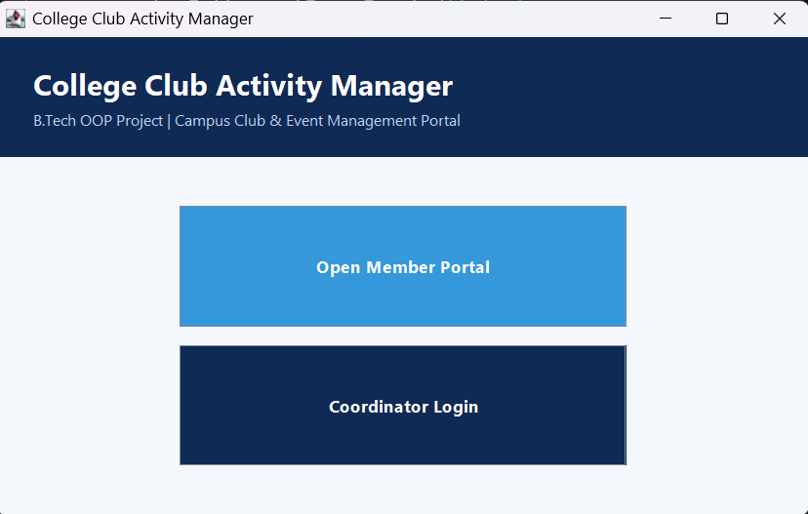
Results and Discussions
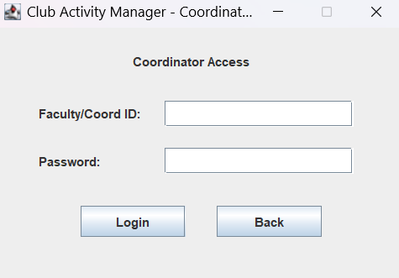
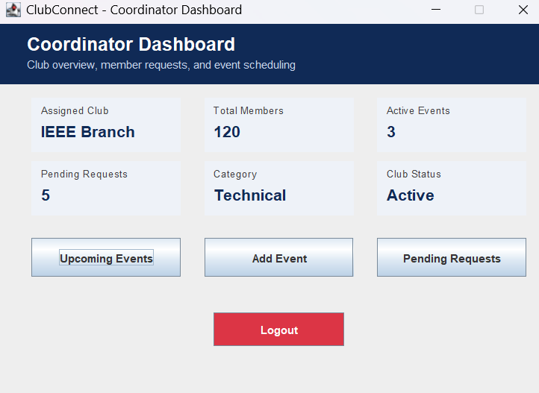

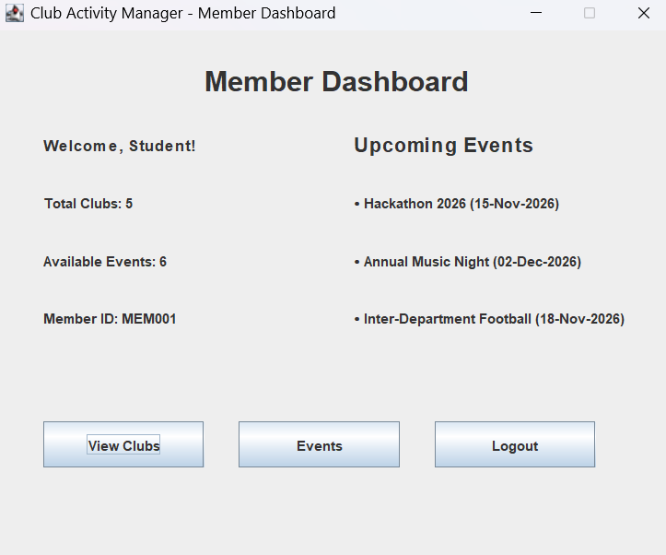
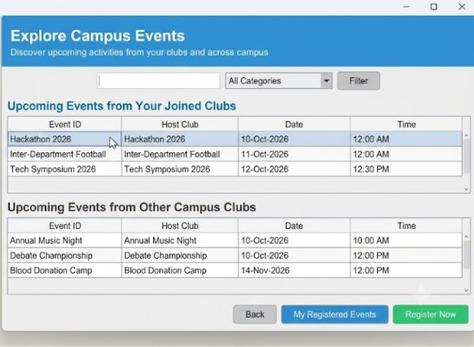
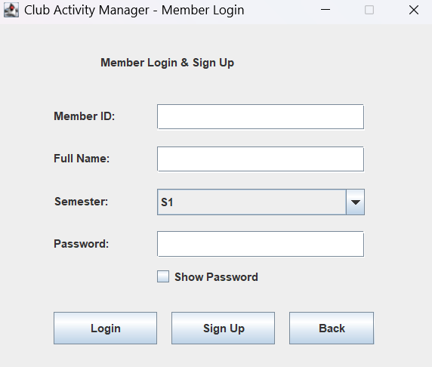

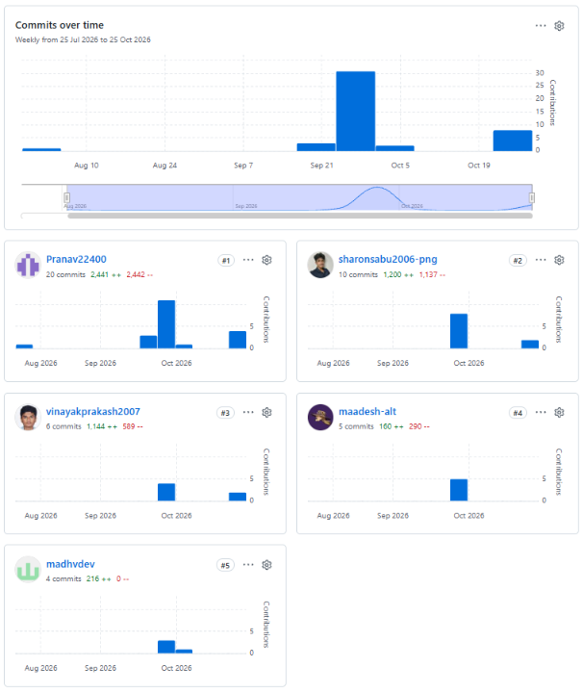
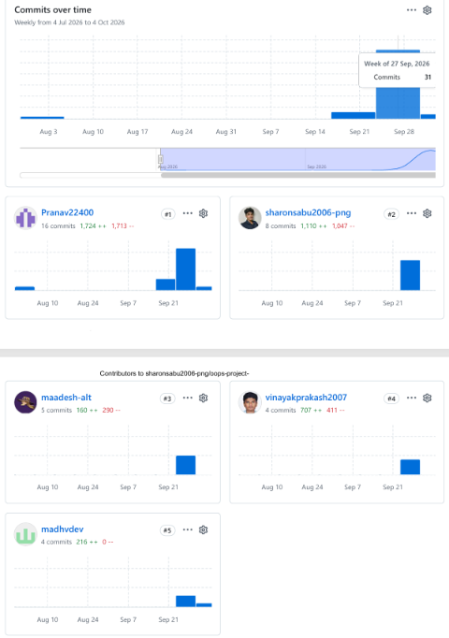

Between July 25, 2026, and October 25, 2026, the project repository recorded a total of 45 commits contributed across all 5 team members. Pranav led the repository activity as the top contributor with 20 commits (2,441 additions, 2,442 deletions), followed by Sharon with 10 commits (1,200 additions, 1,137 deletions). Vinayak contributed 6 commits (1,144 additions, 589 deletions), Maadesh made 5 commits (160 additions, 290 deletions), and Madhav completed 4 commits (216 additions). Development peak activity occurred between late September and early October 2026, marking the primary integration phase of the codebase

Conclusion
The College Club Activity Manager successfully demonstrates a structured, interactive desktop application tailored for campus organizations using Java Swing. By establishing seamless frame navigation, role-based portals for students and coordinators, and clear user workflows, the application effectively models the administrative requirements of campus clubs without relying on backend database dependencies.
Future Scope
While the current UI prototype fulfills all core navigational and layout objectives, future enhancements can expand its capabilities further:
- Database Integration: Incorporating a relational backend (such as MySQL via JDBC) for persistent record management.
- Web & Mobile Deployment: Transitioning the platform to a cloud-hosted web application or mobile app to enable real-time notifications and remote access.
- Online Payment Integration: Incorporating digital payment gateways (such as UPI) for seamless event ticketing and club membership fee collection.
- Automated Communication: Integrating automated email or SMS services to send event reminders and status updates directly to registered students.

References
- Herbert Schildt, Java: The Complete Reference, 12th Edition, McGraw-Hill Education, 2021.
- Cay S. Horstmann, Core Java, Volume I—Fundamentals, 12th Edition, Pearson, 2022.
- Kathy Sierra, Bert Bates, and Trisha Gee, Head First Java, 3rd Edition, O'Reilly Media, 2022.
- Oracle Corporation, Creating a GUI with JFC/Swing, Oracle Java Documentation, Available: https://docs.oracle.com/javase/tutorial/uiswing/.
- Paul Deitel and Harvey Deitel, Java How to Program, Early Objects, 11th Edition, Pearson, 2017.
- Git Documentation, Getting Started - About Version Control, Available: https://git-scm.com/doc.

