Covid-19 Dialog Flow Chatbot

Artificial Intelligence

Project Proposal 2021

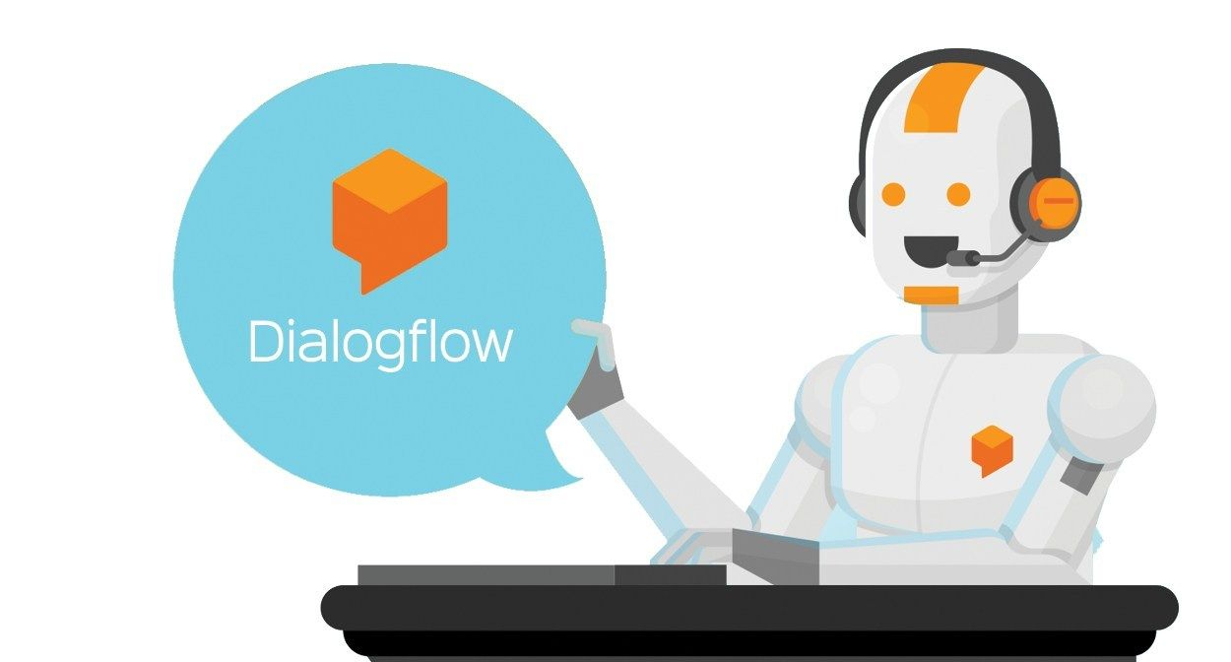

Group Members: Class id: 106266

* Muhammad Sheroz 9852
* Kehkashan Akram 9825

Introduction to problem (You choose)

Introduction:

In this project we creating chatbot dialog flow. It is artificial intelligent awareness system about Covid-19. One can ask questions about covid-19 and it will answer.

Description:

We are building a chatbot that will give its users awareness about covid-19.

What is a Chatbot?

Interacts through instant messaging, artificially replicating the patterns of human interactions.

What is dialog flow?

Dialog flow is a natural language understanding platform used to design and integrate a conversational user interface into mobile apps, web applications, devices, bots, interactive voice response systems and related uses.

GitHub Picture

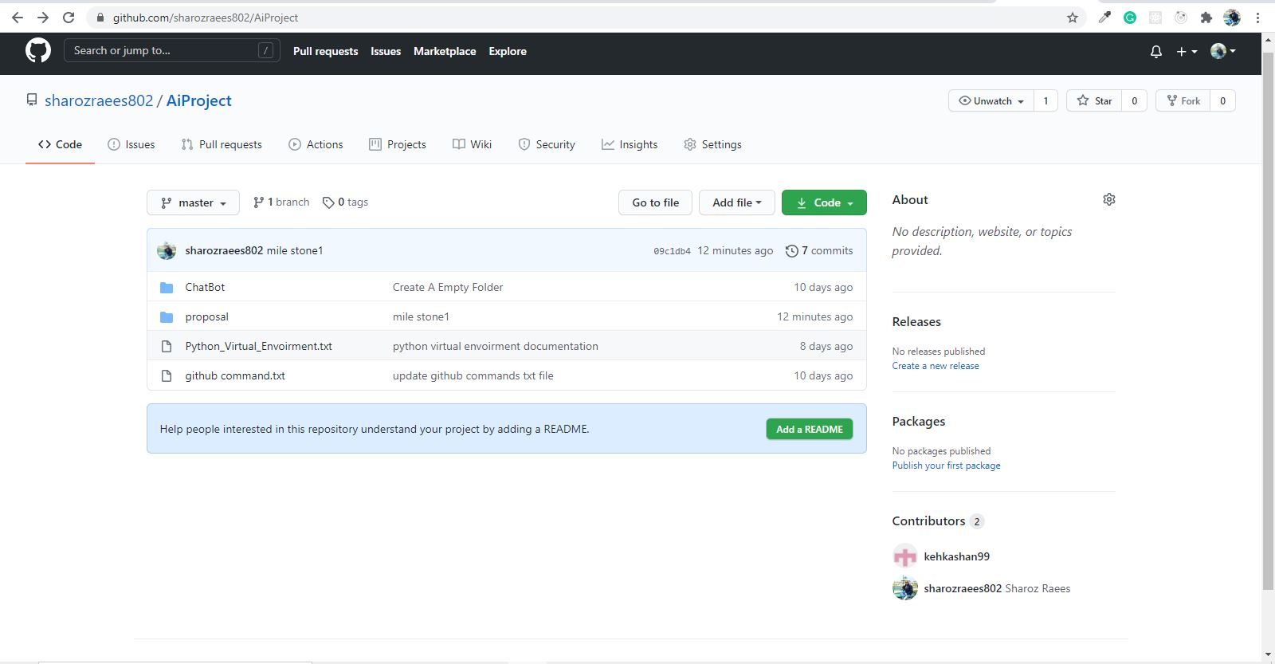

Software Requirements

* Version Control Git and GitHub
* Visual Studio Code
* Jupyter Notebook
* Mongo Db atlas

Project Planning

**Expected Result:** our project will be complete in 9th week

**Code Language:**

We will use Python, Flask, MongoDB, Rapid API, Dialog Flow API

**GitHub Link:** <https://github.com/sharozraees802/AiProject.git>

Date: 13 Feb 2021

|  |  |  |  |  |  |  |  |  |  |
| --- | --- | --- | --- | --- | --- | --- | --- | --- | --- |
|  | Week1 | Week2 | Week3 | Week4 | Week5 | Week6 | Week7 | Week8 | Week9 |
| Google Dialogflow  & NLU |  |  |  |  |  |  |  |  |  |
| Flask/python,  API,  MongoDB |  |  |  |  |  |  |  |  |  |
| Testing &  Deploymente |  |  |  |  |  |  |  |  |  |