Covid-19 Dialog Flow Chatbot

Artificial Intelligence

Project Proposal 2021

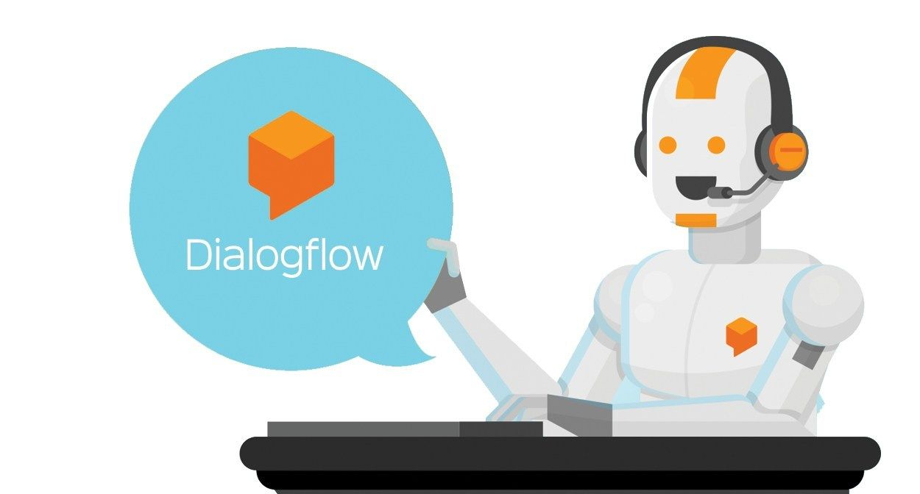

Group Members: Class id: 106266

* Muhammad Sheroz 9852
* Kehkashan Akram 9825

GitHub Picture

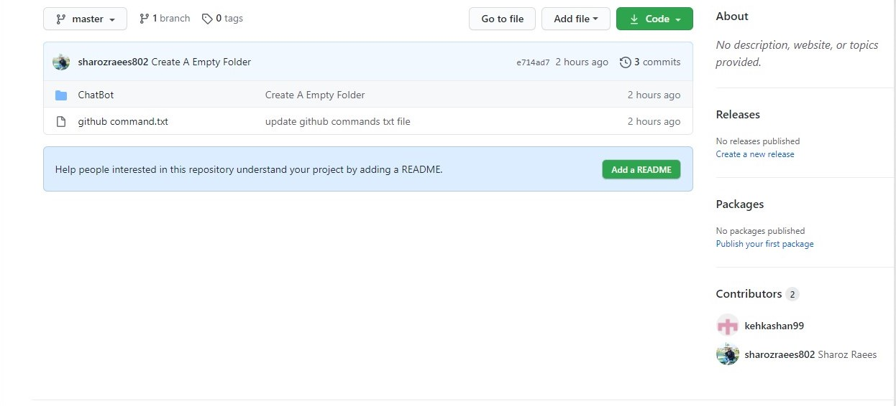

Date: 4 Feb 2021