only facebook scraping is completed. downloading and delete function not working yet.

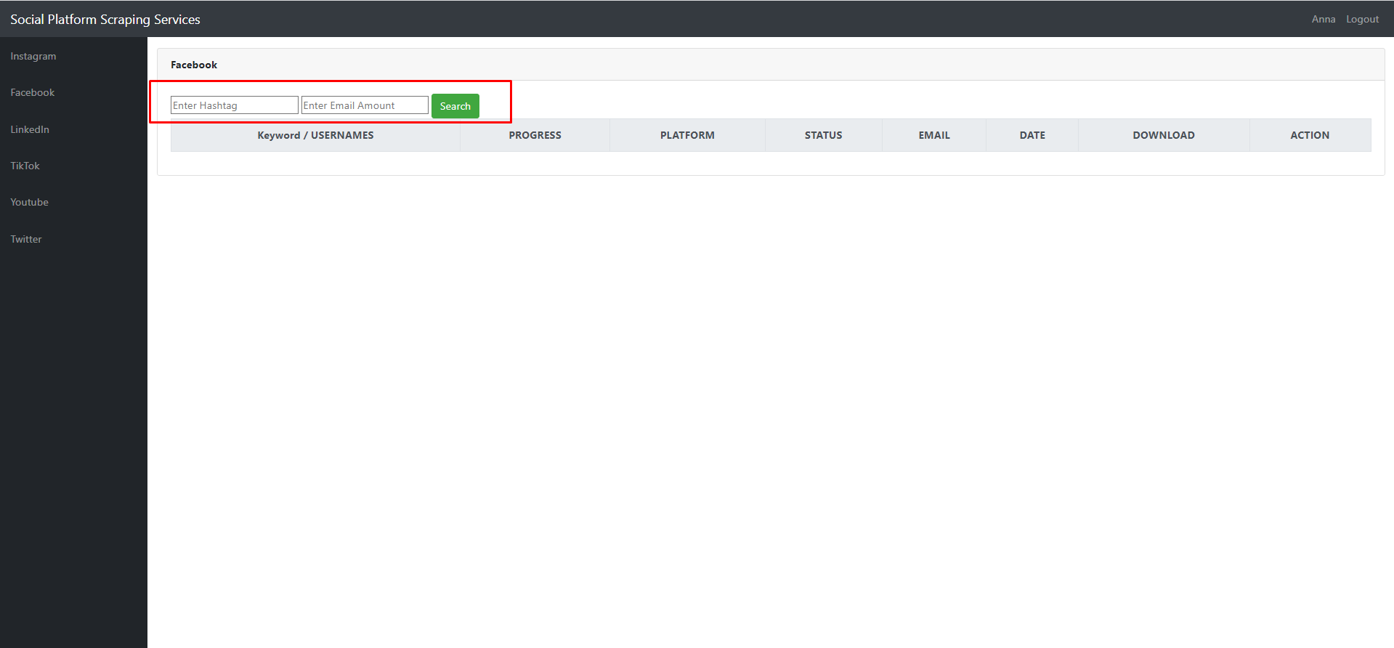

After typing hashtag and number, click search button

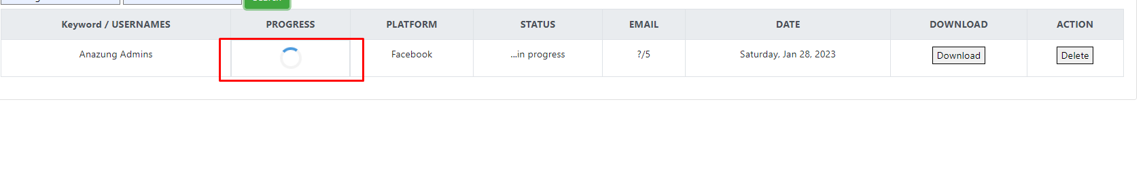

When above field shows completed, check scraped email on db

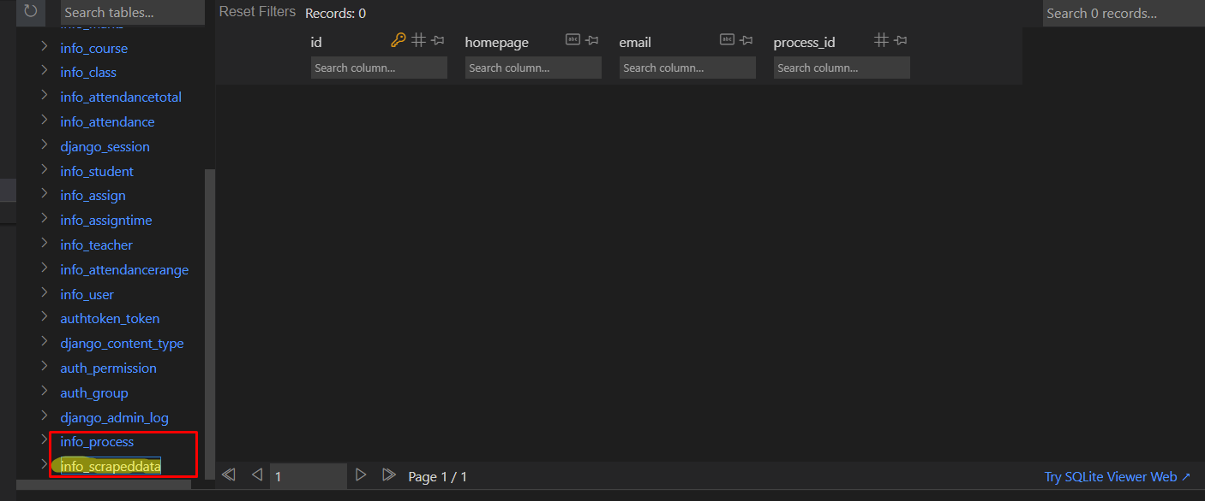

Please check in these 2 tables and you should see scraped emails in highlighted table.

If it works then other pages will be duplication of it…