

**Moving Car Project**

**Team Members:**

|  |
| --- |
| Alaa Ibrahim |
| Bassel Yasser |
| Sharpel Malek |
| Sherif Khadr |

Contents

INTRODUCTION 1

High Level Design 2

**01)** **Layered Architecture** 2

**02)** **Modules Description** 3

**03)** **Drivers’ Documentation** 4

Low Level Design 14

Figure 1: Project Layered Architecture 2

# INTRODUCTION

In our project we have a four-driving wheel robot and moves in a rectangular shape, on this document we will illustrate the module design and how they integrate with each other, we’ll also discuss the used APIs in more detail and providing the flowchart for each function in each module, and making layered architecture.

In this project we used PWM for controlling motor speed, TIMER on normal mode for controlling the duration of motor, DIO for GPIO Pins and External Interrupt Module for Start / Stop Motor

# High Level Design

## **Layered Architecture**

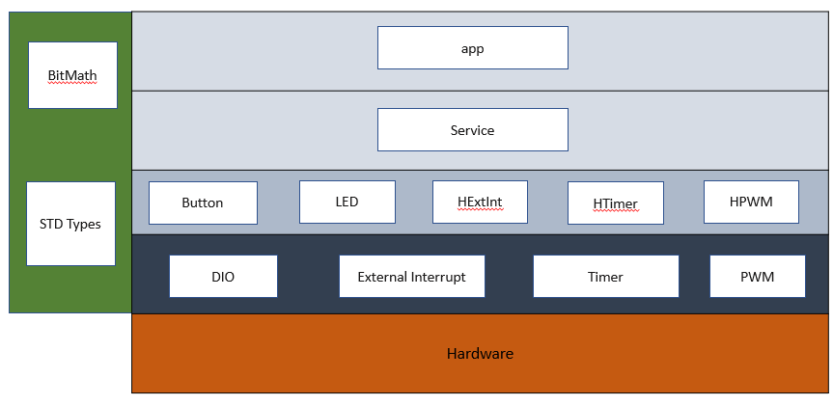

Figure : Project Layered Architecture

## **Modules Description**

**MCAL Layer:**

* **DIO:**
* **External Interrupt:** this module takes place in MCAL layer. it controlsthree external hardware interrupts on pins PD2, PD3, and PB2 which are referred to as INT0, INT1, and INT2 respectively. External interrupts can be level-triggered or edge-triggered.  
  We program this triggering. INT0 and INT1 can be level-triggered and edge-triggered whereas INT2 can be only edge-triggered.
* **Timer:**
* **PWM:** a modulation technique that generates variable-width pulses to represent the amplitude of an analog input signal, and directly communicates to hardware.
* **PWM NORMAL:** it generates the functionality of PWM using the normal mode of timer.

**HAL Layer:**

* **Button:**
* **LED**
* **HPWM:** Is in Middle layer which Application can communicate to MCAL layer**.**
* **HTimer:**
* **HExtInt:** In the HAL layer, which the Application can communicate to the External interrupt module.
* **HPWM_NORMAL:** In the HAL layer, which the Application can communicate to the PWM NORMAL module.

**Service Layer:**

**Application Layer:**

## **Drivers’ Documentation**

**MCAL Layer:**

* **DIO:**
* **External Interrupt:**

**// EXT_INT TYPEDEFS**

**typedef enum {EXTINT_OK=0,EXTINT_NOT_O }EN_EXTINT_ERROR;**

**typedef enum {LOW_LEVEL=0,FALLING_EDGE,RISING_EDGE,ANY_LOGICAL_CHANGE}EN_Sence_Control;**

**typedef enum {EXTINT0=0,EXTINT1,EXTINT2}EN_EXINT_NUMBER;**

**typedef enum {DISABLE=0,ENABLE}EN_GLOBAL_INT;**

**// EXT_INT prototypes**

**/*Description : This function initializes the GLOBAL_INTERRUPT**

**ARGS : takes the state ( ENABLE OR DISABLE )**

**return : return EXTINT_OK if the PIN initializes correctly, EXTINT_NOT_OK otherwise*/**

**EN_EXTINT_ERROR SET_GLOBAL_INTERRUPT(EN_GLOBAL_INT state);**

**/*Description: This function initializes the external interrupt number and its detecting type**

**ARGS : takes the EXINT_NUMBER( INT0,INT1 OR INT2) and sence control.**

**return : EXTINT_OK if the EXINT_NUMBER initializes correctly, EXTINT_NOT_OK otherwise*/**

**EN_EXTINT_ERROR EXTINT_init(EN_EXINT_NUMBER INTx ,EN_Sence_Control INTxSense);**

**/*Description: This function takes the external interrupt number and initializes the call-back function.**

**ARGS : takes the EXINT_NUMBER( INT0,INT1 OR INT2) and pointer to the function we want to execute.**

**return : return EXTINT_OK if the EXINT_NUMBER initializes correctly, EXTINT_NOT_OK otherwise*/**

**EN_EXTINT_ERROR EXTINT_CallBack(EN_EXINT_NUMBER INTx,void(*ptrfunc)(void));**

* **Timer:**
* **PWM:** 
  + **enu_timer1Status_t Timer1_enuInit (enu_timer1Mode_t)**

**Author :** Bassel Yasser Mahmoud

**Function Name:** Timer1_enuInit

**Function Description**: Initialize Timer1 to Fast PWM Mode

**Arguments:** copy_enTmerMode {TIMER1_OVF_MODE, TIMER1_FAST_PWM_MODE,}

**Return:** enu_timer1Status_t {TIMER1_OK or TIMER1_NOK}

* + **enu_timer1Status_t Timer1_enuSetPrescallar(enu_timer1Prescalar_t)**

**Author**  : Bassel Yasser Mahmoud

**Function Nam**e : Timer1_enuSetPrescallar

**Function Description** : Set Prescaller

**Arguments:** Timer1_enuSetPrescallar {TIMER1_PRE_1, TIMER1_PRE_64, TIMER1_PRE_256}

**Return** : enu_timer1Status_t {TIMER1_OK or TIMER1_NOK}

* + **enu_timer1Status_t Timer1_enuFastPWMInit(enu_pwm1Mode_t)**

**Author**  : Bassel Yasser Mahmoud

**Function Name** : Timer1_enuFastPWMInit

**Function Description :** Set PWM Mode

**Arguments: c**opy_enPWMMode {TIMER1_PWM_NORMAL, TIMER1_PWM_CLR_ON_CMP, TIMER1_PWM_SET_ON_CMP}

**Return**  : enu_timer1Status_t {TIMER1_OK or TIMER1_NOK}

* + **enu_timer1Status_t Timer1_enuPWMGenerate (Uchar8_t)**

**Author**  : Bassel Yasser Mahmoud

**Function Name** : Timer1_enuPWMGenerate

**Function Description** : Generate PWM

**Arguments** : copy_u8DutyCycle {1 ~ 100}

**Return**  : enu_timer1Status_t {TIMER1_OK or TIMER1_NOK}

* + **enu_timer2Status_t Timer2_enuInit (enu_timer2Mode_t)**

**Author :** Bassel Yasser Mahmoud

**Function Name:** Timer1_enuInit

**Function Description**: Initialize Timer2 to Fast PWM Mode

**Arguments:** copy_enTmerMode {TIMER2_OVF_MODE, TIMER2_FAST_PWM_MODE,}

**Return:** enu_timer1Status_t {TIMER2_OK or TIMER2_NOK}

* + **enu_timer2Status_t Timer2_enuSetPrescallar(enu_timer2Prescalar_t)**

**Author**  : Bassel Yasser Mahmoud

**Function Nam**e : Timer2_enuSetPrescallar

**Function Description** : Set Prescaller

**Arguments:** Timer2_enuSetPrescallar {TIMER2_PRE_1, TIMER2_PRE_64, TIMER2_PRE_256}

**Return** : enu_timer2Status_t {TIMER2_OK or TIMER2_NOK}

* + **enu_timer2Status_t Timer2_enuFastPWMInit(enu_pwm2Mode_t)**

**Author**  : Bassel Yasser Mahmoud

**Function Name** : Timer2_enuFastPWMInit

**Function Description :** Set PWM Mode

**Arguments: c**opy_enPWMMode {TIMER2_PWM_NORMAL, TIMER2_PWM_CLR_ON_CMP, TIMER2_PWM_SET_ON_CMP}

**Return**  : enu_timer2Status_t {TIMER2_OK or TIMER2_NOK}

* + **enu_timer2Status_t Timer2_enuPWMGenerate (Uchar8_t)**

**Author**  : Bassel Yasser Mahmoud

**Function Name** : Timer2_enuPWMGenerate

**Function Description** : Generate PWM

**Arguments** : copy_u8DutyCycle {1 ~ 100}

**Return**  : enu_timer2Status_t {TIMER2_OK or TIMER2_NOK}

* **PWM NORMAL:**

**/*Description : This function selects the normal mode and enables the GLOBAL_INTERRUPT and overflow interrupt for timer2**

**ARGS : void**

**return : void*/**

**void timer2_init(void);**

**/*Description : This function selects the prescaler (clk/1024). the timer start counting once we call this function.**

**ARGS : void**

**return : void*/**

**void timer2_start(void);**

**/*Description : This function selects the no clock source option. the timer stop counting once we call this function.**

**ARGS : void**

**return : void*/**

**void timer2_stop(void);**

**/*Description : This function calculate the on time based on duty cycle we need .**

**ARGS : takes the duty cycle**

**return : void*/**

**void timer2_set_pwm_normal(uint8_t a_dutycycle);**

**HAL Layer:**

* **Button:**
* **LED:**
* **HPWM:** 
  + **enu_pwmStatus_t pwm_enInit(void)**

**Author** : Bassel Yasser Mahmoud

**Function Name** : pwm_enInit

**Function Description :** Initialize PWM to be fast PWM, set prescaller, Set PWM Mode

**Arguments** : void

**Return**  : enu_pwmStatus_t {PWM_OK or PWM_NOK}

* + **enu_pwmStatus_t pwm_enGenerate(Uchar8_t)**

**Author** : Bassel Yasser Mahmoud

**Function Name** : pwm_enGenerate

**Function Description :** Generate PWM signal

**Arguments** : Uchar8_t

**Return**  : enu_pwmStatus_t {PWM_OK or PWM_NOK}

* **HTimer:**
* **HExtInt:**

/*

Description : This function initializes the external interrupt number and it's detecting type and initialize call back function.

ARGS : takes the EXINT_NUMBER( INT0,INT1 OR INT2) and sense control and and pointer to the function we want to execute when interrupt occurs.

return : return EXTINT_OK if the EXINT_NUMBER initializes correctly, EXTINT_NOT_OK otherwise

*/

EN_EXTINT_ERROR H_EXTINT_create(EN_EXINT_NUMBER INTx ,EN_Sence_Control INTxSense,void(*ptrfunc)(void));

* **HPWM_NORMAL:**

/*

Description : This function selects the normal mode and enables the GLOBAL_INTERRUPT and overflow interrupt for timer2

ARGS : void

return : void

*/

void H_PWM_NORMAL_init(void);

/*

Description : This function selects the no clock source option. the timer stop counting once we call this function.

ARGS : void

return : void

*/

void H_PWM_NORMAL_stop(void);

/*

Description : This function calculate the on time based on duty cycle we need . then start the timer

ARGS : takes the duty cycle

return : void

*/

void H_PWM_NORMAL_setDutyCycle(Uchar8_t dutycycle);

**Service Layer:**

**Application Layer:**

# Low Level Design

**MCAL Layer:**

* **DIO:**
* **External Interrupt:**

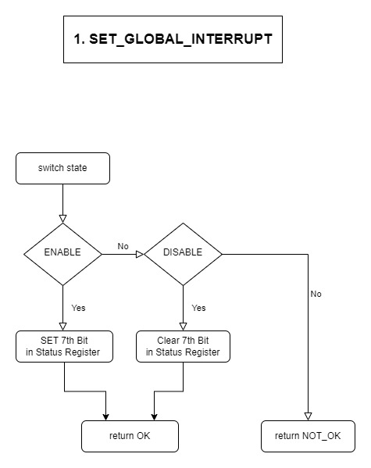

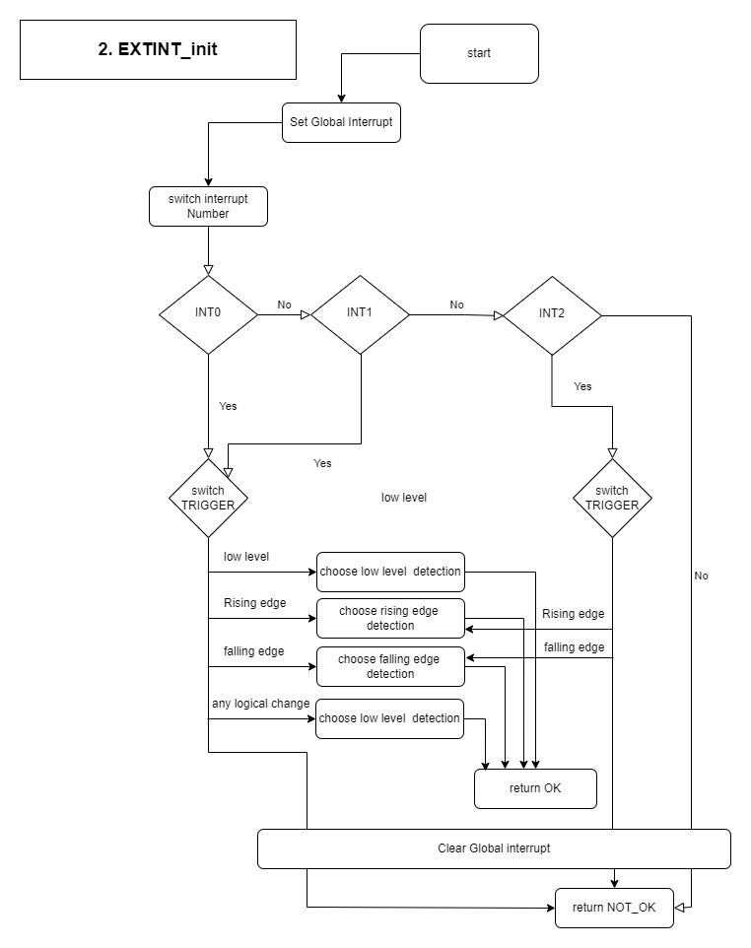

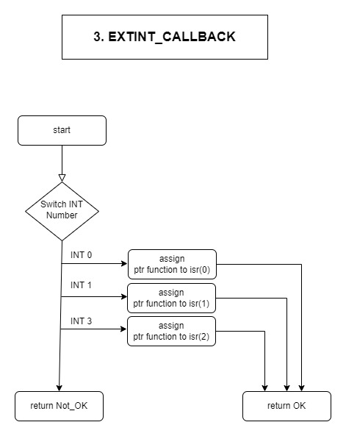

* **Timer:**
* **PWM:** 
  + 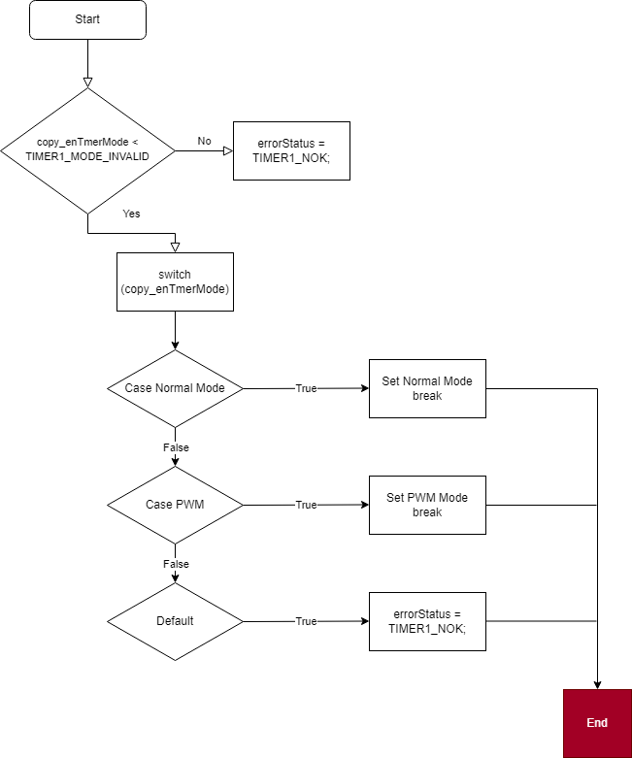**enu_timer1Status_t Timer1_enuInit (enu_timer1Mode_t)**
  + 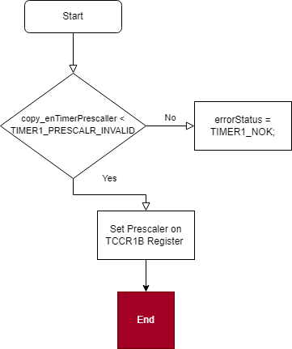**enu_timer1Status_t Timer1_enuSetPrescallar(enu_timer1Prescalar_t)**
  + 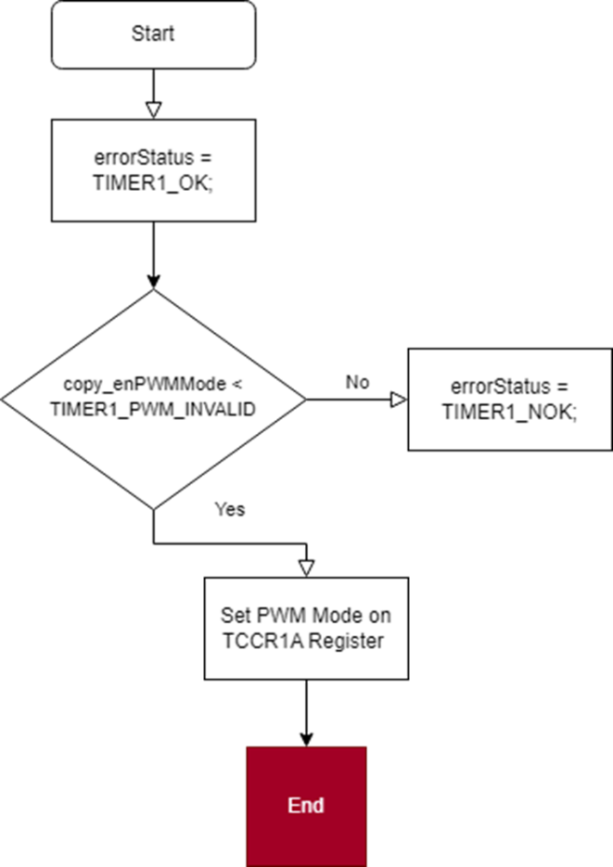**enu_timer1Status_t Timer1_enuFastPWMInit(enu_pwm1Mode_t)**
  + 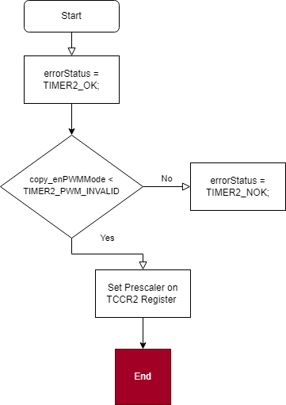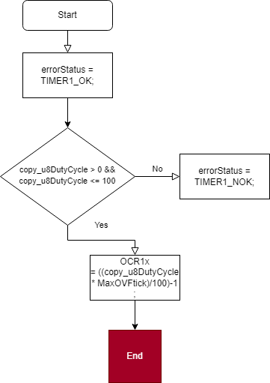**enu_timer1Status_t Timer1_enuPWMGenerate (Uchar8_t)**
  + **enu_timer2Status_t Timer2_enuSetPrescallar(enu_timer2Prescalar_t)**
  + **enu_timer2Status_t Timer2_enuInit (enu_timer2Mode_t)**

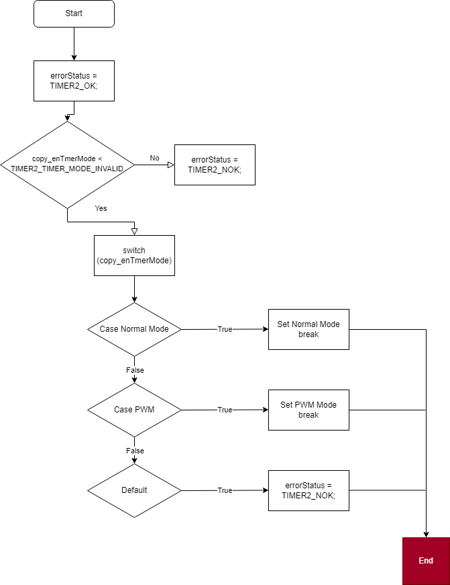

* + **enu_timer2Status_t Timer2_enuFastPWMInit(enu_pwm2Mode_t)**

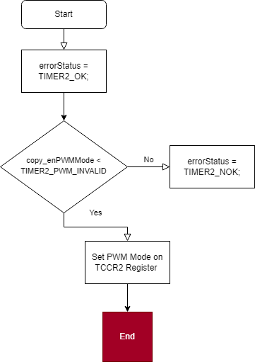

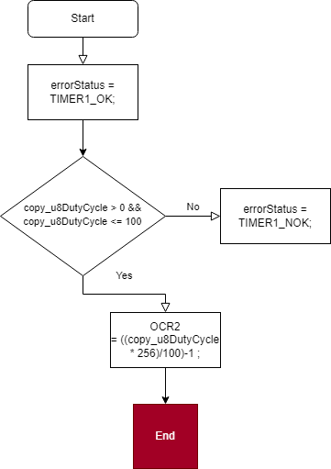

* + **enu_timer2Status_t Timer2_enuPWMGenerate (Uchar8_t)**
* **PWM Normal**

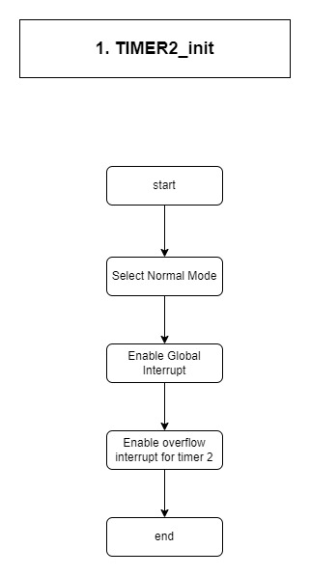

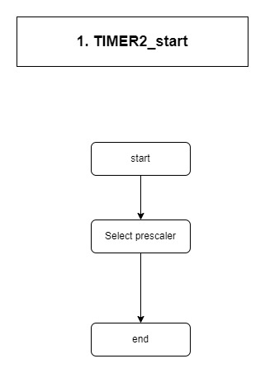

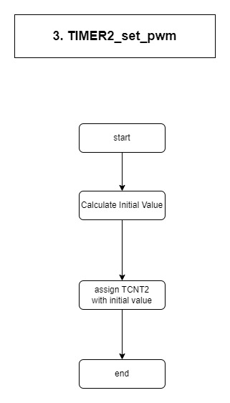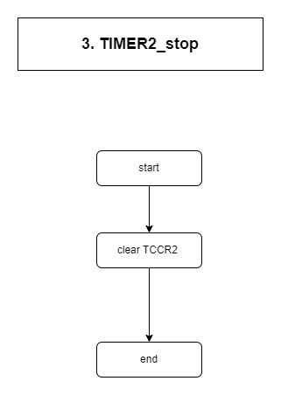

**HAL Layer:**

* **Button:**
* **LED:**
* **HPWM:** 
  + **enu_pwmStatus_t pwm_enInit(void)**

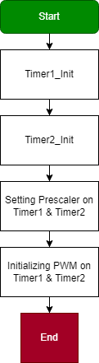

* + **enu_pwmStatus_t pwm_enGenerate(Uchar8_t)**

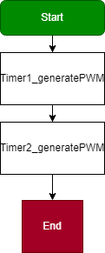

* **HTimer:**
* **HExtInt:**

**Service Layer:**

**Application Layer:**