- open browser, open extension Greasemonkey or Tampermonkey
and install scripts (they located in same directory with this document):
“Vortek Preload.user.js “
and then
“TA stuff.user.js”

“Vortek Preload” must be loaded earlier then “Ta stuff”

after install, it will look like that:
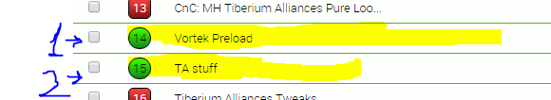

2. open link https://146.185.186.182/ta_db/GameClientBackend/Staring_script?rnd=0.4766798347700387&_=1455324082055

browser will show warning, it's normal.

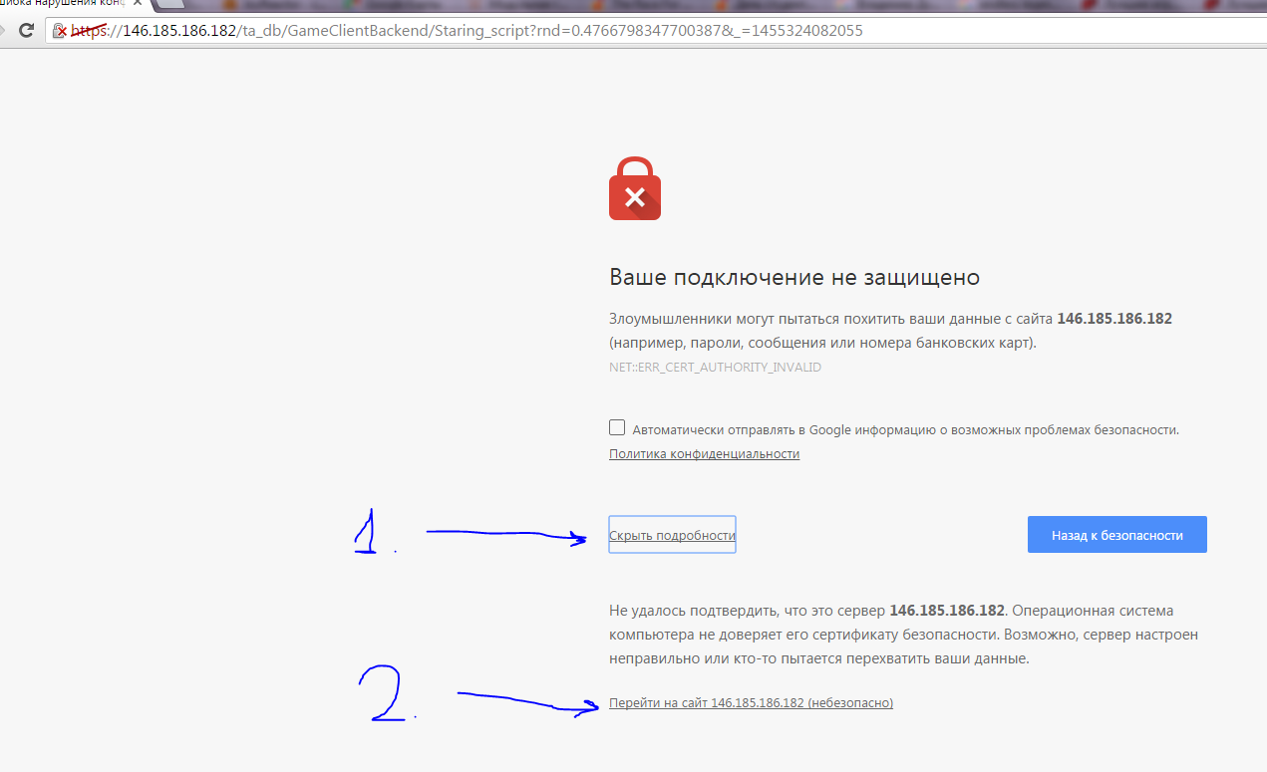
Click on link (1) and then on link (2) to proceed opening page

After that, page with javascript souce will be shown
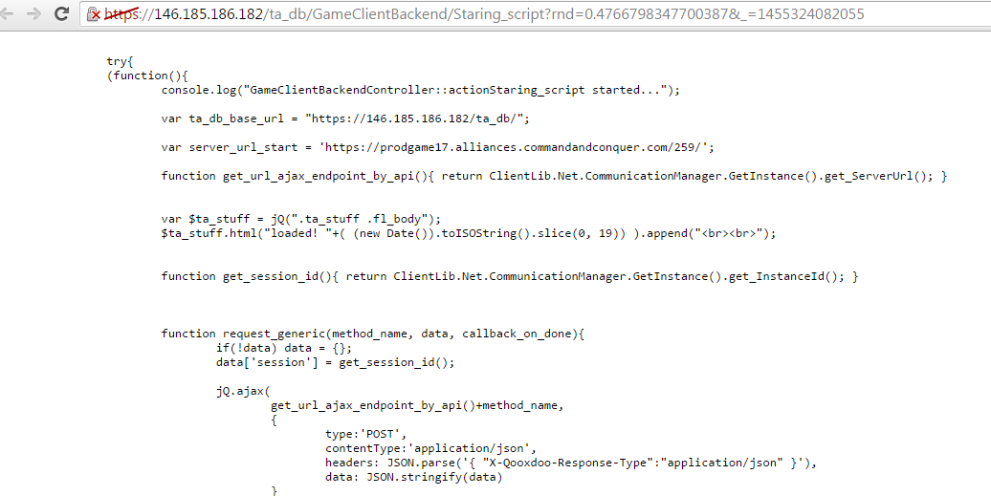

Nothing to do here, just keep this tab open.

3.login to tiberium alliance

there will be small bar. Click “expand”
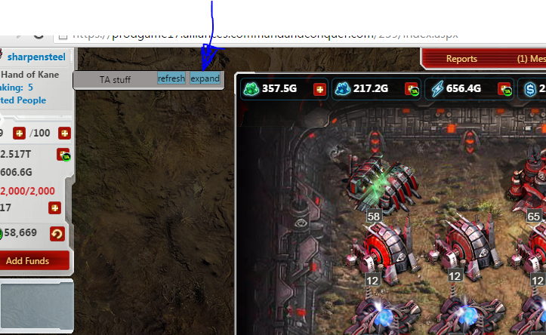

Then click “Hacker attack report”
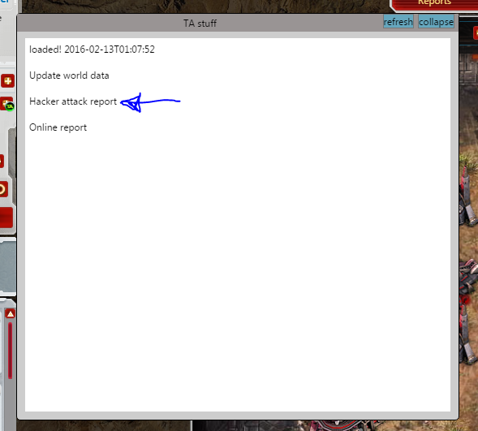

New panel will open, click on it to bring it to top (LOL)
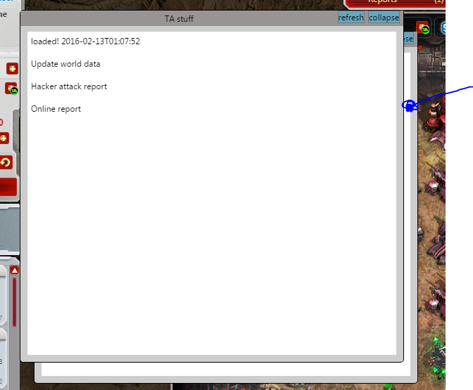

Okey, final part! You can see list who is not injected yet

You can click “refresh” to update report

Also you can click “collapse” to minimize panels
