

**Лабораторная работа 3**

**Выполнил:** Мелдехан Шарполат

Алматы 2021

1. Group functions work across many rows to produce one result per group.

**True**/False

2. Group functions include nulls in calculations.

True/**False**

3. The WHERE clause restricts rows before inclusion in a group calculation.

**True**/False

4. Find the highest, lowest, sum, and average salary of all employees. Label the columns Maximum, Minimum, Sum, and Average, respectively. Round your results to the nearest whole number.

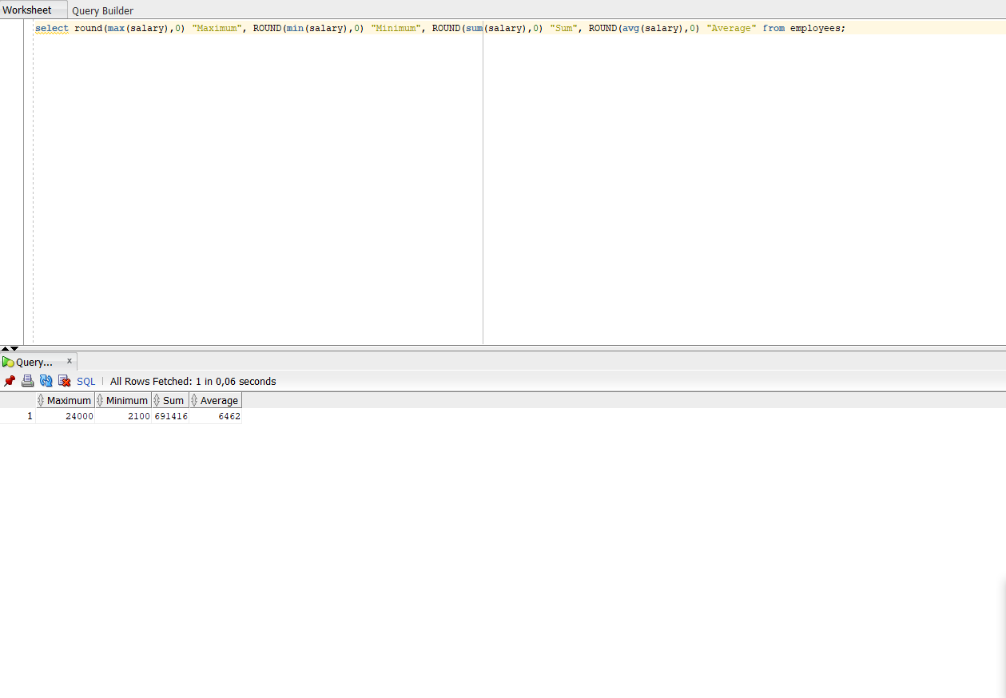

5. display the minimum, maximum, sum, and average salary for each job type.

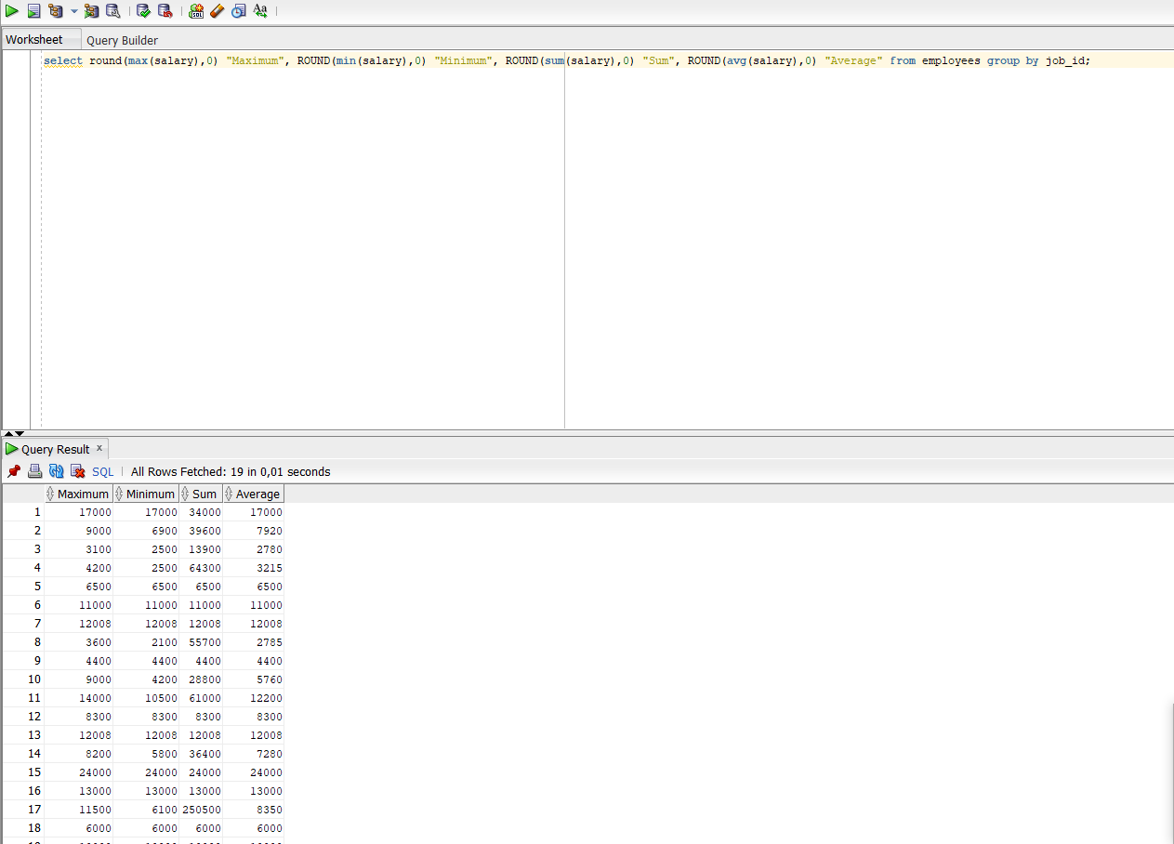

6. Write a query to display the number of people with the same job

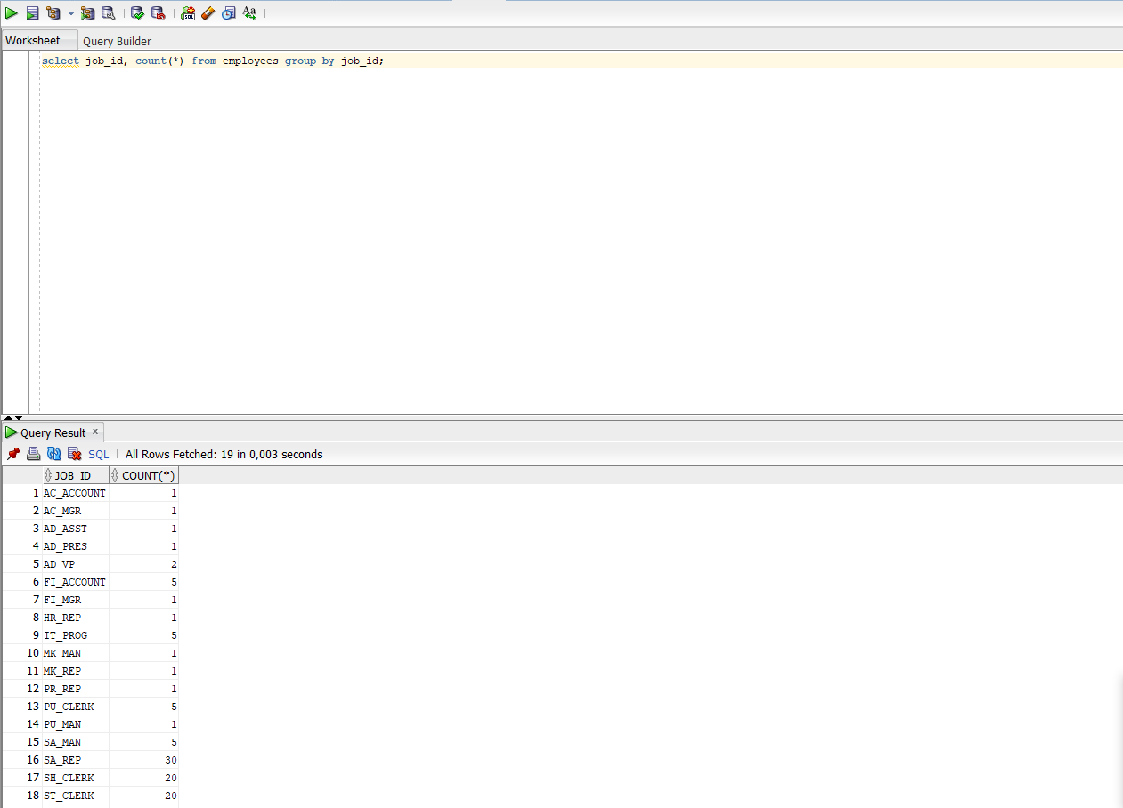

7. Determine the number of managers without listing them. Label the column NumberofManagers. Hint: Use the MANAGER_ID column to determine the number of managers.

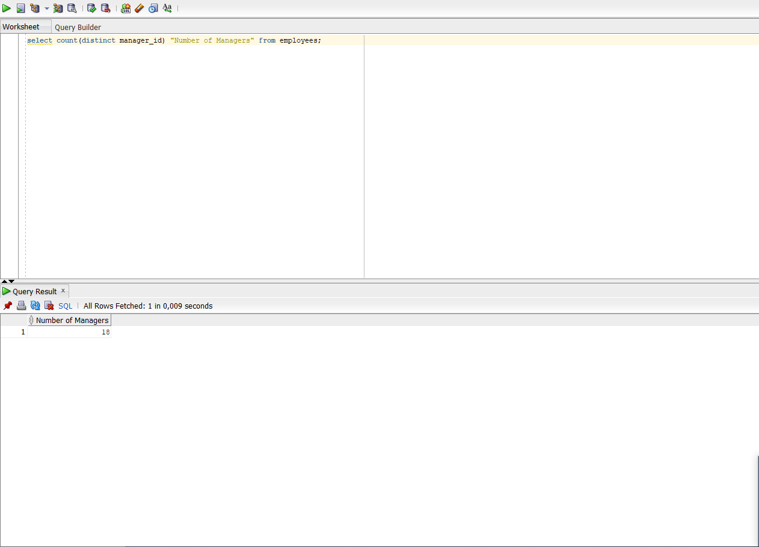

8. Find the difference between the highest and lowest salaries. Label the column DIFFERENCE.

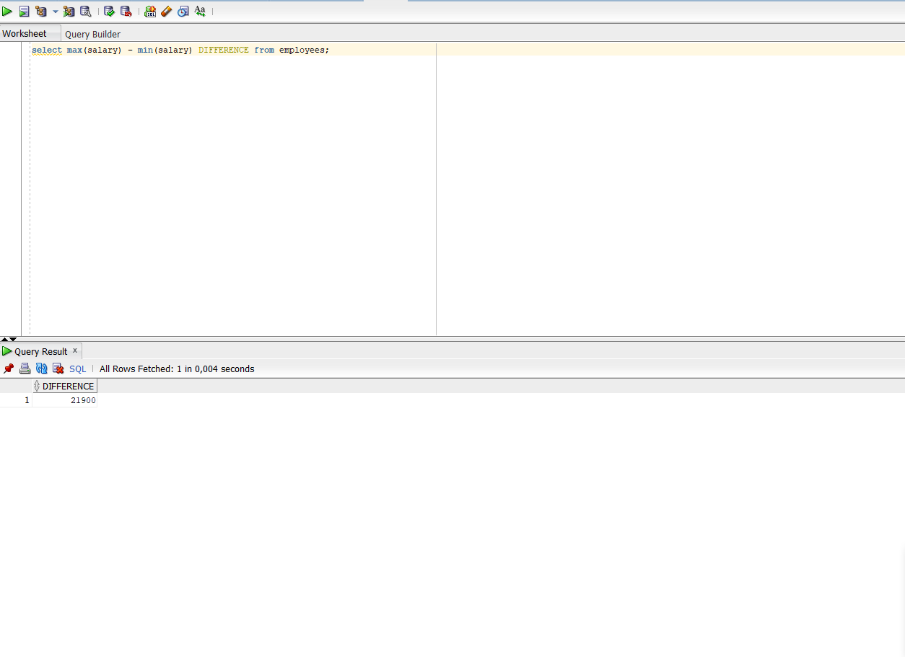

9. Create a report to display the manager number and the salary of the lowest-paid employee for that manager. Exclude anyone whose manager is not known. Exclude any groups where the minimum salary is $6,000 or less. Sort the output in descending order of salary.

