

**Лабораторная работа 4**

**Выполнил:** Мелдехан Шарполат

Алматы 2021

1 Write a query to display the system date. Label the column Date

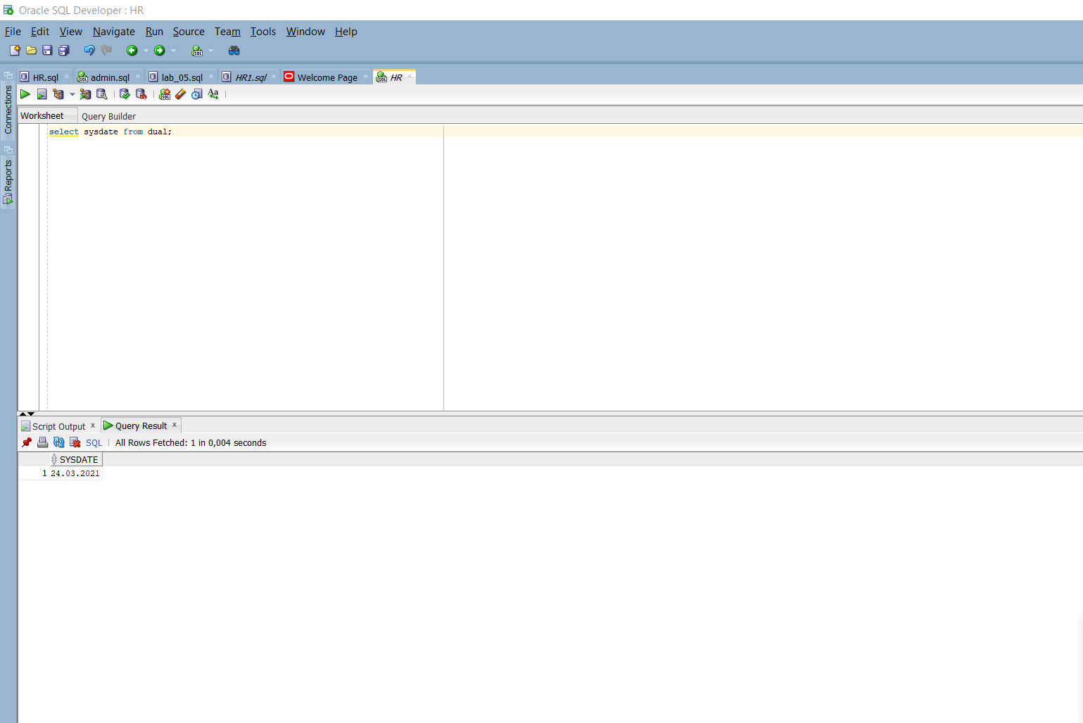

2 The HR department needs a report to display the employee number, last name, salary, and salary increased by 15.5% (expressed as a whole number) for each employee. Label the column NewSalary

3 Run your query in the lab_04_02.sql file.

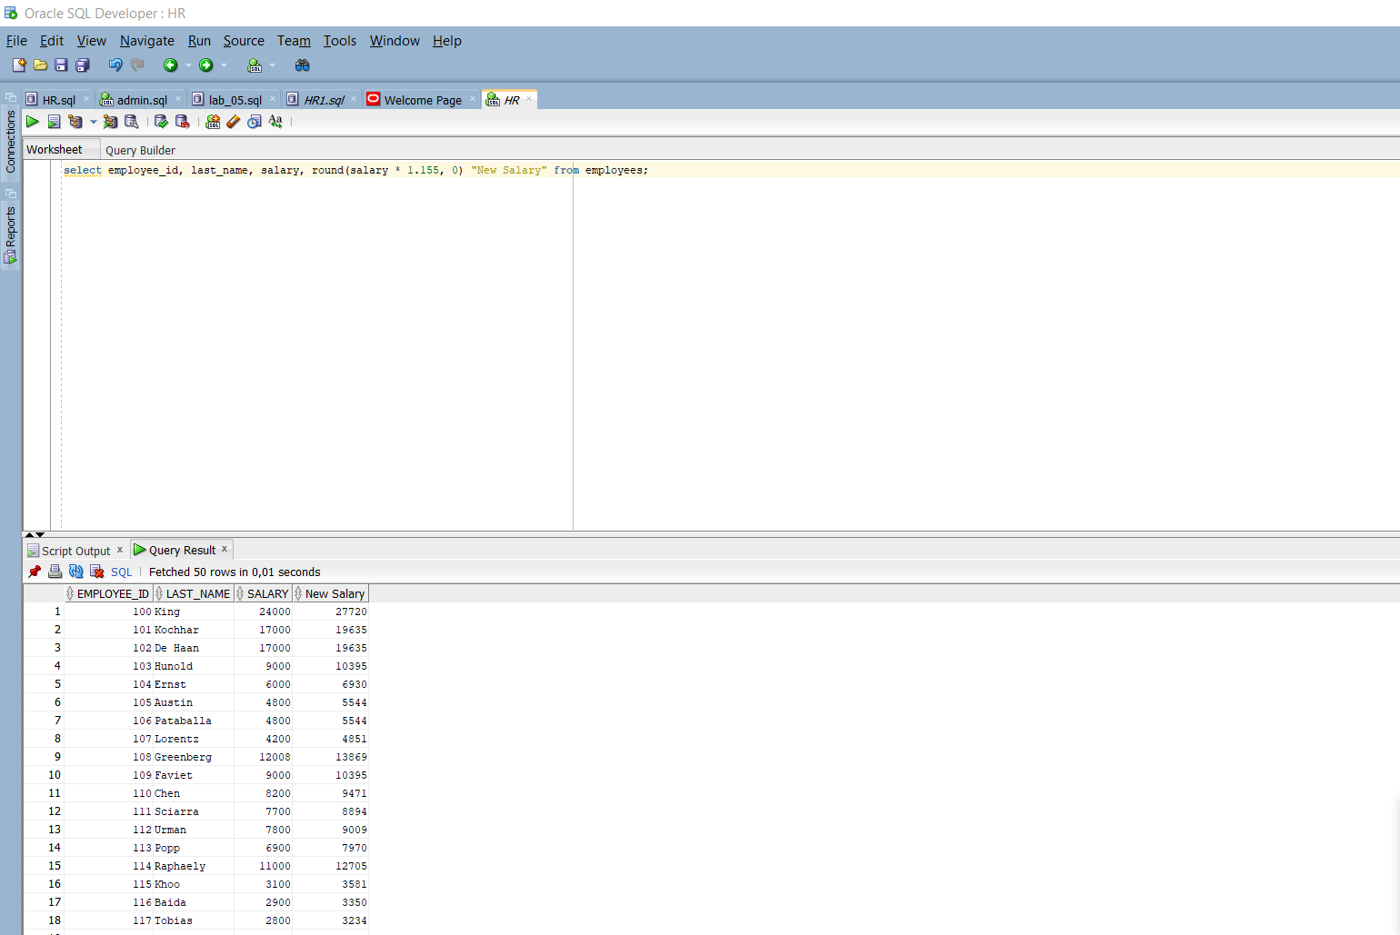

4 add a column that subtracts the old salary from the new salary. Label the column Increase

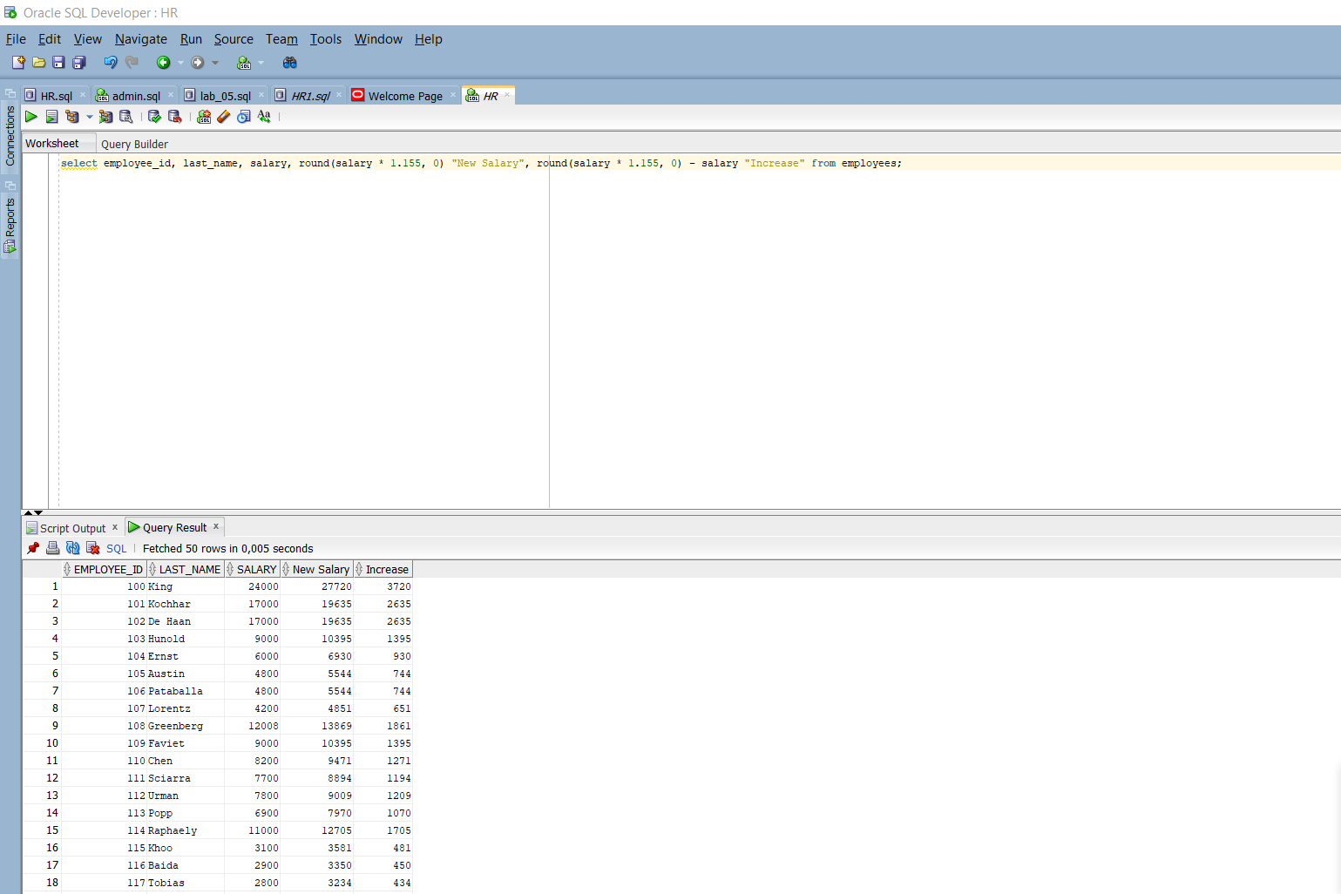

5 Perform the following tasks:

a. Write a query that displays the last name (with the first letter in uppercase and all the other letters in lowercase) and the length of the last name for all employees whose name starts with the letters “J,” “A,” or “M.” Give each column an appropriate label. Sort the results by the employees’ last names.

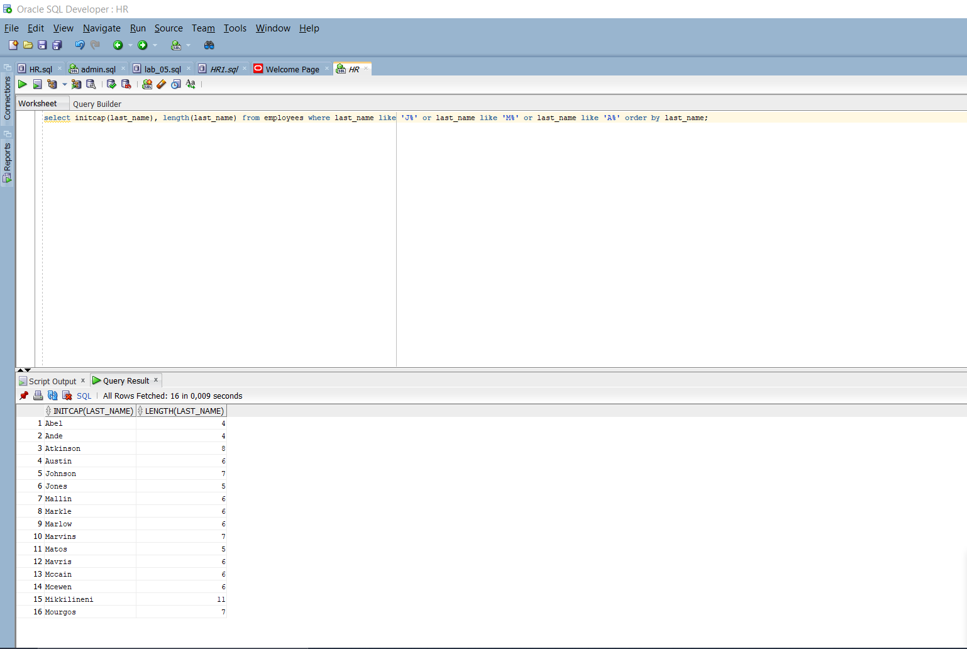

b. Rewrite the query so that the user is prompted to enter a letter that the last name starts with. For example, if the user enters “H” (capitalized) when prompted for a letter, the output should show all employees whose last name starts with the letter “H.”

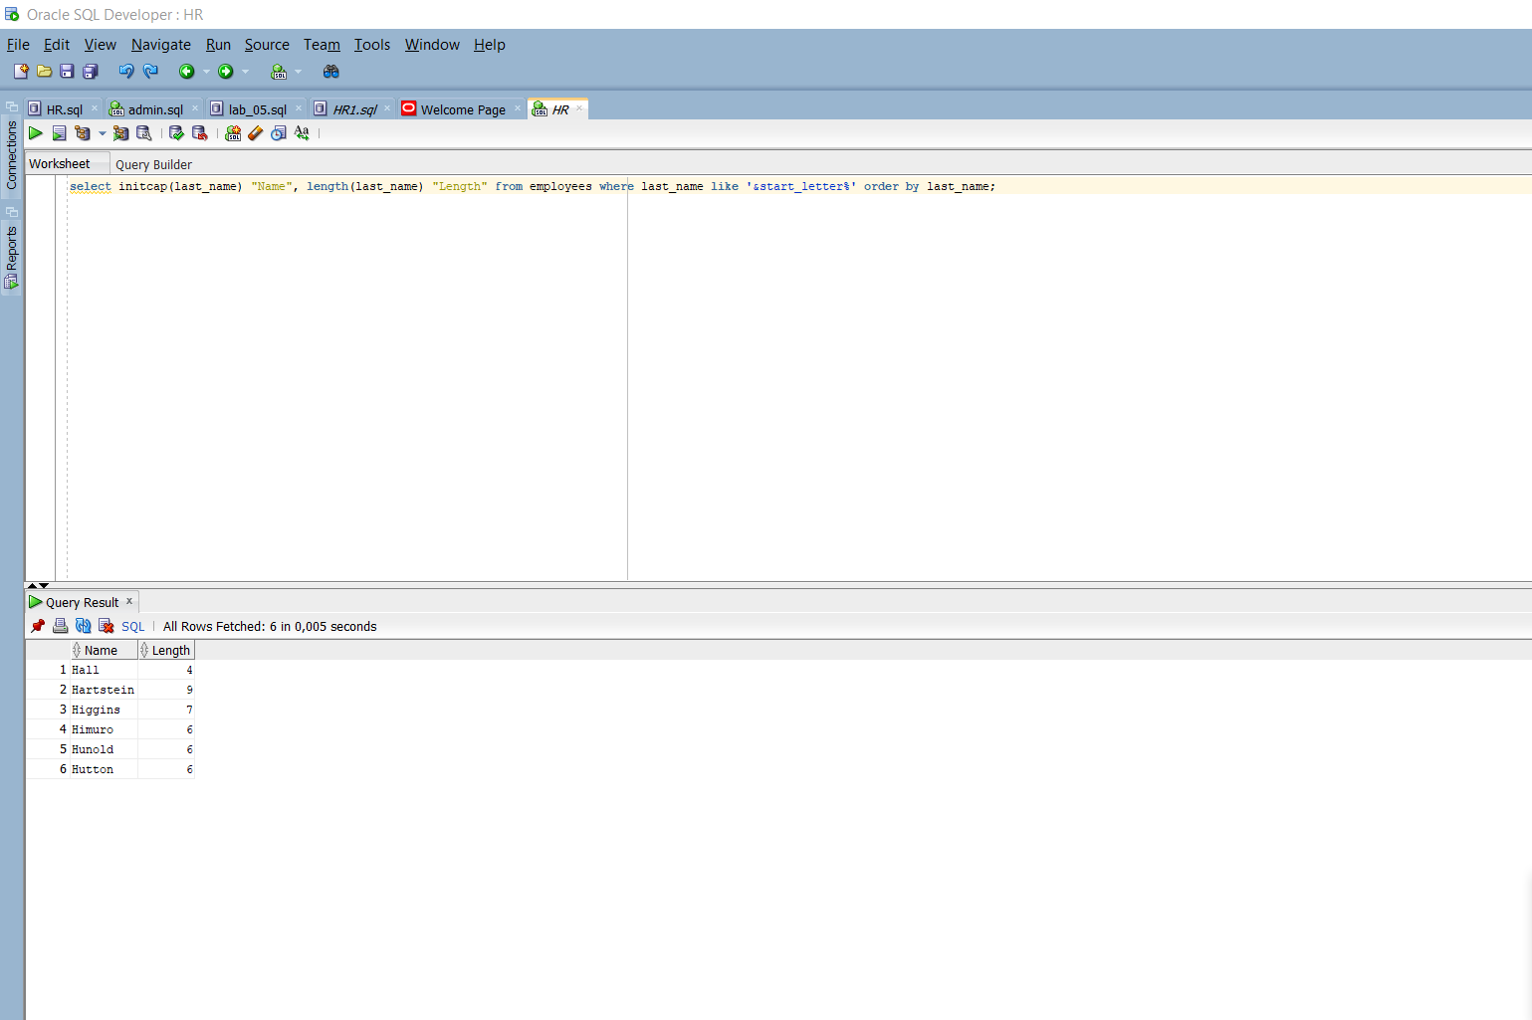

c. Modify the query such that the case of the letter that is entered does not affect the output. The entered letter must be capitalized before being processed by the SELECTquery.

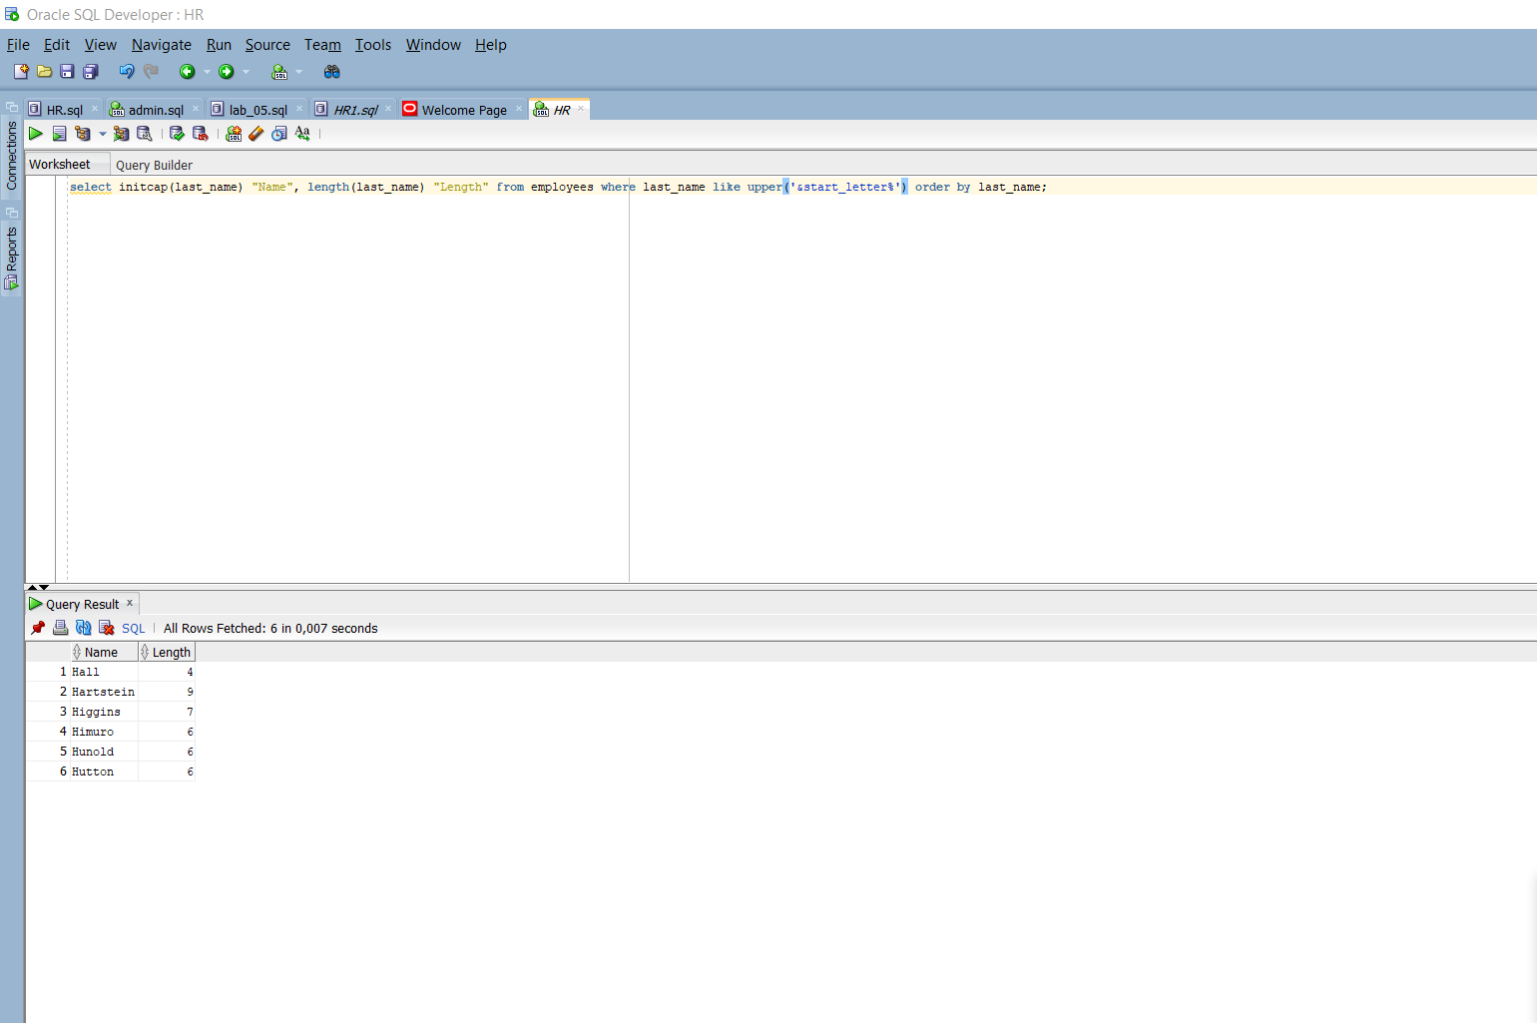

6 The HR department wants to find the duration of employment for each employee. For each employee, display the last name and calculate the number of months between today and the date on which the employee was hired. Label the column as MONTHS_WORKED. Order your results by the number of months employed. The number of months must be rounded to the closest whole number.

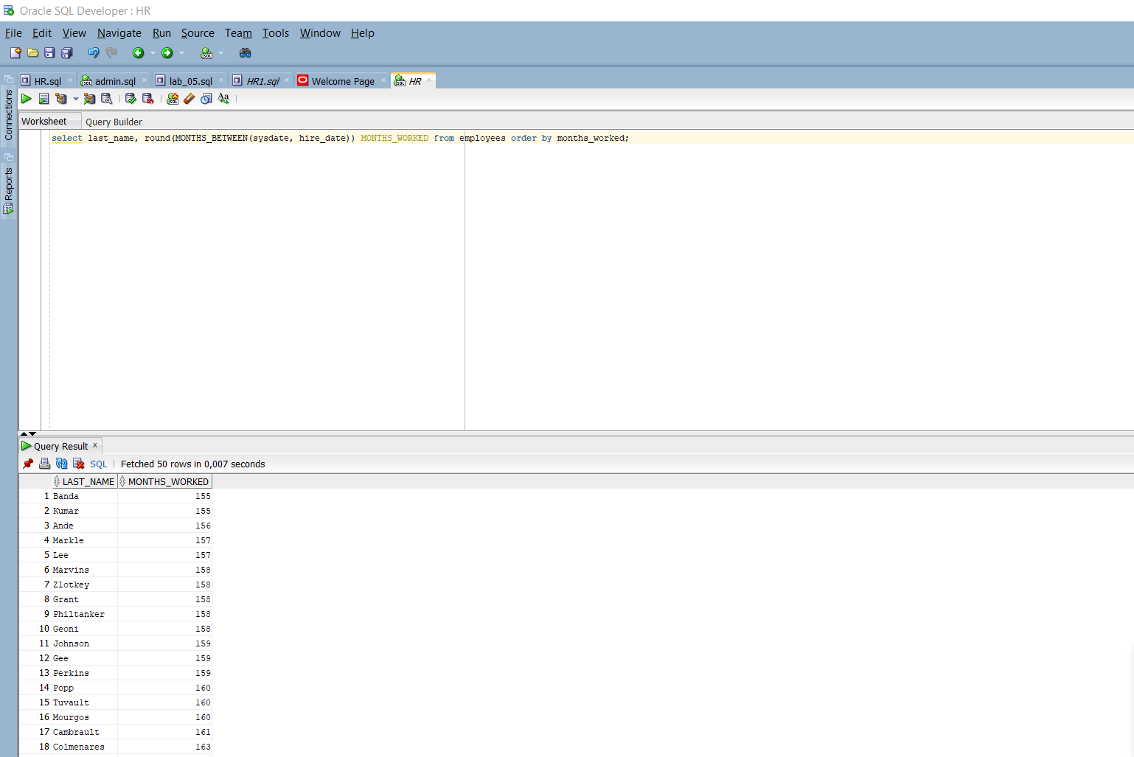

7 Create a query to display the last name and salary for all employees. Format the salary to be 15 characters long, left-padded with the $ symbol. Label the column SALARY.

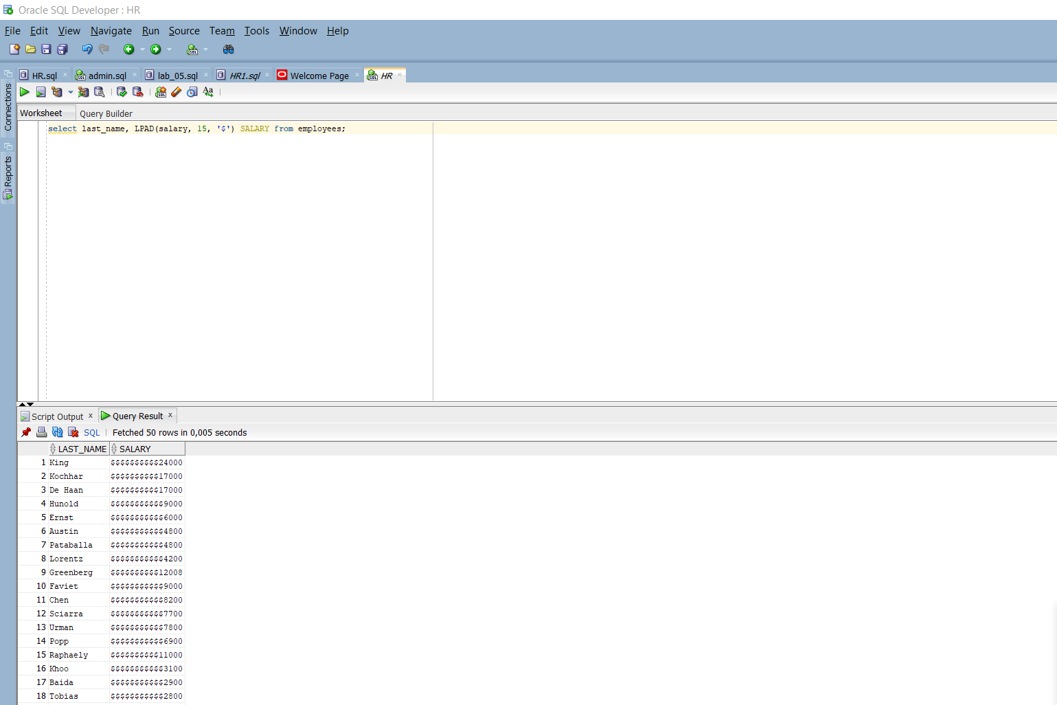

8 Create a query to display the last name and the number of weeks employed for all employees in department 90. Label the number of weeks column as TENURE. Truncate the number of weeks value to 0 decimal places. Show the records in descending order of the employee’s tenure.

