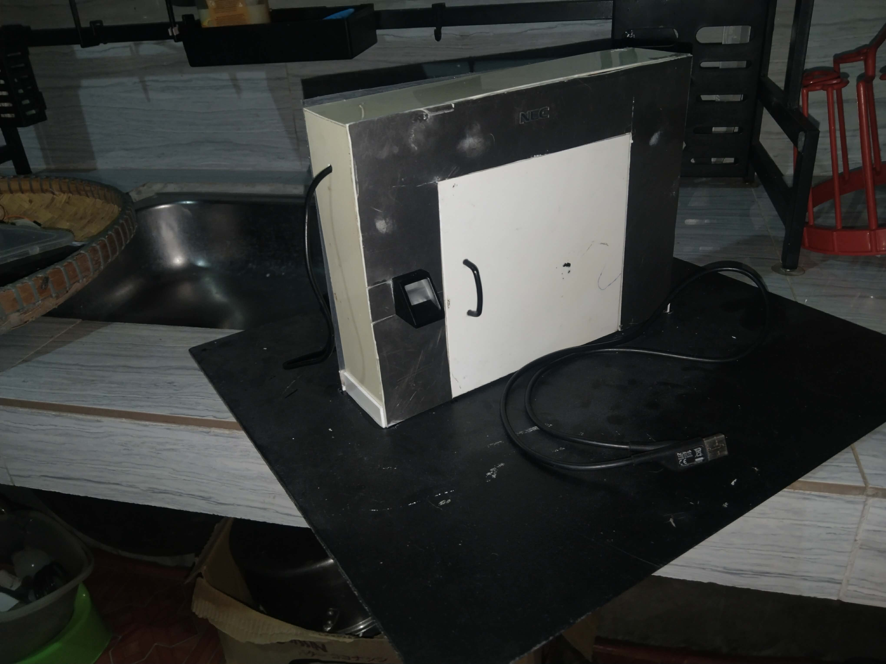
Smart Door System with Fingerprint
January 13, 2026

Group 5
Applications Development and Emerging Technologies

Overview
The Smart Door System is created using NodeMCU with R307S Fingerprint and is implemented in rooms that need enhance security and collect data and saved to the Google Sheets as the database. Only the enrolled fingerprints are eligible to trigger the lock. The data is monitored on either Mobile or Desktop.
Goals
- To ensure that only enrolled fingerprints are able to enter.
- To create a fingerprint-based security for keyless functionality.
- To enhance security for better service.
- To create a monitoring application to know who locked or unlocked the system, that can be viewed online.
Components And Supplies
The following components and supplies are needed to create this project:

R307S Fingerprint Scanner
The biometric input that captures, stores, and matches fingerprints to grant access
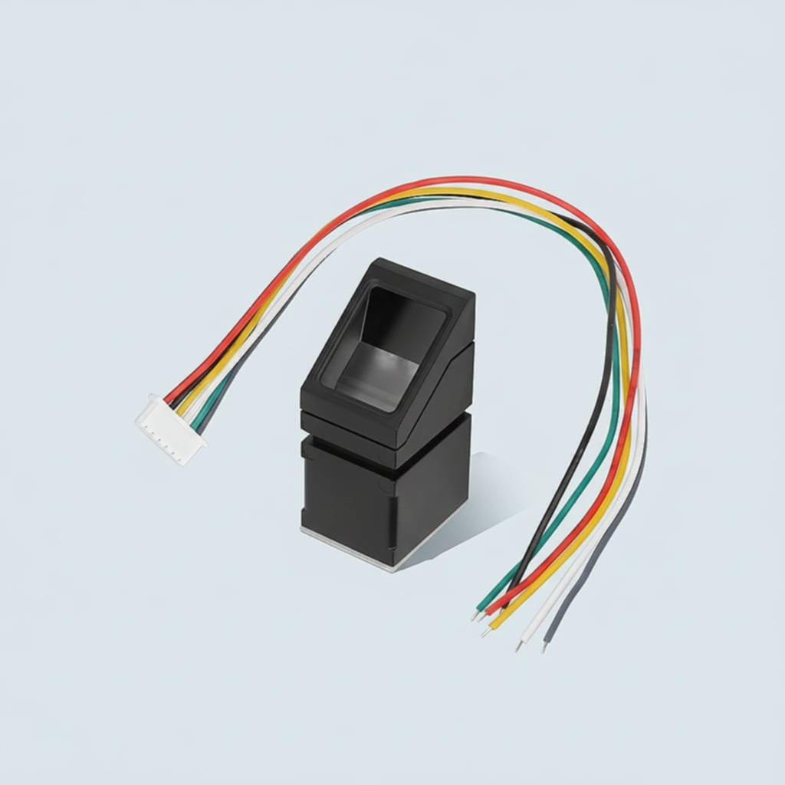
NodeMCU ESP8266
The microcontroller brain; it processes data from the scanner and triggers the lock via Wi-Fi or local logic.
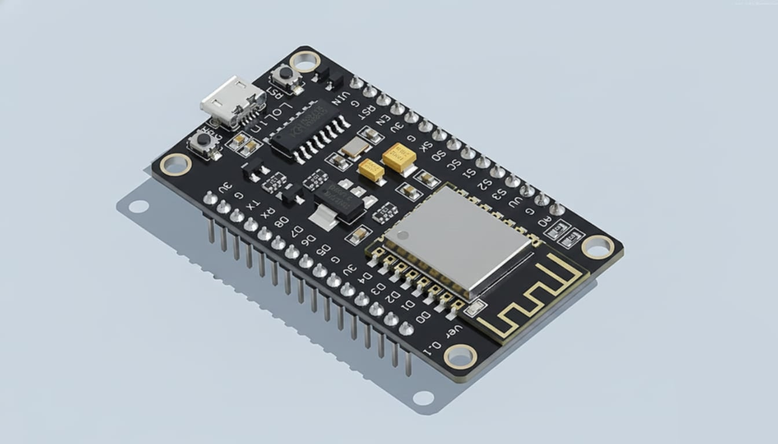
Jumper Wires
The connectors that carry signals and power between all the different modules.
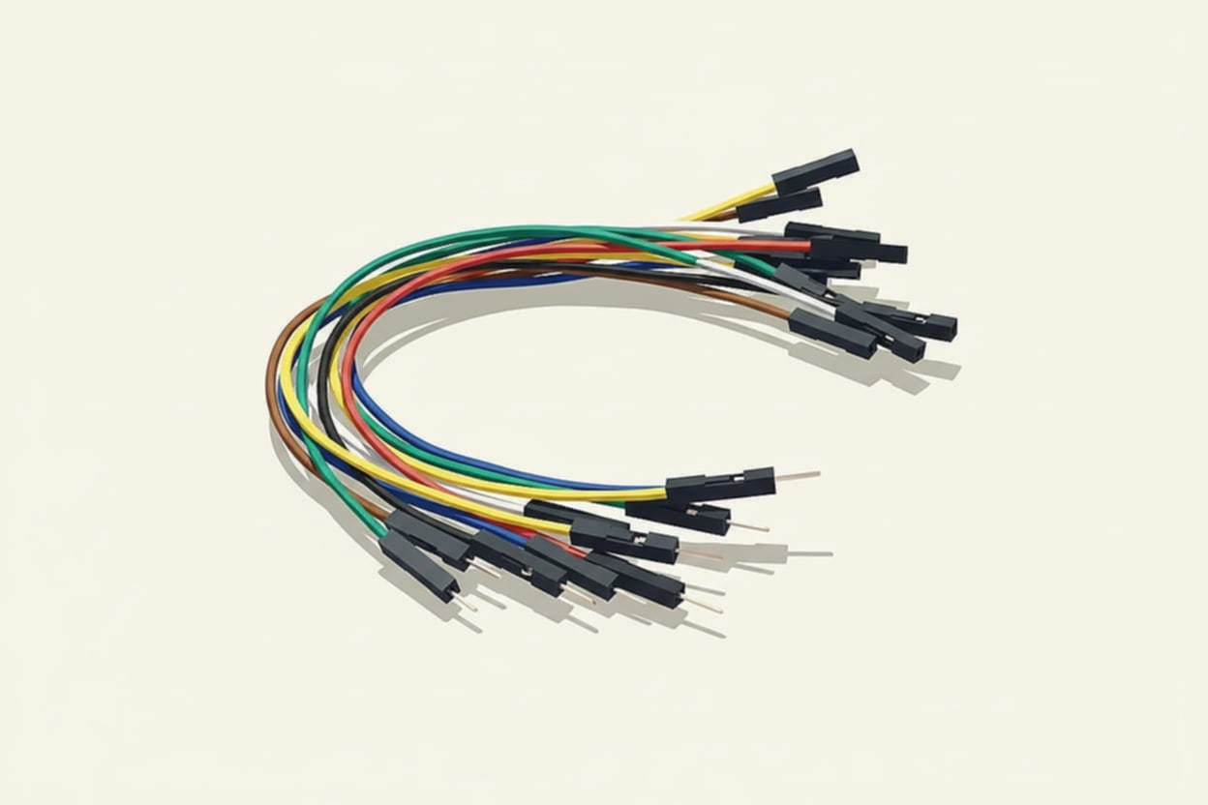
Bread Board
The prototyping base used to plug in components without needing to solder.
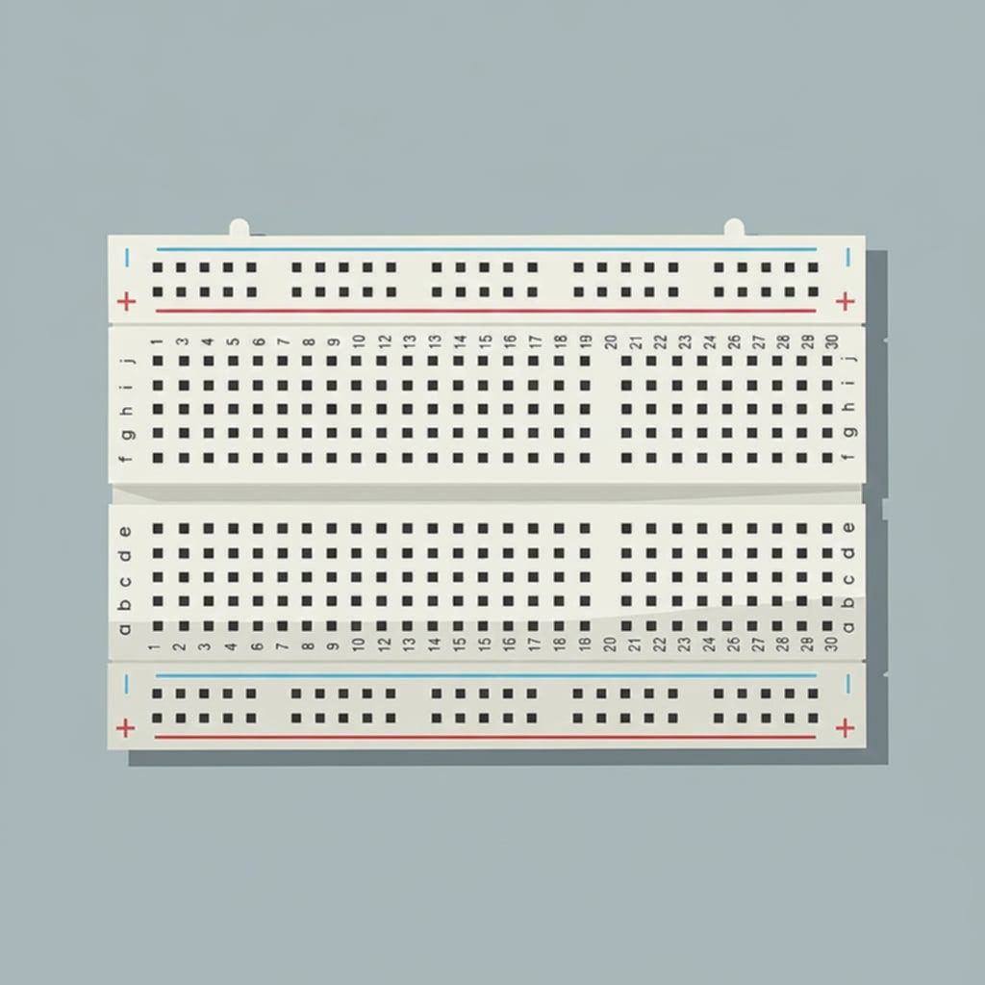
Charger
The power source that provides the necessary voltage (usually 12V) to drive the locking mechanism.
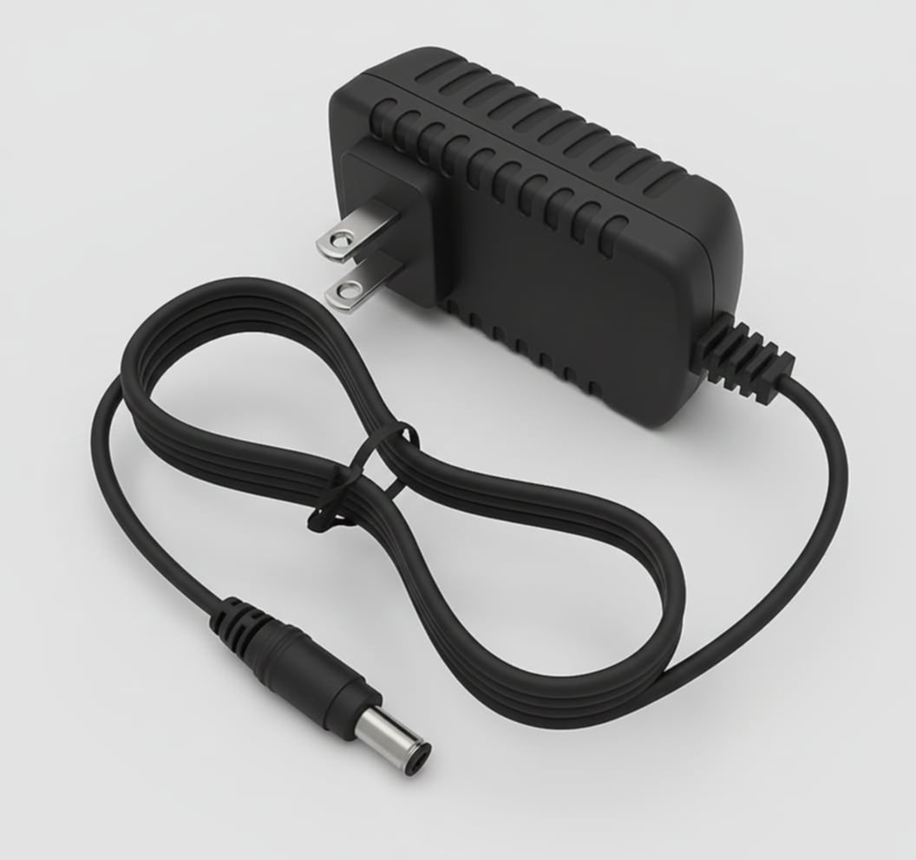
Solenoid Lock
The physical bolt; it uses an electromagnetic coil to retract the latch when powered.
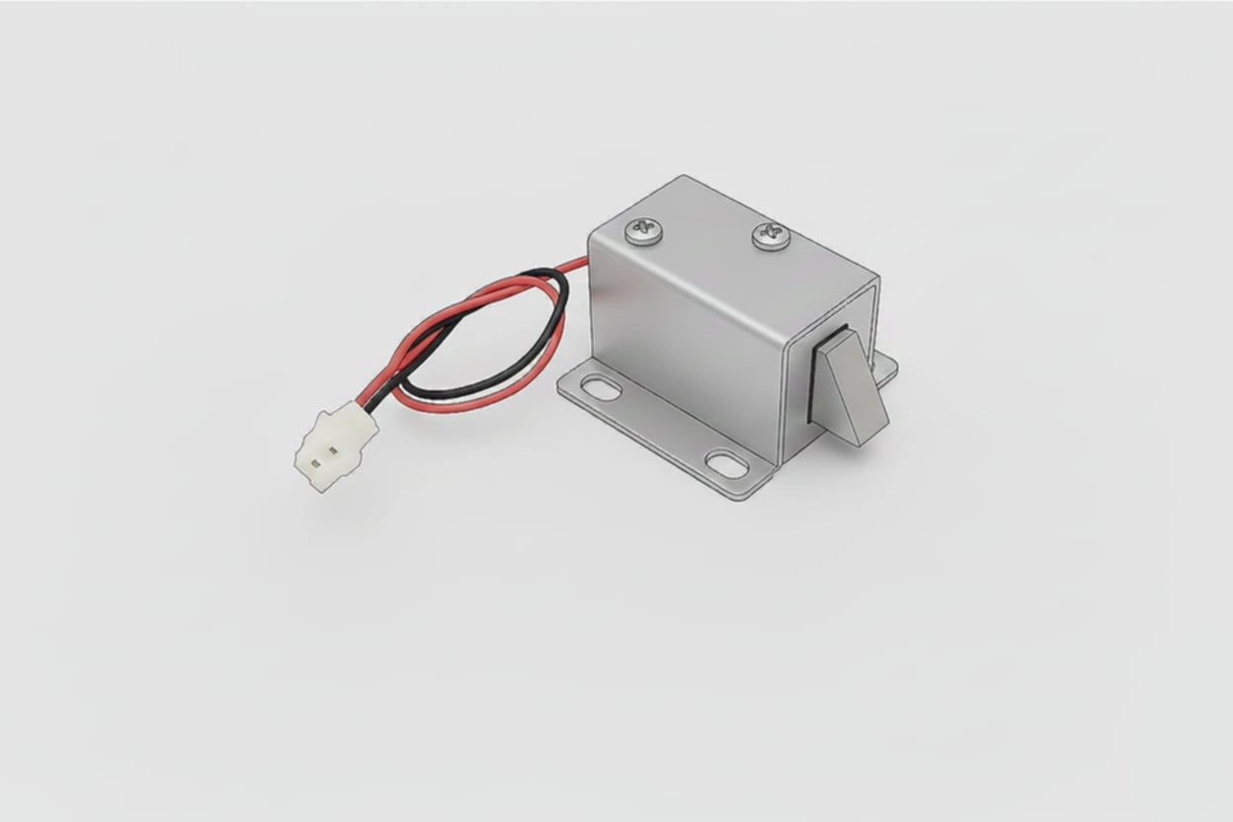
Relay
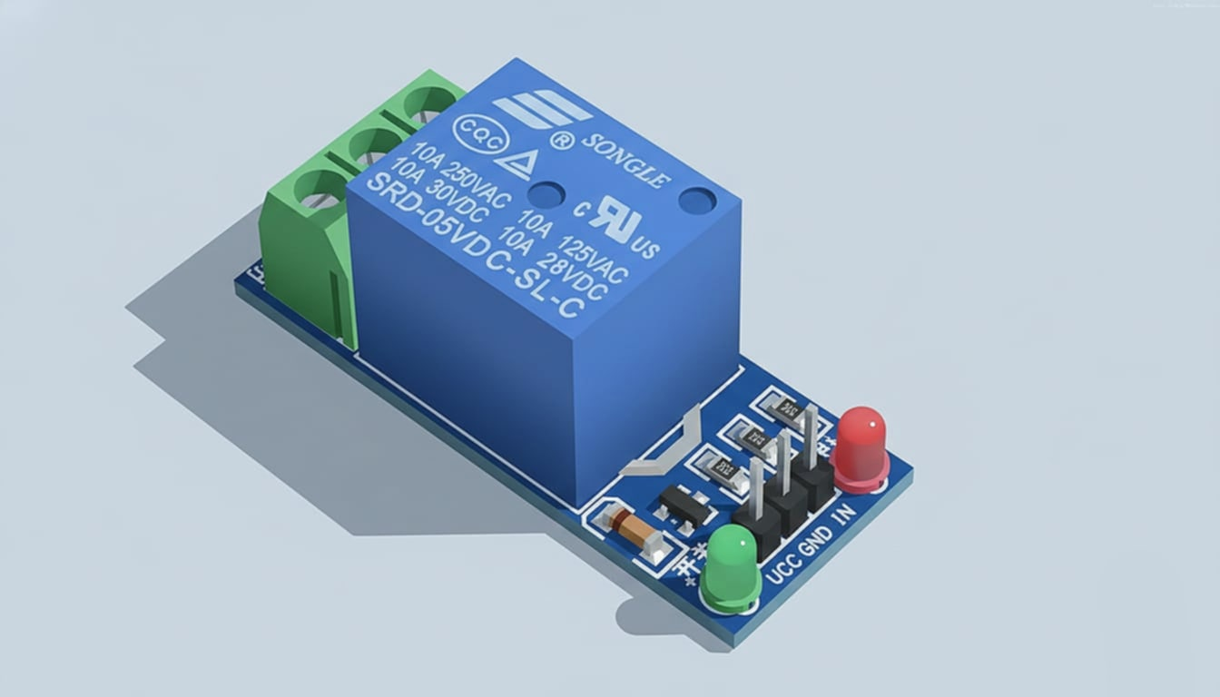
The isolated switch; it allows the low-power NodeMCU to safely control the high-power Solenoid.

App and Services
Arduino IDE
The Arduino IDE is used as the editor of the program needs to upload to the NodeMCU.
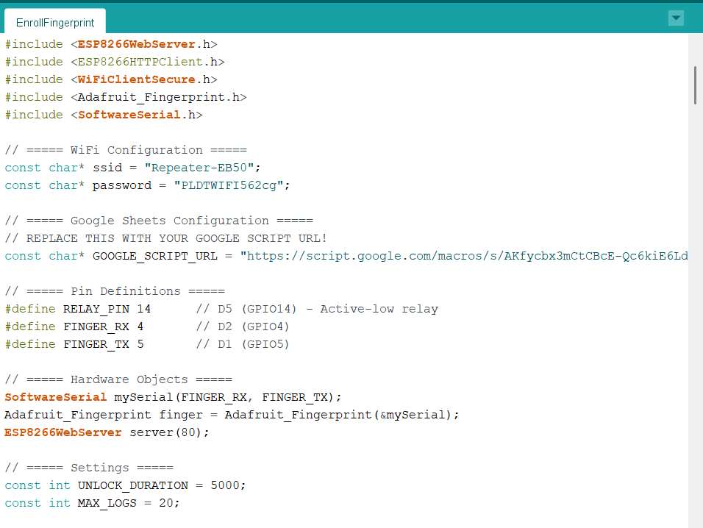
Google Sheets and Appscript
The Google Sheets serves as the database of the gathered data by the device. The Process was programmed using Google Appscript.
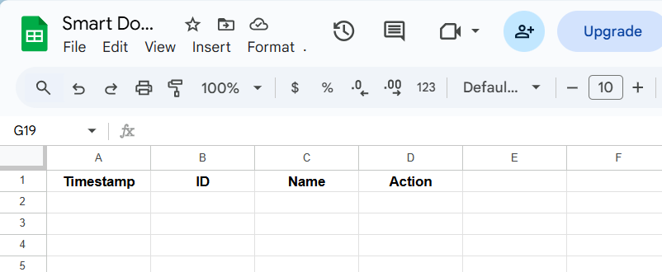
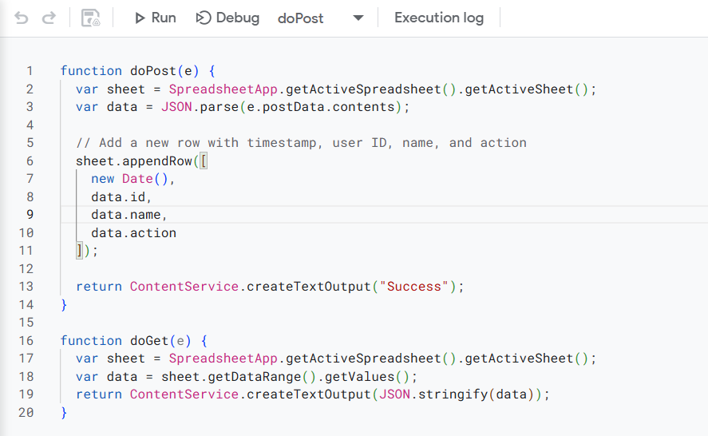
Source Code
#include <ESP8266WiFi.h>
#include <ESP8266WebServer.h>
#include <ESP8266HTTPClient.h>
#include <WiFiClientSecure.h>
#include <Adafruit_Fingerprint.h>
#include <SoftwareSerial.h>
const char* ssid = "Repeater-EB50";
const char* password = "PLDTWIFI562cg";
const char* GOOGLE_SCRIPT_URL = "https://script.google.com/macros/s/AKfycbx3mCtCBcE-Qc6kiE6LdtqbC6MKrp28bD_81KwtHDUCosBTKCmcgEMfHByUVpKXklkBkg/exec";
#define RELAY_PIN 14 // D5 (GPIO14) - Active-low relay
#define FINGER_RX 4 // D2 (GPIO4)
#define FINGER_TX 5 // D1 (GPIO5)
SoftwareSerial mySerial(FINGER_RX, FINGER_TX);
Adafruit_Fingerprint finger = Adafruit_Fingerprint(&mySerial);
ESP8266WebServer server(80);
const int UNLOCK_DURATION = 5000;
const int MAX_LOGS = 20;
String userName[128] = {
"", // ID 0 (unused)
"John", // ID 1
"Sarah", // ID 2
"Bob", // ID 3
// Add more names as needed
};
String accessLog[MAX_LOGS];
int logIndex = 0;
bool doorLocked = true;
unsigned long unlockTime = 0;
int enrollMode = 0;
bool autoLockEnabled = false;
void setup() {
Serial.begin(115200);
delay(100);
pinMode(RELAY_PIN, OUTPUT);
digitalWrite(RELAY_PIN, HIGH);

Serial.println("\n\n=================================");
Serial.println("SMART LOCK + GOOGLE SHEETS");
Serial.println("=================================\n");
Serial.println("[1/4] Fingerprint sensor...");
finger.begin(57600);
delay(500);
if (finger.verifyPassword()) {
Serial.println(" ✓ Connected!");
} else {
Serial.println(" ✗ Not found!");
}
Serial.println("[2/4] Connecting to WiFi...");
WiFi.mode(WIFI_STA);
WiFi.begin(ssid, password);

int attempts = 0;
while (WiFi.status() != WL_CONNECTED && attempts < 20) {
delay(500);
Serial.print(".");
attempts++;
}
Serial.println();

if (WiFi.status() == WL_CONNECTED) {
Serial.println(" ✓ WiFi connected!");
Serial.print(" IP: ");
Serial.println(WiFi.localIP());
} else {
Serial.println(" ✗ WiFi failed - running offline");
}

// Test Google Sheets connection
Serial.println("[3/4] Testing Google Sheets...");
if (WiFi.status() == WL_CONNECTED) {
Serial.println(" Google Script URL configured");
Serial.println(" Will log events to Google Sheets");
} else {
Serial.println(" ⚠️ No WiFi - Google Sheets disabled");
}

// Setup web server
Serial.println("[4/4] Starting web server...");
server.on("/", handleRoot);
server.on("/unlock", handleUnlock);
server.on("/lock", handleLock);
server.on("/logs", handleLogs);
server.on("/setname", handleSetName);
server.on("/enroll", handleEnrollPage);
server.on("/startenroll", handleStartEnroll);
server.onNotFound(handleNotFound);
server.begin();

Serial.println("\n=================================");
Serial.println("SYSTEM READY!");
Serial.println("=================================");

if (WiFi.status() == WL_CONNECTED) {
Serial.print("Web Interface: http://");
Serial.println(WiFi.localIP());
}

Serial.println("\n📋 COMMANDS:");
Serial.println(" ENROLL <ID> - Enroll fingerprint");
Serial.println(" SETNAME <ID> <n> - Set user name");
Serial.println(" UNLOCK - Manual unlock");
Serial.println(" LOCK - Manual lock");
Serial.println(" RELAY TEST - Test relay");
Serial.println(" STATUS - System status");
Serial.println(" AUTOLOCK ON/OFF - Toggle auto-lock");
Serial.println("=================================\n");

// Log system startup
logToGoogleSheets(0, "System", "Started");
}

void loop() {
server.handleClient();

// Handle serial commands
if (Serial.available()) {
String command = Serial.readStringUntil('\n');
command.trim();

if (command.startsWith("ENROLL ")) {
int id = command.substring(7).toInt();
if (id >= 1 && id <= 127) {
startEnrollment(id);
}
} else if (command.startsWith("SETNAME ")) {
int spacePos = command.indexOf(' ', 8);
int id = command.substring(8, spacePos).toInt();
String name = command.substring(spacePos + 1);
if (id >= 1 && id <= 127) {
userName[id] = name;
Serial.println("✓ ID #" + String(id) + " = " + name);
}
} else if (command.equalsIgnoreCase("UNLOCK")) {
unlockDoor(-1);
} else if (command.equalsIgnoreCase("LOCK")) {
lockDoor();
} else if (command.equalsIgnoreCase("RELAY TEST")) {
relayTest();
} else if (command.equalsIgnoreCase("STATUS")) {
printStatus();
} else if (command.equalsIgnoreCase("AUTOLOCK ON")) {
autoLockEnabled = true;
Serial.println("✓ Auto-lock ENABLED");
} else if (command.equalsIgnoreCase("AUTOLOCK OFF")) {
autoLockEnabled = false;
Serial.println("✓ Auto-lock DISABLED");
}
}

// Enrollment mode
if (enrollMode > 0) {
performEnrollment();
return;
}

// Check for fingerprint
int id = getFingerprintID();
if (id >= 0) {
unlockDoor(id);
}

// Auto-lock
if (autoLockEnabled && !doorLocked && millis() - unlockTime > UNLOCK_DURATION) {
lockDoor();
}

delay(50);
}

// ===== Google Sheets Functions =====
void logToGoogleSheets(int id, String name, String action) {
if (WiFi.status() != WL_CONNECTED) {
Serial.println("⚠️ WiFi not connected - skipping Google Sheets log");
return;
}

WiFiClientSecure client;
client.setInsecure(); // Skip SSL certificate validation

HTTPClient http;

// Build JSON data
String jsonData = "{";
jsonData += "\"id\":" + String(id) + ",";
jsonData += "\"name\":\"" + name + "\",";
jsonData += "\"action\":\"" + action + "\"";
jsonData += "}";

Serial.println("📤 Logging to Google Sheets...");
Serial.println(" Data: " + jsonData);

http.begin(client, GOOGLE_SCRIPT_URL);
http.addHeader("Content-Type", "application/json");

int httpCode = http.POST(jsonData);

if (httpCode > 0) {
String response = http.getString();
Serial.println(" ✓ Success! Response: " + response);
} else {
Serial.println(" ✗ Failed with code: " + String(httpCode));
}

http.end();
}

// ===== Fingerprint Functions =====
int getFingerprintID() {
uint8_t p = finger.getImage();
if (p != FINGERPRINT_OK) return -1;

p = finger.image2Tz();
if (p != FINGERPRINT_OK) return -1;

p = finger.fingerSearch();
if (p == FINGERPRINT_OK) {
return finger.fingerID;
}
return -1;
}

void startEnrollment(int id) {
enrollMode = id;
Serial.println("\n=== ENROLLING ID #" + String(id) + " ===");
Serial.println("Place finger on sensor...");
}

void performEnrollment() {
static int stage = 0;
static unsigned long lastAction = 0;

if (stage == 0) {
uint8_t p = finger.getImage();
if (p == FINGERPRINT_OK) {
Serial.println("✓ Image captured");
p = finger.image2Tz(1);
if (p == FINGERPRINT_OK) {
Serial.println("Remove finger...");
stage = 1;
lastAction = millis();
}
}
} else if (stage == 1) {
if (millis() - lastAction > 2000) {
if (finger.getImage() == FINGERPRINT_NOFINGER) {
Serial.println("Place SAME finger again...");
stage = 2;
}
}
} else if (stage == 2) {
uint8_t p = finger.getImage();
if (p == FINGERPRINT_OK) {
p = finger.image2Tz(2);
if (p == FINGERPRINT_OK) {
stage = 3;
}
}
} else if (stage == 3) {
uint8_t p = finger.createModel();
if (p == FINGERPRINT_OK) {
p = finger.storeModel(enrollMode);
if (p == FINGERPRINT_OK) {
Serial.println("✓✓✓ ID #" + String(enrollMode) + " ENROLLED! ✓✓✓");

String name = userName[enrollMode];
if (name.length() == 0) name = "User" + String(enrollMode);

// Log to Google Sheets
logToGoogleSheets(enrollMode, name, "Enrolled");

addLog("Enrolled ID #" + String(enrollMode));
}
}
enrollMode = 0;
stage = 0;
}
}
void unlockDoor(int id) {
Serial.println("\n🔓 UNLOCKING...");
digitalWrite(RELAY_PIN, LOW); // Active-low: LOW = ON
doorLocked = false;
unlockTime = millis();
String name = "Manual";
if (id >= 1 && id <= 127) {
name = userName[id];
if (name.length() == 0) name = "User" + String(id);
}
String msg = (id >= 0) ? "Access: " + name : "Manual unlock";
Serial.println(" " + msg);
Serial.println(" Relay should CLICK");
logToGoogleSheets(id, name, "Unlocked");

addLog(msg);
}
void lockDoor() {
Serial.println("\n🔒 LOCKING...");
digitalWrite(RELAY_PIN, HIGH); // Active-low: HIGH = OFF
doorLocked = true;
Serial.println(" Relay should CLICK");

// Log to Google Sheets
logToGoogleSheets(0, "System", "Locked");

addLog("Door locked");
}
void relayTest() {
Serial.println("\n🔧 RELAY TEST - 3 cycles");
for (int i = 0; i < 3; i++) {
Serial.println("Cycle " + String(i+1) + " - ON");
digitalWrite(RELAY_PIN, LOW);
delay(1000);
Serial.println("Cycle " + String(i+1) + " - OFF");
digitalWrite(RELAY_PIN, HIGH);
delay(1000);
}
Serial.println("Complete!");
}
void addLog(String message) {
String timestamp = String(millis() / 1000) + "s";
accessLog[logIndex] = timestamp + " - " + message;
logIndex = (logIndex + 1) % MAX_LOGS;
}
void printStatus() {
Serial.println("\n=== STATUS ===");
Serial.println("Door: " + String(doorLocked ? "LOCKED" : "UNLOCKED"));
Serial.println("Relay (D5): " + String(digitalRead(RELAY_PIN) == HIGH ? "HIGH (OFF)" : "LOW (ON)"));
Serial.println("Auto-lock: " + String(autoLockEnabled ? "ON" : "OFF"));
Serial.println("WiFi: " + String(WiFi.status() == WL_CONNECTED ? "Connected" : "Offline"));
if (WiFi.status() == WL_CONNECTED) {
Serial.println("IP: " + WiFi.localIP().toString());
}
}
void handleRoot() {
String html = "<!DOCTYPE html><html><head>";
html += "<meta name='viewport' content='width=device-width,initial-scale=1'>";
html += "<style>body{font-family:Arial;background:#1a1a2e;color:#eee;padding:20px;}";
html += ".card{background:#16213e;padding:20px;margin:10px 0;border-radius:10px;}";
html += "button{background:#00adb5;color:white;border:none;padding:15px;margin:5px;";
html += "border-radius:5px;cursor:pointer;font-size:16px;}";
html += "button:hover{background:#007a82;}";
html += "input{padding:10px;margin:5px;border-radius:5px;border:none;width:150px;}";
html += "</style></head><body>";
html += "<h1>🔐 Smart Door Lock</h1>";
html += "<div class='card'><h2>" + String(doorLocked ? "🔒 LOCKED" : "🔓 UNLOCKED") + "</h2>";
if (doorLocked) {
html += "<button onclick=\"fetch('/unlock').then(()=>location.reload())\">Unlock</button>";
} else {
html += "<button onclick=\"fetch('/lock').then(()=>location.reload())\">Lock</button>";
}
html += "</div>";
html += "<div class='card'><h3>Set User Name</h3>";
html += "ID: <input type='number' id='uid' min='1' max='127' value='1'><br>";
html += "Name: <input type='text' id='uname' placeholder='John Doe'><br>";
html += "<button onclick=\"fetch('/setname?id='+document.getElementById('uid').value+'&name='+document.getElementById('uname').value).then(()=>alert('Saved!'))\">Save</button>";
html += "</div>";
html += "<div class='card'>";
html += "<button onclick=\"location.href='/enroll'\">Enroll Fingerprint</button>";
html += "<button onclick=\"location.href='/logs'\">View Logs</button>";
html += "</div>";

html += "<div class='card'><p>WiFi: " + WiFi.SSID() + "</p>";
html += "<p>IP: " + WiFi.localIP().toString() + "</p>";
html += "<p>Uptime: " + String(millis()/1000) + "s</p></div>";
html += "</body></html>";
server.send(200, "text/html", html);
}
void handleUnlock() {
unlockDoor(-1);
server.send(200, "text/plain", "Unlocked");
}
void handleLock() {
lockDoor();
server.send(200, "text/plain", "Locked");
}
void handleLogs() {
String html = "<!DOCTYPE html><html><body style='background:#1a1a2e;color:#eee;padding:20px;'>";
html += "<h1>📋 Access Logs</h1>";
for (int i = 0; i < MAX_LOGS; i++) {
if (accessLog[i].length() > 0) {
html += "<p>" + accessLog[i] + "</p>";
}
}
html += "<button onclick=\"location.href='/'\">Back</button>";
html += "</body></html>";
server.send(200, "text/html", html);
}
void handleSetName() {
if (server.hasArg("id") && server.hasArg("name")) {
int id = server.arg("id").toInt();
String name = server.arg("name");
if (id >= 1 && id <= 127) {
userName[id] = name;
server.send(200, "text/plain", "OK");
return;
}
}
server.send(400, "text/plain", "Invalid");
}
void handleEnrollPage() {
String html = "<!DOCTYPE html><html><body style='background:#1a1a2e;color:#eee;padding:20px;'>";
html += "<h1>👆 Enroll Fingerprint</h1>";
html += "<p>ID: <input type='number' id='id' value='1' min='1' max='127'></p>";
html += "<button onclick=\"fetch('/startenroll?id='+document.getElementById('id').value).then(()=>alert('Check Serial Monitor'))\">Start</button>";
html += "<br><br><button onclick=\"location.href='/'\">Back</button>";
html += "</body></html>";
server.send(200, "text/html", html);
}
void handleStartEnroll() {
if (server.hasArg("id")) {
int id = server.arg("id").toInt();
if (id >= 1 && id <= 127) {
startEnrollment(id);
server.send(200, "text/plain", "Started");
return;
}
}
server.send(400, "text/plain", "Invalid");
}
void handleNotFound() {
server.send(404, "text/plain", "Not Found");
}
Pictures

