Use Case Diagram
The use-case diagram is a diagram that shows what functionality that the system can do, with different roles with diverse functionality. This diagram is used actors for different roles, a rectangular shape that shows boundary, ovals to showcase what a specific role can do within the Research Monitoring System, and lines to connect them together, interchangeably.

Figure 2: Use Case Diagram
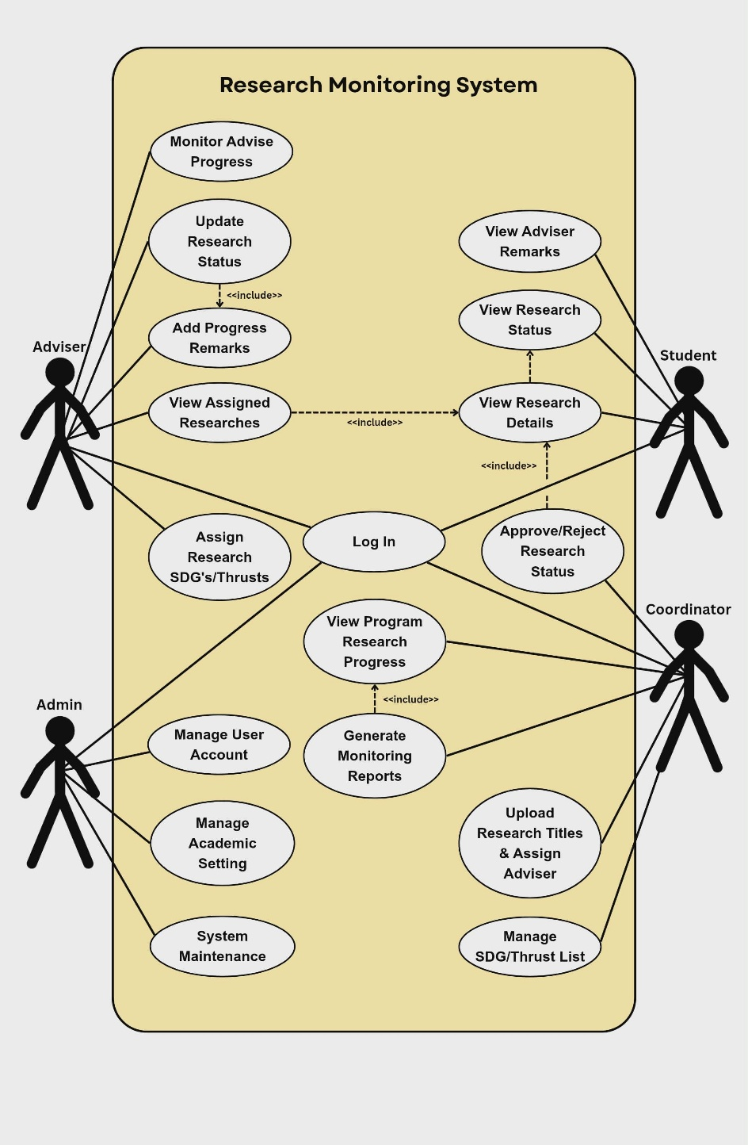
The figure above is the use case diagram. Theis Diagram illustrates the capabilities to each user within the system. Students can log in and access their research title, group members, adviser, current status and approved comments. Advisers can review their assigned students, modify the research status, insert progress notes, label SDGs or thrusts and track advise progress. Coordinators are responsible, for approving or rejecting status changes overseeing the programs research progress generating reports, uploading research titles assigning advisers and managing the SDG/thrust list. Admins manage user accounts, research and academic settings, and handle system maintenance like backups and notifications. This diagram shows the main tasks of each user in a simple way.

