Introduction
‎
‎Integrating data analytics into a research monitoring software system enables institutions to continuously track and appraise research activities in real-time. By combining analytics modules, the system is capable of processing project data, providing visual dashboards, and offering predicted insights regarding study outcomes. This integration reduces the need for manual tracking, spots patterns, and helps managers make data-driven decisions. Consistent monitoring of research output and compliance is ensured via automated reporting and visualization. All things considered, the use of analytics turns traditional research monitoring into a clever, effective, and user-friendly software program.
‎According to IBM (2024), data analytics can be embedded into software systems to process raw research data and produce actionable insights that inform monitoring and reporting. As stated by Microsoft Azure Architecture Center (2024), analytics module such as data pipelines, dashboards, and machine learning models can be integrated into software to automatically analyze research data in real-time. Based on the findings of Elsevier Research Intelligence (2024), research monitoring platforms with integrated analytics dashboards can centralize project data, track researcher performance, and visualize timelines efficiently. Nguyen (2022) explains that analytics dashboards allow administrators to detect delays, evaluate productivity, and generate automated performance reports within research management software. Research by Harvard Data Science Review (2023) shows that predictive analytics integrated into research monitoring software can forecast project outcomes and identify risks using historical data.
‎Conclusion
‎Efficiency, precision, and decision-making are greatly enhanced when data analytics are incorporated into research monitoring software. The system may track research progress, identify dangers, and produce actionable insights in real-time by integrating modules like dashboards, predictive analytics, and automated reporting. This integration facilitates data-driven decision-making, lessens manual labor, and gives administrators and researchers predictive, unambiguous, and visually appealing information. All things considered, analytics-driven research monitoring turns conventional techniques into a clever, automated, and very successful system that enables organizations to oversee research operations more effectively and strategically.

‎https://www.ibm.com/topics/data-analytics
‎https://learn.microsoft.com/en-us/azure/architecture/data-guide/technology-choices/analytics
‎
‎https://www.elsevier.com/solutions/research-intelligence/research-information-management
‎https://www.jist.info/analytics-dashboards-research
‎https://hdsr.mitpress.mit.edu/pub/predictive-analytics-education

Use Case Diagram
The use-case diagram is a diagram that shows what functionality that the system can do, with different roles with diverse functionality. This diagram is used actors for different roles, a rectangular shape that shows boundary, ovals to showcase what a specific role can do within the Research Monitoring System, and lines to connect them together, interchangeably.

Figure 2: Use Case Diagram
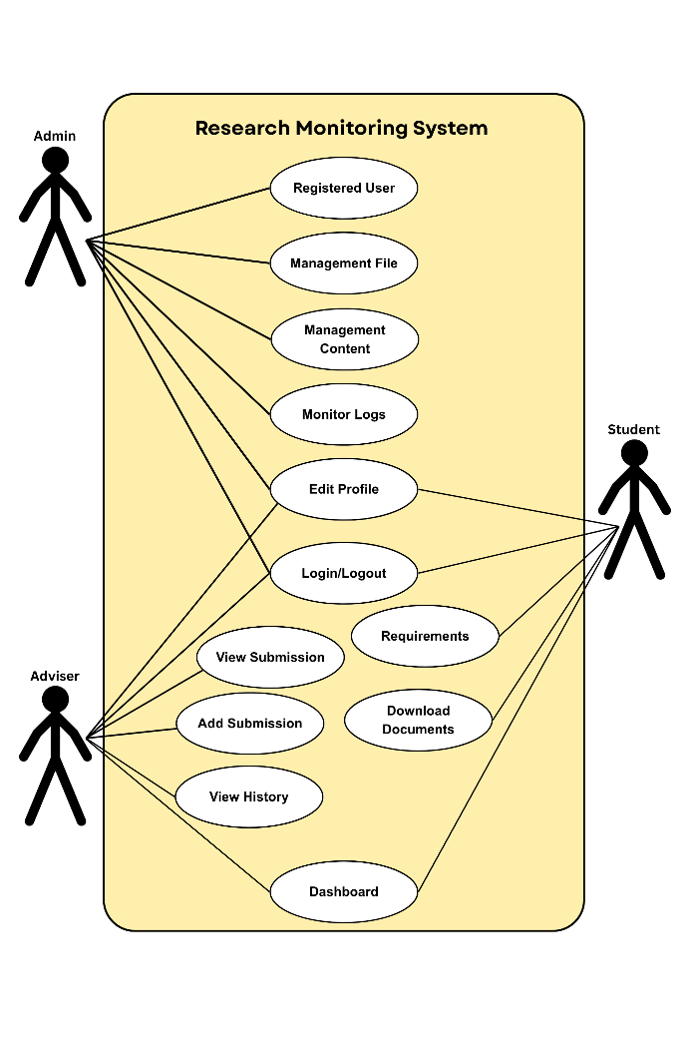
The figure above is the use case diagram. Theis Diagram illustrates the capabilities to each user within the system. Students can log in and access their research title, group members, adviser, current status and approved comments. Advisers can review their assigned students, modify the research status, insert progress notes, label SDGs or thrusts and track advise progress. Coordinators are responsible, for approving or rejecting status changes overseeing the programs research progress generating reports, uploading research titles assigning advisers and managing the SDG/thrust list. Admins manage user accounts, research and academic settings, and handle system maintenance like backups and notifications. This diagram shows the main tasks of each user in a simple way.

