Royal Dutch Shell:

A Macroeconomic Analysis

Shaun Harrington

4/7/2021

# Royal Dutch Shell: A Macroeconomic Analysis

#### Motivation

Royal Dutch Shell is a international company that spans the entire globe. As such, it is subject to several macroeconomic variables throughout numerous countries. Due to COVID-19, we have seen considerable fluctuations in the macroeconomy.

[Insert discussion of change in macroeconomic indicators over past year]

As numerous macroeconomic indicators are highly correlated with revenues, such as the price of a barrel of oil, the net financial impact is exposed to these uncontrollable variables. By understanding the impacts, measures can be taken to mitigate the impact of changes to the macroeconomy.

Royal Dutch Shell (RDS) segments revenue streams by region. Those being the United States, Europe, Other Americas, and Asia/Oceania/Africa. In 2019, the distribution of revenues were: 24% in the US, 29% in Europe, 7% in Other Americas, and 41% in Asia/Oceania/Africa. See below for a chart of revenues by region:

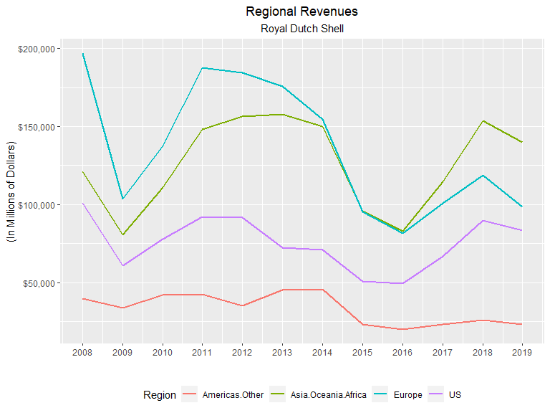

As evidenced in the chart above, revenue streams are subject to large deviations, moreso in some regions than others. Royal Dutch Shell is also experiencing a changing market with revenues during this period decreasing in non-US Americas and Europe yet increasing revenues in the US and Asia/Oceania/Africa. The chart below displays how the regional percent of total revenues has changed during this period.

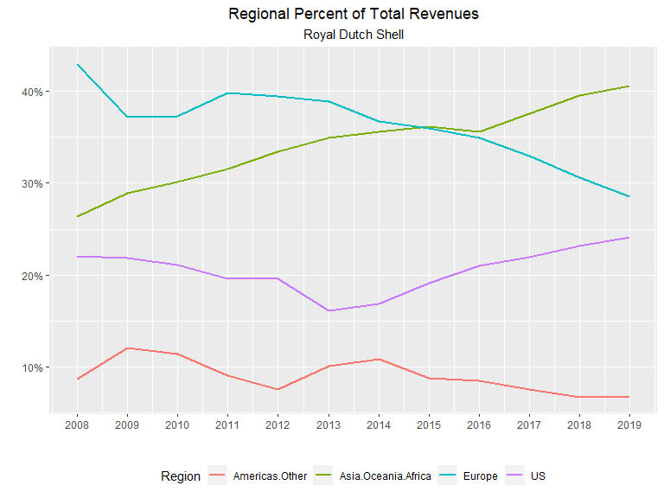

#### Objectives

This report will cover the major macroeconomic indicators and how they impact Royal Dutch Shell. An analysis of specific measures to mitigate this risk will be compared with the goal of maximizing revenues. By evaluating the sensitivity, or elasticity, of these indicators, Royal Dutch shell will be able to quantify the risks of a changing macroeconomy. Using these elasticities, a strategy to mitigate these risks will be developed.

The macroeconomics indicators that will be considered are changes in real GDP, consumption, industrial production, nominal interest rate, inflation, unemployment rate, exchange rate, and natural gas and oil prices. All data is retrieved from the World Bank. The national values for GDP, consumption, and industrial production within a region are summed by year to calculate the total regional values. The nominal interest rates and inflation rates are averaged for each nation using the nation’s GDP as a weight. Likewise, the unemployment rate for each nation in a region is averaged using each nation’s population as a weight.

## Literature Review

#### Determinants of price of oil and natural gas.

#### Correlation of price of oil/LNG with macroeconomic indicators.

#### Limiting exchange rate risk of international corporations.

#### Microeconomics of Fossil Fuel industry to maximize revenues.

## Method of Analysis

#### Scope

By means of a log-log model with regional revenues as the dependent variable and macroeconomics indicators as the independent variables, the elasticities of each of these indicators can be evaluated. However, given that available revenue data only trace back to 2004, this approach is severely limited in the vigor necessary for some of the claims that must be met. As such, a laxed approach must be considered as long as the empirical results do not counter economic theory.

The evaluated elasticities enable the ability to determine which macroeconomic variables impact revenues the greatest. Knowing these sensitivies will indicate where to allocate resources to hedge this risk.

#### Log-Log model evaluation

The following tables are the output of this model for each region. The “dlog()” encapsulating each variable is a function that returns the first difference of the natural log of the variable.

#### Asia/Oceania/Africa:

Asia/Oceania/Africa Log-Log Model.

|  |  |  |  |  |
| --- | --- | --- | --- | --- |
| Predictor | Estimate | SE | t-Statistic | P-Value |
| (Intercept) | -0.35 | 0.17 | -1.99 | 0.10 |
| dlog(consumption) | 6.23 | 5.24 | 1.19 | 0.29 |
| dlog(gdp) | 6.14 | 5.00 | 1.23 | 0.27 |
| dlog(indust.production) | -3.56 | 1.98 | -1.80 | 0.13 |
| dlog(cpi) | -0.05 | 0.33 | -0.16 | 0.88 |
| diff(interest.nom) | -0.02 | 0.03 | -0.85 | 0.44 |
| dlog(oil.price) | 0.71 | 0.13 | 5.53 | 0.00 |
| diff(unemployment.rate) | -0.52 | 0.47 | -1.10 | 0.32 |
| dlog(exchange.rate.index) | 0.47 | 0.82 | 0.57 | 0.60 |

#### Europe:

Europe Log-Log Model.

|  |  |  |  |  |
| --- | --- | --- | --- | --- |
| Predictor | Estimate | SE | t-Statistic | P-Value |
| (Intercept) | -0.18 | 0.10 | -1.79 | 0.13 |
| dlog(consumption) | -4.15 | 7.80 | -0.53 | 0.62 |
| dlog(gdp) | 9.68 | 12.92 | 0.75 | 0.49 |
| dlog(indust.production) | 1.64 | 6.14 | 0.27 | 0.80 |
| dlog(cpi) | 3.62 | 2.02 | 1.80 | 0.13 |
| diff(interest.nom) | 0.04 | 0.06 | 0.61 | 0.57 |
| dlog(oil.price) | 0.77 | 0.12 | 6.49 | 0.00 |
| diff(unemployment.rate) | 0.23 | 0.16 | 1.43 | 0.21 |
| dlog(exchange.rate.index) | 0.95 | 1.39 | 0.69 | 0.52 |

#### United States:

US Log-Log Model.

|  |  |  |  |  |
| --- | --- | --- | --- | --- |
| Predictor | Estimate | SE | t-Statistic | P-Value |
| (Intercept) | -0.16 | 0.31 | -0.51 | 0.63 |
| dlog(consumption) | 9.92 | 17.03 | 0.58 | 0.59 |
| dlog(gdp) | 0.60 | 16.36 | 0.04 | 0.97 |
| dlog(indust.production) | 0.01 | 1.97 | 0.00 | 1.00 |
| dlog(cpi) | -3.37 | 15.50 | -0.22 | 0.84 |
| diff(interest.nom) | -0.13 | 0.08 | -1.69 | 0.15 |
| dlog(oil.price) | 0.03 | 0.06 | 0.42 | 0.69 |
| diff(unemployment.rate) | -0.09 | 0.17 | -0.50 | 0.64 |
| dlog(exchange.rate.index) | -4.18 | 4.80 | -0.87 | 0.42 |

#### Other Americas:

Other Americas Log-Log Model.

|  |  |  |  |  |
| --- | --- | --- | --- | --- |
| Predictor | Estimate | SE | t-Statistic | P-Value |
| (Intercept) | -0.18 | 0.10 | -1.79 | 0.13 |
| dlog(consumption) | -4.15 | 7.80 | -0.53 | 0.62 |
| dlog(gdp) | 9.68 | 12.92 | 0.75 | 0.49 |
| dlog(indust.production) | 1.64 | 6.14 | 0.27 | 0.80 |
| dlog(cpi) | 3.62 | 2.02 | 1.80 | 0.13 |
| diff(interest.nom) | 0.04 | 0.06 | 0.61 | 0.57 |
| dlog(oil.price) | 0.77 | 0.12 | 6.49 | 0.00 |
| diff(unemployment.rate) | 0.23 | 0.16 | 1.43 | 0.21 |
| dlog(exchange.rate.index) | 0.95 | 1.39 | 0.69 | 0.52 |

#### Hedging risk of elasticities

#### Optimization

#### Economic value-added of differing operations

## Results & Discussion

#### log-log model breakdown

#### basis of theoretical model and application

#### discussion of ideal inputs

#### Diverse operations portfolio vs. allocation towards most profitable

## Conclusion

#### Summary of available options to mitigate risk

#### How to maximize revenues given current conditions

#### Discussion of variability outside of scope