OEL PROPOSAL

E-Commerce Sales Analysis
Advanced Exploratory Data Analysis Using Python

Umar Muneer (75600)
Hafiz Sharjeel Ali(75601)
Muhammad Ali Raza (62696)
Haider Hassan (68119)

1. Topic

E-Commerce Sales Analysis Using Python, NumPy, Pandas, Matplotlib & Seaborn

2. Description

This project performs a comprehensive Exploratory Data Analysis (EDA) on an e-commerce sales dataset. The analysis uncovers hidden patterns in customer behavior, product performance, regional sales trends, and revenue seasonality. By leveraging Python's powerful data science stack — NumPy, Pandas, Matplotlib, and Seaborn — the project transforms raw transactional data into actionable business insights through rich statistical summaries and visualizations.

3. Problem Statement

E-commerce businesses generate massive volumes of sales data daily, but without proper analysis, this data remains unutilized. Decision-makers struggle to identify:
- Which products drive the most revenue and which underperform
- Which customer segments are most valuable (RFM Analysis)
- What seasonal or monthly patterns affect total sales
- Which regions or cities contribute most to business growth
This project addresses these challenges by applying structured EDA techniques to extract meaningful patterns from raw sales data.

4. Objectives

- Perform full data cleaning and preprocessing using Pandas
- Conduct descriptive statistical analysis using NumPy
- Identify top-selling products and top revenue-generating countries
- Perform RFM (Recency, Frequency, Monetary) customer segmentation
- Analyze monthly and seasonal revenue trends
- Detect outliers in sales and order quantities
- Visualize all insights using Matplotlib and Seaborn

5. Methodology

5.1 Data Collection
- Dataset: Online Retail E-Commerce Dataset (Kaggle/UCI – UK-based transactional data)
- Columns: InvoiceNo, StockCode, Description, Quantity, InvoiceDate, UnitPrice, CustomerID, Country

5.2 Data Preprocessing
- Handle missing values using Pandas fillna() and dropna()
- Convert date columns to datetime format
- Remove duplicate records
- Feature engineering: extract Month, Year, Day-of-Week from order dates

5.3 Exploratory Data Analysis
- Descriptive statistics: mean, median, std, skewness using NumPy
- Correlation matrix and heatmap to find variable relationships
- Top 10 products by revenue
- Monthly revenue trend line chart
- Regional sales bar chart and pie chart

5.4 RFM Analysis
- Calculate Recency, Frequency, and Monetary scores per customer
- Segment customers into: Champions, Loyal, At-Risk, Lost
- Visualize segments using Seaborn count plots and scatter plots

5.5 Visualization
- Line charts — revenue trends over time
- Bar charts — product and category performance
- Heatmaps — correlation and seasonal patterns
- Box plots — outlier detection in sales values
- Scatter plots — price vs. profit, quantity vs. revenue
- Pie charts — regional contribution breakdown

6. Flowchart

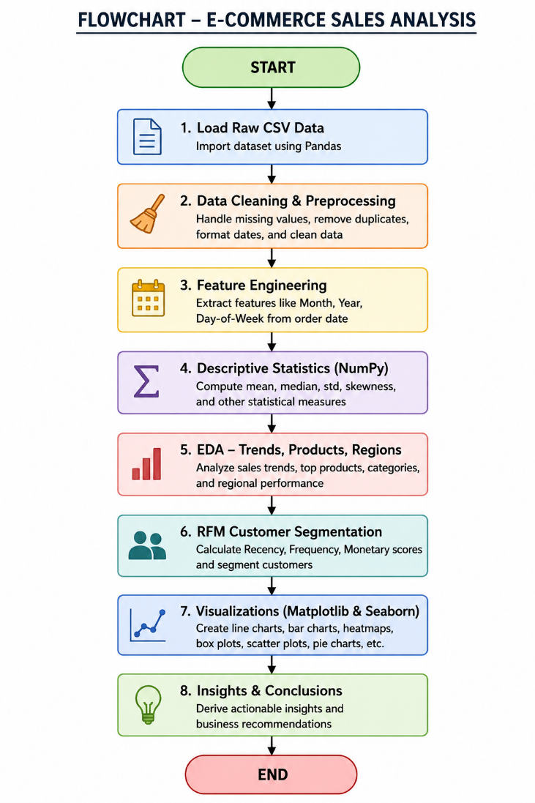

7. Tools & Techniques

Tool / Library | Version | Purpose
Python | 3.11+ | Core programming language
NumPy | 1.26+ | Numerical computations & statistics
Pandas | 2.1+ | Data manipulation & preprocessing
Matplotlib | 3.8+ | Base charting & custom plots
Seaborn | 0.13+ | Statistical & advanced visualizations
Jupyter Notebook | 7.0+ | Interactive development environment

8. Expected Outcomes

- A fully cleaned and preprocessed e-commerce dataset ready for analysis
- Identification of top 10 revenue-generating products
- Monthly and seasonal revenue trend visualizations
- Customer segmentation report based on RFM scoring
- Regional performance breakdown with visual comparisons
- A comprehensive EDA report with 10+ professional visualizations
- Actionable business insights and recommendations for the e-commerce platform

Code:

import numpy as np
import pandas as pd
import matplotlib.pyplot as plt
import seaborn as sns
import warnings

warnings.filterwarnings('ignore')
sns.set_theme(style='whitegrid', palette='muted')
plt.rcParams['figure.figsize'] = (12, 5)

print('All libraries imported successfully!')

df = pd.read_csv('data.csv', encoding='latin1')

print('Dataset Shape:', df.shape)
print('\nFirst 5 Rows:')
df.head()

print('Column Names:', df.columns.tolist())
print('\nData Types:')
print(df.dtypes)

# ── Missing Values ──
print('Missing Values Before Cleaning:')
print(df.isnull().sum())

# Drop rows with missing CustomerID (required for RFM)
df.dropna(subset=['CustomerID'], inplace=True)

# Corrected fillna deployment to avoid inplace warnings
df['Description'] = df['Description'].fillna('Unknown')

print('\nMissing Values After Cleaning:')
print(df.isnull().sum())

# ── Remove Duplicates ──
before = df.shape[0]
df.drop_duplicates(inplace=True)
after = df.shape[0]
print(f'Duplicates removed: {before - after} rows')

# ── Remove Cancelled Orders & Invalid Prices ──
df = df[df['Quantity'] > 0]
df = df[df['UnitPrice'] > 0]

print('Clean dataset shape:', df.shape)

# ── Feature Engineering ──
# Added explicit string matching format to optimize performance speeding up parse times
df['InvoiceDate'] = pd.to_datetime(df['InvoiceDate'], format='%m/%d/%Y %H:%M')

df['Revenue'] = df['Quantity'] * df['UnitPrice']
df['Month'] = df['InvoiceDate'].dt.month
df['Year'] = df['InvoiceDate'].dt.year
df['DayOfWeek'] = df['InvoiceDate'].dt.day_name()
df['CustomerID'] = df['CustomerID'].astype(int)

print('New columns added: Revenue, Month, Year, DayOfWeek')
df[['InvoiceDate','Revenue','Month','Year','DayOfWeek']].head()

revenue = df['Revenue'].values
qty = df['Quantity'].values

print('===== Revenue Statistics =====')
print(f'Mean : £{np.mean(revenue):.2f}')
print(f'Median : £{np.median(revenue):.2f}')
print(f'Std Dev : £{np.std(revenue):.2f}')
print(f'Skewness: {pd.Series(revenue).skew():.2f}')
print(f'Min : £{np.min(revenue):.2f}')
print(f'Max : £{np.max(revenue):.2f}')

print('\n===== Quantity Statistics =====')
print(f'Mean : {np.mean(qty):.2f}')
print(f'Median : {np.median(qty):.2f}')
print(f'Std Dev : {np.std(qty):.2f}')

df[['Quantity','UnitPrice','Revenue']].describe()

# Optional safeguard: Standardize string casing to avoid splitting duplicate products
df['Description'] = df['Description'].str.upper()

top_products = (
df.groupby('Description')['Revenue']
.sum()
.sort_values(ascending=False)
.head(10)
)

plt.figure(figsize=(13, 6))
sns.barplot(x=top_products.values, y=top_products.index, palette='Blues_r')
plt.title('Top 10 Products by Revenue', fontsize=15, fontweight='bold')
plt.xlabel('Total Revenue (£)')
plt.ylabel('Product')
plt.tight_layout()
plt.show()
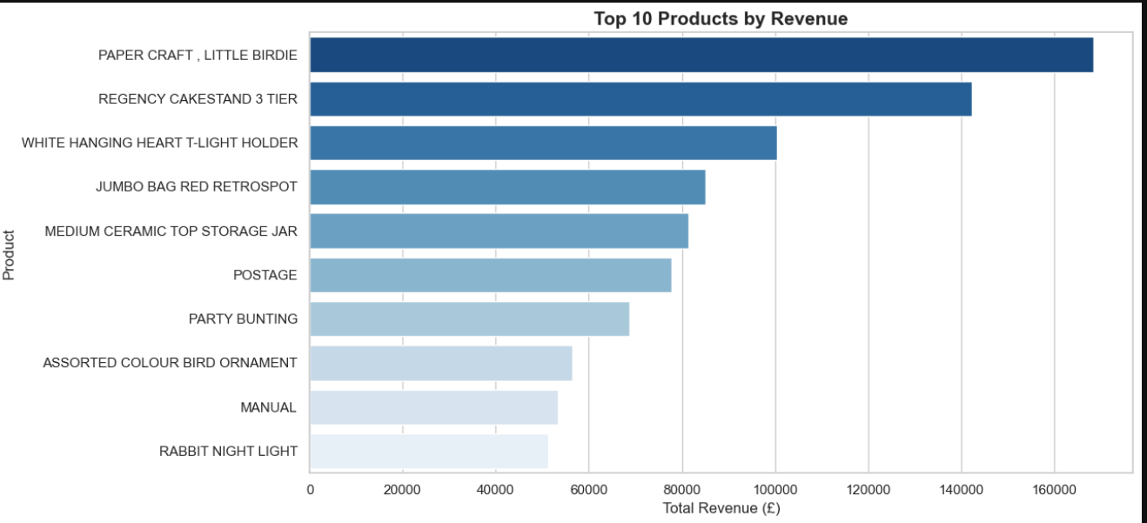

monthly = (
df.groupby(['Year','Month'])['Revenue']
.sum()
.reset_index()
)
monthly['Period'] = monthly['Year'].astype(str) + '-' + monthly['Month'].astype(str).str.zfill(2)
monthly.sort_values('Period', inplace=True)

plt.figure(figsize=(14, 5))
plt.plot(monthly['Period'], monthly['Revenue'], marker='o', color='steelblue', linewidth=2)
plt.fill_between(monthly['Period'], monthly['Revenue'], alpha=0.15, color='steelblue')
plt.title('Monthly Revenue Trend', fontsize=15, fontweight='bold')
plt.xlabel('Month')
plt.ylabel('Total Revenue (£)')
plt.xticks(rotation=45)
plt.tight_layout()
plt.show()
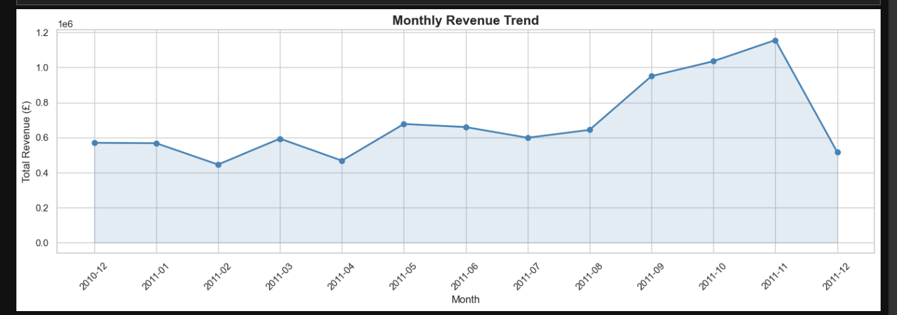

regional = (
df.groupby('Country')['Revenue']
.sum()
.sort_values(ascending=False)
.head(10)
)

fig, axes = plt.subplots(1, 2, figsize=(16, 6))

# Bar chart
sns.barplot(x=regional.values, y=regional.index, palette='viridis', ax=axes[0])
axes[0].set_title('Top 10 Countries by Revenue', fontweight='bold')
axes[0].set_xlabel('Revenue (£)')

# Pie chart
axes[1].pie(regional.values, labels=regional.index, autopct='%1.1f%%',
startangle=140, colors=sns.color_palette('viridis', len(regional)))
axes[1].set_title('Revenue Share by Country', fontweight='bold')

plt.tight_layout()
plt.show()

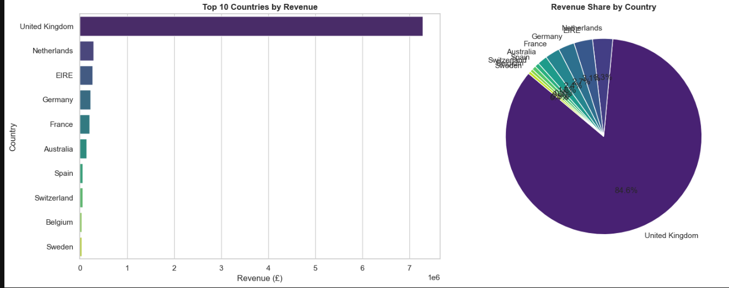

corr = df[['Quantity','UnitPrice','Revenue']].corr()

plt.figure(figsize=(7, 5))
sns.heatmap(corr, annot=True, fmt='.2f', cmap='coolwarm', linewidths=0.5)
plt.title('Correlation Heatmap', fontsize=14, fontweight='bold')
plt.tight_layout()
plt.show()

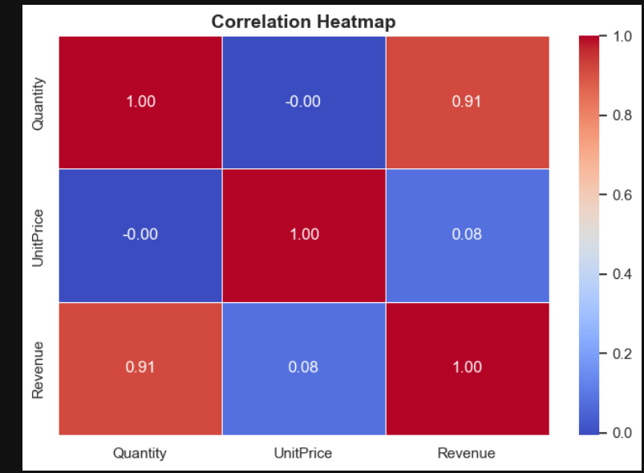

fig, axes = plt.subplots(1, 2, figsize=(14, 5))

# Cap at 99th percentile for visibility
rev_cap = df['Revenue'].clip(upper=df['Revenue'].quantile(0.99))
qty_cap = df['Quantity'].clip(upper=df['Quantity'].quantile(0.99))

sns.boxplot(y=rev_cap, ax=axes[0], color='lightcoral')
axes[0].set_title('Revenue Distribution (Box Plot)', fontweight='bold')
axes[0].set_ylabel('Revenue (£)')

sns.boxplot(y=qty_cap, ax=axes[1], color='lightblue')
axes[1].set_title('Quantity Distribution (Box Plot)', fontweight='bold')
axes[1].set_ylabel('Quantity')

plt.tight_layout()
plt.show()

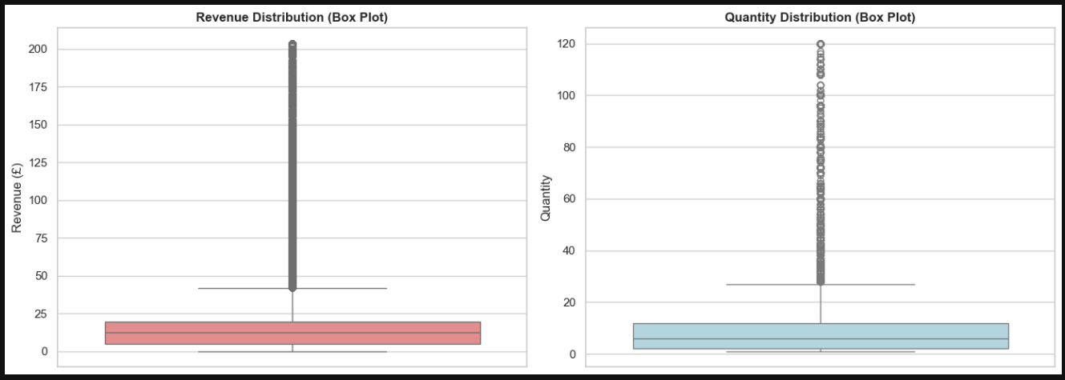

day_order = ['Monday','Tuesday','Wednesday','Thursday','Friday','Saturday','Sunday']
day_sales = df.groupby('DayOfWeek')['Revenue'].sum().reindex(day_order)

plt.figure(figsize=(10, 5))
sns.barplot(x=day_sales.index, y=day_sales.values, palette='Set2')
plt.title('Revenue by Day of Week', fontsize=14, fontweight='bold')
plt.xlabel('Day')
plt.ylabel('Total Revenue (£)')
plt.tight_layout()
plt.show()
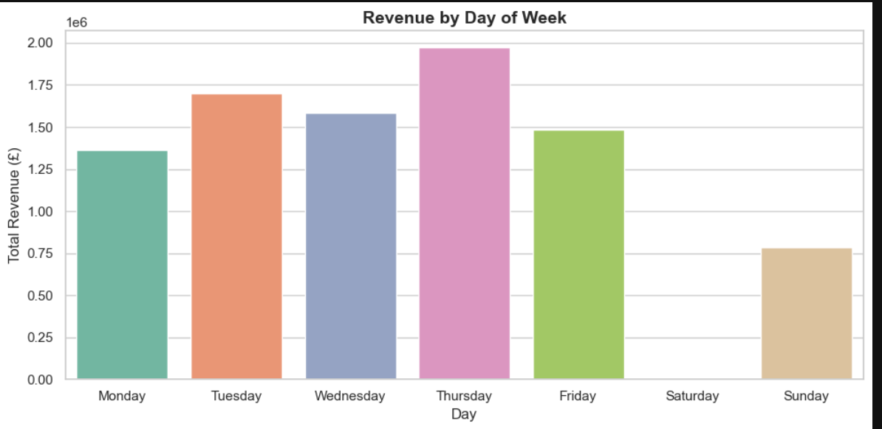

sample = df[df['UnitPrice'] < df['UnitPrice'].quantile(0.95)].sample(3000, random_state=42)

plt.figure(figsize=(10, 5))
sns.scatterplot(data=sample, x='UnitPrice', y='Revenue', alpha=0.4, color='teal')
plt.title('Unit Price vs Revenue', fontsize=14, fontweight='bold')
plt.xlabel('Unit Price (£)')
plt.ylabel('Revenue (£)')
plt.tight_layout()
plt.show()

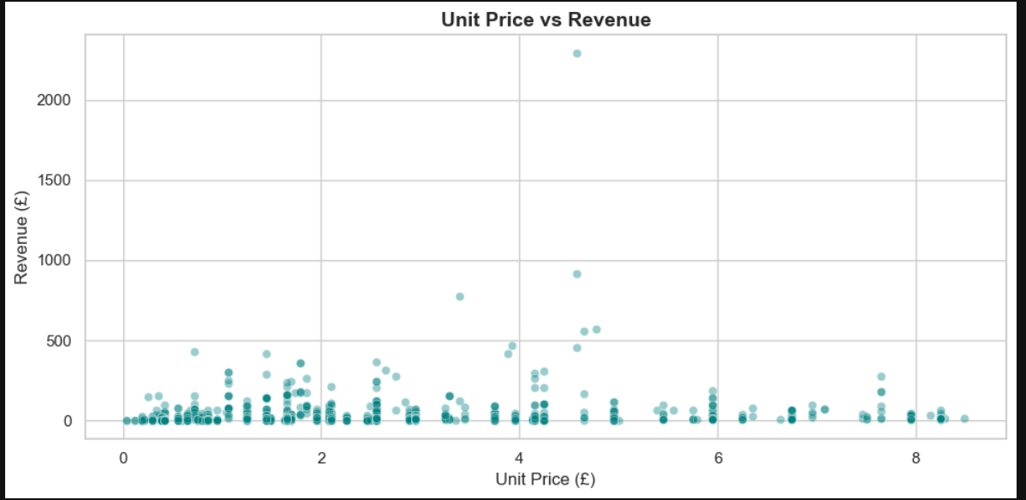

# ── Calculate RFM ──
snapshot_date = df['InvoiceDate'].max() + pd.Timedelta(days=1)

rfm = df.groupby('CustomerID').agg(
Recency = ('InvoiceDate', lambda x: (snapshot_date - x.max()).days),
Frequency = ('InvoiceNo', 'nunique'),
Monetary = ('Revenue', 'sum')
).reset_index()

print('RFM Table (first 5 rows):')
rfm.head()

# ── Score RFM (1–4 scale) ──
rfm['R_Score'] = pd.qcut(rfm['Recency'], q=4, labels=[4,3,2,1]).astype(int)
rfm['F_Score'] = pd.qcut(rfm['Frequency'].rank(method='first'), q=4, labels=[1,2,3,4]).astype(int)
rfm['M_Score'] = pd.qcut(rfm['Monetary'].rank(method='first'), q=4, labels=[1,2,3,4]).astype(int)

rfm['RFM_Score'] = rfm['R_Score'] + rfm['F_Score'] + rfm['M_Score']

# ── Segment Customers ──
def segment(score):
if score >= 10:
return 'Champions'
elif score >= 7:
return 'Loyal'
elif score >= 5:
return 'At-Risk'
else:
return 'Lost'

rfm['Segment'] = rfm['RFM_Score'].apply(segment)
print(rfm['Segment'].value_counts())
rfm.head()

# ── Segment Count Plot ──
plt.figure(figsize=(9, 5))
order = ['Champions','Loyal','At-Risk','Lost']
sns.countplot(data=rfm, x='Segment', order=order,
palette=['#2ecc71','#3498db','#e67e22','#e74c3c'])
plt.title('Customer Segments (RFM)', fontsize=14, fontweight='bold')
plt.xlabel('Segment')
plt.ylabel('Number of Customers')
plt.tight_layout()
plt.show()
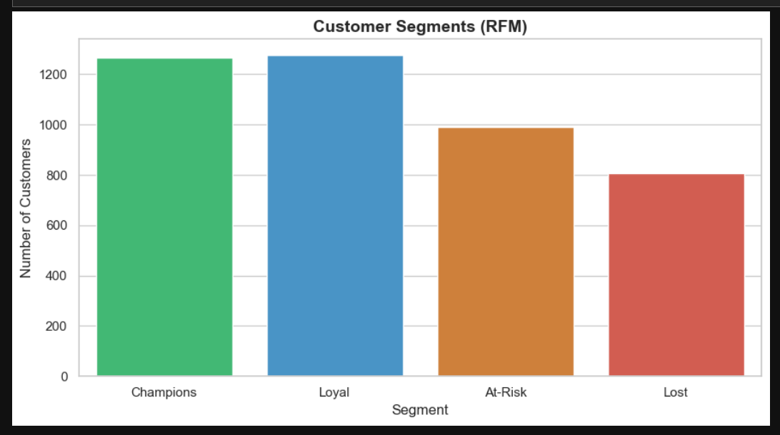

# ── Monetary vs Frequency scatter by Segment ──
plt.figure(figsize=(10, 6))
palette = {'Champions':'#2ecc71','Loyal':'#3498db','At-Risk':'#e67e22','Lost':'#e74c3c'}
sample_rfm = rfm[rfm['Monetary'] < rfm['Monetary'].quantile(0.98)]
sns.scatterplot(data=sample_rfm, x='Frequency', y='Monetary',
hue='Segment', palette=palette, alpha=0.7, s=60)
plt.title('Frequency vs Monetary by Customer Segment', fontsize=14, fontweight='bold')
plt.xlabel('Purchase Frequency')
plt.ylabel('Total Spend (£)')
plt.legend(title='Segment')
plt.tight_layout()
plt.show()

# ── Monetary vs Frequency scatter by Segment ──

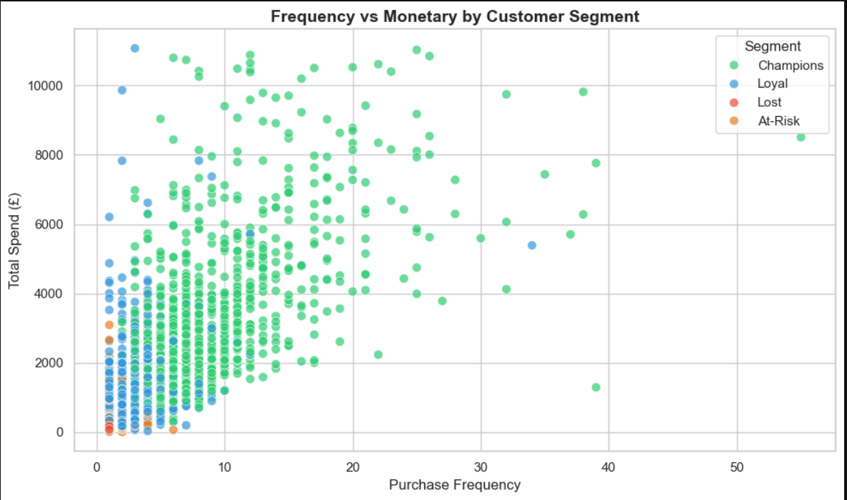

pivot = df.pivot_table(values='Revenue', index='DayOfWeek', columns='Month',
aggfunc='sum').reindex(day_order)
plt.figure(figsize=(14, 6))
sns.heatmap(pivot, cmap='YlOrRd', linewidths=0.3, fmt='.0f', annot=False)
plt.title('Revenue Heatmap — Month × Day of Week', fontsize=14, fontweight='bold')
plt.xlabel('Month')
plt.ylabel('Day of Week')
plt.tight_layout()
plt.show()

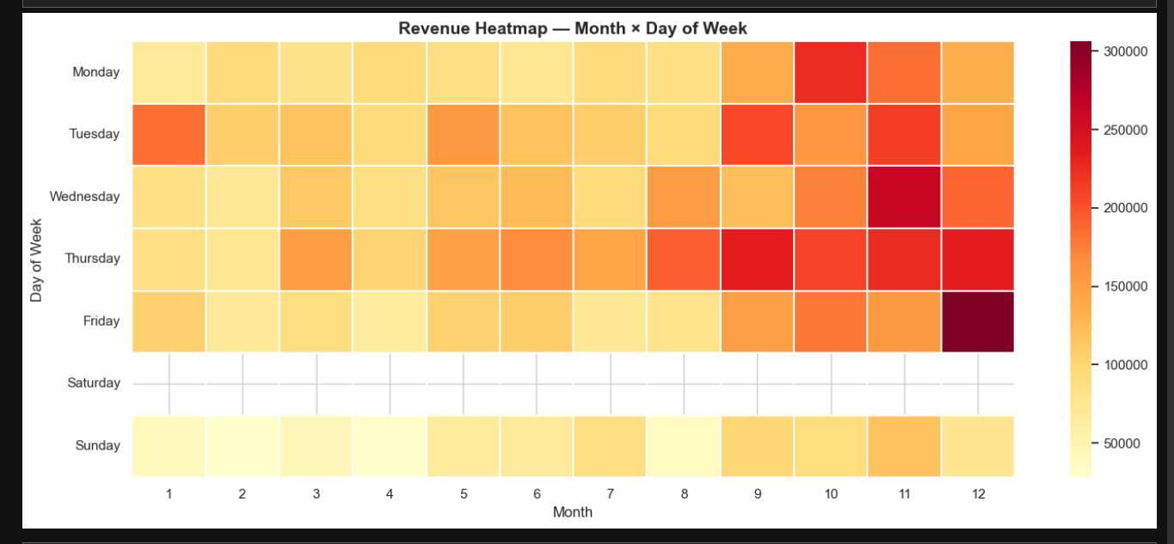

print('='*55)
print(' BUSINESS INSIGHTS SUMMARY')
print('='*55)
print(f"Total Transactions : {len(df):,}")
print(f"Total Revenue : £{df['Revenue'].sum():,.2f}")
print(f"Unique Customers : {df['CustomerID'].nunique():,}")
print(f"Unique Products : {df['Description'].nunique():,}")
print(f"Countries Served : {df['Country'].nunique()}")
print(f"Top Country : {df.groupby('Country')['Revenue'].sum().idxmax()}")
print(f"Best Month (Revenue) : {monthly.loc[monthly['Revenue'].idxmax(), 'Period']}")
print(f"Avg Order Value : £{df['Revenue'].mean():.2f}")
print('-'*55)
print('RFM Segments:')
for seg, cnt in rfm['Segment'].value_counts().items():
print(f" {seg:<15}: {cnt} customers")
print('='*55)

Business_Summary_Output:

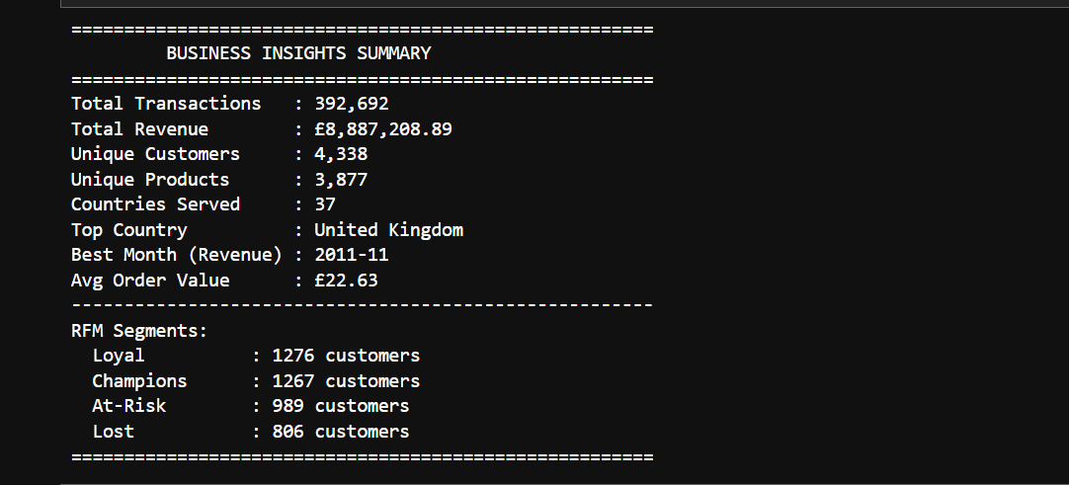

9. Timeline

Day | Task | Deliverable
Day 1 | Data collection and environment setup | Raw dataset + Jupyter environment ready
Day 2 | Data cleaning and preprocessing | Cleaned and preprocessed CSV file
Day 3 | Descriptive statistics & feature engineering | Statistical summary + NumPy analysis
Day 4 | EDA — trends, products, regions | EDA charts + bar/line/pie visualizations
Day 5 | RFM Analysis + customer segmentation | Segmentation plots + RFM score table
Day 6 | Advanced Seaborn visualizations + heatmaps | 10+ complete visualization plots
Day 7 | Final report, insights & submission | Complete Jupyter Notebook + final report

10. References

[1] Wes McKinney, Python for Data Analysis, 3rd Edition, O'Reilly Media, 2022.
[2] Jake VanderPlas, Python Data Science Handbook, O'Reilly Media, 2023.
[3] YT: CampusX
[4] Kaggle E-Commerce Dataset: https://www.kaggle.com/datasets/carrie1/ecommerce-data
[5] Seaborn Documentation: https://seaborn.pydata.org
[6] Matplotlib Documentation: https://matplotlib.org
[7] Pandas Documentation: https://pandas.pydata.org
[8] NumPy Documentation: https://numpy.org/doc

