IQRA UNIVERSITY
Department of Computer Science

MID-TERM LAB PROJECT
ASSIGNMENT SHEET
Based on Lab Sessions 1 – 5

CMC 112-L · Introduction to Python | Labs 1 – 5 | 7 Topics

Academic Year 2026 · BS Computer Science
Instructor: Khansa Shakeel
Submission Deadline: 9 April 2026
Umar Muneer(75600)
Hafiz Sharjeel Ali(75601)
Muhammad Ali Raza (62696)
Haider Hassan (68119)

General Instructions

Read every instruction carefully before starting. Plagiarism of any kind results in zero marks for all involved parties.

Submission Requirements
- Each student submits their own individual work — group submissions are NOT accepted.
- Create one ZIP folder named exactly: StudentName_RollNumber_MidProject
- The ZIP must contain clearly labelled subfolders for each course: EBIZ / COAL / PYTHON
- Upload to LMS portal before the deadline. Late submissions lose per day.

Report Format for Every Topic
- A Word (.docx) report with: your name, roll number, course code, and topic number on the first page.
- Screenshot of every output/result, clearly labelled by topic and part (e.g., Topic 1 – Part A Output).
- Source code pasted into the Word report AND submitted as a separate source file.
- A 4–6 line personal conclusion at the end: what you learned and how it applies in real life.

Marking Criteria
Criterion | Weight | What is evaluated
Correctness of output / design / content | 60 % | Output matches expected result
Code quality / design quality / explanation | 25 % | Clear logic, well-structured, commented
Report, screenshots & conclusion | 15 % | Professional format, all parts present

- Partial marks ARE awarded — attempt every part, even if incomplete.
- In COAL: comment every line of assembly code. In Python: comment key logic blocks.

Academic Integrity Notice: All submissions are checked for similarity. Matching work = 0 marks for every student involved.

SECTION 3 · CMC 112-L · Introduction to Python · 7 Topics (Labs 1 – 5)

Lab Coverage
Lab 1 | Python Basics — history, installation, syntax, variables, data types (int, float, str, bool), operators, input/output, comments, errors
Lab 2 | Control Flow — conditions (if, elif, else), Boolean logic, logical operators, for loops, while loops
Lab 3 | Lists & Tuples — list creation, indexing, slicing, operators; insert, remove, sort, search; tuple basics
Lab 4 | Dictionaries & Sets — dict creation, key-value pairs, add/remove/update; traversal; set operations
Lab 5 | Strings — indexing, slicing, converting strings/numbers, string methods (upper, lower, split, join, replace, strip, find, count)

Topic 1 Python Basics — Variables, Input & Operators
Tools / Platform | Python 3 (IDLE / VS Code) — .py file + Word report
Lab | Lab 1 – Python Basics, Data Types, Input/Output, Operators
Submit | Word report (code + output screenshots) + Source: topic1.py

Part A — Variable & Data Types Explorer
- Ask the user to enter: their name (str), age (int), CGPA (float), and whether they are a student (yes/no — store as bool).
- Print a formatted output using f-strings: 'Hello [name]! You are [age] years old. Your CGPA is [cgpa]. Student: [True/False]'
- Print the data type of each variable using type() — show all 4 types in your output.

Source Code:

print("--- Part A: User Data Collection ---")
name = input("Enter your Name: ")
age = int(input("Enter your Age: "))
cgpa = float(input("Enter your CGPA: "))
# Note: int('42.75') raises ValueError because int() cannot parse a string containing a decimal point directly.

is_student = input("Are you a student? (yes/no): ").lower() == 'yes'

print(f"Hello {name}! You are {age} years old. Your CGPA is {cgpa}. Student: {is_student}")
print(f"Name type: {type(name)}")
print(f"Age type: {type(age)}")
print(f"CGPA type: {type(cgpa)}")
print(f"Student type: {type(is_student)}")

Output:
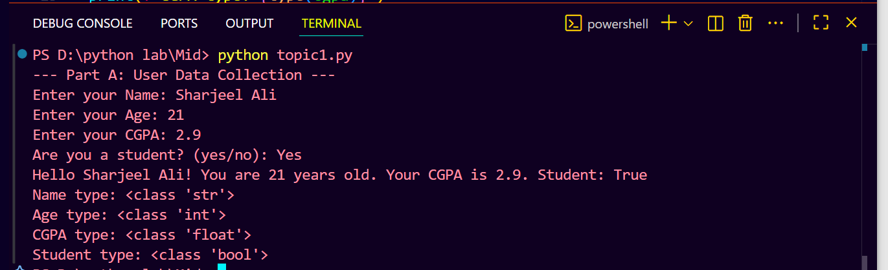 | 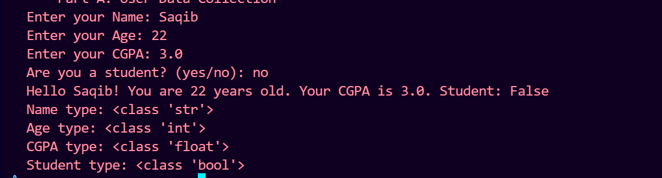

Part B — Arithmetic Calculator
- Ask the user to enter two numbers (a and b).
- Compute and print ALL of these: a+b, a-b, a*b, a/b (float division), a//b (floor division), a%b (modulus), a**b (exponent).
- Label each result clearly. Handle the case where b = 0: print 'Cannot divide by zero!' instead of crashing.

Source Code:
# Part B: Calculator with arithmetic operations
print("\n--- Part B: Basic Calculator ---")
num1 = float(input("Enter first number: "))
num2 = float(input("Enter second number: "))

print(f"Addition: {num1} + {num2} = {num1 + num2}")
print(f"Subtraction: {num1} - {num2} = {num1 - num2}")
print(f"Multiplication: {num1} * {num2} = {num1 * num2}")

# Safety: Prevent division by zero
if num2 != 0:
print(f"Division: {num1} / {num2} = {num1 / num2}")
print(f"Floor Division: {num1} // {num2} = {num1 // num2}")
print(f"Modulus: {num1} % {num2} = {num1 % num2}")
else:
print("Cannot divide by zero!")

print(f"Exponentiation: {num1} ** {num2} = {num1 ** num2}")

Output:

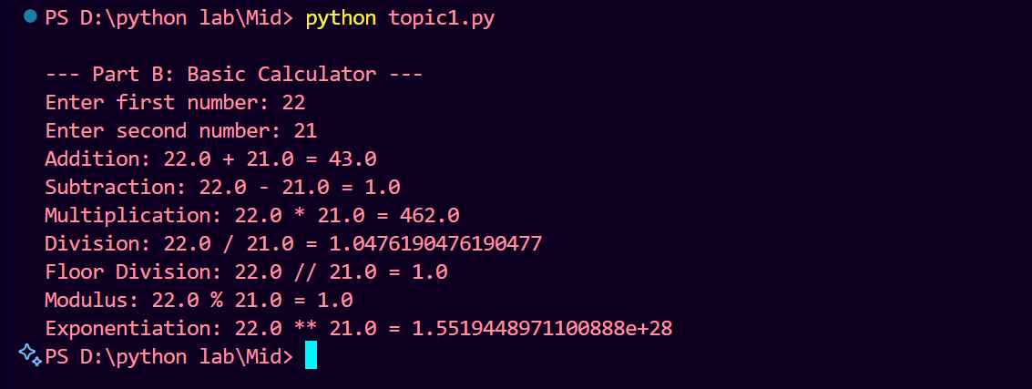

Part C — Type Conversion
- Ask the user to enter a number as a string (e.g., '42.75'). Convert it to float and multiply by 2. Print the result.
- Show that int('42.75') would fail — explain why in a code comment.

Source Code:
print("\n--- Part C: String to Float Conversion ---") # comment hata diya
num_str = input("Enter a number (e.g., 42.75): ")
num_float = float(num_str)
result = num_float * 2
print(f"Result after converting to float and multiplying by 2: {result}")

print("\n--- Demonstrating int conversion error ---")
try:
int_val = int('42.75')
print(f"Converted value: {int_val}")
except ValueError as e:
print(f"Error converting '42.75' to int: {e}")
Output:
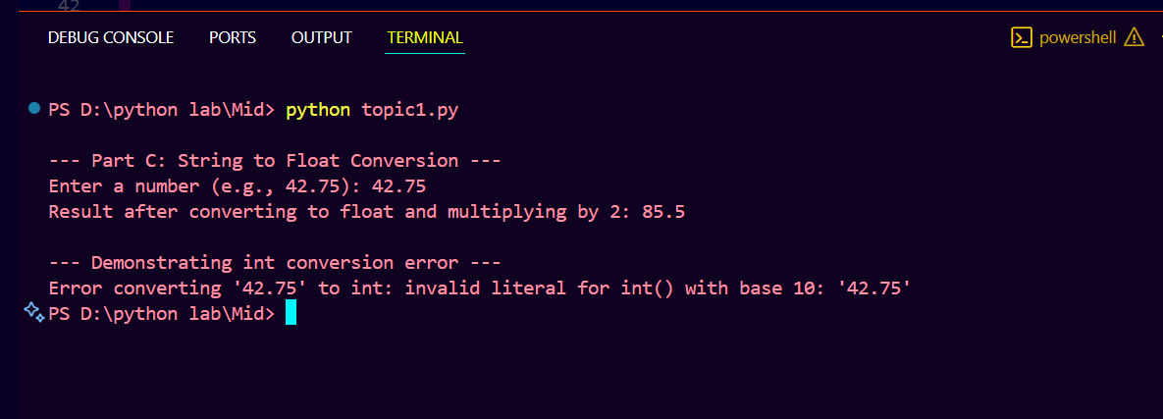 | 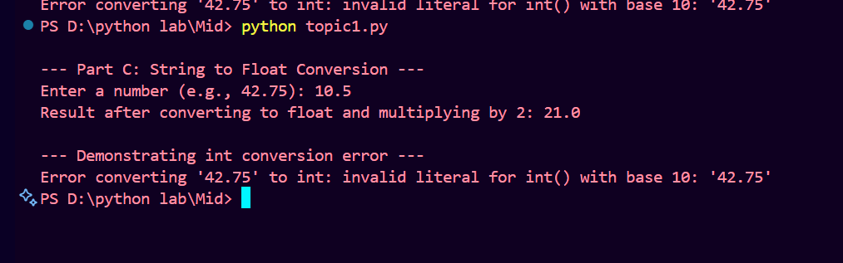

Conclusion:
Topic 1 — Python Basics, Variables & Operators In this topic, I learned how to declare variables of different data types such as string, integer, float, and boolean in Python. I also practiced taking user input and displaying formatted output using f-strings. The arithmetic calculator helped me understand all basic operators including floor division and modulus. In real life, these concepts are used in every program — from simple calculators to large-scale applications that process user data.

Topic 2 Conditions and Loops
Tools / Platform | Python 3 — .py file + Word report
Lab | Lab 2 – Conditions (if/elif/else), Loops (for, while)
Submit | Word report (code + output screenshots) + Source: topic2.py

Part A — Grade Classifier ()
- Ask the user to enter marks for 3 subjects. Compute the average.
- Using if/elif/else, classify the grade: A (>=80), B (>=65), C (>=50), D (>=40), F (<40).
- Print: 'Your average is [avg]. Your grade is [grade].' Also print a motivational message for each grade level.

Source Code:

# Part A: IQRA Grading Scale
# Part A: Grade Classifier

print("--- Part A: Three Subject Grading ---") # duplicate print hata diya

subjects = ["Subject 1", "Subject 2", "Subject 3"]
marks = []

for sub in subjects:
mark = float(input(f"Enter marks for {sub}: "))
marks.append(mark)

average = sum(marks) / len(marks)

if average >= 80:
grade = "A"
message = "Excellent! You have mastered the material."
elif average >= 65:
grade = "B"
message = "Well done! Keep pushing for higher scores."
elif average >= 50:
grade = "C"
message = "Good effort, but there is room for improvement."
elif average >= 40:
grade = "D"
message = "You passed, but consider reviewing the material."
else:
grade = "F"
message = "Don't give up! Seek help to improve your scores."

print(f"Your average is {average:.2f}. Your grade is {grade}.")
print(f"Message: {message}")
Output:

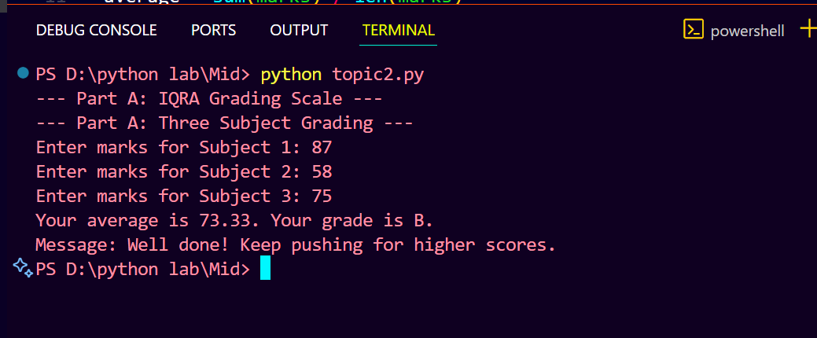

Part B — Number Pattern with For Loop ()
- Ask the user for a number N. Using range() and a for loop, print all numbers from 1 to N.
- Next to each number, print EVEN or ODD. At the end, print the count of even and odd numbers.

Source Code:
print("\n--- Part B: Even or Odd Iterator ---")
n = int(input("Enter a number (N) to iterate up to: "))
even_count = 0
odd_count = 0
for i in range(1, n + 1):
if i % 2 == 0:
status = "EVEN"
even_count += 1
else:
status = "ODD"
odd_count += 1
print(f"{i} is {status}")
print(f"Total even numbers: {even_count}")
print(f"Total odd numbers: {odd_count}")

Output:

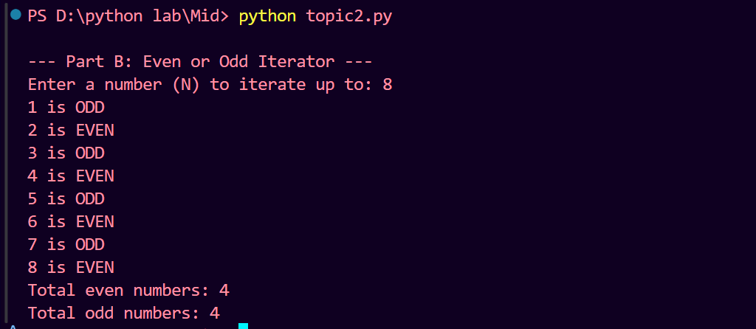 | 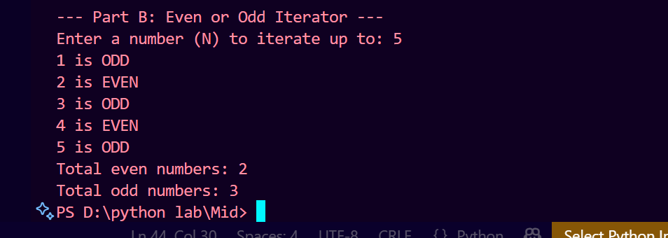

Part C — While Loop with Validation ()
- Ask the user to guess a number between 1 and 10 (the correct answer is 7). Use a while loop.
- If wrong: print 'Too high!' or 'Too low!' depending on the guess. If correct: print 'Correct! You got it in [X] attempts.' and break.

Source Code:
print("\n--- Part C: Number Guessing Game ---")
target = 7
attempts = 0
guess = None
while guess != target:
guess = int(input("Guess the number (between 1 and 10): "))
attempts += 1
if guess < target:
print("Too low! Try again.")
elif guess > target:
print("Too high! Try again.")
else:
print(f"Correct! You got it in {attempts} attempts.")

Output:
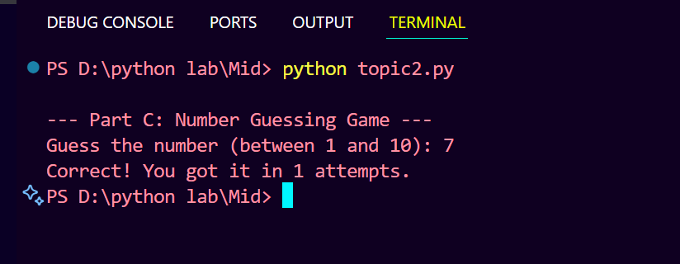 | 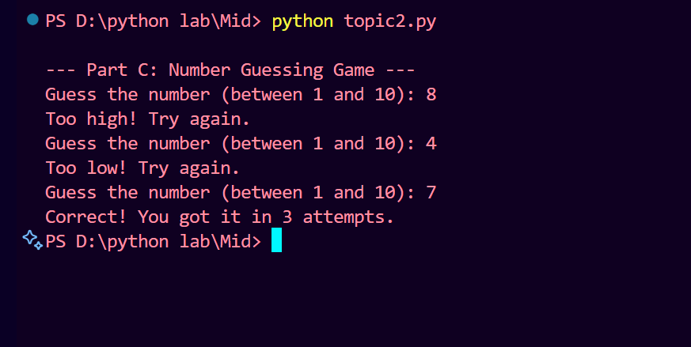
Conclusion:
Topic 2 — Conditions and Loops In this topic, I learned how to use if/elif/else conditions to make decisions in a program, which is similar to how we make decisions in real life. For loops helped me iterate over a range of numbers efficiently, while the while loop taught me how to repeat actions until a condition is met. The guessing game showed me how loops and conditions work together. These concepts are used in real-world applications like login systems, grade calculators, and game development.

Topic 3 Lists and Tuples
Tools / Platform | Python 3 — .py file + Word report
Lab | Lab 3 – Lists, Tuples, list operators, insert/remove/sort/search
Submit | Word report (code + output screenshots) + Source: topic3.py

Part A — Student Marks List (8 marks)
- Create a list called marks with 6 student marks of your choice (between 40 and 100).
- Demonstrate ALL of the following operations — print the result after EACH step with a label:
- (i) Print the full list (ii) Access marks[0] and marks[-1] (iii) Slice marks[1:4] (iv) Append 88 (v) Insert 95 at index 2 (vi) Remove the lowest mark (vii) Sort in ascending order (viii) Sort in descending order (ix) Find the index of mark 95 (x) Print len(marks)

Source Code:

# Topic 3: Lists and Tuples

# Part A: Student Marks List
print("--- Part A: Student Marks List ---")
# 1. Original list
marks = [75, 45, 90, 60, 35, 82]
print(f"1. Original list: {marks}")

# 2. First and last elements
print(f"2. First element (marks[0]): {marks[0]}")
print(f" Last element (marks[-1]): {marks[-1]}")

# 3. Slice marks[1:4]
print(f"3. Slice marks[1:4]: {marks[1:4]}")

# 4. Append 88
marks.append(88)
print(f"4. After appending 88: {marks}")

# 5. Insert 95 at index 2
marks.insert(2, 95)
print(f"5. After inserting 95 at index 2: {marks}")

# 6. Remove the lowest mark
lowest = min(marks)
marks.remove(lowest)
print(f"6. After removing the lowest mark ({lowest}): {marks}")

# 7. Sort ascending
marks.sort()
print(f"7. After sorting ascending: {marks}")

# 8. Sort descending (reverse)
marks.sort(reverse=True)
print(f"8. After sorting descending: {marks}")

# 9. Index of 95
index_95 = marks.index(95)
print(f"9. Index of 95: {index_95}")

# 10. Length of the list
print(f"10. Length of list: {len(marks)}")

Output:
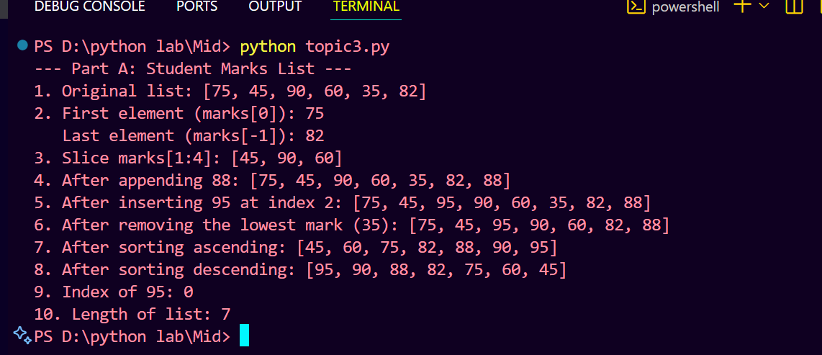

Part B — Tuple Basics ()
- Create a tuple: student = ('Ali Ahmed', 20, 'Computer Science', 3.75)
- Access and print: student's name (index 0), program (index 2). Demonstrate that tuples are immutable —
- try student[0] = 'New Name' and show the TypeError in your screenshot.

Source Code:
# Part B: Tuple Immutability
print("\n--- Part B: Tuple Immutability ---")
student = ('Ali Ahmed', 20, 'Computer Science', 3.75)
print(f"Student name: {student[0]}")
print(f"Program: {student[2]}")
try:
# Attempt to modify the tuple (should raise TypeError)
student[0] = 'New Name'
except TypeError as e:
print(f"Error captured when trying to modify tuple: {e}")
Output:

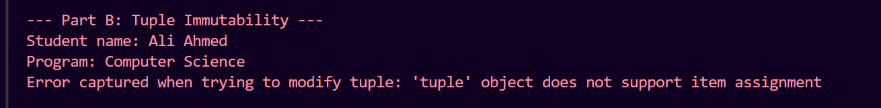
Part C — List Comprehension (3 marks)
- Using list comprehension, create a new list of only the marks that are >= 60 from your marks list.
- Create another list comprehension that squares every mark in the original list. Print both results.

Source Code:
# # Part C: List Comprehensions
print("\n--- Part C: List Comprehensions ---")
marks = [75, 45, 90, 60, 35, 82]
# Marks >= 60
passed_marks = [m for m in marks if m >= 60]
print(f"Marks >= 60: {passed_marks}")
# Square of all marks
squared_marks = [m**2 for m in marks]
print(f"Squares of all marks: {squared_marks}")

Output:

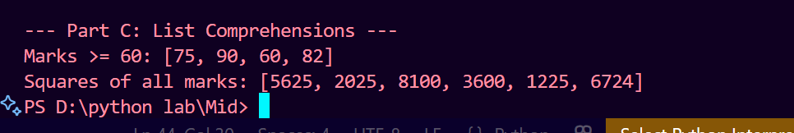

Conclusion:

Topic 3 — Lists and Tuples In this topic, I learned how to store and manage collections of data using lists and tuples. I practiced operations like append, insert, remove, sort, and slice, which are very useful for handling real-world data. List comprehension taught me how to write clean and efficient code in fewer lines. The difference between lists and tuples — that tuples are immutable — is an important concept used in situations where data should not be changed, like storing fixed configuration values.

Topic 4 Dictionaries and Sets
Tools / Platform | Python 3 — .py file + Word report
Lab | Lab 4 – Dictionaries, Sets, CRUD operations, traversal
Submit | Word report (code + output screenshots) + Source: topic4.py

Part A — Student Grade Book (Dictionary) (9 marks)
- Create a dictionary called gradebook where keys are student names and values are their marks (add 5 students with marks of your choice).
- Demonstrate ALL of these operations — print the state of the dict after EACH change:
- (i) Print all keys (ii) Print all values (iii) Print all key-value pairs using .items() (iv) Add a new student (v) Update an existing student's mark (vi) Delete one student using del (vii) Check if 'Ali' is in the dictionary (viii) Use .get() to safely access a key that doesn't exist (show it returns None instead of error)

Source Code:
# Part A: Student Gradebook Dictionary
print("--- Part A: Student Gradebook ---")
# A dictionary with 5 student names as keys and their grades as values
gradebook = {
"Sharjeel": 85,
"Ali": 90,
"Raza": 78,
"Umar": 88,
"Saqib": 92
}
print(f"Initial gradebook: {gradebook}")
# Print all keys, values, and items explicitly
print(f"Keys: {list(gradebook.keys())}")
print(f"Values: {list(gradebook.values())}")
print(f"Items: {list(gradebook.items())}")
# Adding a new student
gradebook["Hamza"] = 81
print(f"After adding Hamza: {gradebook}")
# Updating an existing student's grade
gradebook["Sharjeel"] = 95
print(f"After updating Sharjeel's grade: {gradebook}")
# Deleting a student record
del gradebook["Raza"]
print(f"After deleting Raza: {gradebook}")
# Check if a specific key exists
key_to_check = "Ali"
print(f"Does '{key_to_check}' exist in gradebook? {key_to_check in gradebook}")
# Using .get() for a missing student — returns None instead of raising an error
student = "Grace"
score = gradebook.get(student) # No default value, so returns None if key not found
print(f"Score for {student}: {score}")

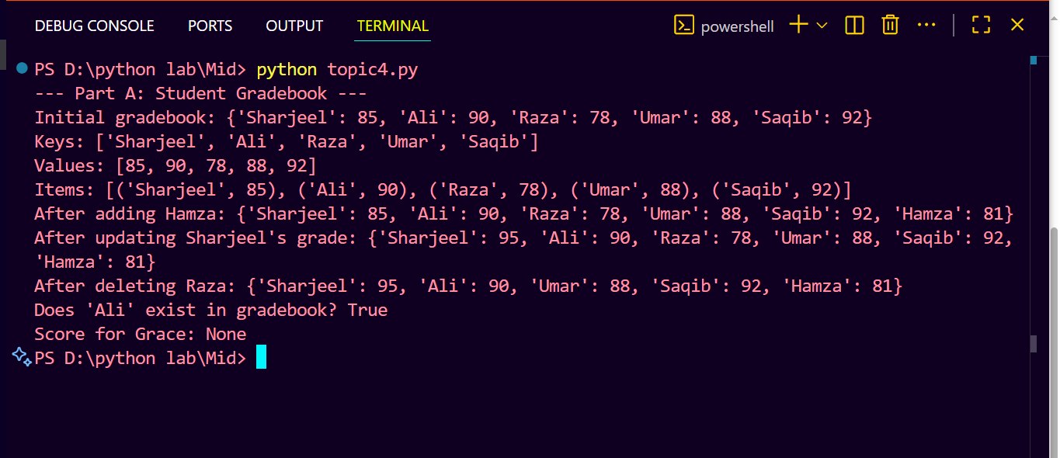

Part B — Set Operations ()
- Create two sets: subjects_A = {'Math', 'Python', 'Physics', 'English'} and subjects_B = {'Math', 'Chemistry', 'Python', 'Biology'}
- Find and print with clear labels: Union (|), Intersection (&), Difference A-B, Difference B-A, Symmetric Difference (^).
- Explain in a comment what each operation means in plain English.

Source Code:
# # Part B: Set Operations
print("\n--- Part B: Set Operations ---")
# Define the exact subject sets as required
subjects_A = {'Math', 'Python', 'Physics', 'English'} # Set of subjects offered in curriculum A
subjects_B = {'Math', 'Chemistry', 'Python', 'Biology'} # Set of subjects offered in curriculum B

print(f"subjects_A: {subjects_A}")
print(f"subjects_B: {subjects_B}")

# Union combines all unique elements from both sets (A ∪ B). Demonstrated using both the method and the '|' operator.
union_method = subjects_A.union(subjects_B)
union_operator = subjects_A | subjects_B
print(f"Union (method): {union_method}")
print(f"Union (operator): {union_operator}")

# Intersection finds common elements present in both sets (A ∩ B). Demonstrated using both the method and the '&' operator.
intersection_method = subjects_A.intersection(subjects_B)
intersection_operator = subjects_A & subjects_B
print(f"Intersection (method): {intersection_method}")
print(f"Intersection (operator): {intersection_operator}")

# Difference A - B yields elements in set A that are not in set B. Demonstrated using both the method and the '-' operator.
difference_AB_method = subjects_A.difference(subjects_B)
difference_AB_operator = subjects_A - subjects_B
print(f"Difference A-B (method): {difference_AB_method}")
print(f"Difference A-B (operator): {difference_AB_operator}")

# Difference B - A yields elements in set B that are not in set A. Demonstrated using both the method and the '-' operator.
difference_BA_method = subjects_B.difference(subjects_A)
difference_BA_operator = subjects_B - subjects_A
print(f"Difference B-A (method): {difference_BA_method}")
print(f"Difference B-A (operator): {difference_BA_operator}")

# Symmetric Difference gives elements that are in either set but not in both (A Δ B). Demonstrated using both the method and the '^' operator.
sym_diff_method = subjects_A.symmetric_difference(subjects_B)
sym_diff_operator = subjects_A ^ subjects_B
print(f"Symmetric Difference (method): {sym_diff_method}")
print(f"Symmetric Difference (operator): {sym_diff_operator}")

Output:

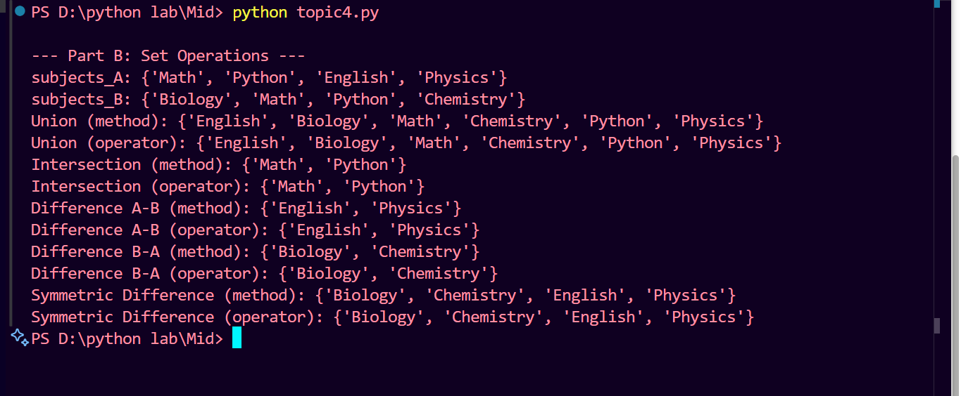
Conclusion:
Topic 4 — Dictionaries and Sets In this topic, I learned how dictionaries store data as key-value pairs, which is similar to a real-life phonebook or student record system. I practiced adding, updating, deleting, and safely accessing dictionary entries using .get(). Set operations like union, intersection, and difference taught me how to compare and combine groups of data. These concepts are widely used in databases, search systems, and data analysis applications.

Topic 5 String Manipulation
Tools / Platform | Python 3 — .py file + Word report
Lab | Lab 5 – Strings: indexing, slicing, methods
Submit | Word report (code + output screenshots) + Source: topic5.py

Part A — String Methods Explorer (8 marks)
- Create a variable: sentence = ' Hello, Welcome to Python Programming! '
- Apply and print the result of ALL of these methods with labels:
- (i) strip() (ii) lower() (iii) upper() (iv) title() (v) replace('Python', 'Advanced Python') (vi) split(',') (vii) find('Welcome') (viii) count('o') (ix) startswith('Hello') (x) endswith('!')

Source Code:
# Part A – Demonstrate common string methods

sentence = " Hello, Welcome to Python Programming! "

print("Original:", repr(sentence))
print("strip():", sentence.strip())
print("lower():", sentence.lower())
print("upper():", sentence.upper())
print("title():", sentence.title())
print("replace('Python', 'Advanced Python'):", sentence.replace('Python', 'Advanced Python'))
print("split(','):", sentence.split(','))
print("find('Welcome'):", sentence.find('Welcome'))
print("count('o'):", sentence.count('o'))

stripped = sentence.strip()
print("startswith('Hello'):", stripped.startswith('Hello'))
print("endswith('!'):", stripped.endswith('!'))

Output:

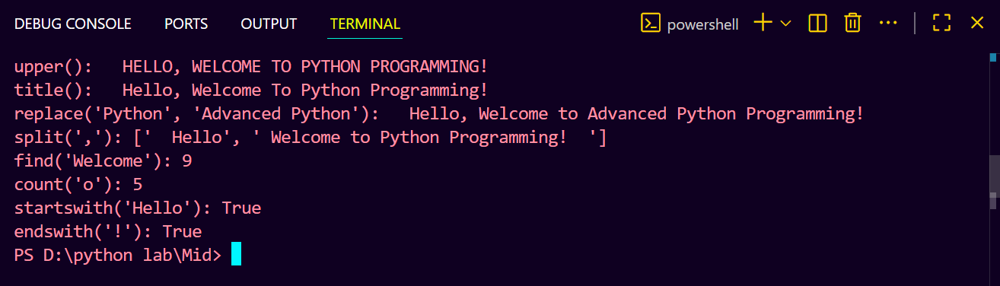

Part B — Indexing and Slicing ()
- Given: word = 'PROGRAMMING'
- Print: first character, last character, characters at index 3 to 7 (slice), every other character (step 2), and the word reversed using slicing [::-1].

Source Code:

word = 'PROGRAMMING'
print('First character:', word[0])
print('Last character:', word[-1])
print('Slice from index 3 to 7 (inclusive of 3, exclusive of 7):', word[3:7])
print('Every other character (step 2):', word[::2])
print('Reversed word:', word[::-1])

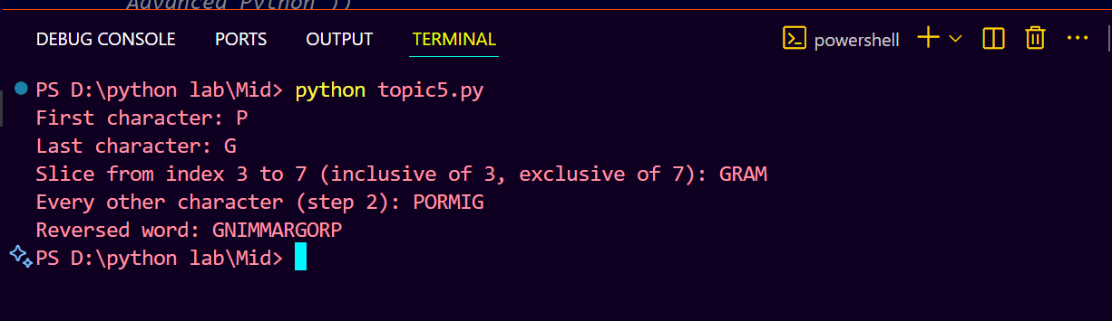

Part C — String to Number Conversion (3 marks)
- Ask the user to enter a price as a string (e.g., '1499.99'). Convert to float. Apply a 10% discount and print the discounted price formatted to 2 decimal places using f-strings.
Source Code:
# Part C – Price input, discount, and formatted display
price_input = input('Enter the original price: ')
try:
price = float(price_input)
discounted = price * 0.9 # Apply a 10% discount
print(f'Discounted price: ${discounted:.2f}')
except ValueError:
print('Invalid price entered. Please provide a numeric value.')

Output

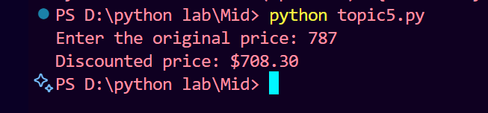

Conclusion:
Topic 5 — String Manipulation In this topic, I learned how to work with strings using various built-in methods like strip, upper, lower, replace, split, and find. Indexing and slicing showed me how to access specific parts of a string efficiently. Converting strings to numbers and applying discounts taught me practical type conversion skills. String manipulation is used everywhere in real life — from processing user input in forms to formatting reports and messages in applications.

Topic 6 Functions — Define, Call, Return
Tools / Platform | Python 3 — .py file + Word report
Lab | Lab 3 & 4 tasks involving functions — apply what you know
Submit | Word report (code + output screenshots) + Source: topic6.py

Note: Functions are not a separate lab session in Labs 1–5, but writing functions is expected from Lab 3 onward. This topic tests your ability to organise code into reusable functions.

Part A — Build 4 Simple Functions
- Write FOUR functions (2. each) — each must have a docstring comment explaining what it does:
- calculate_average(marks_list) → takes a list of marks, returns the average as a float rounded to 2 decimal places.
- find_highest(marks_list) → takes a list of marks, returns the highest mark WITHOUT using the max() built-in.
- count_passed(marks_list, pass_mark) → takes a list and a pass threshold, returns how many students passed.
- format_result(name, average) → takes a student name and average, returns the string: 'Student: [name] | Average: [avg] | Grade: [A/B/C/D/F]'

Source Code:
Part B — Call All Functions
- Create a list: marks = [72, 85, 45, 90, 63, 38, 78, 55]
- Call all four functions with this list and print their outputs clearly labelled.
- For format_result(), call it for two different students with different averages to show grade changes.

Source Code:
# topic6.py – Student marks utilities

# ============================================================
# Part A: Define 4 Functions
# ============================================================

def calculate_average(marks_list):
"""Return the average of *marks_list* rounded to two decimal places.
If the list is empty the function returns 0.0.
"""
if not marks_list:
return 0.0
return round(sum(marks_list) / len(marks_list), 2)

def find_highest(marks_list):
"""Return the highest mark from *marks_list* without using max().
If the list is empty the function returns None.
"""
if not marks_list:
return None
highest = marks_list[0]
for mark in marks_list[1:]:
if mark > highest:
highest = mark
return highest

def count_passed(marks_list, pass_mark):
"""Count how many marks are greater than or equal to pass_mark.
Returns an integer count.
"""
count = 0
for mark in marks_list:
if mark >= pass_mark:
count += 1
return count

def format_result(name, average):
"""Return a formatted string showing the student's name, average and grade.
The grade is derived from the average using a simple scale:
>=80 -> A, >=65 -> B, >=50 -> C, >=40 -> D, else F.
"""
if average >= 80:
grade = "A"
elif average >= 65:
grade = "B"
elif average >= 50:
grade = "C"
elif average >= 40:
grade = "D"
else:
grade = "F"
return f"Student: {name} | Average: {average:.2f} | Grade: {grade}"

# ============================================================
# Part B: Call All Functions
# ============================================================

if __name__ == "__main__":
# Sample marks list as required
marks = [72, 85, 45, 90, 63, 38, 78, 55]

# Call calculate_average
avg = calculate_average(marks)
print(f"Average: {avg}")

# Call find_highest
highest = find_highest(marks)
print(f"Highest mark: {highest}")

# Call count_passed
passed_count = count_passed(marks, pass_mark=40)
print(f"Number passed (>=40): {passed_count}")

# Call format_result for two different students to show grade changes
print(format_result("Ali", avg))
print(format_result("Sharjeel", 90))
Output:

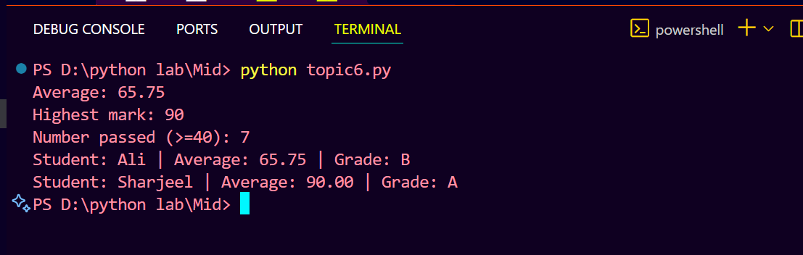

Conclusion:
Topic 6 — Functions In this topic, I learned how to define reusable functions with parameters and return values, which makes code organized and easier to maintain. Writing docstrings taught me the importance of documenting code so others can understand it. The four functions I wrote — calculate_average, find_highest, count_passed, and format_result — showed me how to break a large problem into smaller, manageable pieces. In real life, functions are the building blocks of every software application and help avoid code repetition.

Topic 7 Mini Project — Student Report Card
Tools / Platform | Python 3 — .py file + Word report
Labs | Combines ALL Labs 1–5: data types, loops, lists, dicts, strings, conditions
Submit | Word report (code + output screenshots) + Source: topic7.py

This is the integration topic — it tests whether you can combine concepts from all 5 labs into one working program.

Scenario — Read carefully:
Build a simple Student Report Card Generator. The program stores marks for students, computes grades, and displays a formatted report.

Part A — Data Entry ()
- Ask the user to enter: student name (string) and marks for 4 subjects: Math, Python, Physics, English (all integers).
- Store the marks in a dictionary: student = {'name': name, 'Math': m, 'Python': p, 'Physics': ph, 'English': e}
- Validate each mark: if the entered value is not between 0 and 100, keep asking until a valid mark is entered (use a while loop with try/except for non-number input).

Part B — Computation ()
- Compute: total = sum of all 4 subject marks. Calculate: average = total / 4.
- Using if/elif/else, determine the grade: A (>=80), B (>=65), C (>=50), D (>=40), F (<40).
- Find the highest subject and the lowest subject from the dictionary values using a loop (no max() or min() built-in allowed).

Part C — Formatted Report (8 marks)
- Print a clearly formatted report card using f-strings and string methods. The report must include:
- Student name (in Title Case using .title()), each subject with its mark, the total, average (2 decimal places), final grade, highest subject, lowest subject, and a personalised message based on the grade (e.g., 'Excellent work!' for A, 'Keep it up!' for B, 'You need to improve.' for F).
- Use = or - characters to create visual separators in your output (e.g., a line of ========= above and below the report).

Source Code:

# topic7.py – Student Report Card Generator

"""Interactive script that collects a student's marks for a set of subjects
and prints a formatted report card.

Features implemented per assignment requirements:
- Average calculated and displayed with two-decimal precision
- Final grade obtained via the get_grade helper
- Highest and lowest subject/mark identified without using max/min
- Personalized message based on the grade
- Visual separators made of = and - characters
- Clean, well-commented sections for readability
"""

# ------------------------------------------------------------
# Helper functions
# ------------------------------------------------------------

def get_grade(average: float) -> str:
"""Return a letter grade for average using the standard scale.

- A : average >= 80
- B : 65 <= average < 80
- C : 50 <= average < 65
- D : 40 <= average < 50
- F : average < 40
"""
if average >= 80:
return "A"
elif average >= 65:
return "B"
elif average >= 50:
return "C"
elif average >= 40:
return "D"
else:
return "F"

def personalized_message(grade: str) -> str:
"""Return a brief message tailored to the supplied grade."""
messages = {
"A": "Excellent work! Keep it up.",
"B": "Well done! A little more effort for an A.",
"C": "Good effort, but there is room for improvement.",
"D": "You passed, consider reviewing the material.",
"F": "You need to improve. Seek help and keep practicing.",
}
return messages.get(grade, "")

# ------------------------------------------------------------
# Main execution block
# ------------------------------------------------------------

def main() -> None:
print("=" * 40)
print(f"{'Student Report Card Generator':^40}")
print("=" * 40)

# --------------------------------------------------------
# Input collection
# --------------------------------------------------------
name = input("Enter Student Name: ").strip().title()

# Collect marks for each subject with validation
math_mark = None
python_mark = None
physics_mark = None
english_mark = None

for subject, var_name in [("Math", "math_mark"), ("Python", "python_mark"),
("Physics", "physics_mark"), ("English", "english_mark")]:
while True:
try:
raw = input(f"Enter marks for {subject} (0-100): ")
mark = int(raw)
if 0 <= mark <= 100:
if var_name == "math_mark":
math_mark = mark
elif var_name == "python_mark":
python_mark = mark
elif var_name == "physics_mark":
physics_mark = mark
elif var_name == "english_mark":
english_mark = mark
break
else:
print("Error: Marks must be between 0 and 100.")
except ValueError:
print("Error: Please enter a valid numerical value.")

# Store all data in a single dictionary as per requirements
student = {
'name': name,
'Math': math_mark,
'Python': python_mark,
'Physics': physics_mark,
'English': english_mark
}

# --------------------------------------------------------
# Calculations
# --------------------------------------------------------
# Extract only the subject marks (exclude 'name' key)
subject_marks = {k: v for k, v in student.items() if k != 'name'}

total = sum(subject_marks.values())
average = round(total / len(subject_marks), 2) # two-decimal average
grade = get_grade(average)

# Determine highest and lowest subject using a manual loop (no max/min allowed)
first_subj, first_mark = next(iter(subject_marks.items()))
highest_mark = first_mark
highest_subj = first_subj
lowest_mark = first_mark
lowest_subj = first_subj

for sub, mark in list(subject_marks.items())[1:]:
if mark > highest_mark:
highest_mark = mark
highest_subj = sub
if mark < lowest_mark:
lowest_mark = mark
lowest_subj = sub

# --------------------------------------------------------
# Output report
# --------------------------------------------------------
print("\n" + "=" * 40)
print(f"{'STUDENT REPORT CARD':^40}")
print("=" * 40)
print(f"Name: {student['name']}")
print("-" * 40)
for sub, mark in subject_marks.items():
print(f"{sub:<15}: {mark:>7.2f}")
print("-" * 40)
print(f"Total Marks : {total:>7.2f}")
print(f"Average : {average:>7.2f}")
print(f"Highest Mark : {highest_subj} ({highest_mark:>5.2f})")
print(f"Lowest Mark : {lowest_subj} ({lowest_mark:>5.2f})")
print(f"Final Grade : {grade:>5}")
print(f"Message : {personalized_message(grade)}")
print("=" * 40)
print(f"{'PROMOTED' if grade != 'F' else 'RETAINED':^40}")
print("=" * 40)

if __name__ == "__main__":
main()

Output:

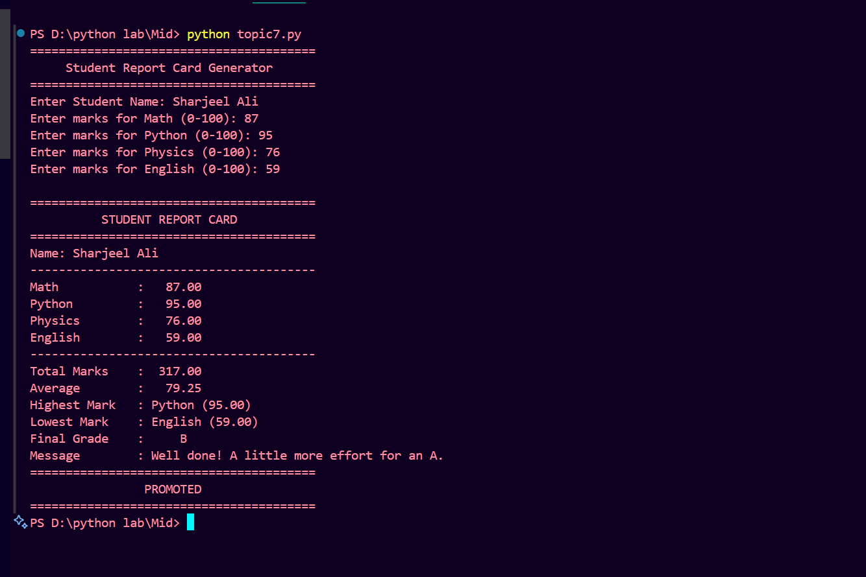

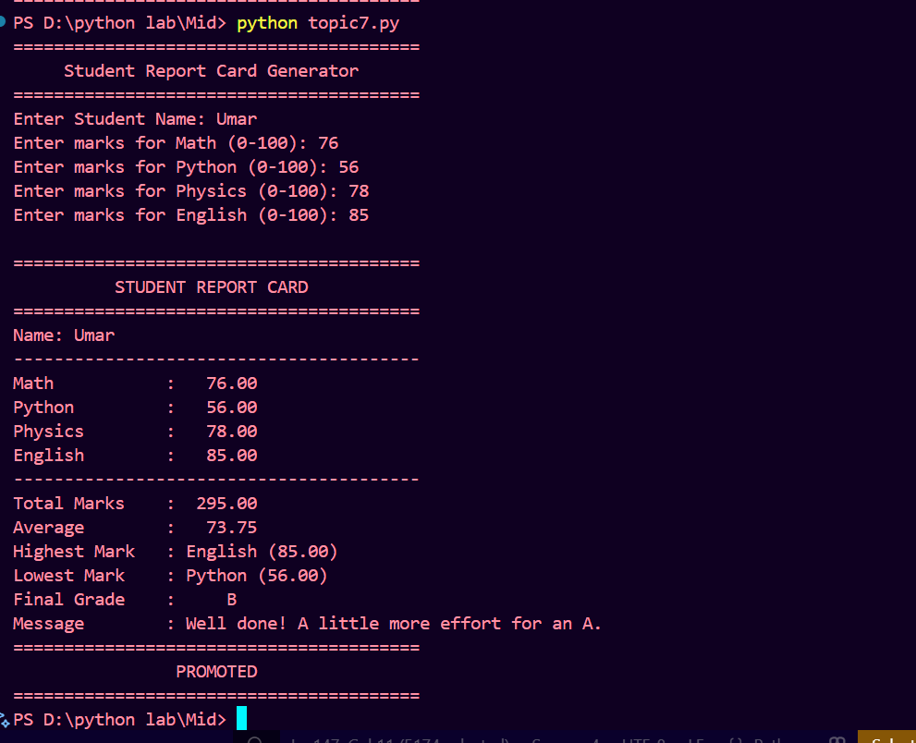

Conclusion:
Topic 7 — Mini Project: Student Report Card In this mini project, I combined all the concepts learned in Labs 1 to 5 into one complete working program. I used dictionaries to store student data, loops for input validation, conditions for grading, and f-strings for formatted output. Building this project gave me confidence that I can design and write a complete Python program from scratch. In real life, such systems are used in schools and universities to automate result processing and generate student report cards efficiently.

Python Marks Summary —

T-1 | T-2 | T-3 | T-4 | T-5 | T-6 | T-7 (Mini Project)

Python Checklist
☐ | Topics 1–6: topic1.py … topic6.py — each submitted as separate .py file
☐ | Topic 7: topic7.py — mini project source file
☐ | ALL Python topics: Word report with code pasted AND output screenshots for at least 2 test runs per topic
☐ | ALL Python topics: 4–6 line conclusion per topic in the Word report

