I want to change the setup skill to
- assume Xomnia as the company. You can even say that in the introduction of the LinkedIn thought leader agent at Xomnia or something. Xomnia is a data and AI consultancy firm based in Amsterdam.
- ask for name and function title or role only, no company name or industry
-

In the process provided by the script to create API keys for Google Sheets and Drive, I followed it, but I had to create an OAuth configuration first, asking for support email addresses etc. make sure to include this in the process steps suggested, I guess before step 3:
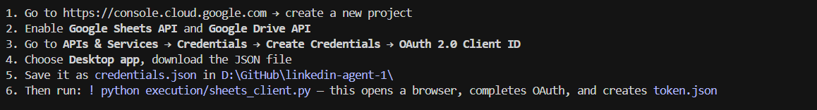
Do not display number 6 here yet, it’s confusing.
instead of asking the user to run a python script, can you make it so that you run it for the user directly.
In the google console, the oauth also needs to be set to External (under Audience) with Testing access, and the user should be added as a test user under
when authenticating Google for your agent, press Proceed here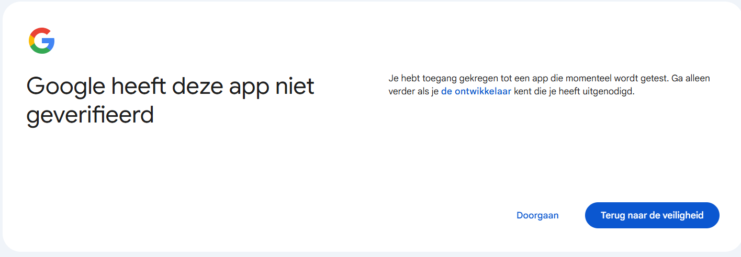

During step 4, assume the user has no google sheet yet and create a new one without asking:
After the .env file is created, the script continues with executing files in the .venv folder, but there is none in the repo. It got it correct, but probably because claude was just smart enough, but can we make this more efficient
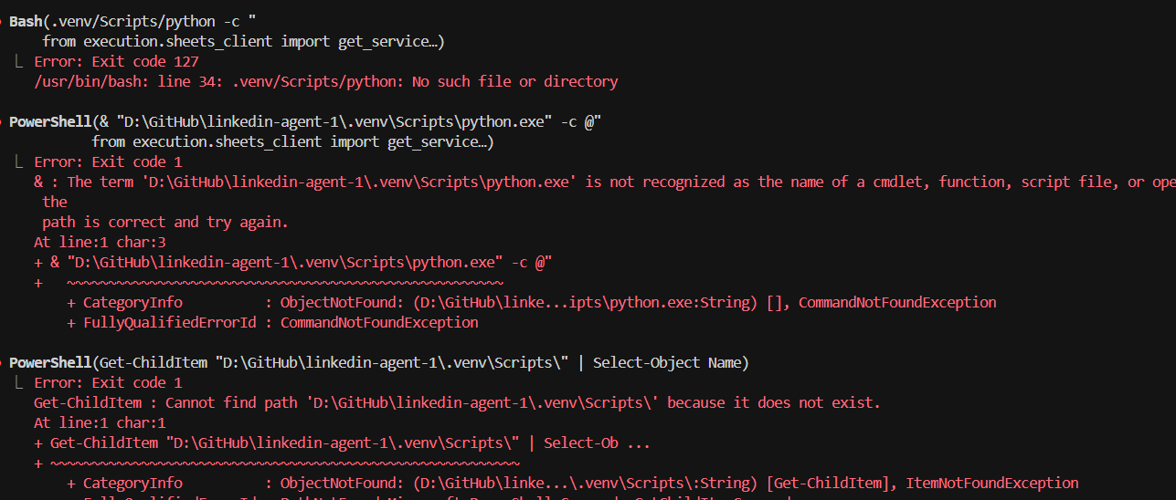
In Step 5, when creating the linkedin App, use the name “Xomnia Thought Leader Agent” instead of “Xomnia LinkedIn Agent” as the agent can’t have the name of LinkedIn in the name. Also it should provide some guidance on the LinkedIn Page URL , by clicking the “create page” button below
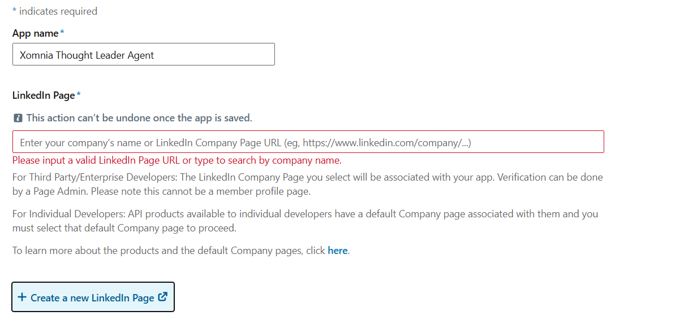
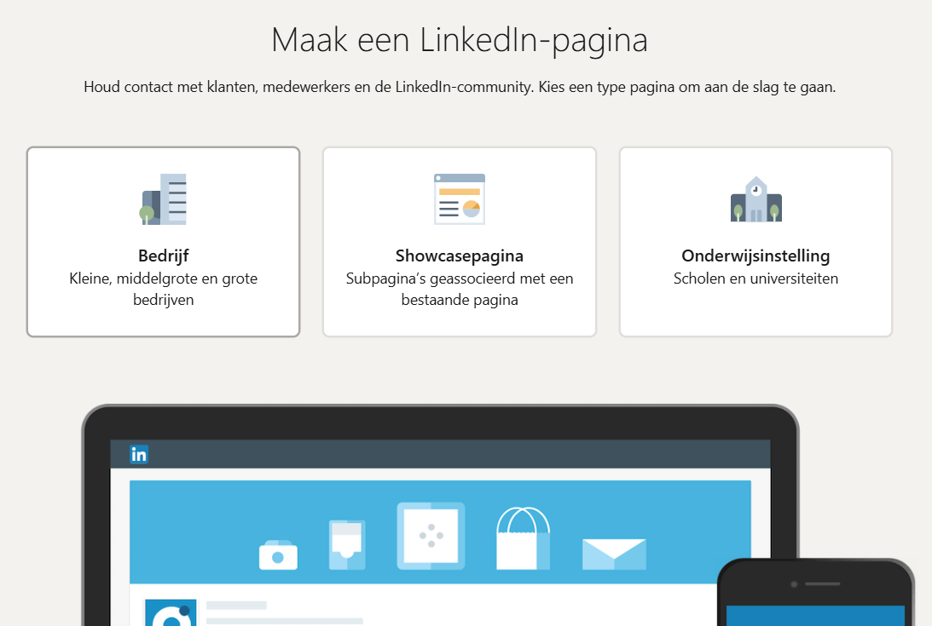
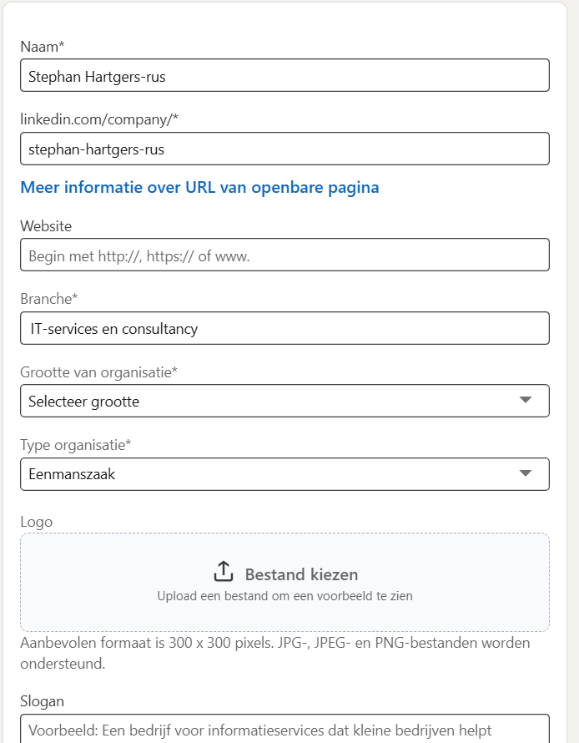

Maybe first help the user to create a company page from the user, so that it’s available at the time it’s needed to create the LinkedIn App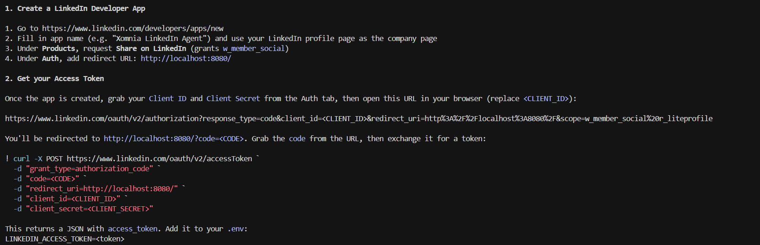

The error in the URL says r_liteprofile scope is not authorized for your app. LinkedIn deprecated r_liteprofile — it's no longer available to new apps.
Remove it from the OAuth URL. You only need w_member_social for posting. Use this URL instead:
https://www.linkedin.com/oauth/v2/authorization?response_type=code&client_id=7861g6ik7cs00j&redirect_uri=http%3A%2F%2Flocalhost%3A8080%2F&scope=w_member_social

This part is too cumbersome, is there an easier way, e.g., providing the client-id and secret in the env file and then claude executing something to trigger the next step, instead of some curl command?
