Python Installation Guide

1. System requirement

Participants should bring their laptop (preferably Windows 7 or higher/ Mac OS installed). 64-bit hardware is preferable.

2. Install Python Distribution

Download Anaconda distribution for **Python 3.6**. The following link has distribution for Windows and Mac OS.

<https://www.anaconda.com/distribution/>

Please install 32-bit or 64-bit distribution as per your OS (Windows or MAC). 64 bit is preferable.

3. Install Additional Components

In Mac: Open Terminal

In Windows: From Programs Menu, select ***Anaconda Command Prompt***

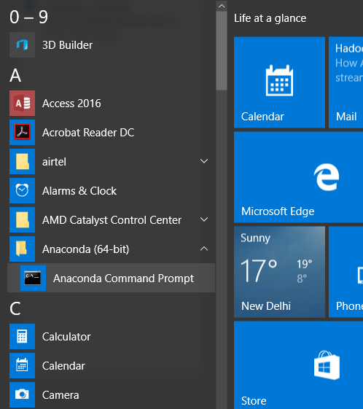

At the terminal prompt, type the following commands

pip install seaborn

pip install tweepy

pip install beautifulsoup4