HR Insights Assistant

Purpose:
An AI-powered HR insights platform that uses a hybrid RAG architecture to query structured employee data and unstructured performance reviews to answer questions and for intelligent reporting to help make faster decisions.

Architecture Diagram:
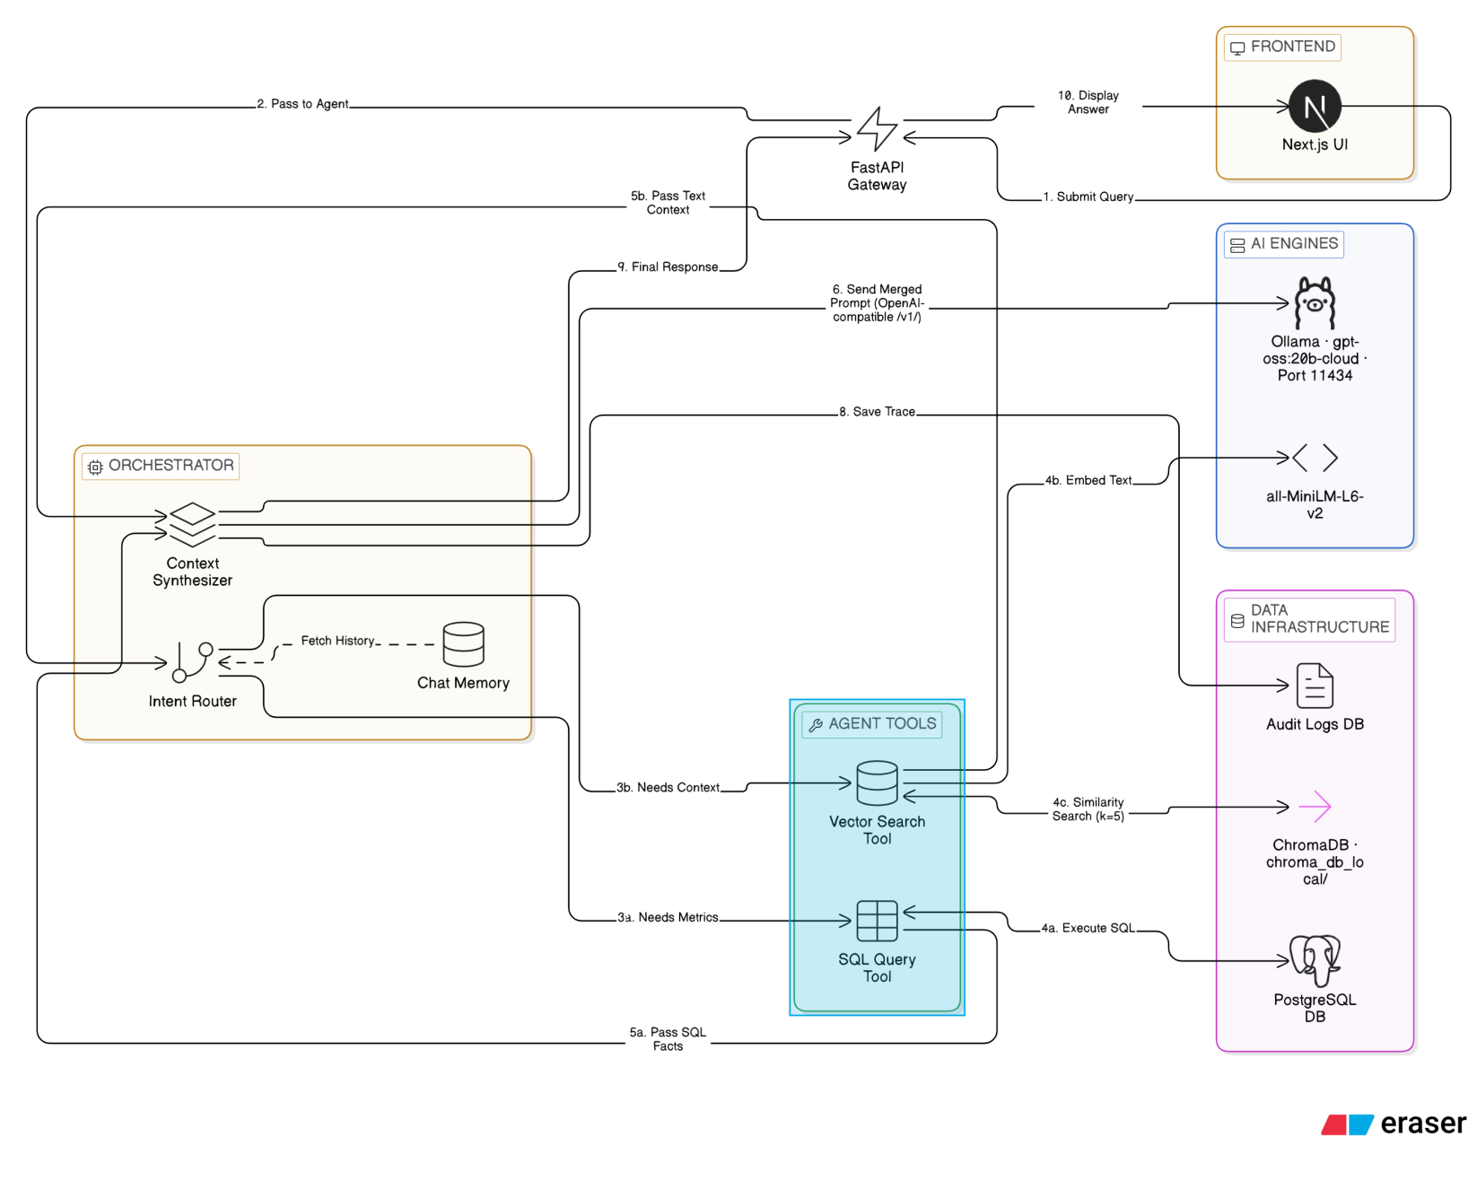
Tech Stack:
Frontend - Next.js 14, React, TypeScript
Backend - FastAPI, Python
Intent Routing - Ollama(gpt-oss:20b-cloud)
SQL Database - PostgreSQL
Vector Store - ChromaDB
Embeddings - HuggingFace (all-MiniLM-L6-v2)
LLM - Mistral-7B-Instruct (LM Studio)

Pre-requisites:
· Python 3.10+
· Node.js 18+
· PostgreSQL 18+
· Ollama account

Core Components:

1. Intent Router(`decide_route()`)
Purpose: Analyzes user question and classifies it into one of three categories.

Categories:
- SQL: Queries about numbers, hours, dates, rates, timesheets (structured data)
- VECTOR: Queries about reviews, feedback, opinions, text summaries (unstructured data)
- BOTH: Hybrid queries requiring both data types

Process:
1. Takes user question as input
2. Sends prompt to Ollama(gpt-oss:20b-cloud)
3. Parses LLM response for category keywords
4. Returns category classification

Example:

Input: "How many hours did John work last week?"
Output: "SQL" (asking for quantitative data)

Input: "What feedback did Sarah receive in her review?"
Output: "VECTOR" (asking for qualitative feedback)

Input: "What are John's total hours and review comments?"
Output: "BOTH" (asking for both types)

2. SQL Module (`text_to_sql_pipeline()`)
Purpose: Converts natural language queries into executable SQL and retrieves structured data.

Table: `employees`
emp_id | INT(PK )
full_name | VARCHAR
role | VARCHAR
department | VARCHAR
manager_name | VARCHAR
date_joined | DATE
email | VARCHAR
annual_salary | DECIMAL
is_active | BOOLEAN

Table: `timesheets`
timesheet_id | INT(PK)
emp_id | INT (FK) → employees.emp_id
week_ending_date | DATE
hours_worked | DECIMAL
overtime_hours | DECIMAL
projects_worked | VARCHAR
status | VARCHAR

Table: ‘billing_finances’
record_id | INT(PK)
emp_id | INT (FK) → employees.emp_id |
pay_period_end | DATE
gross_pay | NUMERIC
tax_deductions | NUMERIC
benefits_deduction | NUMERIC
net_pay | NUMERIC
Currency | VARCHAR(default ‘USD’)

Process:
1. Takes user question and database schema context.
2. Sends to LLM to generate SQL query
3. Executes query against PostgreSQL (Port 5432)
4. Returns structured result: `{ sql_query, columns, rows, error }`

Key Rules:
- No complex subqueries or CTEs.
- No window functions.
- Date filters only applied if user explicitly requests a specific year.
- Simple SELECT, WHERE, GROUP BY, ORDER BY.

Example Output:
json
{
"sql_query": "SELECT full_name, SUM(hours_worked) as total_hours FROM employees JOIN timesheets ON employees.emp_id = timesheets.emp_id GROUP BY full_name",
"columns": ["full_name", "total_hours"],
"rows": [["John Doe", 160], ["Jane Smith", 155]],
"error": null
}

3. Vector Module (`query_vector_db()`)
Purpose: Performs semantic search over embedded documents using ChromaDB.

Data Source: Local ChromaDB instance at `chroma_db_local/`

Embedding Model: `all-MiniLM-L6-v2` (HuggingFace)

Process:
1. Takes user query as input.
2. Converts query to embedding using HuggingFace model.
3. Searches ChromaDB for top 5 most similar documents.
4. Extracts document content and metadata.
5. Returns: `{ context: str, sources: list[str] }`

Example Output:
json
{
"context": "John received excellent feedback on his project management skills… His communication was clear and effective...",
"sources": ["performance_review_2025_1.doc", "performance_review_2025_2.doc"]
}

4. Orchestrator (`process_query()`)
Purpose: Coordinates the entire query flow and synthesizes responses.

Process Flow:

1. decide_route(question)
─ Result: "SQL" | "VECTOR" | "BOTH"

2. Based on route:
─ If "SQL": Execute text_to_sql_pipeline()
─ If "VECTOR": Execute query_vector_db()
─ If "BOTH": Execute both in parallel

3. Aggregate results into evidence object

4. Use LLM to synthesize final response
- Input: Original question + evidence data
- Output: Natural language answer

5. Return structured response:
{
"response_text": "...",
"intent": "SQL" | "VECTOR" | "BOTH",
"evidence": {
"sql_query": "...",
"sql_columns": [...],
"sql_table": [...],
"vector_context": "...",
"vector_sources": [...],
"latency": 1.23
}
}

5. FastAPI Backend (`backend/main.py`)
Purpose: Provides REST API interface for frontend communication.

Endpoint: POST /api/chat
Content-Type: application/json

{
"query": "How many hours has John worked in 2025?"
}

Response:
{
"response_text": "John worked a total of 160 hours in 2025.",
"intent": "SQL",
"evidence": {
"sql_query": "SELECT SUM(hours_worked) FROM timesheets...",
"sql_columns": ["total_hours"],
"sql_table": [[160]],
"vector_context": null,
"vector_sources": null,
"latency": 0.45
}
}

6. Frontend (Next.js - Port 3000)
Purpose: User interface for interacting with the RAG system.

Key Components:
`ChatInterface.tsx`
- Main chat component
- Message history display
- Query input field
- Real-time loading states
- Calls `/api/chat` endpoint

`EvidenceDrawer.tsx`
- Displays SQL results in table format
- Shows vector search results and sources
- Collapsible drawer for evidence inspection

`InsightCard.tsx`
- Formats and displays AI-generated response
- Shows metadata (intent, latency)

Installation:
Step 1: Clone the repository
https://github.com/AndrewRaj0510/Employee_Performance_Reporting.git

Step 2: Create a virtual environment and install all libraries.
python3 -m venv venv
Activate: venv\Scripts\activate (for Windows)
Install libraries: pip install -r requirements.txt
Backend libraries: 1. cd backend
- pip install -r requirements_backend.txt

Step 3: Install node modules for next.js
- cd frontend
- npm install

Step 4: Postgre DB setup
- Navigate to SQL folder - cd SQL
- Configure your database credentials
- DB_CONFIG = {
"dbname": "poc",
"user": "postgres",
"password": "your_password", # ← Update this
"host": "localhost",
"port": "5432"
}
- Run the script - create_tables.py

Step 5: Configure Ollama
- Sign in to your Ollama account: `ollama signin`
- Pull the cloud model: `ollama pull gpt-oss:20b-cloud`
- Confirm the status of the model by running this command ‘ollama list’
- Ollama serves the OpenAI-compatible API automatically at `http://localhost:11434/v1/`.
- API key is not needed as it is a cloud model

Step 6: Vector DB setup
- Navigate to folder Vector_DB - cd Vector_DB.
- OPen chat.py and verify if the ‘OLLAMA URL’ is correct.
- Run chat.py to initialize the vector db.

Step 7: Create audit table
- From the root directory run the below python script to create audit table.
  - python create_audit.py
- Configure DB credentials before running.

Step 8. App start up
- Start the backend server
  - cd backend
  - uvicorn main:app --reload
- Open new terminal
- Start the frontend server
  - cd frontend
  - npm run dev
  - Open http://localhost:3000 to see the UI.

Step 9:
- Test Queries: Ask questions in the UI to test the SQL route, the Vector route, and the Hybrid route.
- What is the feedback Alex has gotten in the month of January?
- What are the total hours worked by Sarah Jenkins in the month of December and how was her performance review?
- Compare the leadership styles of Alex Rivera and David Chen based on their Q4 activities.
- a) Ask SQL query: *"How many hours did John work?"*
- Expected: SQL route, results in table, sources shown
b) Ask Vector query: *"What feedback did John receive?"*
- Expected: VECTOR route, relevant excerpts shown, sources listed
c) Ask hybrid query: *"What are John's total hours and feedback?"*
- Expected: BOTH route, both SQL and Vector results shown.
- Check for outputs and supporting evidence presented.
- Log Verification: Check the audit_logs table in Postgres to ensure the interaction was recorded.
- 4. Verify latency and evidence accuracy

Query Flow Examples
Example 1: SQL Query

User Input: "How many hours did John work in January 2025?"

1. Router Analysis:
→ Query about NUMBERS and DATES → SQL

2. SQL Module:
→ Generates: SELECT SUM(hours_worked) FROM timesheets
WHERE emp_id = (SELECT emp_id FROM employees WHERE full_name = 'John')
AND EXTRACT(MONTH FROM week_ending_date) = 1
AND EXTRACT(YEAR FROM week_ending_date) = 2025
→ Executes against PostgreSQL
→ Returns: 168 hours

3. Evidence Shown:
- SQL Query executed
- Query results in table format

Example 2: Vector Query

User Input: "What were John's strengths mentioned in his review?"

1. Router Analysis:
→ Query about FEEDBACK and OPINIONS → VECTOR

2. Vector Module:
→ Converts query to embedding
→ Searches ChromaDB for similar documents (k=5)
→ Finds: performance_review_2025.pdf
→ Extracts relevant passages about strengths

3. Response Synthesis:
→ LLM generates: "According to his review, John excelled in project management, communication, and team collaboration..."

4. Evidence Shown:
- Relevant excerpts from documents
- Source files and metadata

Example 3: Hybrid Query

User Input: "Show me John's total hours and manager feedback"

1. Router Analysis:
→ Query about both NUMBERS and FEEDBACK → BOTH

2. Execute in Parallel:
a) SQL Module → Gets total hours (168)
b) Vector Module → Finds manager feedback documents

3. Response Synthesis:
→ LLM combines both: "John has logged 168 hours total. His manager noted excellent leadership and communication skills..."

4. Evidence Shown:
- Both SQL and Vector results
- Query results, source metadata shown.

Sample Execution:

