We created three server files which are order server, catalog server and frontend server, the frontend server is the main server which the user will interact with. It will pass operations to the other two servers through the commands.

Database:

We used csv file which stores the data as text ordered by id->title->quantity->price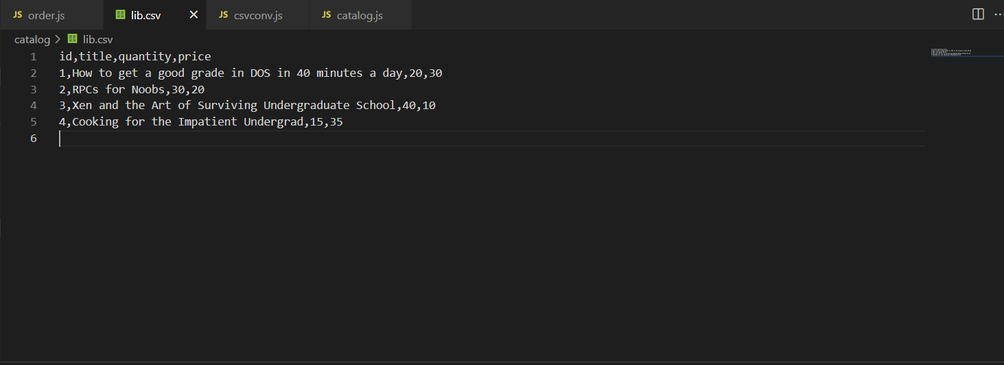

Frontend Server Functions:

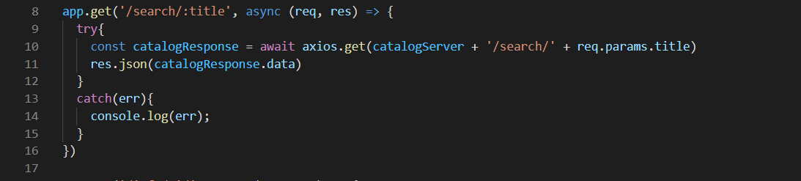

This function will take the input title from the specific format then send the input to the catalog server to process the value using search method which will search for a title of a book.

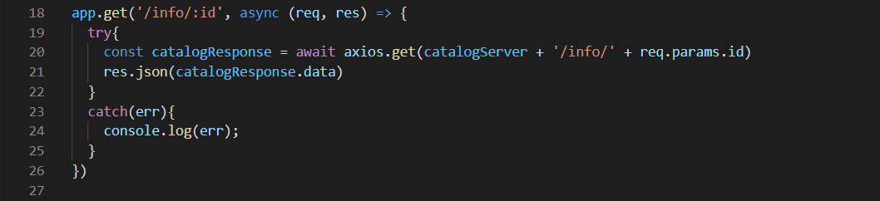

Get the info about a specific book using id which is unique with the format then send the request to the catalog server to process it.

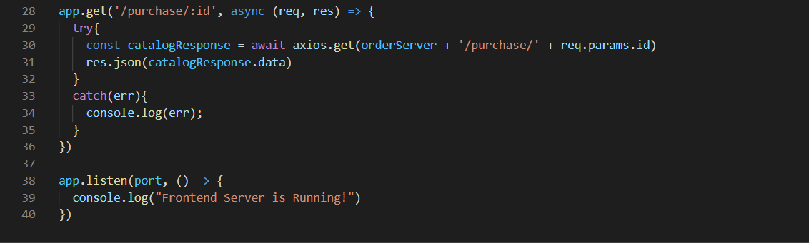

This function will pass the purchase request to order server with the id of the book to let the order server handle the purchase request using the determined format, the request will come from order server.

Catalog Server Functions:

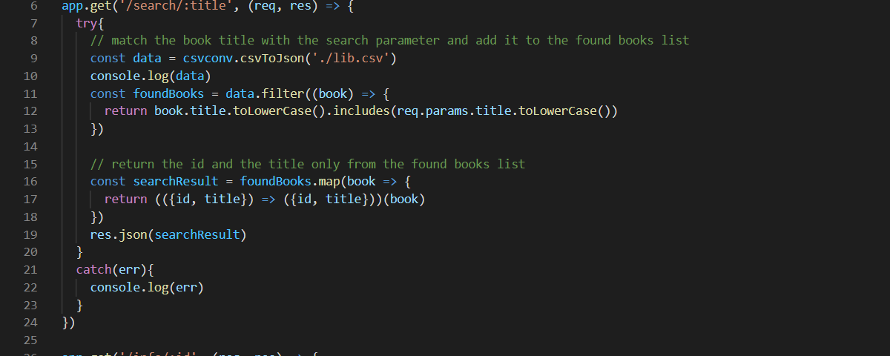

Using the format /search/:title get the title value and search through the csv file for a match with the entered title, if it equals at least one of the titles show the matched title book information if not match return empty message.

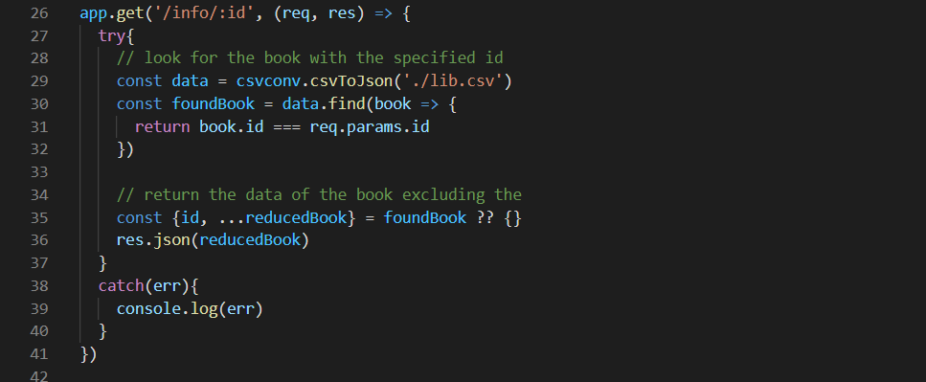

Using info request get search in csv file to a matched id the get all the info about it if exists, if the book with id does not exist print empty message.

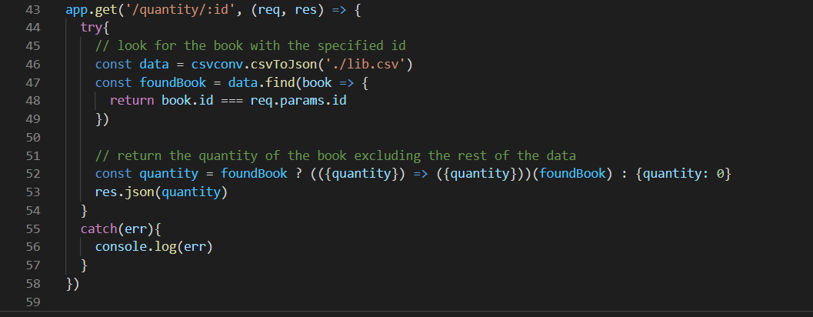

Check the quantity of a book using id if the book exists and the quantity not 0 show the quantity, else show 0.

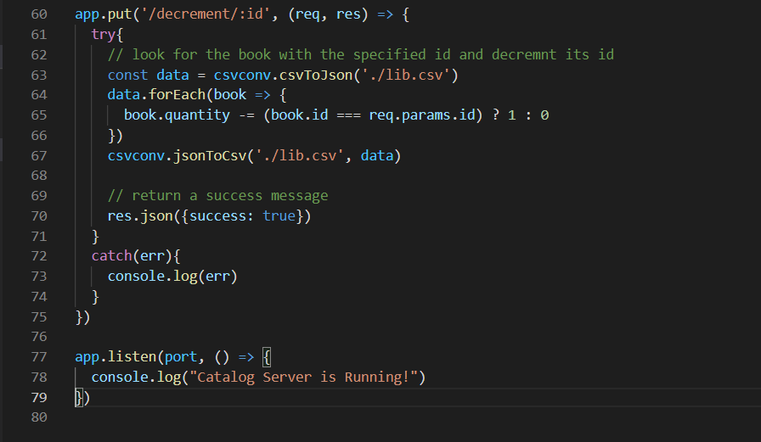

Decrement the quantity of a specific book using id by 1 search in csv file , then search for a match in id then edit the value of quantity.

Order Server Functions:

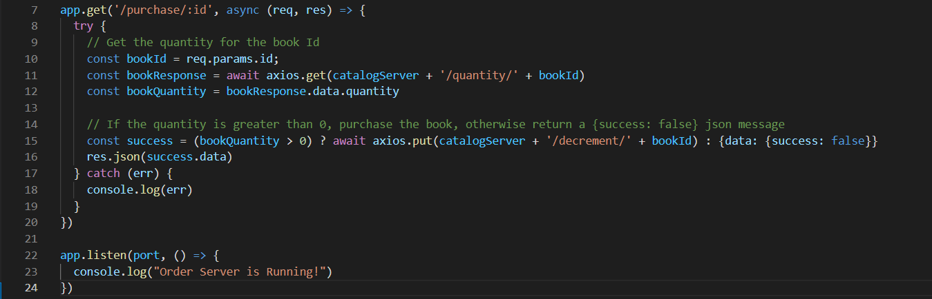

There is only one function which will handle the purchase requests then pass them to catalog server the order server will check the quantity of the book if exists then call the decrement function to decrease the quantity by 1.

Docker Configuration:

We started by creating docker file for each server file and type the following for each file:

Catalog docker file we used port 3002:

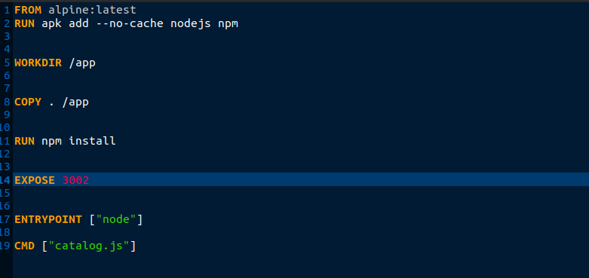

Frontend docker file we used port 3001:

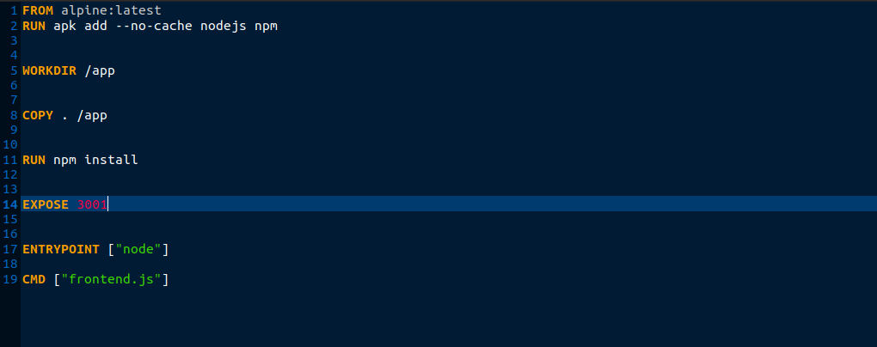

order docker file we used port 3003:

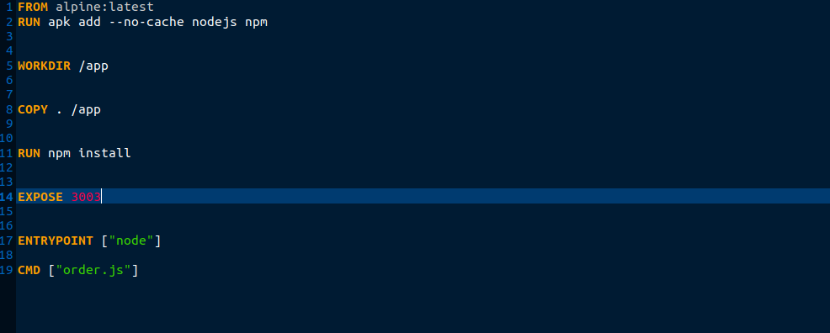

Then we need to run every docker on a different IP address and port by using docker network create commands.

For catalog server we enter: sudo docker network create –subnet 192.168.0.1/16 frontend

Then sudo docker run –dit –net dock –ip 192.168.0.1/16 –p 3002:3002 –name catalog:catalog

For frontend server we enter: docker network create –subnet 192.168.0.3/16 frontend

Then sudo docker run –dit –net dock –ip 192.168.0.2/16 –p 3001:3001 –name fronend:frontend

For order server we enter: docker network create –subnet 192.168.0.2/16 order

Then sudo docker run –dit –net Khalid –ip 192.168.0.1/16 –p 3003:3003 –name order:order

Then we build every docker:

docker build -t catalogImage

docker build -t frontendImage

docker build -t orderImage