**Week 4 Assignment - Week4: Deployment on Flask**

Name: Dmitry Sharukhin

Batch code: LISUM15

Submission date: Nov 23, 2022

Submitted to: Data Glacier

1. Code of Flask app

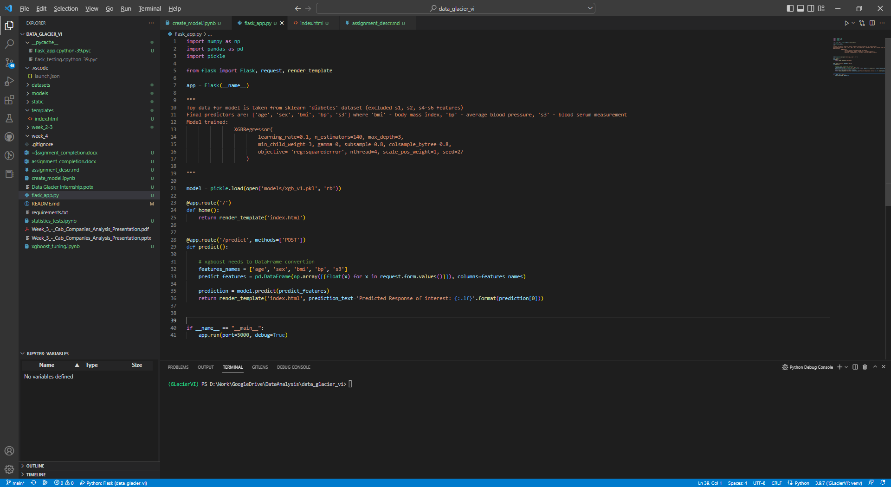

2. Changed index.html (input fields edited)

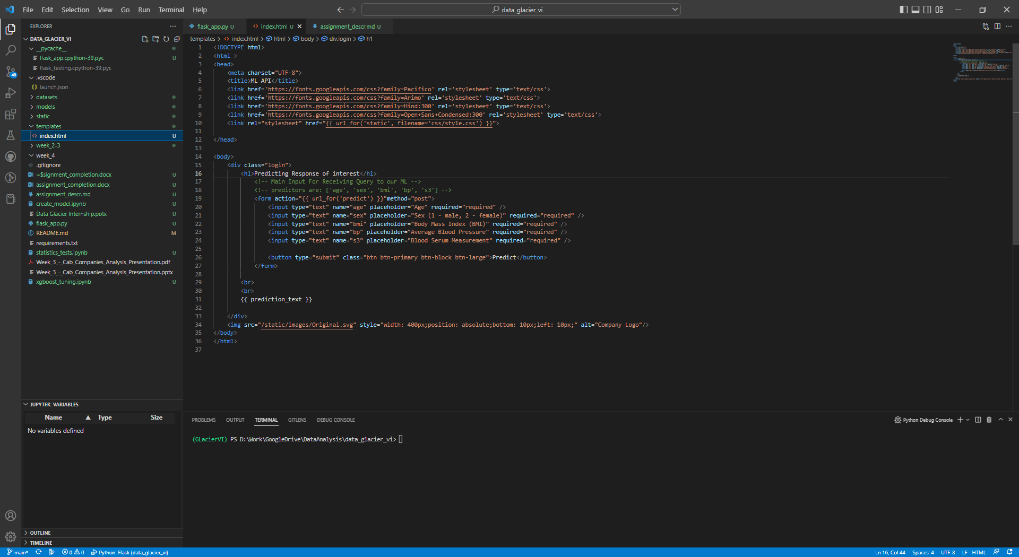

3. Running Flask in debug mode in VisualStudioCode

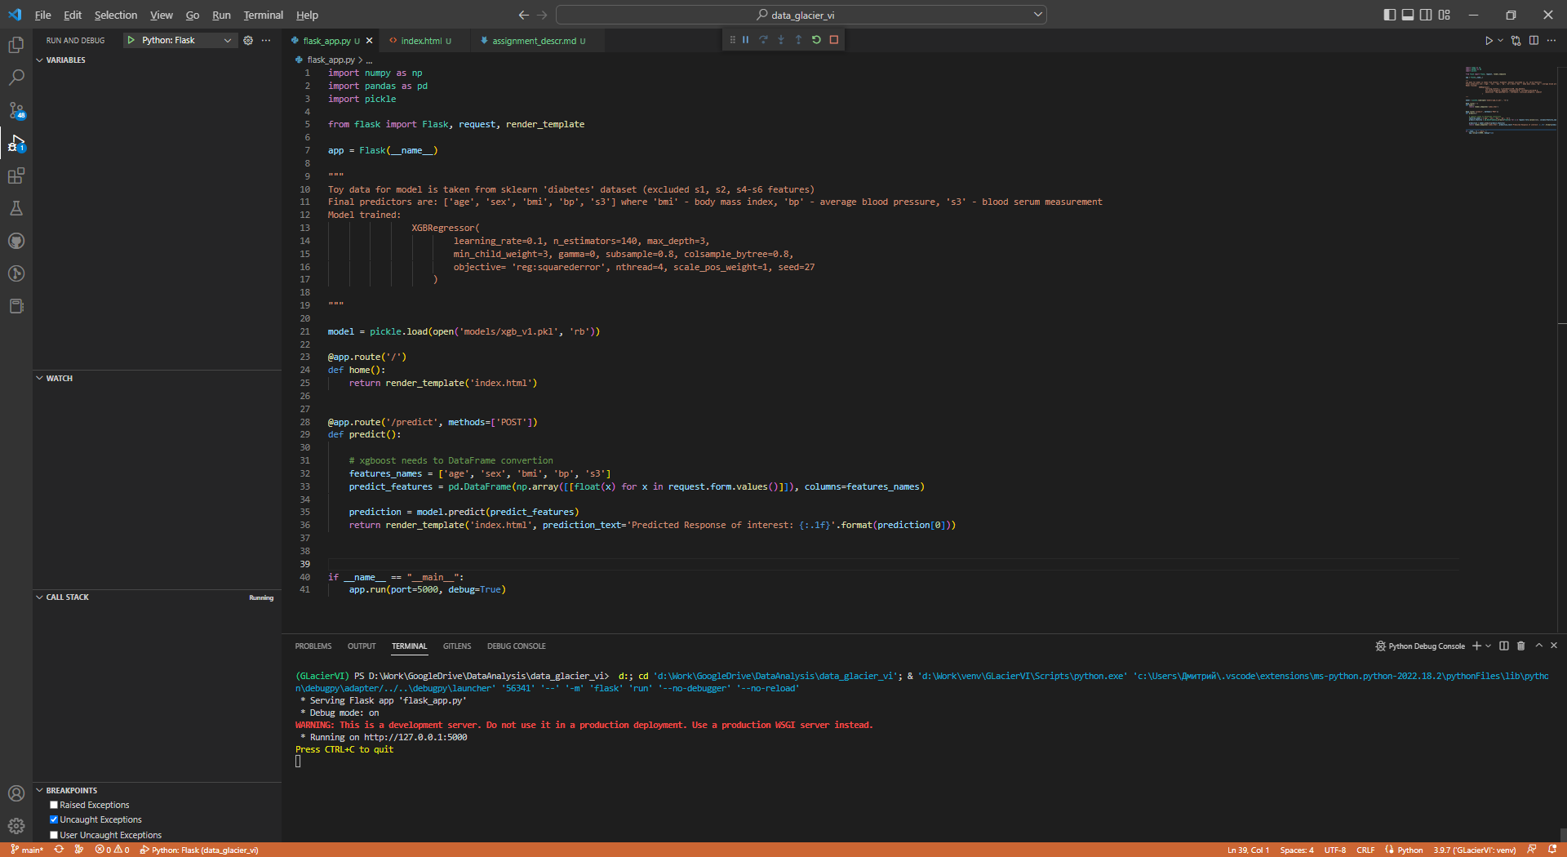

4. Running app homepage

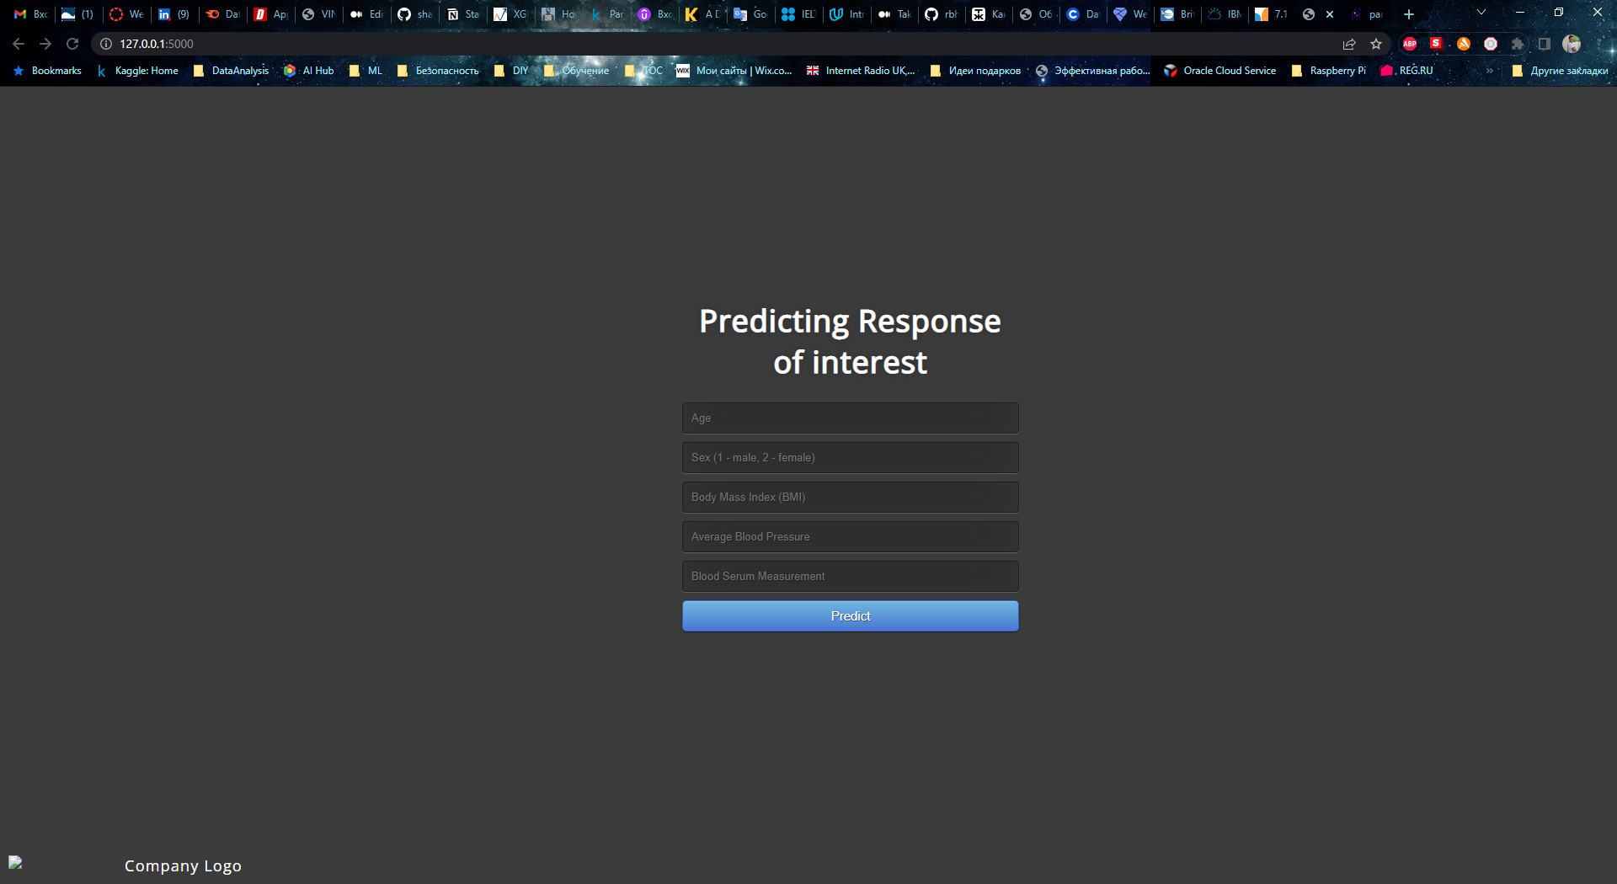

5. Filling test data

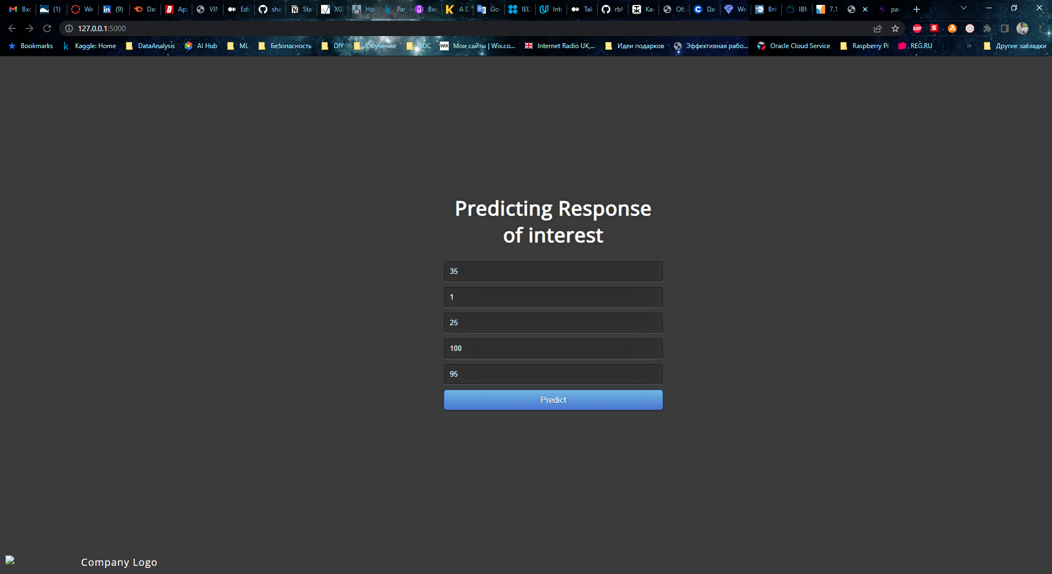

6. Prediction result shown on web page

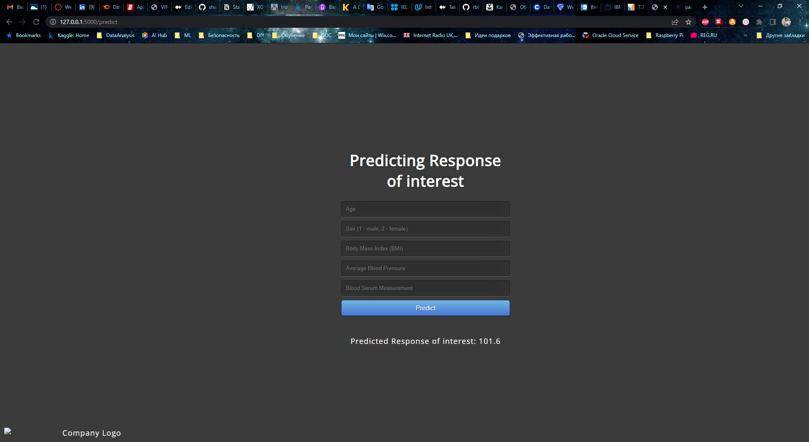

7. Flask output in terminal window

