**Week 5 Assignment - Week 5: Cloud and API deployment**

Name: Dmitry Sharukhin

E-mail: sharuhinda@gmail.com

Batch code: LISUM15

Submission date: Nov 28, 2022

Submitted to: Data Glacier

1. Initial code of Flask app

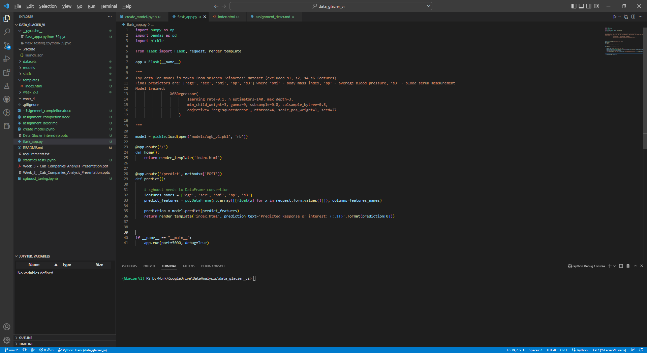

2. Changed app code to use streamlit library (necessary condition to deploy app in StreamlitCloud)

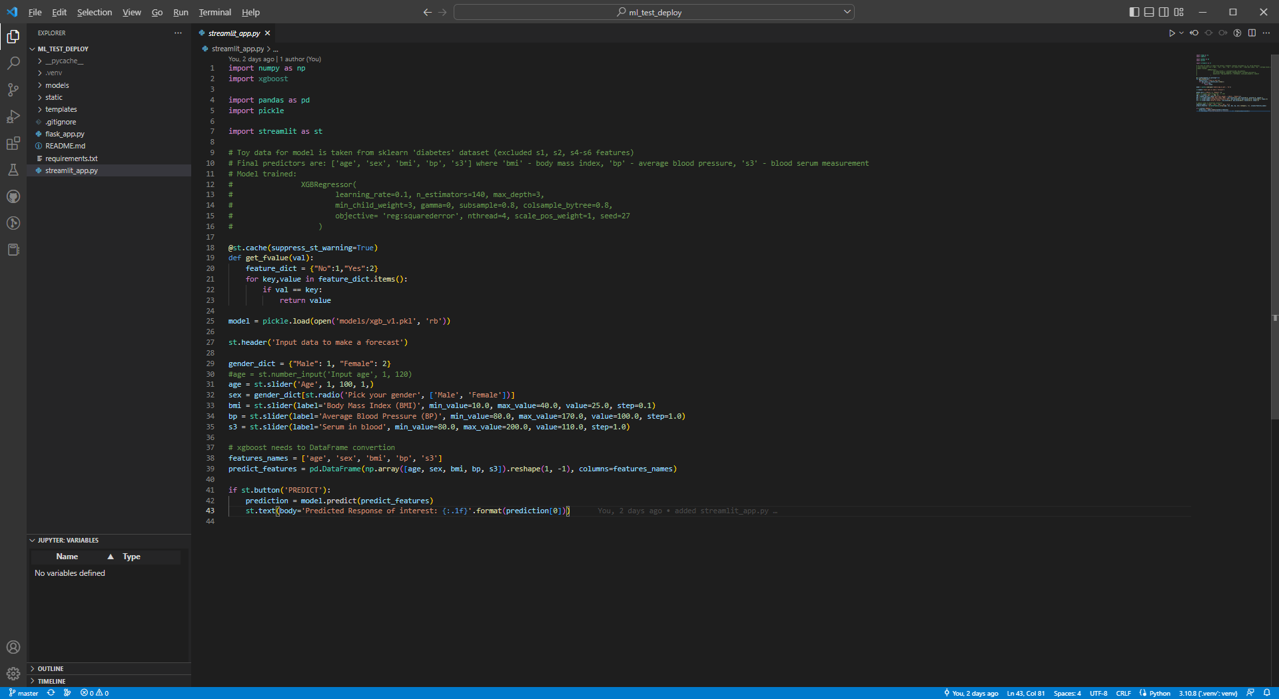

3. Login to Streamlit Cloud (https://share.streamlit.io/)

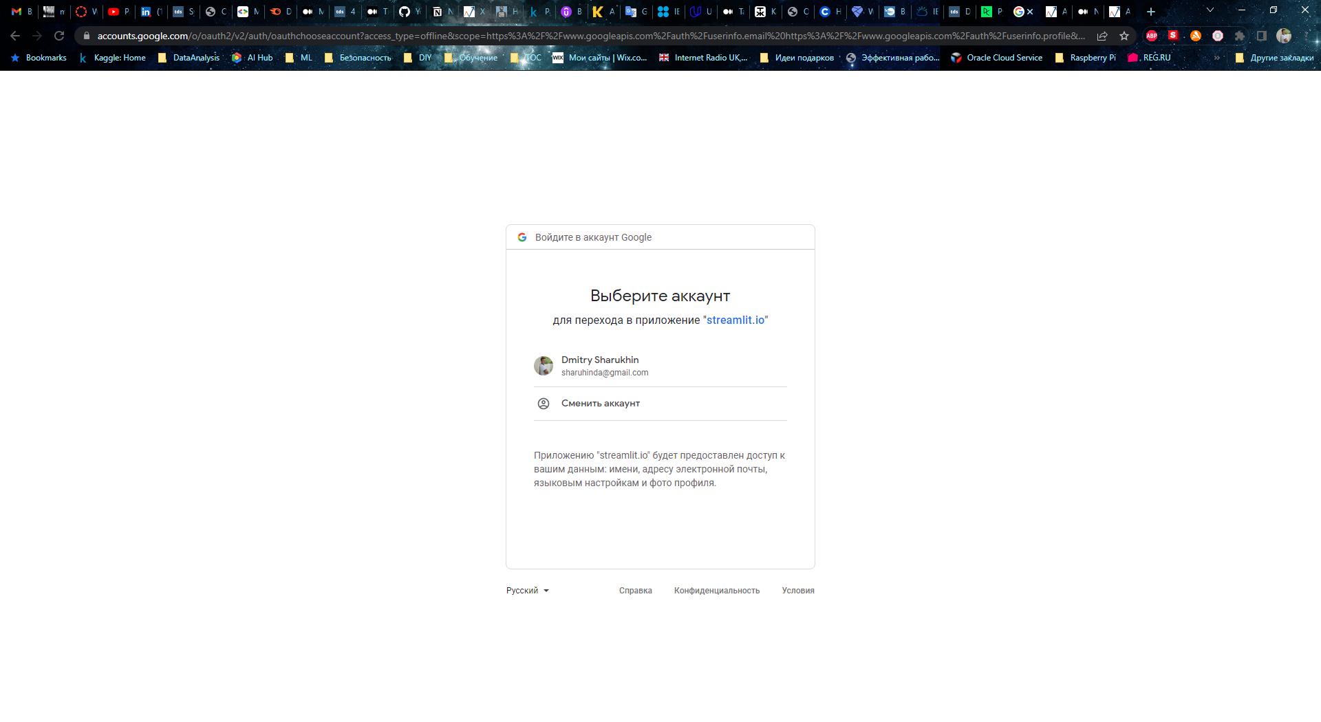

4. Cloud homepage with no apps deployed and no github connection

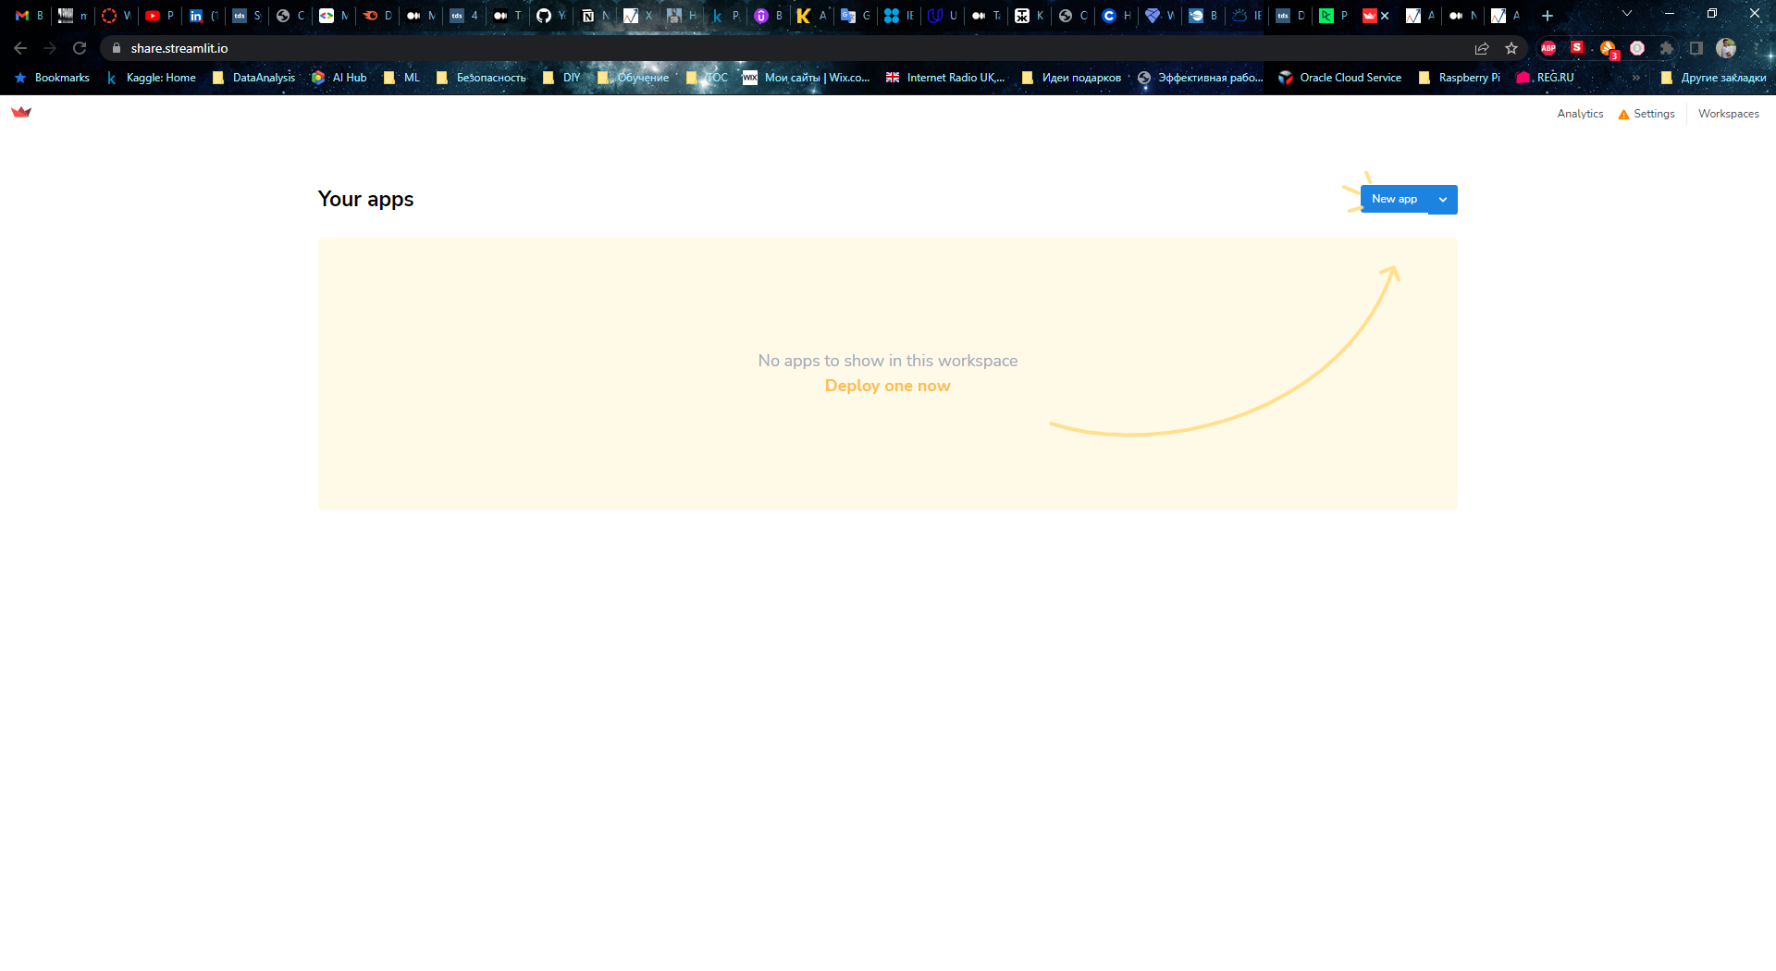

No github profile connected

5. Connected github profile to choose repository from

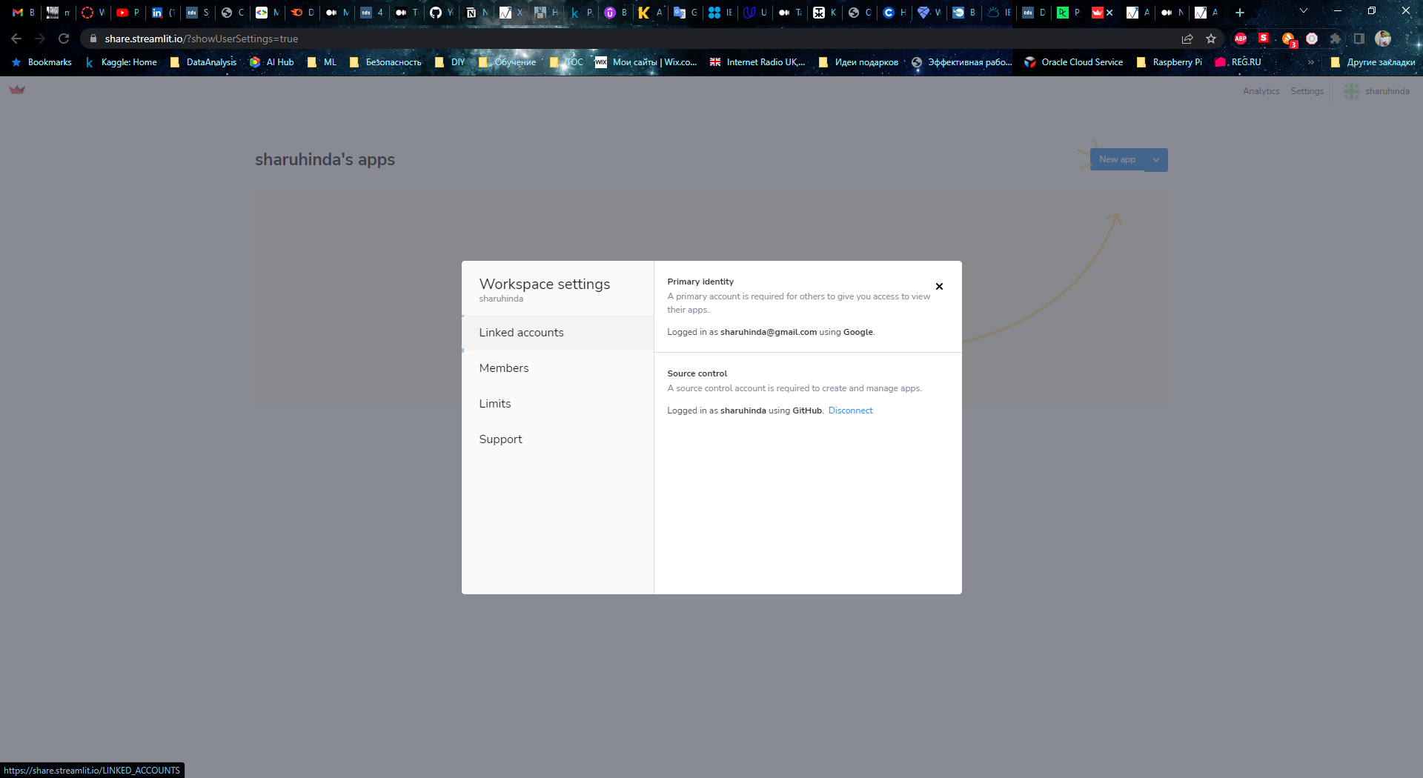

Github profile connected

6. Choosing repository to deploy app from

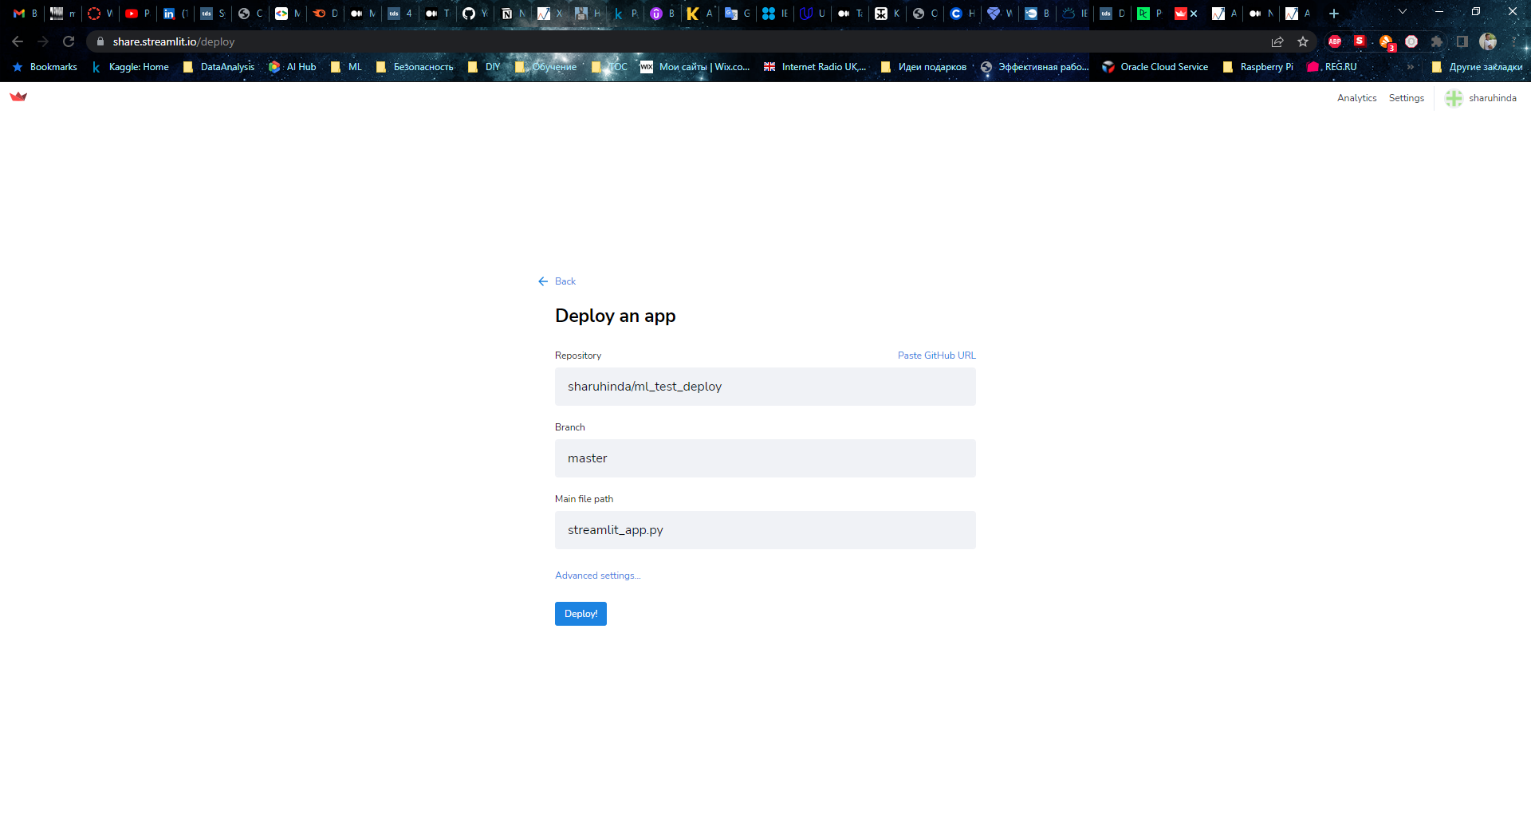

7. Deployment process with log

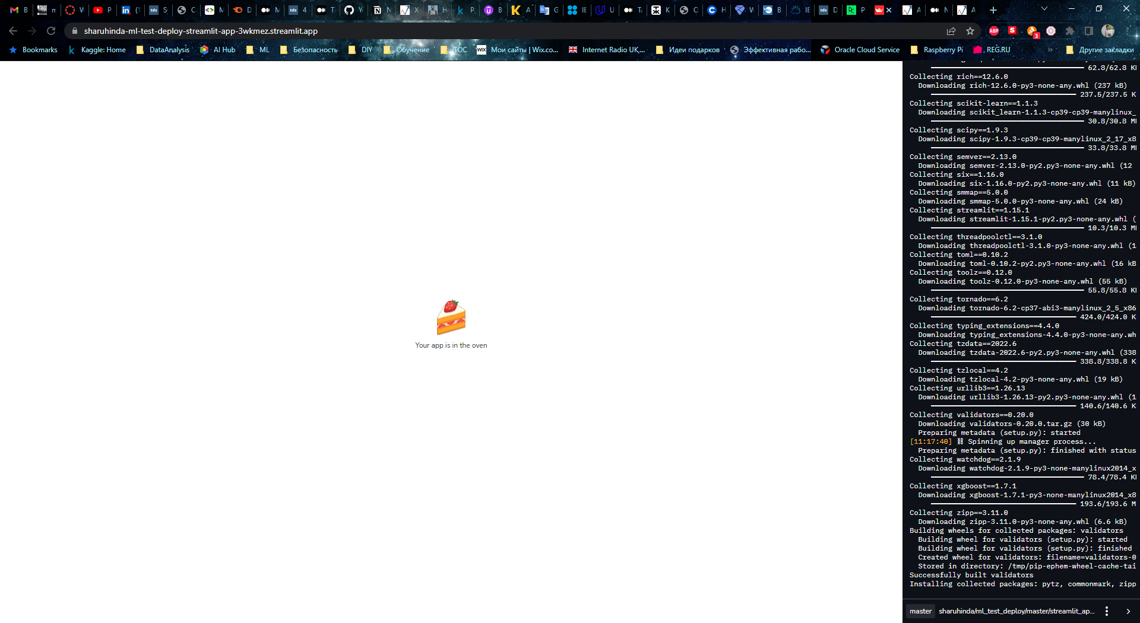

8. App has been deployed and ready (assigned address: <https://sharuhinda-ml-test-deploy-streamlit-app-3wkmez.streamlit.app/>)

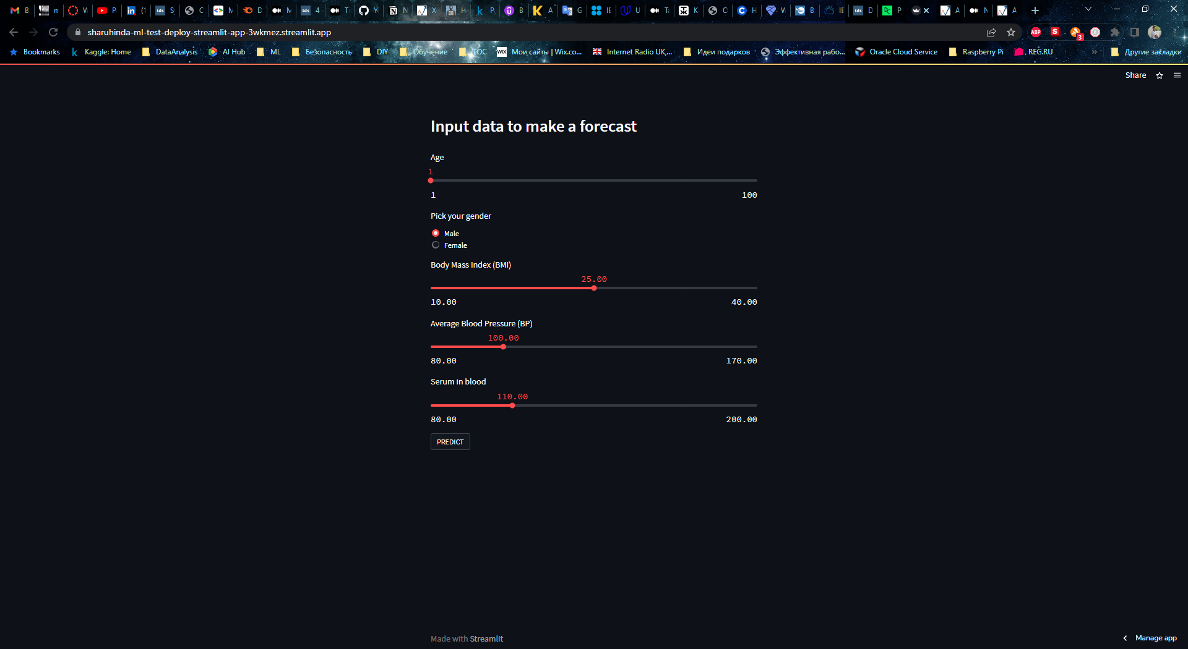

9. Making prediction

