Q-33

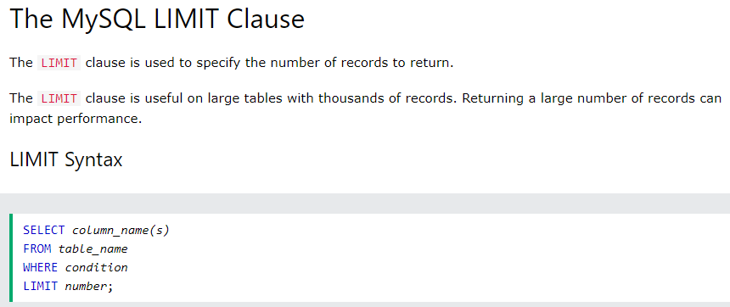

Ans-34-select first_Name,salary from worker order by salary desc limit 1 offset 4 ;

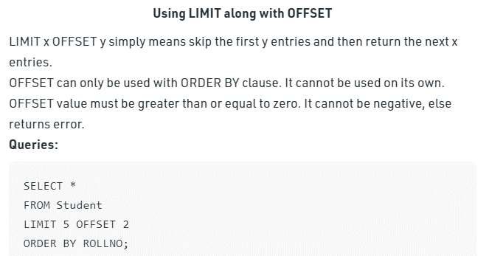

35-SELECT first_name, salary FROM worker WHERE Salary IN (SELECT Salary FROM worker GROUP BY Salary HAVING COUNT(*) > 1)

**36-Write an SQL query to show the second highest salary from a table.**

If salary are different we use limit but if salary may be same then

But ye query smjh ni ai h iske liye in Operator ek br pdhna pdega

